
New England Patriots - Book Event
“Comeback!”
Tom Brady’s Two-Year Mission to Overcome Deflategate

Written by Northboro Author Vin Femia
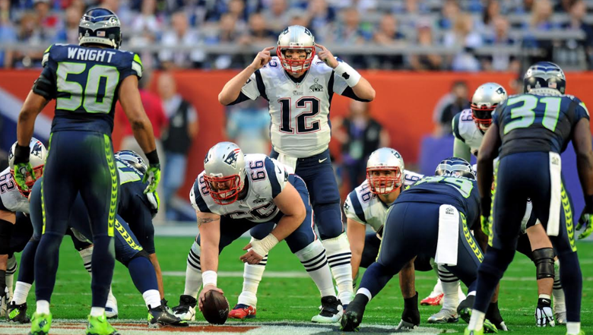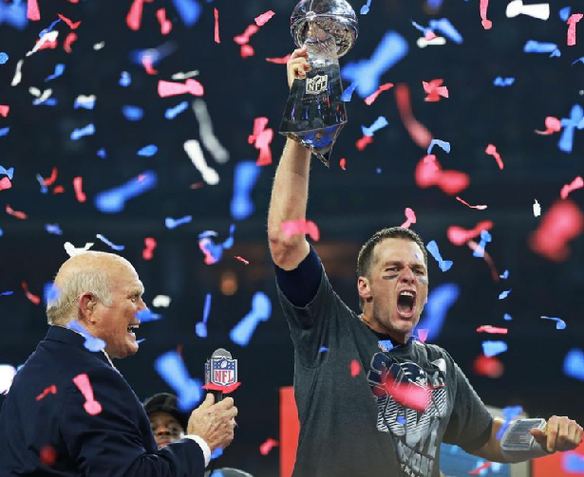

Book Talk and Q&A, Book Sale and Signing
Friday, October 27, 5:30 PM
243 West Main Street, Northboro MA 01532

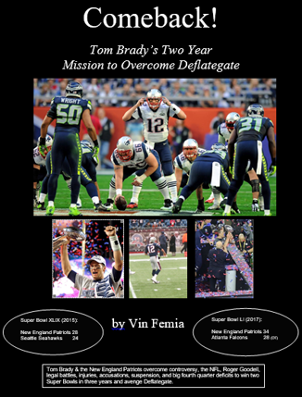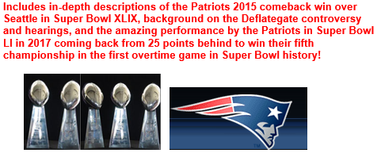
➔Join us for snacks at the Tailgate at 5:15
➔ Stay for the talk at 5:30
➔ Good chance to buy holiday gifts for the sports fans in your family

Upton Bell, Patriot General Manager 1971-72:
“… a very detailed and interesting summary of the Deflategate controversy and how the Patriots
overcame that with two thrilling Super Bowl victories over the last three seasons …a ‘must-read’ for all Patriot fans.”

Steve Grogan, Patriot Quarterback 1975-1990, member of the Patriot Hall of Fame:
“Vin captured the history of the Patriots very well in his earlier book, Patriot Pride, and now, with Comeback he provides readers with an excellent summary of the entire Deflategate story and the Patriots’ thrilling last-minute Super Bowls wins in 2015 and 2017.”

