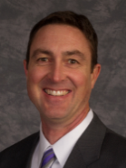
Cottonwood Drive
Over the last few weeks, I have received several calls and emails asking about the repair status of Cottonwood Dr. Unfortunately, my answer to that question is another question… When will South Weber make repairs to their road? I don’t have an answer to this question, but I can tell you that South Weber is beginning to listen to the plight of Uintah City of making repairs to the road. Since late last year, I have made it a priority to talk often with the Mayor and the city manager to understand their perspective and search for a solution. Although these conversations were centered on having South Weber prioritize the road repairs to be completed this year, South Weber has recently asked Uintah City to partner with them to make repairs to the road, which will cost Uintah City $100K of the $370K price tag. Essentially this request is suggesting the city is 27% culpable for the deterioration of the road, which I find interesting and not in line with my thoughts, and I suspect many of the citizens of Uintah City do not agree with the level of culpability that South Weber advocates. If the council agrees to pay $100K toward the repair of Cottonwood Drive, repairs will occur this summer. The residences of Uintah will have a new road to travel on, but financially crippling the city for the next few years.

Though a large number of Uintah residence travel this road daily, I’m of the opinion Uintah City should not take on so much cost burden to repair a road that is owned by another city. I believe an equitable solution can be reached with South Weber, but it will take some time to work out a solution. I know this will be a challenging time for city residence while the road continues to deteriorate, but at this time the city can’t take on such a large expense. The council and I will discuss this matter in depth while we prepare the 2017/2018 budget and I assure you that we will not minimalize this issue.

While the City Council searches for a solution, I encourage you to submit your opinions via email to Mayor@UintahCity.com and to South Weber (phone number (801) 479-3177).
- Lawrence Flitton
Time to Vote
This year Uintah City will be holding elections for the following offices: Mayor (1) and City Council (2). In order to qualify as a candidate, interested individuals must file in person between June 1st and June 7th at the City Office. Office hours for filing during the week of June 1st – 7th are: Monday – Wednesday 9am – 5pm; Thursday and Friday 9am-1pm. Outside of those hours, you may contact the City Recorder Darinda Wardell at 307-679-1105.
If a Primary Election is needed, it will be held on August 15th. Residents who are registered to vote will receive their ballots at the end of July. The General Election date is November 8.
Even though the elections are a still few months away, it’s always a good idea to make sure that your registration information is up-to-date by logging onto www.voter.utah.gov. All you need is your Utah license/ID number and 5 minutes.
Remember: June 1-7th is the only time that you may officially file as a candidate for office! Make your voice heard.
For more information, please contact the City Recorder at: 801-479-4130.

From the Desk of Chief Pope
As with the last couple of months, with increased temperatures comes Spring runoff and high river water. April has been no different. This not only brings the potential flood issues it makes our river’s more dangerous. Be mindful of the rising water’s for flooding and the swift water’s when thinking about swimming. In both cases, please be prepared and be safe.

The department had the honor of serving the Uintah community during the pancake breakfast the morning of the Easter Egg hunt. We enjoy seeing familiar faces and enjoy meeting members of the community that we have not met before. The best part of the day is watching the kids hunt for Easter eggs. Councilwoman Michelle Roberts and the volunteers did another amazing job this year.

Open Burn Season has begun, and we would like to thank the community for ensuring the rules and regulations are followed for a safe and legal open burn season. For more information about Burn Permits, visit http://www.uintahcity.com/uintah-city-open-burn-instructions.htm.

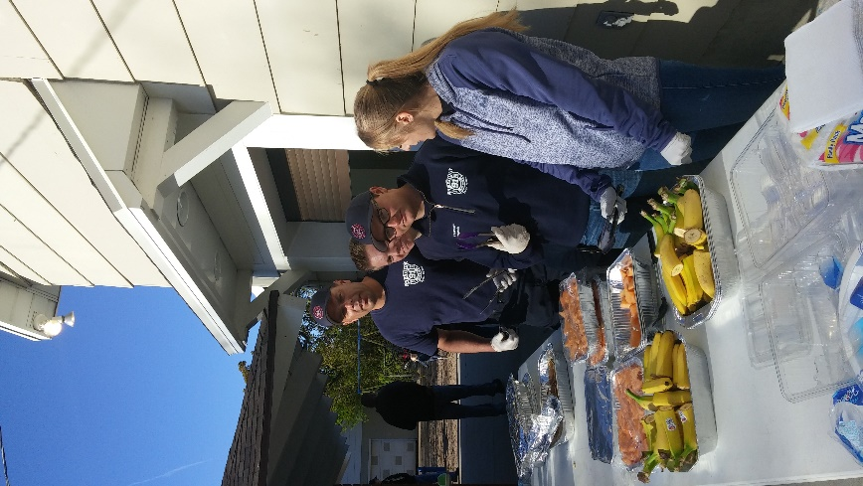
The National Fire Protection Association selected Chief Pope to represent the Uintah City Fire Department (the only Utah Selection) at the 2017 Rural Fire and Life Safety Symposium in Boston in May. Chief Pope was one of 60 selected out of 1,100 candidates in the United States and Canada. This is a testament to the professionalism and recognition of your Uintah City Fire Department firefighters as leaders in small town firefighting and life safety.

Just a reminder for everyone…we have two programs FREE to all Uintah residents. We have partnered with Red Cross to install smoke detectors free of charge to those Uintah homes that do not have them, or do not have an adequate amount of them. We also offer free home safety checks. These checks are to assist you in pointing out possible safety issues you may have in your home. We rather prevent fires from happening to keep you and your families safe. Please contact the department for more information.

During the month of April, the department was dispatched to 4 medical calls and a vehicle fire. We pride ourselves to ensure safety; compassion and the utmost care are given to the Uintah residents. Thank you for allowing us to serve the Uintah community.

Did you know compliments of Invisible Fence of Salt Lake City in conjunction with their campaign Project Breathe: Uintah City Fire Department now carries pet oxygen masks on Engine 91? The goal of the campaign is to donate one set of pet oxygen masks to every fire department nationwide. So far, the program has saved an estimated 10,000 pets from fires and smoke inhalation.

- William Pope
City Contact List
City Council Members  Mayor Lawrence Flitton  (801) 633-5129  mayor@uintahcity.com  Michelle Roberts  801-388-0810  michelleroberts362@gmail.com  Gordon Cutler  (801) 476-0356 or  (801) 726-0613  z940799@comcast.net  Jerry Smith  (801) 476-7502 or (801) 209-2595  jerryandpat1968@yahoo.com  Greg Johnson  (801) 475-0306  johnsongregory1850@gmail.com | Fire Chief  William Pope (801) 425-2802  wpope2953@gmail.com  Planning Commission Secretary & Court Clerk  Crystal Western | (801)479-4130 | uintahcity@uintahcity.com  Park Reservations  (801)479-4130  Public Works/Maintenance  Jeff Holden (801)388-3558  City Recorder: Darinda Wardell  (801)479-4130 uintahcity@uintahcity.com | Animal Control  Office (801)399-8244 or emergency (801)629-8221  Hours – Monday – Friday 8 am - 5 pm Saturday 8 am to Noon.  Blue Stakes  Dial 811, (800) 662-4111 or (801) 208-2100  Monday-Friday 7am to 5 pm  Building Inspector: Jeff Monroe  (801)479-4130 or (801)395-8288  Cemetery: Stephanie Howell  (801)814-1262 showell@xmission.com or Jerry Smith (801)476-7502 or (801)209-2595 jerryandpat1968@yahoo.com  Sheriff Dispatch: (801)629-8221

