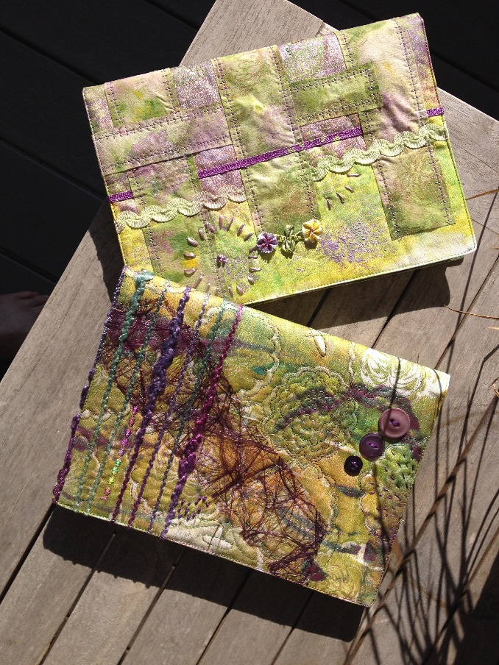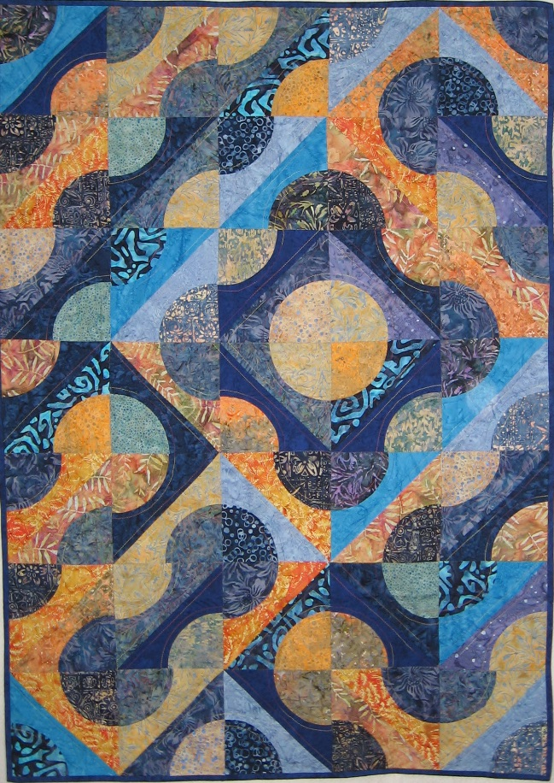

My name is Kerry Glen. I have been a passionate quilter for many years now, so much so that in 1995 I decided to make it my career. I operate Tulis Textiles from my home in Northland New Zealand. It is wonderful to be able to work in an environment that fully caters for all my creative needs.

Since starting Tulis I have sold and worked with Batik fabrics, I love the contemporary feel these fabrics add to even the most traditional patterns. I have a reputation as being a bit of a "circle freak" as I have gravitated to working with pieced circular shapes. I have taught classes specialising in piecing using tools and templates to create exiting quilts .More recently I have developed a series of classes working with surface design techniques applying paint and marks to fabric and therefore creating unique works of art. I have had the pleasure of working with students both here in New Zealand and also Australia, passing on those techniques I have learnt and developed during my quilting career over the last 16 years. Since locating to Northland I have run a number of weekend retreats and workshops employing tutors from New Zealand and Australia for classes of up to 20 ladies. I regularly attend Quilt and Trade shows in the US and Britain to keep abreast of trends and products to share with both my clients and my students.

