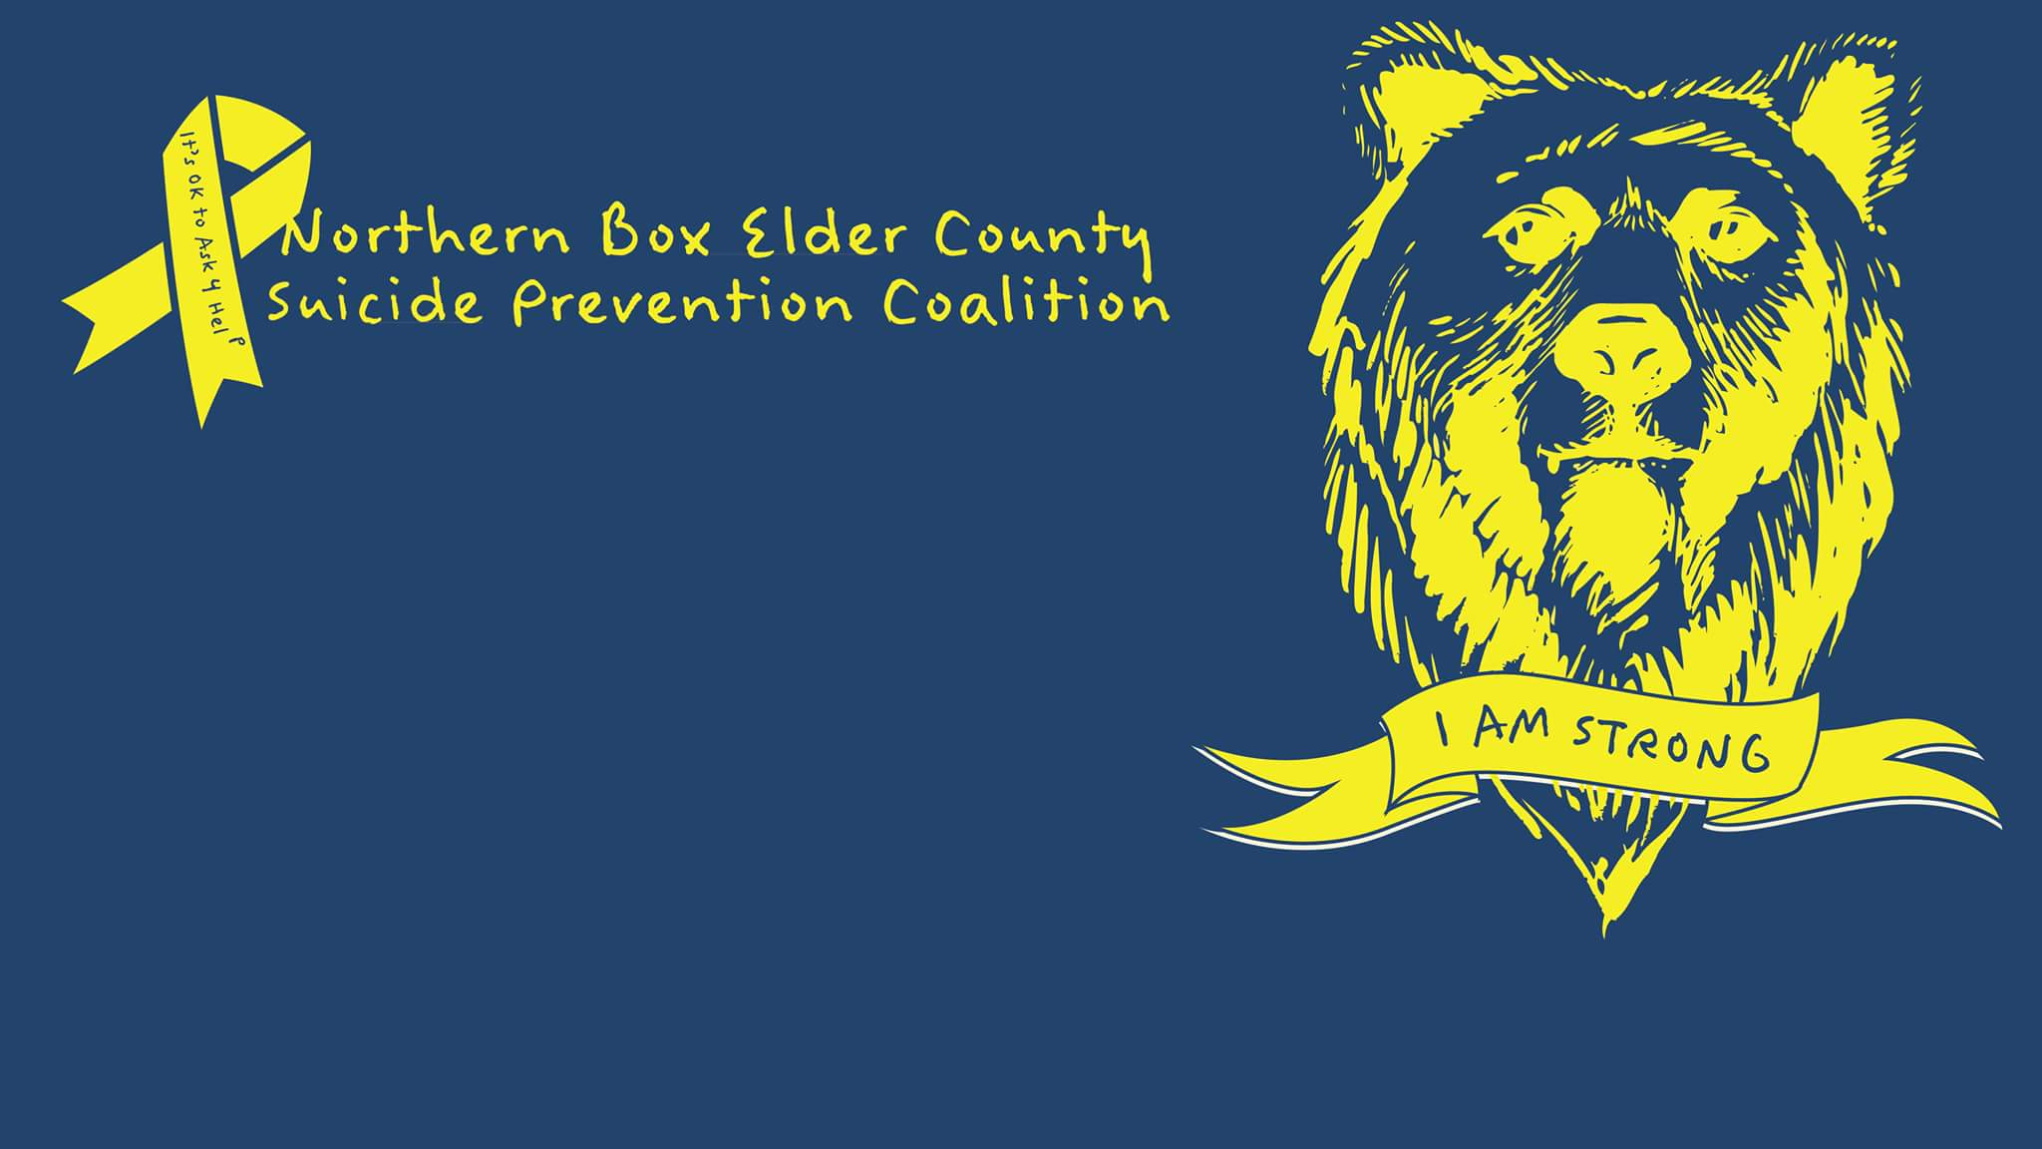  Aug 5, 2017  Wheat & Beet Fun Run  Join us in supporting our local Suicide Prevention!  IPG joins Garland’s Annual Wheat and Beet Days. Proceeds will be donated to Northern Box Elder County Suicide Prevention Coalition.  - On Average, there are 121 suicides per day nationally  - In Utah, Suicide is the 1st leading cause of death (ages 10-24)  - Utah is ranked 5th in the nation for death by suicide | 5k at 8am  Kids Run at 9am  ────  1st and 2nd place prizes and Raffle to follow race  ────  Individual – 20$  Family – 50$  ────  Run for a good cause! Proceeds donated  ────  Register at:  http://tiny.cc/gy04ky
REGISTER: http://www.active.com/garland-ut/running/wheat-and-beet-charity-fun-run-2017

