Simple thread tension adjustments



WWW.QuiltCentralAcademy.com

Trademarked,Registered,Copyrights.

Although many adjustments can have an effect on the tensions, like needle bar height, foot height, needle to hook relationship, basket finger placement, angle of the needle, batting density, weave of the fabric, this tension is adjustment instruction sheet is just for switching from one thread type to another. That is why we say “simple thread adjustments”.
Learn the standard settings for the tension. If you choose a brand or type of thread that you like in your bobbin case you can build a stash of colors and seldom have to adjust your bobbin because the weight or size will always be the same. When I say a standard thread I mean a thread that is similar to the coats dual duty thread you probably have purchased to piece patchwork with. I personally buy perma-core 30 tex thread for almost everything I do. It is industrial grade thread and is similar to the dual duty.
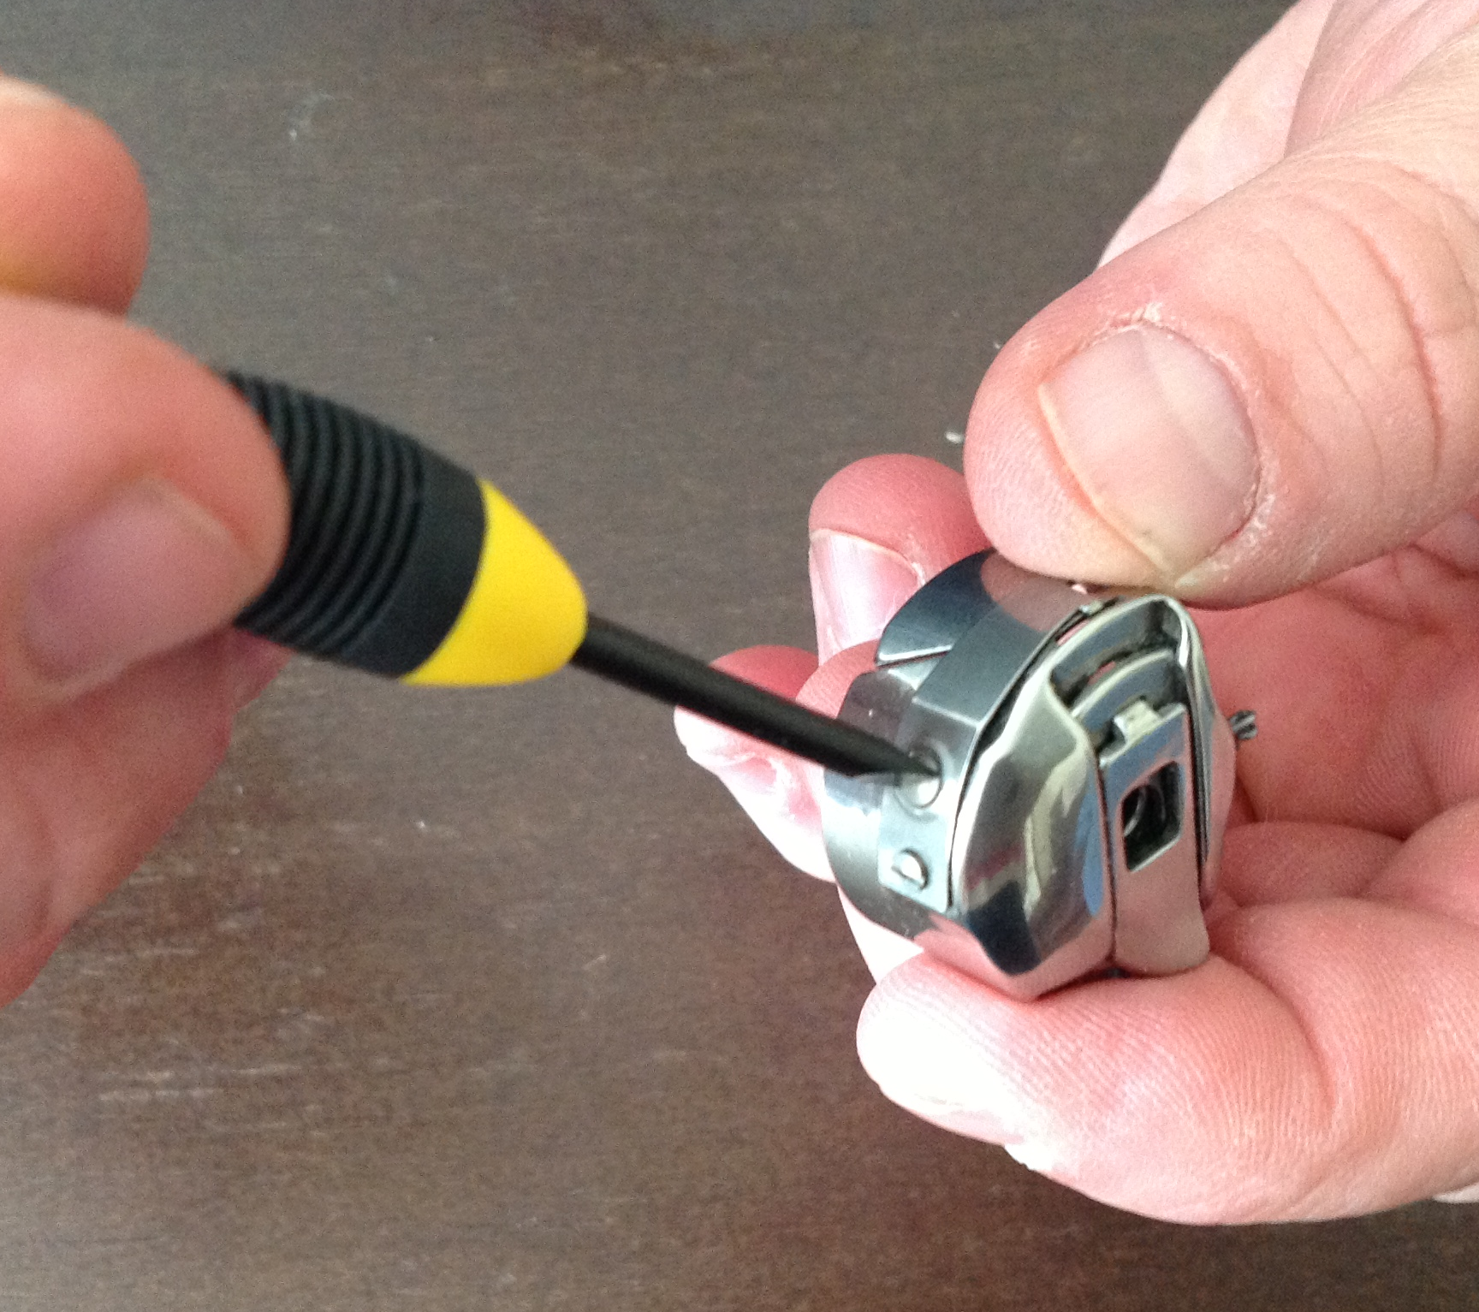

We start with the bobbin case. Take a look at your bobbin case. See the little metal strap that in on one side of the case? That is called the tension strap. When you put the bobbin case in and pull the thread down the little slot and under the tension strap the bobbin should pull clock wise in the case. The truth is that most machines will run with ease no matter if the bobbin turns clockwise or counter clockwise but the old fashioned way is to have the bobbin turn clockwise when the thread is pulled. On some bobbin cases you will see an extra guide called a pigtail. That extra guide makes sure the thread is in the pick up zone to make the knot. Most threads will be in the zone for pick up without going through the pigtail. The pigtail just insures that any stubborn or wire like thread will stay in that zone. When you add the use of the pigtail it also adds tension to the lower thread. If you want to use a fat thread in the bobbin case you might skip using the pigtail. If you are using a skinny or slippery thread you would want to use the pigtail for sure. Normal dressmakers thread weights like you use for piecing and buy at your local fabric store fall right in the middle, where you can decide to use the pigtail or not. I personally like to put that thread in the pigtail. Not every brand machine has a bobbin case with a pigtail. Now take a look again at that tension strap on that case. See the 2 screws on that strap? The small one holds the strap on and the big one is the tension adjustment screw. That bigger screw is short. It only has 2 turnings on it. When adjusting the screw hold it over a table or fabric so if the screw pops out you can find it. So be very careful when adjusting. Only adjust about 1/8th of a turn at a time.
To adjust the screw you need to leave the thread out of the pigtail yet down the slot and under the tension strap. Suspend the bobbin case by the thread. It should creep down the thread without much of a jiggle. Loosen or tighten to get this effect. Now add the pigtail guide to the thread. You now should be able to hold the bobbin case upright, but with a snap or wiggle get it to let out thread. If you have a fat thread don’t use the pigtail. Fat threads are squeezed tight enough under the tension strap without adding any more. Put the bobbin case into the machine. Take note that the bobbin case has a protrusion on the right side of the bobbin case and it matches a notch on the right side of the bobbin basket. Also inside of the bobbin basket the center shaft has a groove in it. The bobbin case must “snap” into that groove. If you do not hear the “snap” try again until you do. If the case is not in, the needle will hit it when you start sewing. I also would like to mention that when you have your bobbin case out it would be a good idea to have a lint brush or paint brush handy so that you could brush the fuzzies out of the bobbin basket.( Note: There are only 2 real rules with taking care of your long arm. Keep the fuzzies out of it and oil when needed. Most long arms are built to last and last if you just keep them clean and oiled.)
The point of adjusting tensions is to get the knot to lock in the batting so you cannot see the top thread on the bottom or the bottom thread on the top. Now that you have the bottom thread set in a normal position lets sew a figure 8 on the edge of your fabric to test the tensions. After you sew a figure 8 roll the edge of your quilt over and look at the stitches and the tension. Do you need to pull the top thread up or let it down to get the knot to be in the middle of the batting? I should also mention here that if you are using a real long arm batting that has either a 60/40 cotton/poly blend or a ½ inch bonded poly then you should not have much fussing to do to get that thread to lock in the batting because you have enough thickness or fluff to do that. If you are using skinny cotton batting or a skinny poly batting or any less of a blend than a 60/40 you are going to have to work at that adjustment. Also we recommend that if you are not using a real long arm batting then stick to the same color of thread top and bottom for better looking results. If you are using a skinny batting and have your tensions perfect, you might still see the color of the backing or the underneath thread right down through the needle holes and it will appear that your tensions are off when they really are not. Also if you are using a really large size needle and the holes in the fabric are staying open it might appear that your tensions are off because you can see the color of the backing in the hole. If that is the case you can close the holes with a quick swipe of a wet toothbrush.

