November- The Sawtooth Star
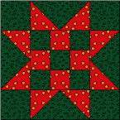
Red
2-A ... 8 squares 3 1/2" x 3 1/2"
2-B ... 4 squares 2 1/2" x 2 1/2"

Green
1-A ... 4 squares 3 1/2" x 3 1/2"
1-B ... 5 squares 2 1/2" x 2 1/2"
1-C ... 4 rectangles 3 1/2" x 6 1/2"
ASSEMBLY INSTRUCTIONS
Step 1. Flying Geese Unit
Draw a diagonal line on wrong side of Piece 2-A red squares. Layer Piece 2-A square and Piece 1-C green rectangle, right sides together. Sew on top of drawn line. Cut away excess fabric 1/4" from seamline. Press seam allowance. Repeat for other end of rectangle (Diagram I). Make 4.
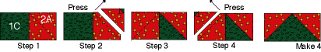
Diagram I
Step 2. Nine-patch unit
Using Diagram II as a guide, sew red (Piece 2-B) and green (Piece 1-B) 2 1/2" x 2 1/2" squares together to make nine-patch unit.
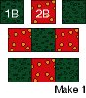
Diagram II
Step 3. Block Assembly
Using Diagram III as a guide, sew green 3 1/2" x 3 1/2" squares (Piece 1-A) to Flying Geese units and nine-patch unit together to make Sawtooth Star Block.
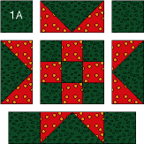 Thank you McCall’s Quilt Block Patterns
Diagram III

December The Chinese Coin
Cutting Instructions
Background
... Piece 1A - Cut 4 strips 2" x 9 1/2"
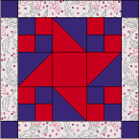
Purple
... Piece 2B - Cut 4 squares 2" x 2"
... Piece 2C - Cut 2 squares 3 7/8" x 3 7/8"
... Piece 2D - Cut 1 strip 2" x 18" (extra allowed for squaring)
Red
... Piece 3C - Cut 2 squares 3 7/8" x 3 7/8"
... Piece 3D - Cut 1 strip 2" x 18" (extra allowed for squaring)
... Piece 3E - Cut 1 square 3 1/2" x 3 1/2"

Piecing the block
Step 1. Referring to Diagram I, sew purple 2" x 18" strip to red 2" x 18" strip. Cut 8 segments 2" x 3 1/2". Stitch
together 2 segments to make four-patch unit). Make 4.
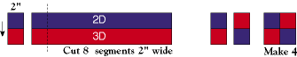
Diagram I
Step 2. On wrong side of Piece 2C purple squares, draw diagonal line. Layer square with Piece 3C red square, right sides together. Sew 1/4" seam on each side of marked line; cut apart on marked line. Press open to make pieced squares (Diagram II). Make 4.




