______________________________
Block of the Month – January – Party Hats
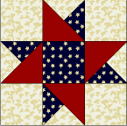
12” x 12” finished block
Cutting Instructions:
Background
... A - Four squares 4 1/2" x 4 1/2"
... B - One square 5 1/4" x 5 1/4" cut twice diagonally
Red
... C - Two squares 4 7/8" x 4 7/8" cut once diagonally
Blue
... A - One square 4 1/2" x 4 1/2"
... B - One square 5 1/4" x 5 1/4" cut twice diagonally
Assembly Instructions:
Step 1. Using Diagram I as a guide, sew pieces together to form pieced-square.
Diagram I, and blue square t
Step 2. Referring to Assembly Diagram, turn pieced-squares to form star. Sew together pieced-squares, background squares o form rows. Sew rows together to make block.
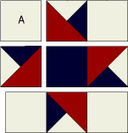

Block of the Month – February – “Shoo-Fly”
Cutting Instructions  Cream  ... Piece 1A - Cut 2 squares 4 7/8" x 4 7/8"  ... Piece 1B - Cut 4 rectangles 2 1/2" x 4 1/2"  ... Piece 1C - Cut 1 square 4 1/2" x 4 1/2"  Green print  ... Piece 2A - Cut 2 squares 4 7/8" x 4 7/8"  ... Piece 2B - Cut 4 rectangles 2 1/2" x 4 1/2" | Block Size: 12" Finished  Beginner Level

Piecing the block
Unit 1 - Pieced-square
On wrong side of Piece 1A cream squares, draw diagonal line with the marking tool of your choice. Layer square with Piece 2A green print square, right sides together. Sew 1/4" seam on each side of marked line; cut apart on marked line. Press open to make pieced squares (Diagram I). Make 4.
Unit 2
Sew Piece 1B cream rectangle to 2B green print rectangle to make pieced squares. (Diagam II). Make 4.
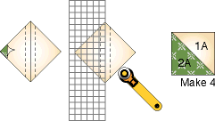  Diagram I | 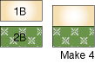  Diagram II
Assembling Block
Using Assembly Diagram as a guide, sew pieces and units together to make rows. Sew rows together to make Shoo-Fly block.
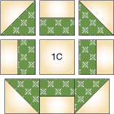
Assembly Diagram

