Block of the Month - July

Spinning Star  Cutting Instructions  Background  ... Cut 6 squares 3 7/8" x 3 7/8"  Blue Print  ... Cut 4 squares 3 7/8" x 3 7/8"  Floral Print  ... Cut 6 squares 3 7/8" x 3 7/8" | Size: 12" Finished
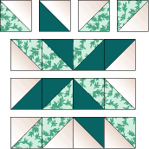
ASSEMBLY INSTRUCTIONS
Piecing the block
Pieced Squares: On wrong side of lightest fabric, draw diagonal line with the marking tool of your choice. Sew 1/4" seam on each side of marked line; cut apart on marked line. Press 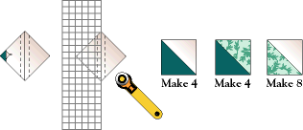
Block assembly: Lay out pieced squares using this assembly diagram as a guide. 9
Block of the Month- August - Four Patch

Finished Size 12" x 12"

Cutting Instructions  Cream Fabric ... Color #1  ... 1A - Cut 4 rectangles 2 1/2" x 4 1/2""  ... 1B - Cut 12 squares 2 1/2"  Green ... Color #2  ... 2B - Cut 4 squares 2 1/2" | Purple ... Color #3  ... 3A - Cut 4 rectangles 2 1/2" x 4 1/2"  Purple Print .... Color #4  ... 4C - Cut 4 rectangles 2 1/2" x 6 1/2"
ASSEMBLY INSTRUCTIONS
Step 1. On wrong side of square, draw diagonal line. Sew directly on top of marked line; cut away excess fabric. Press towards triangle (Diagram I). Note the direction of the drawn line for the short half trapezoid (4 1/2" rectangle used) as compared to the long half trapezoid (6 1/2" rectangle used). Make 4 of each.
Diagram 1
Step 2. Sew together pieces as shown in Diagram II to make quadrant. Make 4.
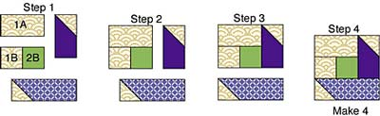
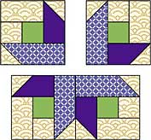
Diagram IIStep 3. Sew 2 rows of 2 quadrants each, rotating as shown (Assembly Diagram). Stitch rows together to make Four-patch Block.

Assembly Diagram

