The 2016/2017 Block of the Month…

As we have done for the past year, we will offer two 12” block patterns in each issue of the Newsletter. At the end of the year, you should have a sampler quilt to display at a Fall meeting.
You might want to chose a colorway and use it throughout as a unifying theme, or you might find a block that you like and create it in many colors. Whatever you chose, we hope you will take advantage of the blocks to create something lovely.

This year McCalls Quilting has given us permission to use the patterns on their website. Thank you, McCalls

Block of the Month – September, ‘16

Double Pinwheel
Skill Level INTERMEDIATE
Finished Size 12" x 12"

Cutting Instructions  Wine  ... Piece A - cut two squares 5 3/8", cut in half once diagonally to make four triangles  Stripe  ... Piece B - cut four rectangles 2 1/4" x 5 1/8". Referring to Diagram 1, cut into "ne-way" half trapezoids | Blue  ... Piece C - cut one square 4 3/4", cut in half diagonally twice to make four triangles  Background  ... Piece D - cut four rectangles 2" x 6 7/8". Referring to Diagram 1, cut into "one-way" half trapezoids.  ... Piece E - cut one square 7 1/4", cut in half diagonally twice to make four triangles
Cutting One-way Half Trapezoid  Place rectangles, right side of fabric up, on cutting mat. Using 45° angle line on the ruler, cut off lower right corner. CUT EXACTLY AS SHOWN IN DIAGRAM 1 | 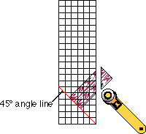 8.
8Step 1. Stitch together pieces A - E as shown in Diagram II to make sub-unit. Make 4.
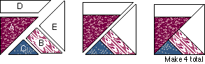Diagram II
Step 2. Refer to Assembly Diagram for following steps. Sew 2 rows of 2 sub-units each. Sew rows together to make Double Pinwheel Block.
(pattern from the McCall’s website)

Block of the Month – October, ‘16

Blazing Star

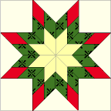

Skill Level INTERMEDIATE
Finished Size 12" x 12"

CUTTING INSTRUCTIONS  Background - Fabric 1  ... Piece B ... Cut 4 squares 4" x 4"  ... Piece C ... Cut 1 square 6 1/4" x 6 1/4", cut in half diagonally twice to make 4 quarter-square triangles  Yellow - Fabric 2  ... Piece A ... Cut 8 diamonds (see below) | Green Print - Fabric 3  ... Piece A ... Cut 16 diamonds (see below)  Red Solid - Fabric 4  ... Piece A ... Cut 8 diamonds (see below)
CUTTING DIAMONDS
For an easy way to cut the diamonds in Blazing Star, refer to "Rotary Cutting Unusual Shapes" instructions in our Lessons section. If you prefer not to download the template diagram, use the following instructions and Diagram I when cutting the required diamond shaped pieces:
... Cut strip of fabric 1 3/4" wide x WOF (width of fabric)
9.
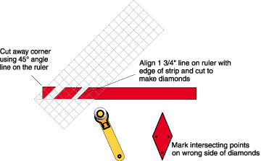
Diagram I
SUB UNIT ASSEMBLY
Pieced Diamonds: Using intersecting points, align diamonds and sew from edge to edge. (Diagram II) Make 8.

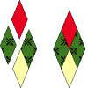
Diagram II
BLOCK ASSEMBLY
Sew pieced diamonds together forming quadrants. Sew quadrants together. (Diagram III) Set-in quarter-square triangles and corner squares to complete the Blazing Star block. (Diagram IV)

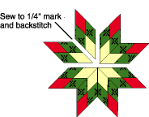
Diagram III

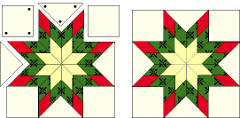 Diagram IV

(pattern from the McCall’s website, thanks. McCall’s) 10.

