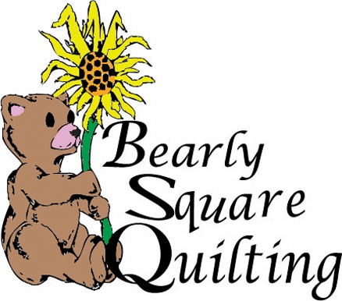
Registration Form for Festival Days Quilt Show
One Form Per Quilt – 3 Max with preference of order
If not enough room to hang all quilts, we will pick by preference.
Quilts must be in by Sept 11^{th,} at 5 pm, 2017
Show Dates: Sept 15th & 16th, 2017

Every quilt has a story and we would like to know yours! What was your inspiration? Why did you make it? Where did it come from and why is it special to you? People like to read the quilt history and why you chose the pattern. Please include this information on a 5 x 7 card so we may attach it to your quilt.

Quilt Show Number:______________________________(we will assign this number)

Order of Preference:_____________________________________________________

Submitted By:___________________________________________________________________

Email__________________________Phone No:________________________________________

Address:_____________________________Town:_________________________Zip:__________

Quilt Name:______________________________________________________________________

Pattern, Source or Designer Name:____________________________________________________

Pieced By:______________________________________Quilted By:__________________________

Questions? Contact the shop at 406-265-4424, or stop in at 109 1st Street West, Havre
All quilts must be picked up by Wednesday, September 20that 5 pm.

