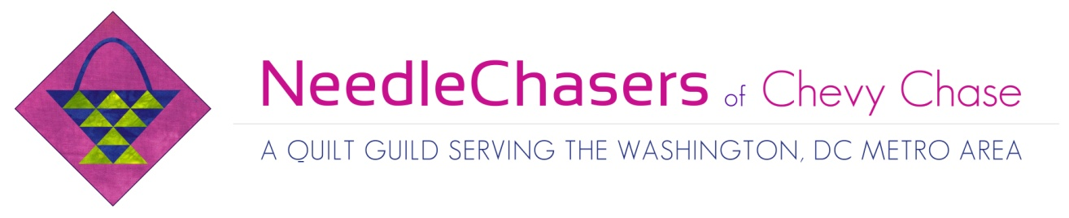NeedleChasers Event Registration Form
Thank you for your interest in this NeedleChasers Event. This is your official registration form for the workshop listed below. Please complete this form and submit it with your payment to either Kim Kellman or Nancy Balz. Check should be made payable to NCCC. Your spot in this workshop will be secured only when this form and payment are received.
Registration Information
- Teacher’s Name: Rachel Derstine
- Event or Workshop: Artful Couching
- Date and Time: Thursday, April 13, 10:00 a.m.- 4:00 p.m.
- Location: North Chevy Chase Christian Church
- Supply list:
- Square Within a Square Quilt
  - Bring an assortment of coordinating fabrics, preferably precut into 2.5” strips. Your blocks will each made of 2 (2.5” x 6.5”) rectangles and 3 (2.5” x 2.5”) squares. Just bring a jelly toll of your favorite color combo if you are pressed for time.
  - Batting and backing
  - Thread in assorted colors for piecing
- Raindrop Quilt
  - Bring an assortment of coordinating fabric scraps in a variety of sizes and shapes. This quilt is a great way to use up old leftover fabrics.
  - Batting and backing
  - Thread for quilting
  - Reynolds Parchment Paper for fusing
  - Misty Fuse (I will have precut packages for sale)
- Rotary mat and rotary cutter ruler
- Scissors
- Pins
- YLI Corporation Wonder Invisible Thread Size .004 1,500 Yds: Clear- for your bobbin. I will have a few available for sale.
- Madeira Super Twist #30 weight metallic thread. (Available from madeiramart.com) I will have an assortment for sale.
- Pellon® 360 EZ-Stitch® Tear-Away Stabilizer, 1 – 3 yards. I will have some for sale.
- Portable Sewing Machine in good working order, machine manual, tools and accessories with normal quilting foot and open embroidery foot (Bernina #20) or braiding foot (Bernina #21)
- Knee lift, if you have one
- Size #90/14 Topstitch needle for your sewing machine.
- Fat straw (pick one up at Starbucks)
- Masking tape
- Soup size plastic bowl to hold your yarn.
- Fray Check
- Assorted yarns and cording in colors to coordinate with your project. Worsted weight yarn is best but you may use almost any weight and style of yarn. I like to use yarns with a bit of sparkle in them when I can find them. I will have a limited amount of yarn for sale.
- Optional: check with your organization to see if you may bring your own personal iron and ironing surface. If you plan to fuse (the raindrop quilt) irons can get very sticky. It’s a good idea to bring an iron-cleaning product along in case you accidentally get fusible on an iron.

Items I will have available for sale - I will accept cash, checks or credit cards.
- Fabric packs of 2.5” strips (half jelly roll size)- $15
- Misty Fuse – 20”x 90” packs - $10
- Madeira Super Twist #30 weight thread – 1100 spools $10 each
- A limited amount of assorted yarns
- Pellon® 360 EZ-Stitch® Tear-Away Stabilizer - $4 per yard
- Limited amount of YLI Corporation Wonder Invisible Thread Size .004 1,500 Yds - $4

- Workshop fee: Member: $60.00 Non-member: $70.00 (after 3/13/2017)
Print two copies, keep one for your records and send the completed form, along with your check to either:
Kim Kellman | -or | Nancy Balz
8511 Hempstead Ave. |  | 7816 Glenbrook Road
Bethesda, MD 20817 |  | Bethesda, MD 20814
kimberlykellman@gmailcom  301-461-1211 |  | Nancy.balz@verizon.net  301-654-8663

------------Cut Here and Return Bottom Portion-----------------------------------------------
By completing this Workshop Registration form, I agree to the following Cancellation Policy: To receive a refund and cancel your place in the workshop, Kim Kellman or Nancy Balz must be notified electronically or by phone at least 30 days prior to the event. Requests received after this date will be honored only if there is a person on the waitlist able to fill your spot. If for any reason the event is cancelled, full refunds will be issued.
Name _____________________________________________
Signature __________________________________________
Email _____________________________________________
You will receive a written confirmation for your space in the workshop via email or U.S. mail

