For ThreadNews Subscribers--AUGUST Freebie!
Selecting perfect color combinations has never been easier...And here’s the scoop from CT Publ...
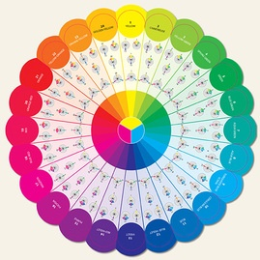
By popular demand, Joen Wolfrom has designed a durable, color-accurate, double-sided, multi-purpose color wheel that is perfectly sized for use in your studio, workroom, office, or sewing room. It’s easily transportable!
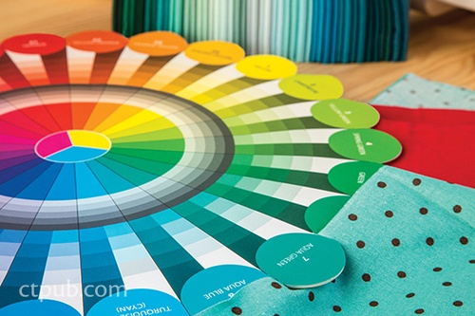
One side of the wheel features 24 pure colors with 4 essential color-plan wheels for each color. The opposite side shows a range of each pure color’s tints, shades, and tones. Pure-color wedges are slotted so you can audition colors (fabrics, paint swatches, etc.) alongside them to ensure a perfect match.

• Beautiful color reference based on the Ives scientific color theory–the definitive color source for nearly a century
• Perfect companion to the Ultimate 3-in-1 Color Tool and Studio Color Wheel (both in stock here.)
• Includes instructions for choosing colors that work together, taking the mystery out of working with tints, tones and shades

*EXTRA TIP from Canadian/BC Appliqué Artist/instructor, Val Ursulak

I found the Color Wheel very useful. I had washed several pieces of fabric and was putting them away a la Joen Wolfrom's 24 pure colours. I usually use her 3 in 1 Color tool to do this but found it much faster to use the Color Wheel. So there we go - one of its benefits. Be sure to tell people that there are other instructions and information inside the cardboard piece at the top of the package.

Comment below on this new TOOL. Please identify yourself with initial and last name for contact. 1 winner tba!

Happy Color Matching,

Cinderella
Cindy Scraba (www.cindysthreadworks.com)

