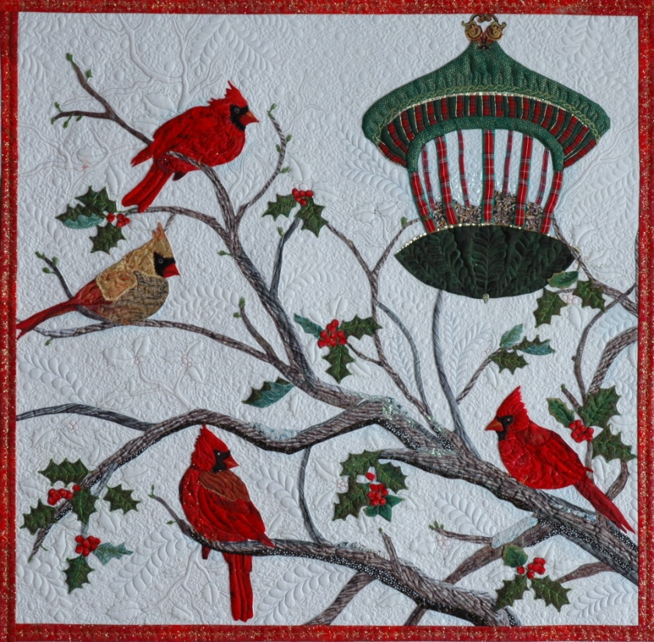

**Audubon Cardinals**

*For confident beginner appliqué students.*

*$13.95 pattern fee.*

*Required to be payed to instructor at the time of the workshop.*

**One day workshop**

**Birds at the feeder are everyones favorite winter scene.** This pattern is from Kathy award winning quilt “Audubon’s Christmas.” We will review “Multiple Appliqué” techniques and begin your own version of Kathy’s award winning quilt. Use multiple prints and fabric paint crayons to add additional depth and form to your little birds. The bird feeder and each bird is created as a unit “off block”. Kathy will show you how to add visual layers to your projects with your quilting designs.

**Multiple Day workshops only-**

Improve your Machine quilting. Day two will include time to practice your machine quilting. Bring a practice sandwich and we will discuss marking, faux trapunto, thread, needle and batting choices.

**Appliqué technique. Choose between turned finished edges or raw edge fused. Many students use a combination of these two techniques. All students should bring; Basic Sewing supplies, small 4 inch scissors for cutting small body parts.**

**Raw edge Appliqué-**

Small 4 inch paper scissors along with fabric scissors

3 yds fusible.

1 colored pencil or black sharpie. Fused appliqué pressing sheet.

**Hand Appliqué-Wait till you see the new “Apliquick” method of turning edges. It makes these small pieces soooo EASY!!**

Bring your preferred hand appliqué supplies, small appliqué scissors, needles, template material or purchase the foundation stabilizer from Kathy. 50 weight or higher thread to match fabrics. Small appliqué pins, spray sizing, clear white glue pen.

**Fabric requirements**

**Back ground fabric -** 27 x 26.5 inches.

**Birds**-3-4 fat quarters of red tone on tone small scale print or batik fabrics. 2 golden brown 6 x 8 scraps. One should be brighter and lighter. 10 inch scrap of black.  The term *tone on tone* refers to a printed fabric that is made by combining different shades and tones of the same color. Tone on tone fabrics often appear to be solid when viewed from a distance, but their printed motifs become recognizable on closer inspection.

**Holly leaves and berries-Quarter** yd of holly leaf green. 10 scrap of lighter green.  10 x 10 inch scrap of bright red.

*Optional-Pre printed small  holly leaves and berries to fussy cut.*

**Branches**. 1/3 yd.  I combined 3 different prints and a few scraps to add shading.

**Bird feeder.**  Quarter yd darker green, quarter yd medium green.  12  x 12 inch scrap of fabric that could pass for bird seed. 1/4 yd of Striped Christmas fabric. Strips will need to be cut from the striped fabric in 1/4 inch and 1/2 inch.

*Optional-24 inches of quarter inch metallic trim.  Synthetic heat tolerant sheer for behind the feeder for a reflective light look.*

Please feel free to e mail me questions at [walrusdesigns@aol.com](mailto:walrusdesigns@aol.com)