Bow Tie
12” X 12

From one 3 ½” strip of Background Fabric cut:
Eight 3 ½” squares
From 4 different scraps of fabric cut:
Two 3 ½” squares
Two 2 ¼” squares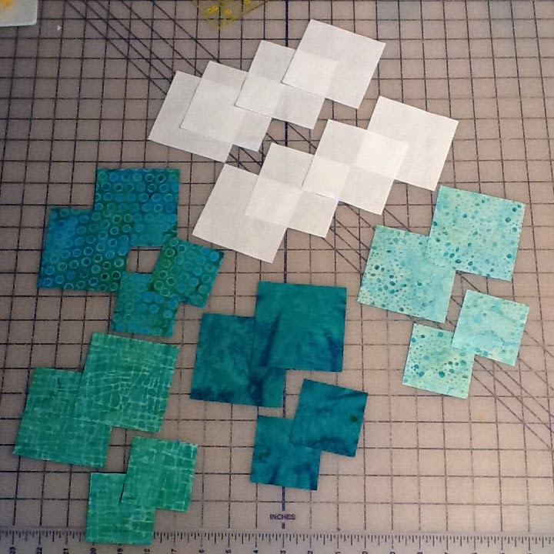

On the wrong side of the 2 ¼” squares draw a line diagonally from corner to corner.
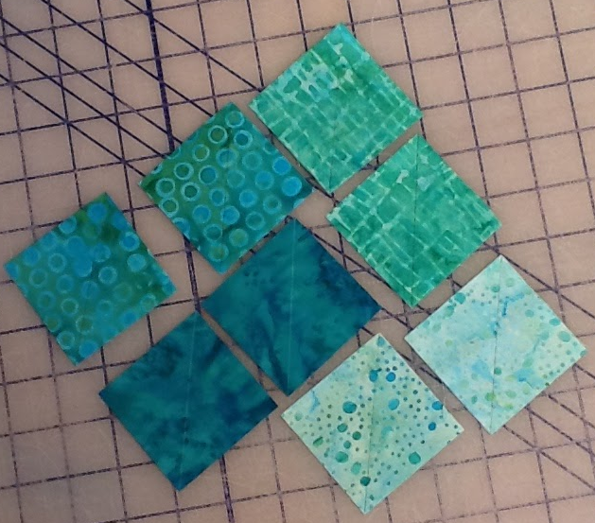

With right sides together, pin the 2 ¼” square onto two of the background squares. Sew on the line. 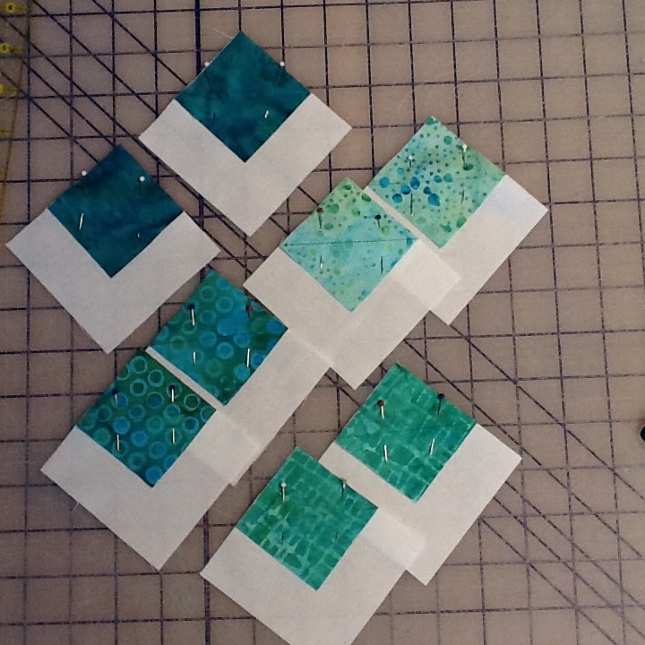

Fold square on the stitching line. This forms a corner triangle. Press in place. Trim the lower two layers away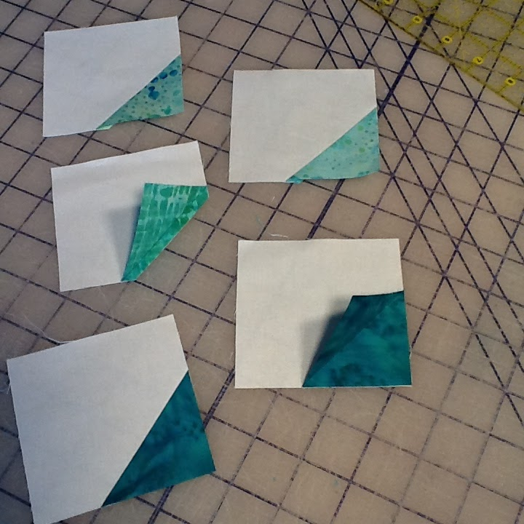

Arrange your pieces as shown. Sew together. The small block should measure 6 ½” at this point. Make a bow tie block from each set of prepared pieces.
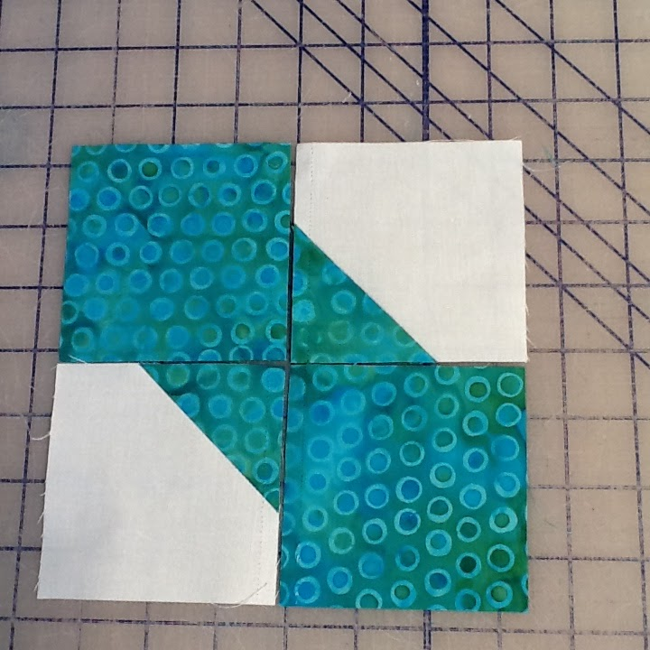

Arrange the four smaller blocks into your larger quilt block. I have included three different layouts for you.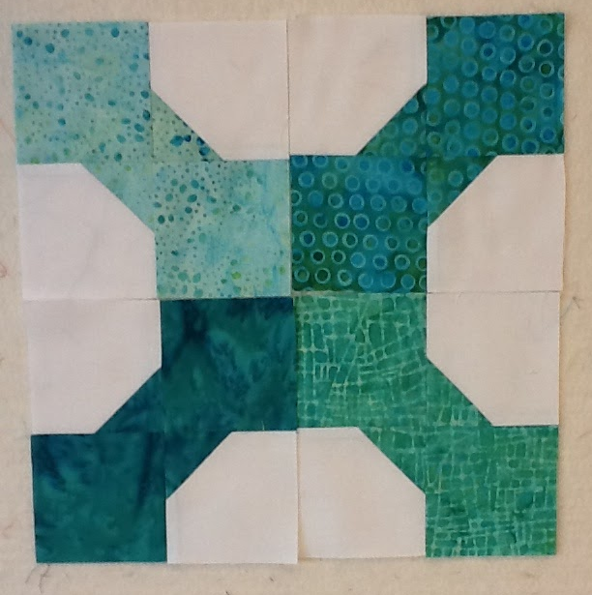

This layout is one of my favorites!!
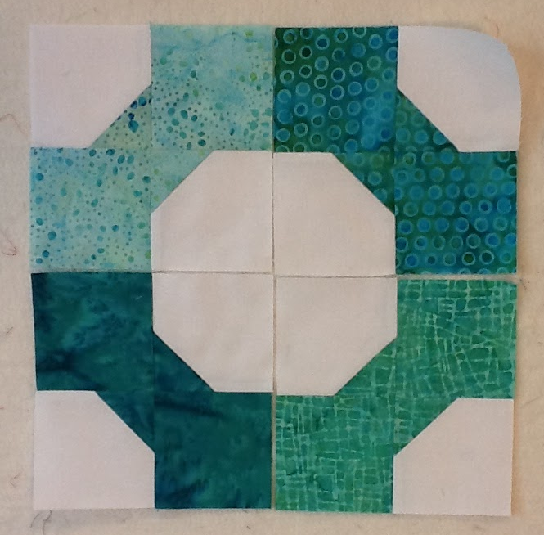

This is the most common layout.
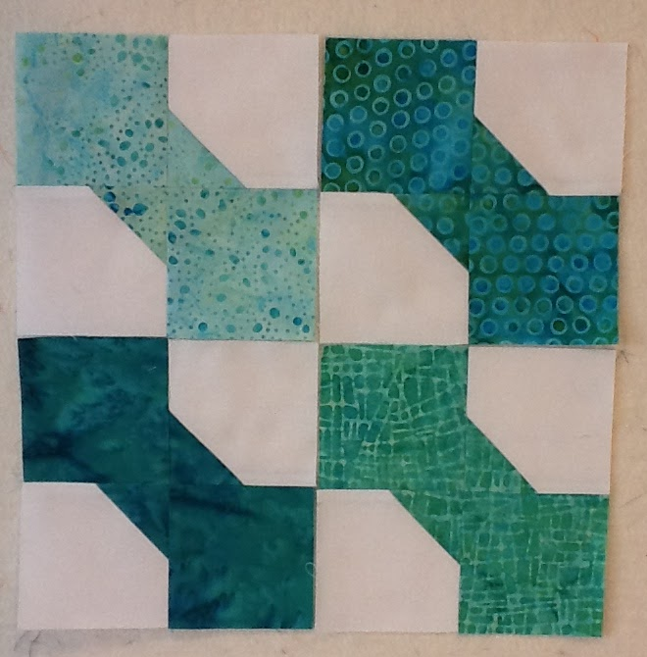

Enjoy!!

