Let’s Get Organized Class Supply List
Bernice Duffy Thurs., November 2, 10:00-2:00
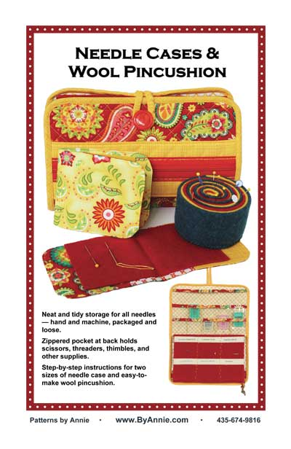
Pattern: Needle Cases and Wool Pincushion
Materials:
Fat quarter of main fabric
Fat Quarter of coordinating fabric
Fat Quarter of coordinating fabric
Felted wool or wool felt
10” x 16” clear vinyl
By Annie’s Soft and Stable 11” x 14” for medium size
Twill tape
12” or longer zipper
1 button
¼” wide elastic
See back of pattern for more detailed information, including pincushion. All materials are available at Prairie Point.

Supplies:
Sewing machine in good working order. Please be familiar with your machine.
Rotary cutting system (cutter, ruler, mat)
90/14 Microtex needle for machine
Please make any refund requests at least two days before class day. No refunds less than two days before.
Thank you
Zipper foot, Quarter inch foot, and Regular foot
Other sewing supplies such as scissors, seam ripper, pins, etc.
Marker

You may also want a By Annie® Stiletto, Basting Tape, and Wonder Clips. You will be shown these things in class. Materials and supplies are available at Prairie Point.
Pre-preparation:
Before coming to class, have the main fabric and lining quilted with the Soft and Stable. Refer to General Quilting Instructions on page 1. This may be done free-motion or straight line with your walking foot. Any type of simple design will be fine.
Prairie Point 913-268-3333 or call Bernice at 913-239-9779.

