Let’s Get Organized Class Supply List
Bernice Duffy Fri., October 20 10:00-2:00
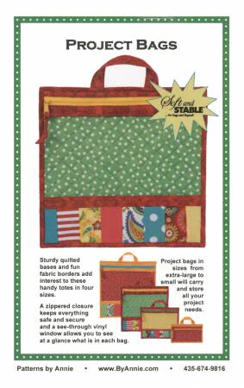
Pattern: Project Bags
Materials: for large size
Fat quarter of main fabric
Fat Quarter of lining fabric
¼ yard of contrasting fabric
Scraps of 8 fabrics
By Annie’s Soft and Stable 18” x 58” makes one of each size
Clear vinyl
14” or longer zipper
1” strapping 12”
See back of pattern for more info. Feel free to make any of the sizes.

Supplies:
Sewing machine in good working order. Please be familiar with your machine.
Rotary cutting system (cutter, ruler, mat)
90/14 Microtex needle for machine
Please make any refund requests at least two days before class day. No refunds less than two days before.
Thank you
Zipper foot, Quarter inch foot, and Regular foot
Other sewing supplies such as scissors, seam ripper, pins, etc.
Marker

You may also want a By Annie® Stiletto, Basting Tape, and Wonder Clips. You will be shown these things in class. Materials and supplies are available at Prairie Point.
Pre-preparation:
Before coming to class, have the main fabric and lining quilted with the Soft and Stable. Refer to General Quilting Instructions on page 1. This may be done free-motion or straight line with your walking foot. Any type of simple design will be fine.
Prairie Point 913-268-3333 or call Bernice at 913-239-9779.

