Let’s Get Organized Class Supply List
Bernice Duffy August 16, 9:30-1:30
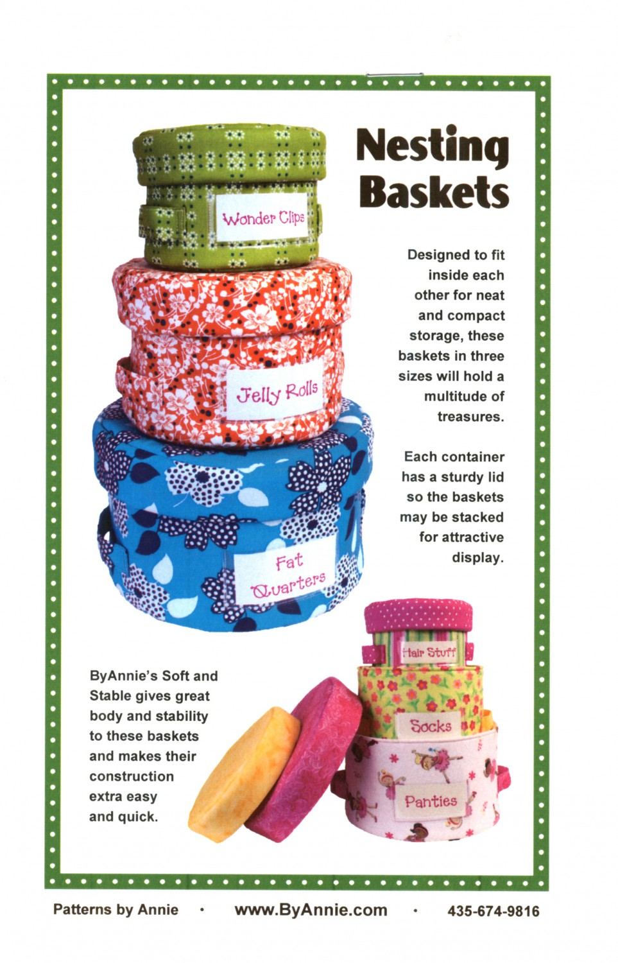
Pattern: Nesting Baskets
Materials: For Medium size basket. See back of pattern for fabric requirements for small or large.
5/8 yd. main fabric
½ yd. coordinating fabric
By Annie’s Soft and Stable 20” x 58”
Vinyl, small amount Bring the tissue to class, too.
1” strapping, optional
Freezer paper or template plastic. Freezer paper can be found in the grocery store, usually in the canning department
Thread

Supplies:
Sewing machine in good working order. Please be familiar with your machine.
Rotary cutting system (cutter, ruler, mat)
Please make any refund requests at least two days before class day. No refunds less than two days before.
Thank you
90/14 Microtex needle for machine
Zipper foot, Quarter inch foot, and Regular foot
Other sewing supplies such as scissors, seam ripper, pins, etc.

You may also want a By Annie® Stiletto, Basting Tape, Washable marker and Wonder Clips. You will be shown these things in class. Materials and supplies are available at Prairie Point.
Pre-preparation:
Before coming to class, use the freezer paper to make templates on page 9 for the size you are making. Cut main fabraic, coordinating fabric, vinyl, and Soft & Stable according to pattern instructions on page 1, A, for the size you want to make in class. Notice the cutting layout suggestions on page 4-7.
Prairie Point 913-268-3333

