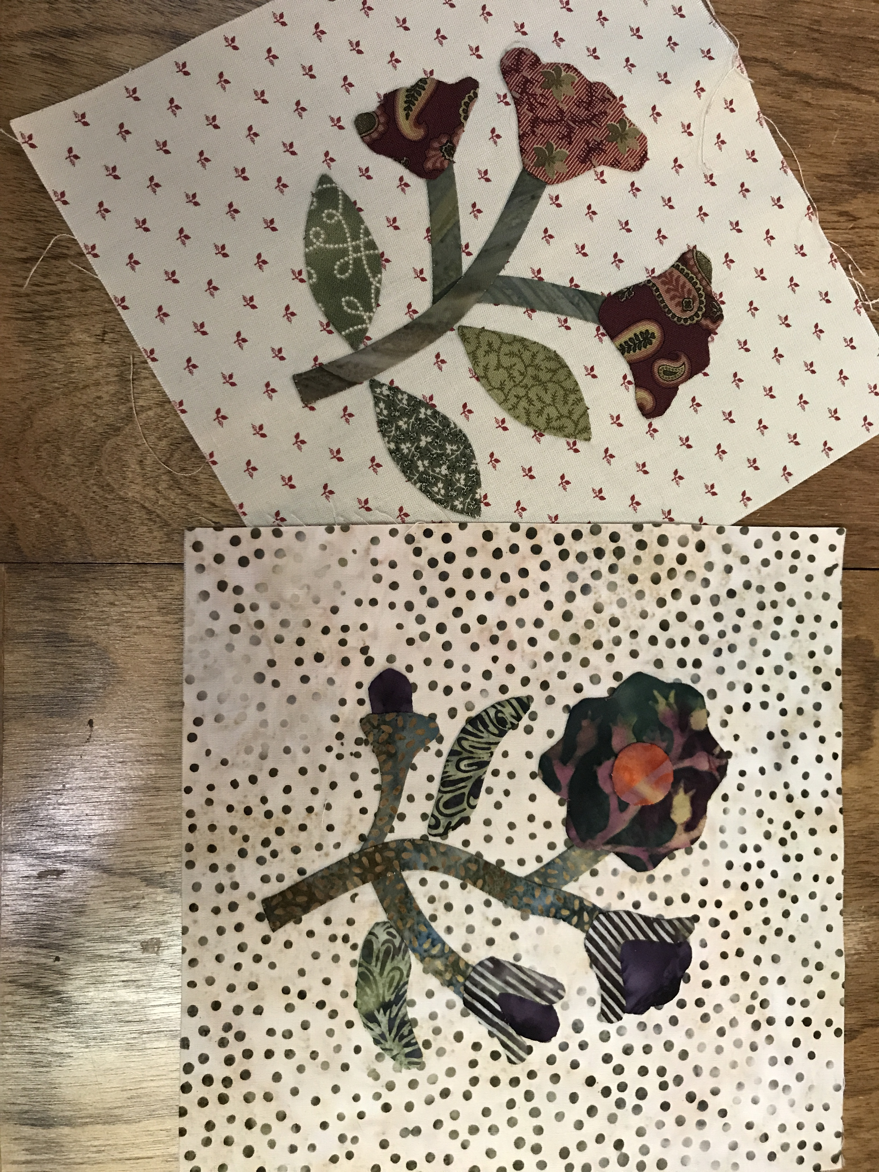
HanD APPLIQUÉ
  - Learn tips and tricks to master
  - the art of hand appliqué
October 15 1230-330PM

Supply list

- Appliqué pins
- Roxanne’s glue
- Appliqué or Straw needles – size 10 or 11
- Silk or bottom line thread to match fabric choices
- Needle threader
- Freezer paper
- Frixion pen
- Thimble
- Three 8 inch square background pieces
- Fabric scraps for stem (will be cut on bias) leaves, flowers
- Clover bias maker 9mm

Optional
- Perfect Circles
- Sand board
- Dressmaker tracing wheel

