Basic Quilting Tools:

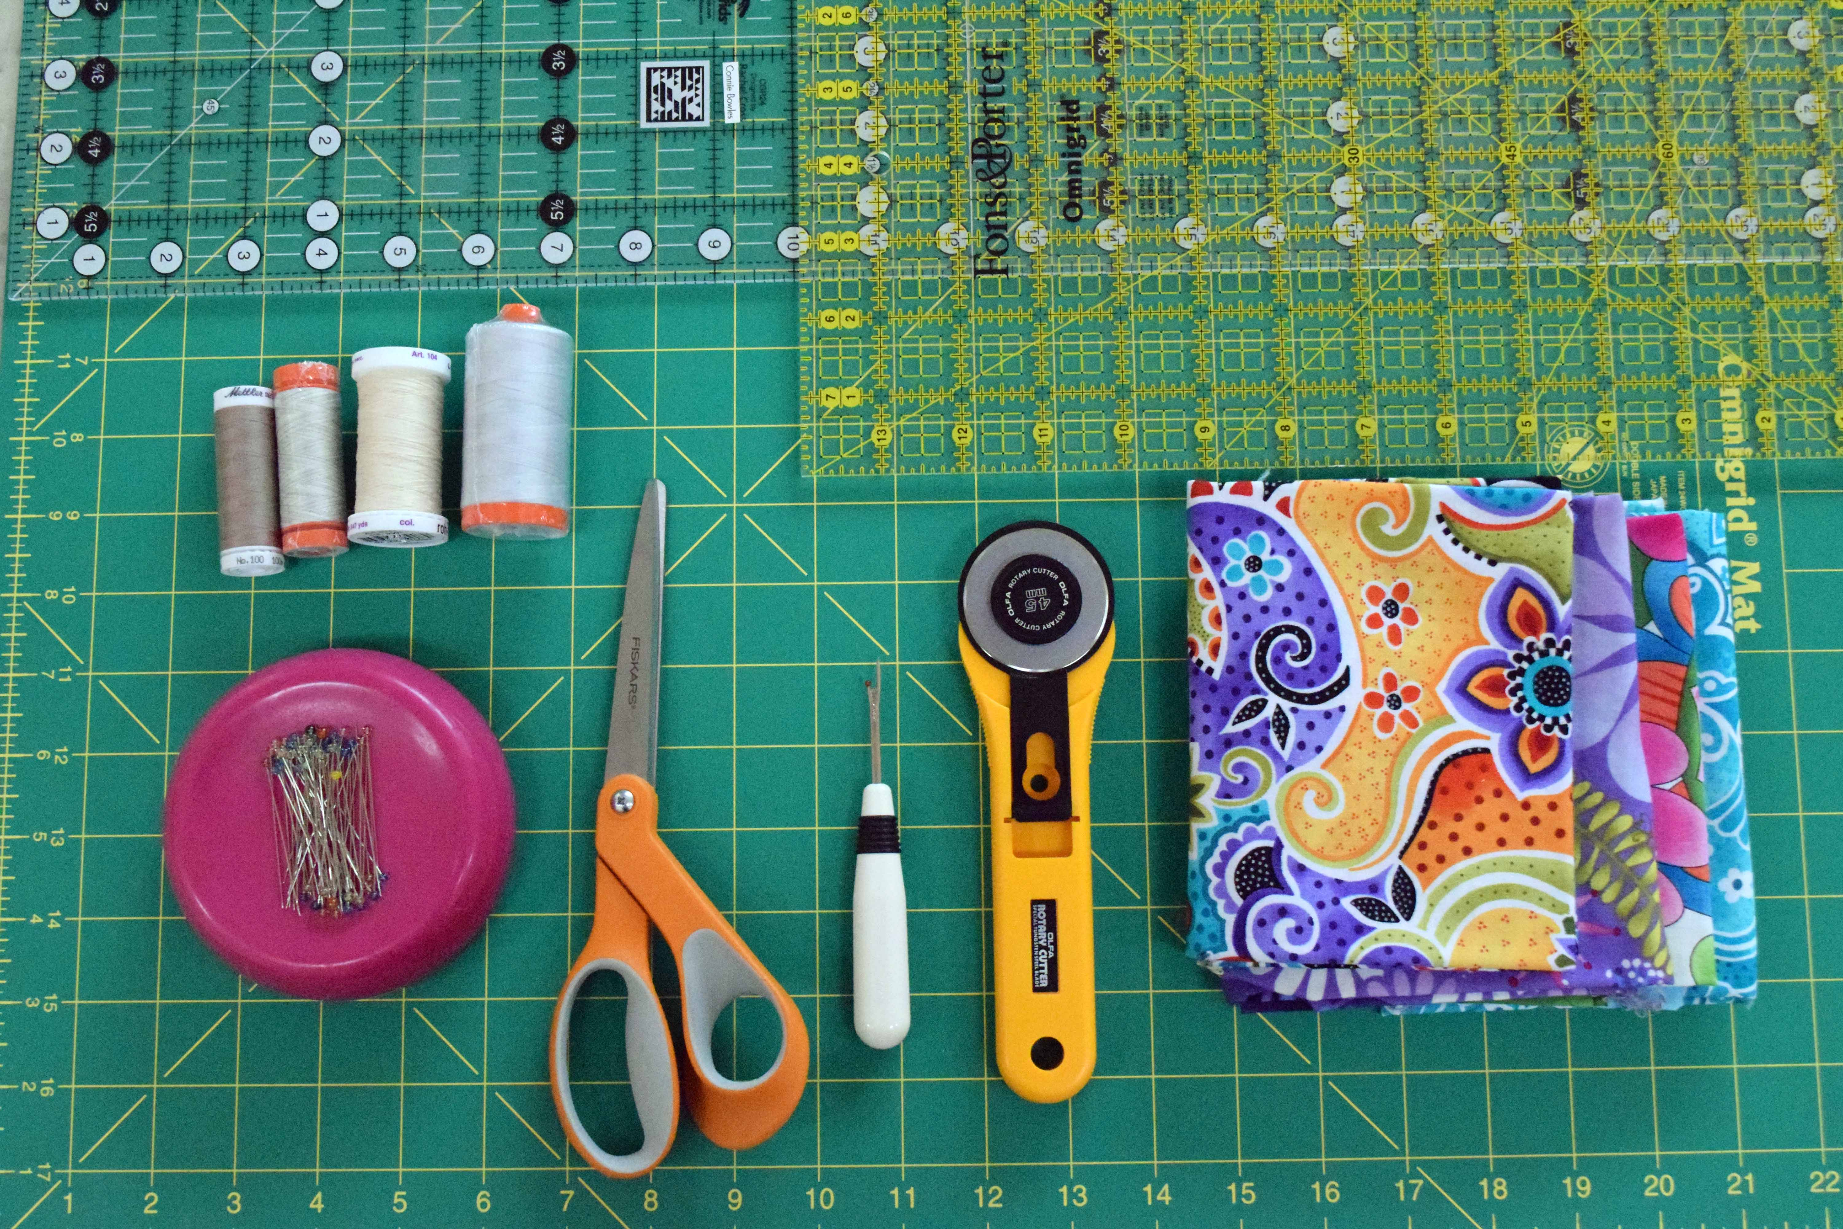

Scissors, Seam Ripper, Rotary Cutter, Long pins with glass heads, Quilters ruler (5” or 6” x 24 and a 6” x 12” ruler would be helpful in cutting smaller pieces of fabric), Self Healing Mat (18 x 24” minimum), cotton thread (gray, cream or tan will blend with most fabrics).

An Iron is necessary and almost any iron will do, but one that gets hot is important. A steam function would be helpful.

If you have a sewing machine that will sew a good, straight line, you are ready to go! If your machine is giving you trouble, take it in to get serviced. It’s like a car – a little maintenance and some oil will keep it running well for a long time. If you are looking for advice on buying a sewing machine Melissa Mortenson of Polka Dot Chair has an excellent post on how to pick a sewing machine. (www.polkadotchair.com/2012/12/how-to-pick-a-sewing-machine)

Connie Bowles
Conniebowles3@gmail.com

