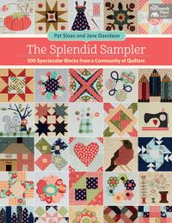
New – Monthly Program The Splendid Sampler
On the FIRST Saturday of every month, starting on September 2nd we will begin a new monthly program. We will be using the Splendid Sampler book and will have a trunk show of one of the settings for these blocks. These Lecture Demo Classes will begin at 11am OR 1:30pm. Maximum capacity is 25 students for this session.
We will teach 4 blocks at each session. Two will be for beginners and two will be for more advanced quilters. The blocks are a variety of pieced, appliqué and hand embroidered. You can join the class as a beginner, advanced or both. We will run this program for 15 months. There are quite a few settings in the book for 30 block samplers.

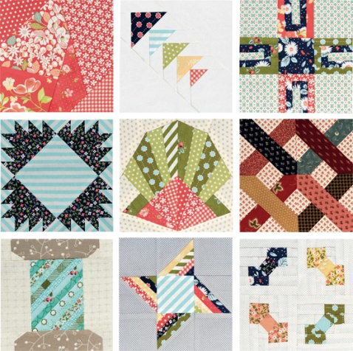
Sign up fee is $27.99 and you will receive the book at our first meeting in September. We think you will be delighted with this book as it is made up of a variety of designers work including Lisa Bongean - Primitive Gatherings, Kathy Brown - The Teachers Pet, Kim Christopherson - Kimberbell Designs, Joanna Figueroa – Figtree, Brigitte Heitland - Zen Chic, Jackie Kunkel - Canton Village Quilt Works, Me and My Sister Designs - Barb Groves and Mary Jacobson, Laurie Simpson - Minick & Simpson, Celine Perkins - Perkins Dry Goods, Kathy Schmitz, Pat Sloan, Kate Spain, Anne Sutton - Bunny Hill Designs, Victoria Findlay Wolfe. If you don’t recognize these names they are all designers who have either taught at our shop or designed patterns and fabrics that we have carried.

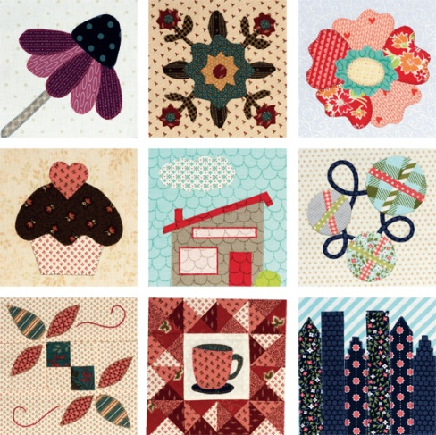
The monthly fee will be $10 and will include the fabrics to make (2) blocks for either beginner or advanced. Some of you may want to do all (4) blocks in which case the fee will be $17.50 per month. The fee for the September class will be due up to two weeks before the class or August 19th. We will need that time to prepare your kits so that no one will be disappointed. At the September meeting you will pay for the October class.

Now some of you will want to pay in advance and we have taken that into account. You can pay 5 months in advance. For the first 5 month payment you will receive a coupon for a discount of 20% off the background fabric (minimum 3 yard cut).

We think this will be a fun project and the results will be quite an accomplishment for beginners and advanced quilters alike. Join us for some fun.

