Pieceful Quilting, Inc.
Creative Inspiration One Block at a Time

3027 Jericho Turnpike
East Northport NY 11731
631-670-6254
www.piecefulquilting.com
Mini Cosmetics Bag
Date and Time of Class: ___________________________________________
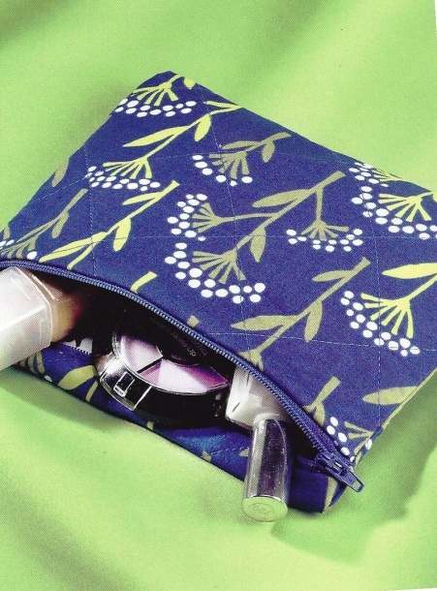
ALL SUPPLIES ARE AVAILABLE AT PIECEFUL QUILTING
Note: THIS CLASS HAS A LITTLE HOMEWORK
Supplies:
1 Fat Quarter for outer bag and zipper tabs
1 Fat Quarter for lining
12 – 14 inch zipper
½ yard of fusible fleece

Equipment:
6 x 24 inch ruler, thread, scissors, seam ripper, pins or clips
CLASS POLICY
Payment is required upon registration. Store credit is given for any class you cannot attend only if Pieceful Quilting is notified one week prior to the class, afterward only if a replacement student can be found. No store credit will be given to students who cancel less than one week before class for any reason. Be sure to pick up the items on your supply list prior to class so you can be prepared with supplies and fabrics. Supply lists will be distributed when you register for the class. For classes cancelled by Pieceful Quilting you will receive a store credit or refund by check.

Home Work
Cut (2) 10 inch by 7 inch rectangles from outer fabric
Cut (2) 1 ½ by 3 inch rectangles for zipper tabs
Cut (2) 10 inch by 7 inch rectangles from lining fabric

