Pieceful Quilting, Inc.
Creative Inspiration One Block at a Time

3027 Jericho Turnpike
East Northport NY 11731
631-670-6254
www.piecefulquilting.com

Mini "At Your Fingertips" Tool Holder

Date and Time of Class: ___________________________________________
ALL SUPPLIES ARE AVAILABLE AT PIECEFUL QUILTING

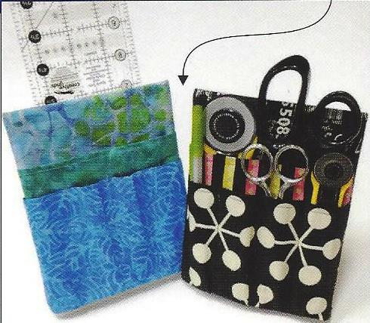
Supplies:
At Your Fingertips Pattern by Karen Montgomery
5 x 7 inch photo frame/sign holder
3 Quarter yards by wof in coordinating fabrics

Basic Sewing Supplies including walking foot, thread, removable fabric marker (water soluble, air erase or frixion), rotary cutting supplies.

CLASS POLICY
Payment is required upon registration. Store credit is given for any class you cannot attend only if Pieceful Quilting is notified one week prior to the class, afterward only if a replacement student can be found. No store credit will be given to students who cancel less than one week before class for any reason. Be sure to pick up the items on your supply list prior to class so you can be prepared with supplies and fabrics. Supply lists will be distributed when you register for the class. For classes cancelled by Pieceful Quilting you will receive a store credit or refund by check.

