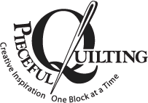
3027 Jericho Turnpike
East Northport NY 11731
631 670 6254

Store Hours Monday through Saturday 10am to 5pm Sunday 11 – 4pm
pieceful@optonline.net www.piecefulquilting.com

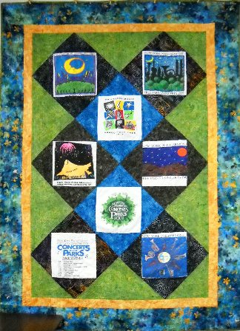
T-Shirt Quilt
Scottie
$35
Every kid has a bunch of great t-shirts they just don’t want to part with. Why not recycle them into these wonderful cozy memory quilts. I’ll bet you won’t be able to choose just 18 shirts! The setting pictured used much less.
Thursday Nov 3 AND Nov 17 10:30 – 12:30

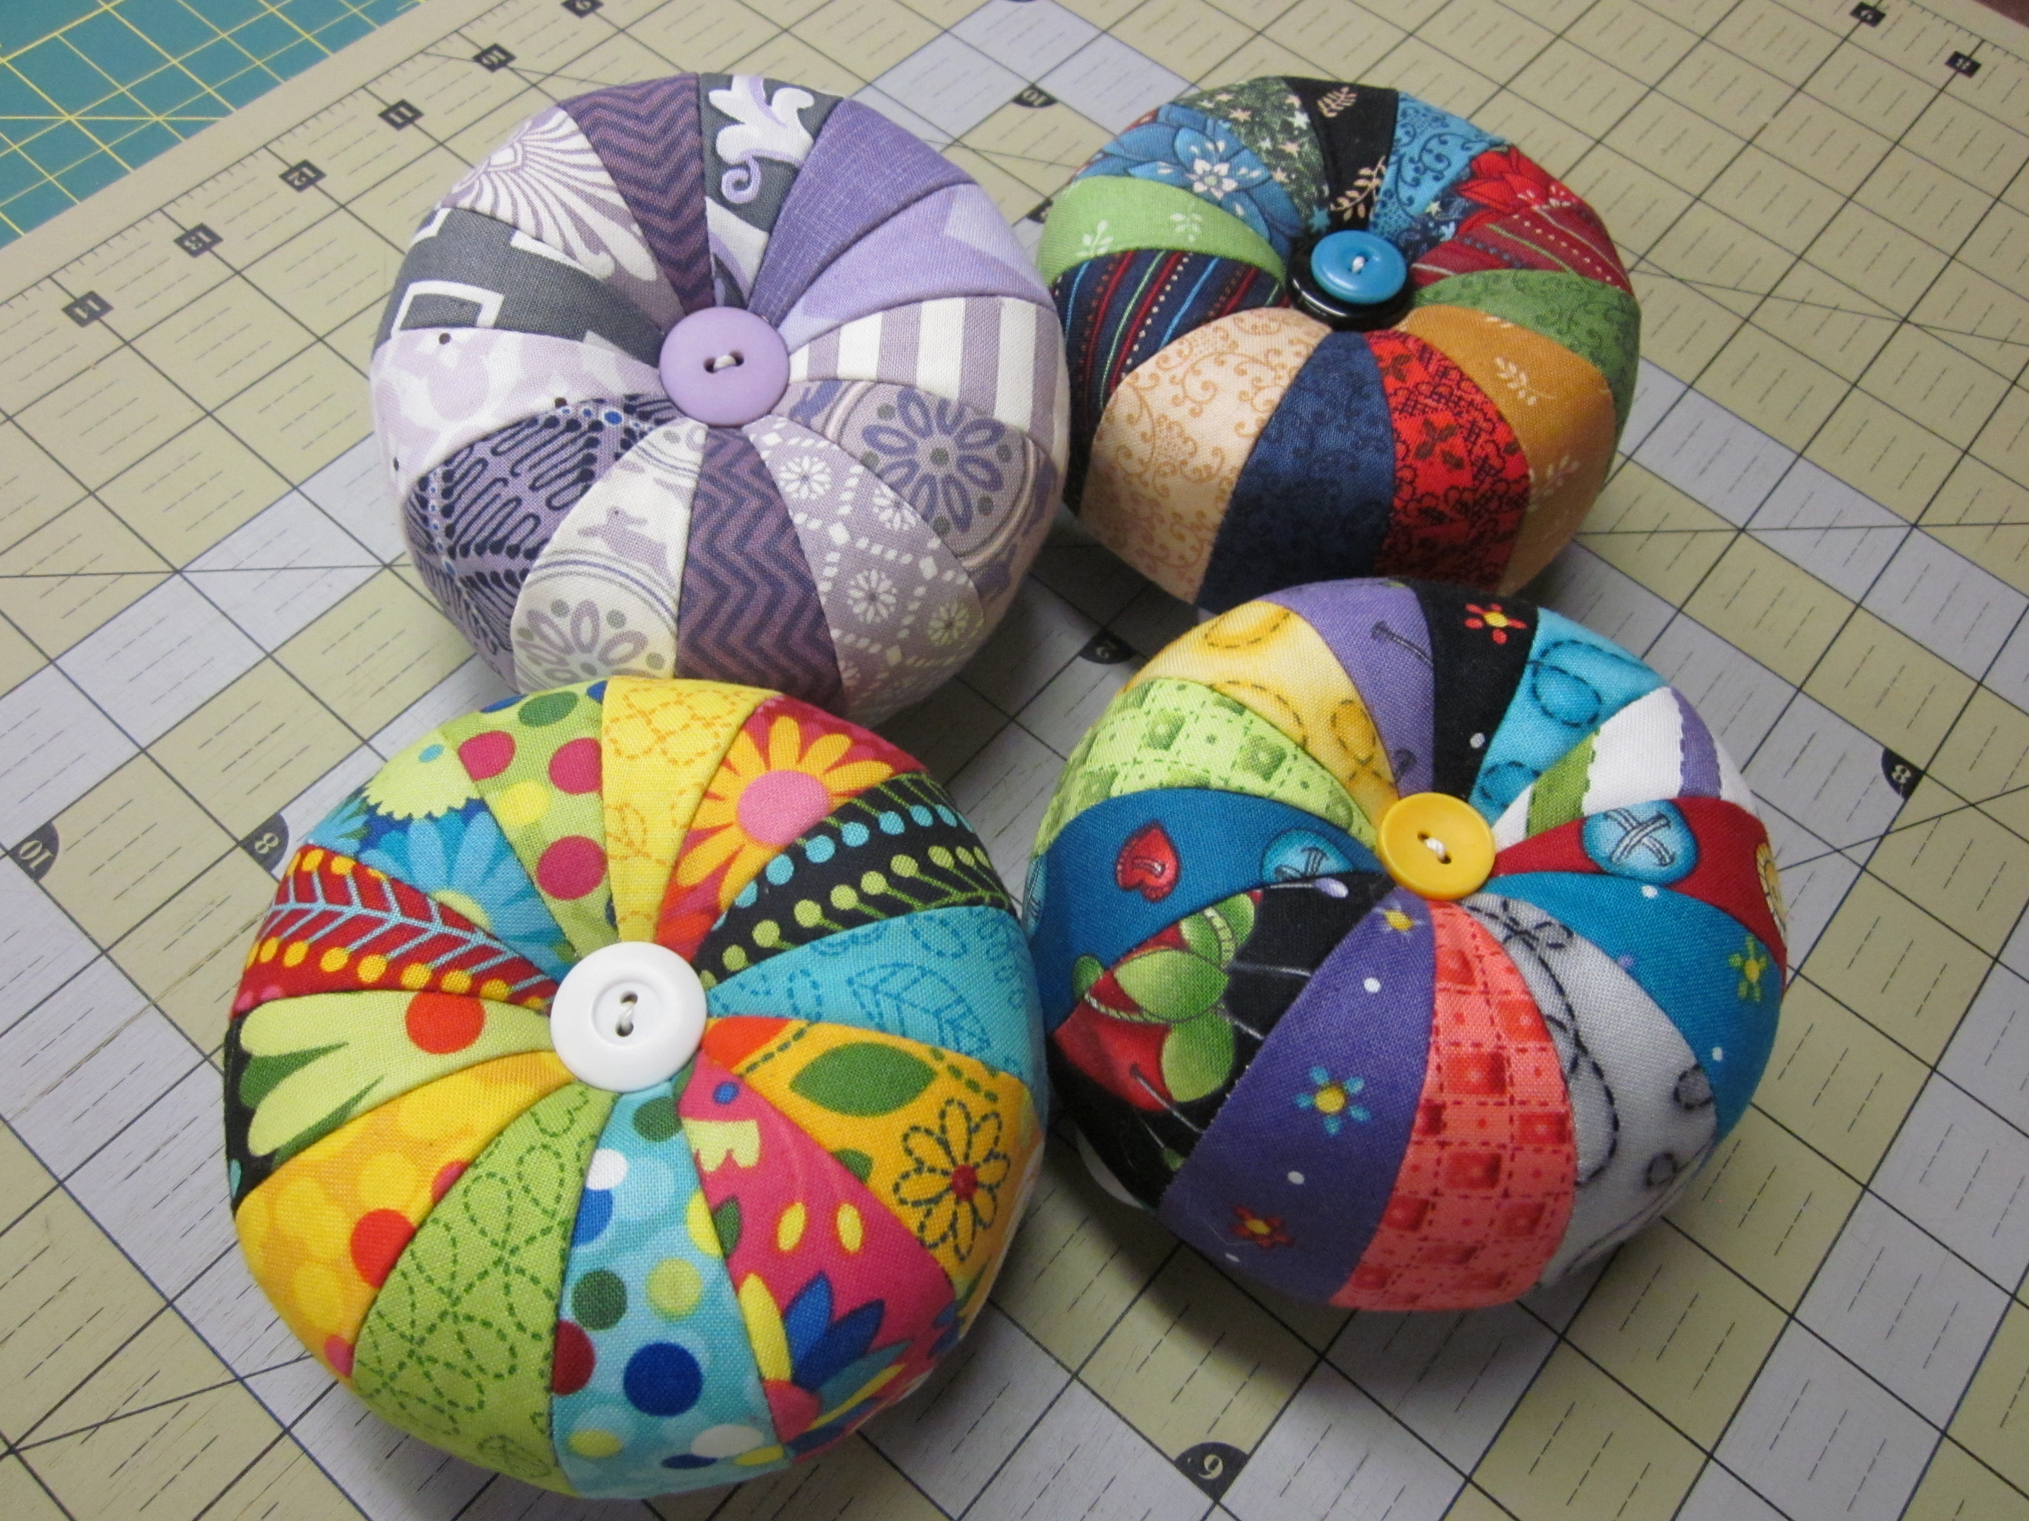
Tuffet Pincushion
Debbie
$25
If you are not up for making a full size tuffet, try one of these little mini cuties. We have the kits (required for the class). It’s a great way to use up some scraps and have fun.
Sunday October 30 10:30 – 1:00pm
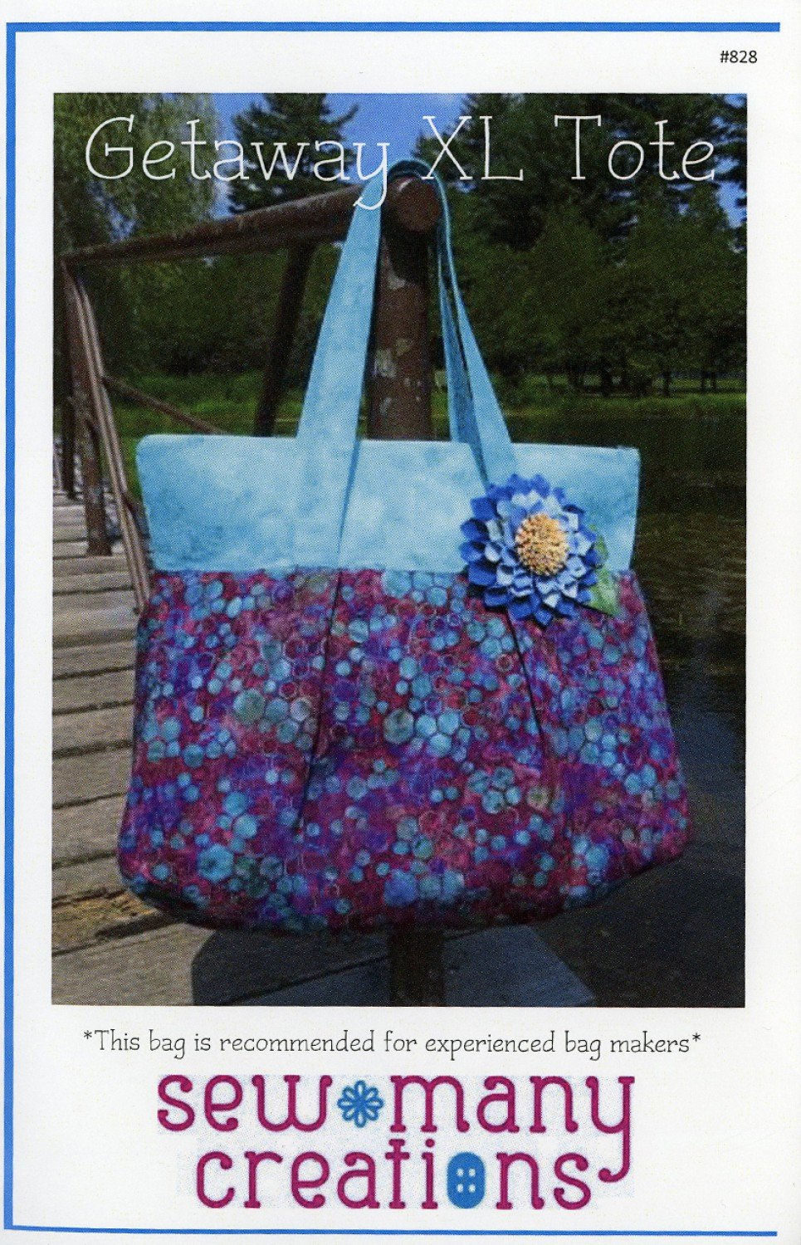
Getaway Tote XL
Debbie
$40
You can REALLY get away with this tote. The Getaway XL Tote Bag is perfect for just about anyone! It's roomy interior holds tons of stuff. It's great for work, the gym, a weekend getaway or quilt retreat.
Inside there's 2 sets of zipper pockets and 2 sets of divided pockets. The top has a zipper to keep everything safe inside. Don't worry about all the zippers though – You have DEBBIE to calm your nerves and keep you happy! Pattern Required.
Monday October 24 10:30 – 1:30
Saturday October 29 10:30 – 1:30

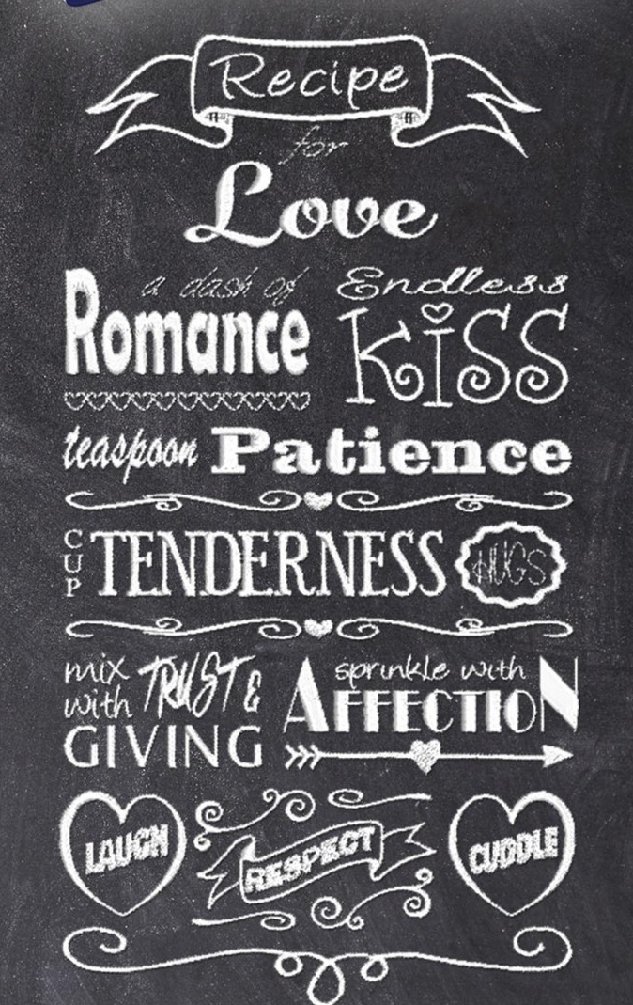
Recipes for Life – (Machine Embroidery)
Scottie
$50 includes CD with 9 Recipes.
Embroidery designs styled after Recipes for … Creativity, Friendship, Happiness, Joyfulness, Learning, Love, Marriage, Success and Good Life. Collection includes (9) recipe style embroidery designs. This is a quick and easy gift not just for the holidays but for Bridal Showers, House Warming, Birthdays and many more.
Pattern includes CD with all designs.
Thursday October 20 10:30 – 12:30
Saturday October 22 10:30 – 12:30

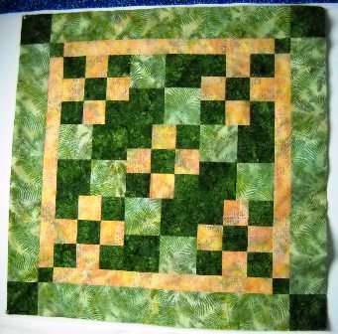
Learn to Quilt at Pieceful Quilting - Quilting 101
This beginning quilting program is fun and absolutely pain free. We have designed 5 classes that will take you from beginning to end and teach you the basic skills you need to begin your quilting career. Or perhaps you haven’t quilted in a long time and need a refresher to sharpen your skills.
You will make a crib or lap size quilt using a simple but fun pattern. You will learn to cut accurately and safely, to sew a perfect quarter inch seam, add borders, make the quilt “sandwich”, machine quilt and finally bind that quilt with seamless binding. And most importantly you will definitely have fun along the way. So get your date book out now, seating is limited, so here’s the schedule.
Basic Cutting Sunday October 23 11 – 2pm
Piecing - ¼ Inch Seams Sunday November 6 11 – 2pm
Adding Borders & Basting Sunday November 20 11 – 2pm
Machine Quilting Sunday December 4 11 – 2pm
Binding Your Quilt Sunday December 18 11 – 2pm
Class Fee $115 Instructor – Debbie

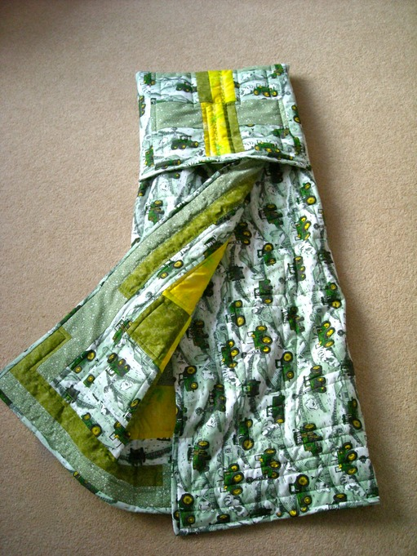
Quillow
$35
Therese
This is a classic project that never gets old. It’s perfect for your perfect grandchild. What's better than a cozy quilt that's tucked inside a soft pillow - A QUILLOW!
Saturday November 12 10:30 – 1:30pm

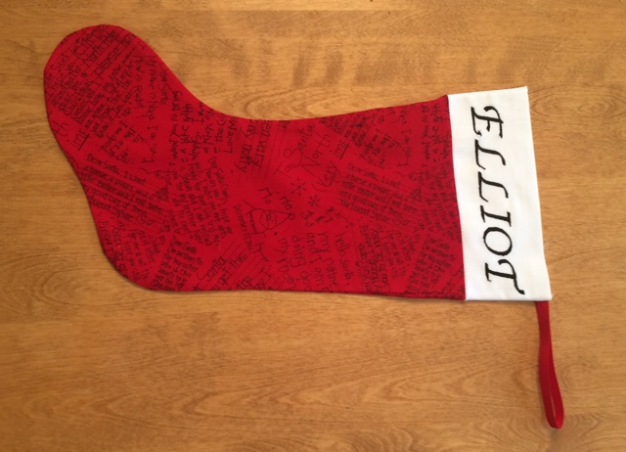
Personalized Christmas Stocking
Therese
$25
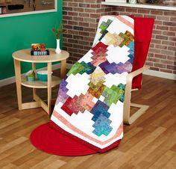
This is just a one of a kind holiday gift. The project is made with both a Serger and an Embroidery machine. IF YOU NEED TO USE ONE OF OUR MACHINES WE WILL HAVE SOME AVAILABLE BUT YOU MUST REGISTER IN ADVANCE OR BRING YOUR MACHINES. A personalized gift is just sew special!
Sunday November 13 11 – 1pm

Strip Club
Mary
Fee $7.50
We are about to embark on a new adventure in quilting. Join us, all you quilting strippers. We know you’re out there. The fun includes a free “strip” pattern, door prizes, The BIG REVEAL of the monthly strip quilt, and great discounts on strip sets. This was our LAST Strip Club Quilt.
Sunday November 20 2 – 3pm (Note later time)

CLASS POLICY
Payment is required upon registration. Store credit is given for any class you cannot attend only if Pieceful Quilting is notified one week prior to the class, afterward only if a replacement student can be found. No store credit will be given to students who cancel less than one week before class for any reason. Be sure to pick up the items on your supply list prior to class so you can be prepared with supplies and fabrics. Supply lists will be distributed when you register for the class. For classes cancelled by Pieceful Quilting you will receive a store credit or refund by check


Pieceful Quilting Professional Stash Buster Certification Program

Enroll by December 31, 2016 in the PQSBCP for $25 get a free stash busters book for inspiration. In January bring in a UFO (See rules for details) Have your picture taken with your project.
Come back in February with your project finished (See rules for details). Have your picture taken with the finished project. Receive your certificate as an Apprentice Stash Buster and a coupon for 10% off any *Regularly priced item.
Continue on each month with a different project for March, April, and May and rise up the ranks from Apprentice, to Journeywoman, to Master, to Grand Master Stash Buster and receiving increasingly valuable discounts. The program will culminate with a Graduation party at the end of June in 2017 for ALL Participants (not just Grand Masters).
Your UFO must be baby size quilt (36 x 48 inches) or larger. It must be unquilted. But it can be in any stage up to that point. Only ONE entry per customer per level of achievement.
Finished Definition: Quilted, labeled and bound

FRIENDS AND FAMILY NIGHTS

Let’s face it. Your family has no idea what this quilting and sewing passion is all about. They have no idea why you need yet another tool and MORE fabric. So let’s educate them so that you will be thrilled with your holiday presents. (Don’t forget to act surprised!)

Thursday November 17 from 5 – 8pm
Friday November 18 from 5 – 8pm

Pieceful Quilting will open our doors especially for your friends and family.
Refreshments, FREE gift wrapping and gift giving advice.

Here’s a way to drop a hint:

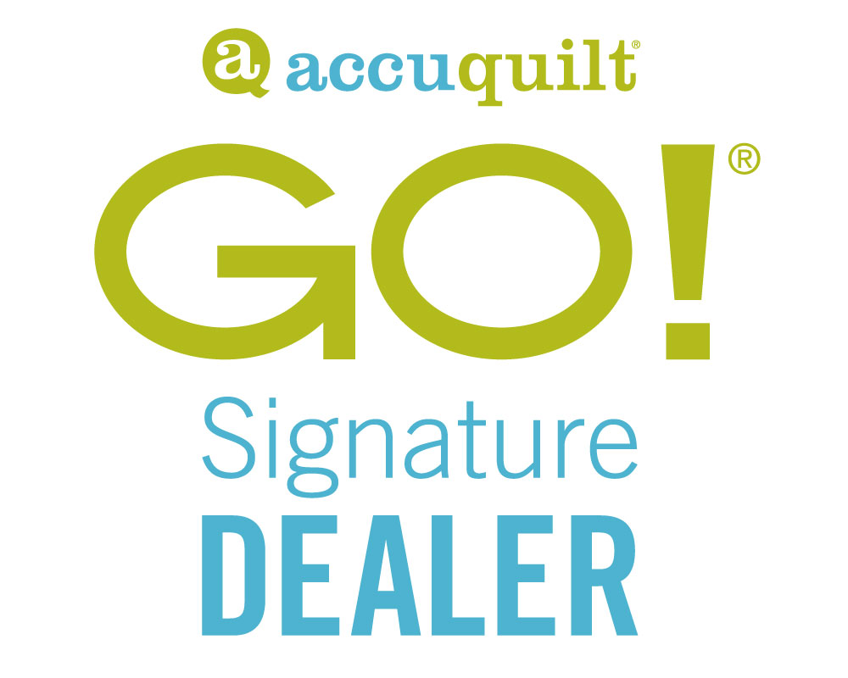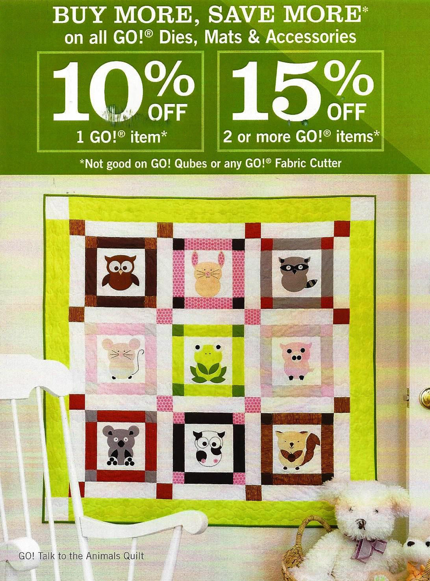
AccuQuilt October Specials
Let's Get Organized - Project-of-the-Month Program
This is an annual (12 month) program that we will be presenting every 3 months starting in January on the 3rd Saturday of the month.
You will have two options. You can sign up for the hands on class (including instruction, pattern and kit) OR to pick up (pattern only). The classes will vary in length depending on the number of new techniques presented. There will be choices of hardware and components for kits. THEREFORE IT IS IMPERATIVE THAT YOU SIGN UP BY DECEMBER 1st for this program if you want a class. Seating is limited.
CLASS AND KITS - $199
Pick up will be for pattern ONLY. We will have some component parts for each project as well for those who pick up and for those who want to make more than one of these clever projects.
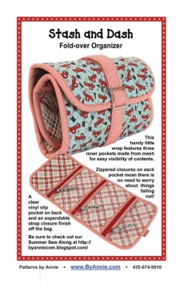
Stash and Dash
Mary
Hands on Class – ($99.99 VALUE) (kit includes pattern, slider, mesh, zipper, vinyl, soft and stable and strapping choices include Antique Brass or Nickle hardware and white, black, teal or raspberry mesh and zipper) – JUST ADD FABRIC)
Pick Up Pattern Only – $9.99
This handy little wrap features three inner pockets made from mesh for easy visibility of contents. Each pocket has a zipper closure — no need to worry about things falling out! A clear vinyl slip pocket on back and an expandable strap closure finish off the bag. Stash and Dash is perfect to use as an emergency car kit, first aid kit, organizer for supplies (sewing, cosmetics, or office), kid’s quiet book, or purse organizer — the possibilities are endless! How will you use Stash and Dash?
Saturday January 21 10:30 – 3:30
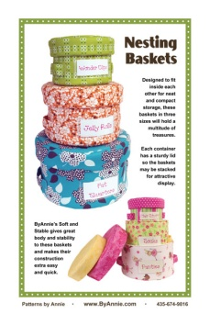
Nesting Baskets
Scottie
Hands on Class – ($69.99 VALUE) (kit includes soft and stable, strapping and vinyl for all THREE Boxes.)
Pick Up Pattern Only - $9.99
In this class you will make the MEDIUM size box. You will use your zig-zag or sew overlock stitches. Fun and easy to make, these nesting baskets in three sizes will hold a multitude of treasures. When empty, they will stack inside each other for neat and compact storage. Each container has a sturdy lid so the baskets may be stacked for attractive display. Perfect for the sewing room, bathroom, nursery, child's room, craft room — or anywhere in the house!
Saturday February 18 10:30 -1:30
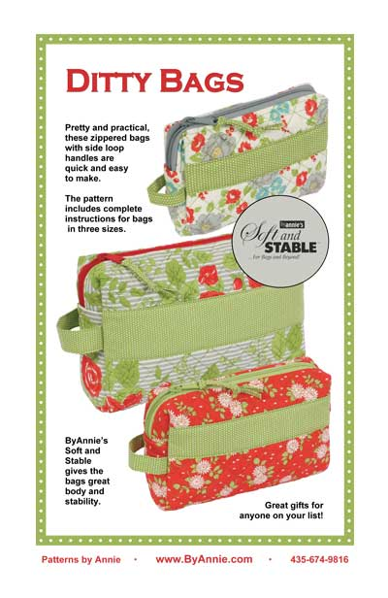
Ditty Bags
Debbie
Hands On Class – ($69.99 VALUE) (Kit includes soft and stable and three zippers for THREE bags)
Pick up Pattern Only - $9.99
Pretty and practical, these zippered bags with side loop handles are quick and easy to make. Add a clear vinyl lining for an easy-to-clean cosmetics bag. Small (6½”W x 4”H x 1½”D): This smart case will carry your most important beauty supplies or other items and will fit easily in most purses or bags. Medium (8”W x 4½”H x 2½”D): Not too small and not too big, this bag fits neatly into a larger purse or your favorite tote and can carry and protect a multitude of supplies. Large (10”W x 6"H x 3”D): For more than the basics, this large and spacious case holds bottles, brushes and more. Use it to organize a diaper bag or make it in more masculine fabrics for a great guy’s toiletries bag.
Saturday March 18 10:30 – 1:30

Pieceful Quilting Spring Getaway 2017
  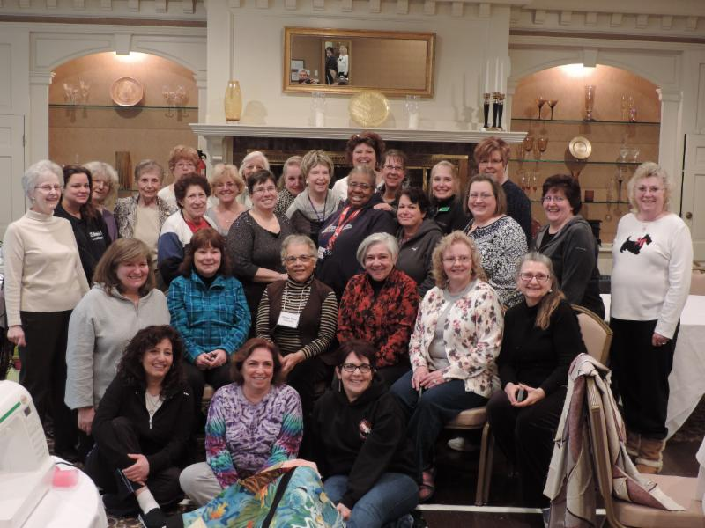
  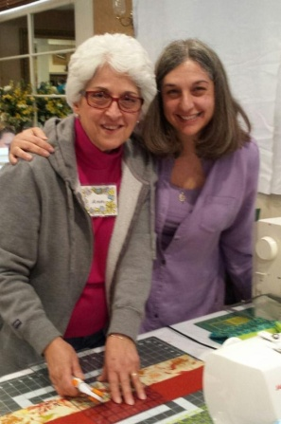
  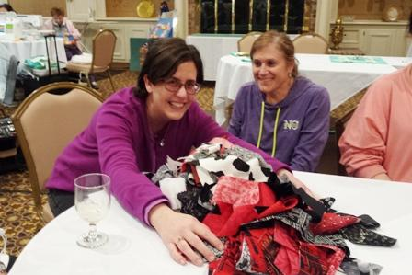
  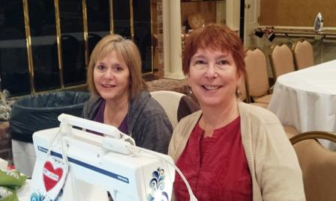
  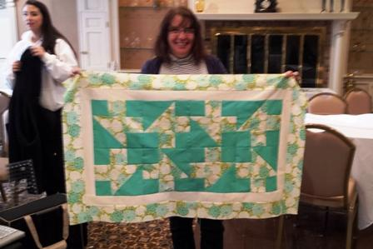
  It's time to save the date and reserve your spot for Pieceful Quilting's Spring 2017 Getaway. Yes, this IS fun. Yes, you will finish a quilt top. No, you will not gain 10 pounds (well that one is a maybe). A Slight change for 2017 - WE COULD ONLY GET ONE WEEKEND FOR 2017 (March 17, 18 and 19th) This might make a great holiday gift from your benefactor or to YOURSELF!
  This may seem far off, but trust me, it's not that far away. And with only one weekend option this will fill up fast. So make your reservation as soon as you can. We HATE to disappoint.
  We will be going back to Danfords Inn in Port Jefferson, right on Long Island Sound. You may already know that Danford's has changed hands and so there are a lot of renovations that have been done and the menu will be beefed up.
  The meeting room is large, the food is fantastic and the environment is serene. Perfect for relaxing, seeing old friends and just plain havin' a good time. To give you an idea of just how much fun this is; last year we had 8 people who LIVE in Port Jefferson who joined us for the getaway.
  The fun starts on Friday night with a delicious dinner and then down to business. Saturday morning brings a scrumptious breakfast, more sewing, more eating, more sewing, and more eating. Are your bags packed yet???
  The Getaway Weekend is an all-inclusive package that includes your hotel room, 2 Dinners, 2 Breakfasts and 1 Lunch, A mystery quilt kit, games, prizes and lots of fun. The cost for a Double Occupancy Room is $485 per person. There are a few Single Occupancy Rooms at a rate of $585. There is a non-refundable $100 deposit required by January 1st. The Balance is due by January 15th. As in year's past, this event sells out rather quickly and space is limited, so call the East Northport store at 631- 670-6254 as soon as possible or sign up on line at www.piecefulquilting.com

SPECIAL ORDERS
If you don’t see a book, pattern, or notion in our store that you like, please ask up to special order it for you. There is no charge for this service.

PRIVATE LESSONS
We are happy to organize customized private lessons in our classroom for individuals or small groups. Call 631 670-6254 for details.

Pieceful Quilting Long Arm Quilting Service
Prices are for allover free motion quilting. We do not do custom work. 50% deposit due upon drop –off.
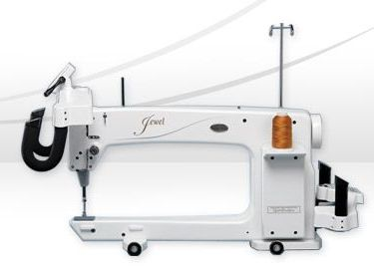
- Pricing includes Signature solid colored thread.
- Specialty thread such as variegated or poly blend can be purchased and used for your quilt.
- We do free motion quilting in a free form pattern of loops, leaves, stars, flowers or hearts
- We recommend Quilters Dream Select batting. We do not accept Mountain Mist batting.
Quilting is estimated at 3 cents per square inch. Multiply width times length and rounded up the nearest dollar. There is a minimum charge of $70.
Services provided for an additional charge
- Prep fee: Ironing, squaring piecing the back or extending the back. $40 per hour.
- Binding Fee: 30 cents per linear inch.
- Rush fee: 25% of the total cost of the quilting service.

Join us for FREE Sit and Sew
Every Friday from 11am to 4pm
Bring your latest project, sewing machine and whatever else you may need to sew the day away among others who love to do what YOU love to do.

