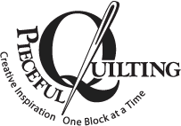
3027 Jericho Turnpike
East Northport NY 11731
631 670 6254

Store Hours Monday through Saturday 10am to 5pm Sunday 11 – 4pm
pieceful@optonline.net www.piecefulquilting.com

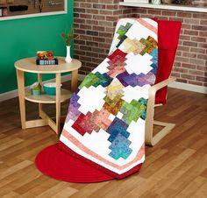
Strip Club
Mary
Fee $7.50
We are about to embark on a new adventure in quilting. Join us, all you quilting strippers. We know you’re out there. The fun includes a free “strip” pattern, door prizes, The BIG REVEAL of the monthly strip quilt, and great discounts on strip sets. This was our LAST Strip Club Quilt.
Sunday April 30 11:30 – 12:30pm
Sunday July 16 11:30 – 12:30pm

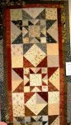
Quilting 102
Debbie
$95
This is the next step in your beginning quilting career. This is a fun series of 4 classes (note the price is for the series of class instruction) and you will be amazed at how quickly you will learn to use this very versatile technique. You will make bed runner. You can use all the skills you learned in Quilting 101, and add this to your knowledge base. The half square triangle is used in hundreds of blocks but you only have to learn this once! There is a book required for this class.
Sunday May 7, June 4, June 25 and July 3 11:00 to 1:30pm
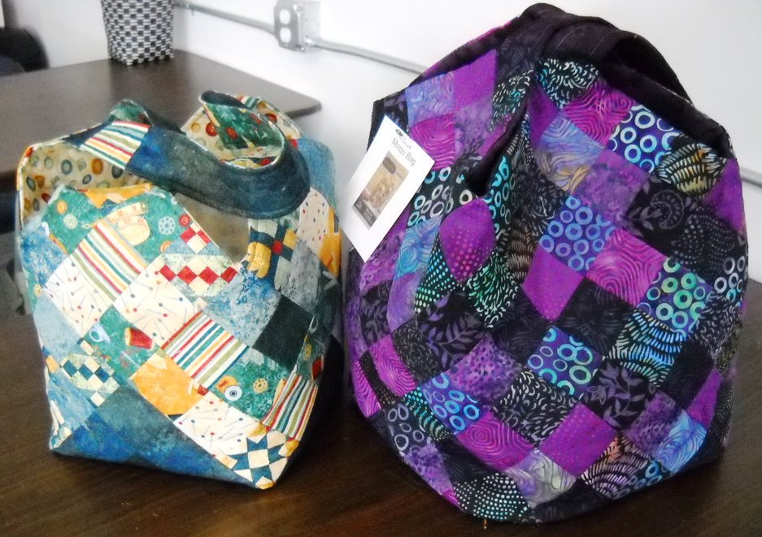
Midi Mondo Bag
Scottie
Fee $25
This is the smaller version of our MOST POPULAR bag. Use your scraps! Use a jelly roll! Cut that stuff up and make something cool. Pattern and foundation required.
Thursday May 18 10:30 – 1:30pm
Saturday May 13 1 – 4pm

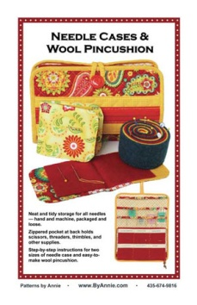
Let's Get Organized - Needle Case & Wool Pincushion
Debbie Fee $25
You'll always have the right needle close at hand when you store them in these convenient cases.
This is one of those organizational tools that you don't know you need until you have it — and then you wonder how you managed without it. We will make the Large Needle Case which measures about 10" x 13" when open and folds to measure about 10" x 6½".
The Small Needle Case measures about 4" x 9½" when open and folds to measure about 4" x 4¾".
Inside the Large Needle Case, a zippered pocket holds scissors, needle threaders, thimbles and other supplies. PATTERN REQUIRED
Saturday May 20 10:30 – 1:30

KIMBERBELL EMBROIDERY WORKSHOP
Pocket Tags
Scottie
Fee: $12.99 Includes Kit to make this project for a 4 x 4 or 5 x 7 hoop.

Our gift tag features a hidden pocket between two layers of felt where you can slip a gift card, movie tickets, money, or kind note, even jewelry! A perfect present by itself or use it to top a larger gift. The stitched sentiment �You are loved� will make anyone feel special. This is a lecture demo presentation but you WILL receive the materials to go home and make this project. If you don’t yet own an embroidery machine, make an appointment to make this on one of our machines.
Saturday May 10 10:30 – 12:30pm

Thursday May 11 10:30 – 12:30pm

HOOP SISTERS Enchanted Embroidery
Fee - $60 includes CD with designs and layout for a quilt
Scottie

Scottie will help you embroider these elegant flowers in this three hour hands on class. Bring your embroidery machine to start this lovely project. You will complete at least one block in this class. There are 14 motifs in all. This one is truly enchanted!

Thursday May 11 1:30 – 3:30

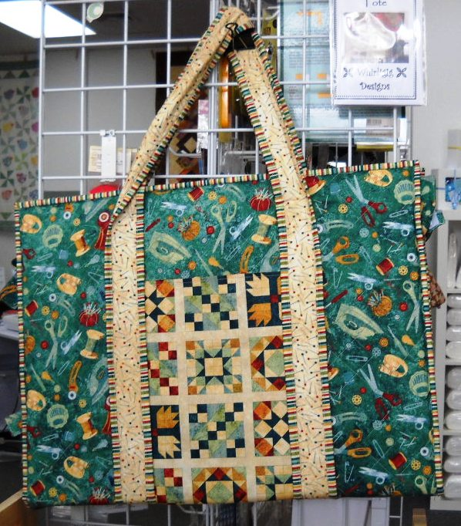
On the Go Tote
Debbie
Fee $40
Wow, Aren't you stylish with this tote to bring your cutting mat and tools to class. Pockets galore! Two Part class. HOMEWORK and Pattern required.

Sunday May 21 AND May 28th 11 – 2pm

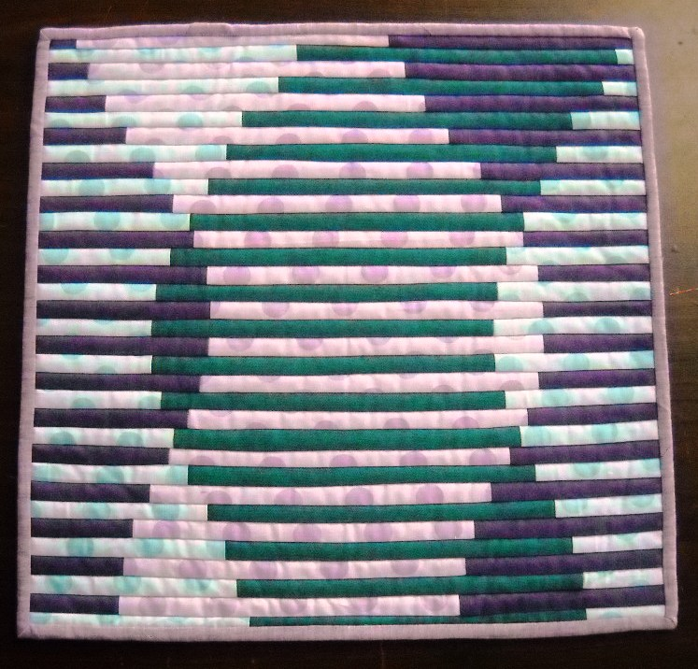
Sine Wave
Mary Fee $25
Now THIS is a cool technique! You’ll be amazed as your Sine Wave takes shape as you move along this quilt as you go technique. This would make a great center medallion for a baby with Scientist parents! Or just use as a little table topper and amaze ALL your friends.
Saturday June 17 2:00 – 5pm
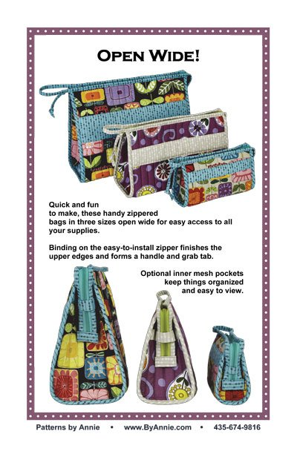
Let’s Get Organized
Open Wide
Therese Fee $25
Quick and fun to make, these handy zippered bags in three sizes open wide for easy access to all your supplies.
Binding on the easy-to-install zipper finishes the upper edges and forms a handle and grab tab. wo inner mesh pockets keep things organized and easy to view. Slip these classy bags in your suitcase — or use them to maximize the space on your vanity. Be sure to make a few to have on hand for gifts. Who wouldn’t love a cute bag for cosmetics or other supplies?
Saturday June 17 10:30 – 1:30

CLASS POLICY
Payment is required upon registration. Store credit is given for any class you cannot attend only if Pieceful Quilting is notified one week prior to the class, afterward only if a replacement student can be found. No store credit will be given to students who cancel less than one week before class for any reason. Be sure to pick up the items on your supply list prior to class so you can be prepared with supplies and fabrics. Supply lists will be distributed when you register for the class. For classes cancelled by Pieceful Quilting you will receive a store credit or refund by check

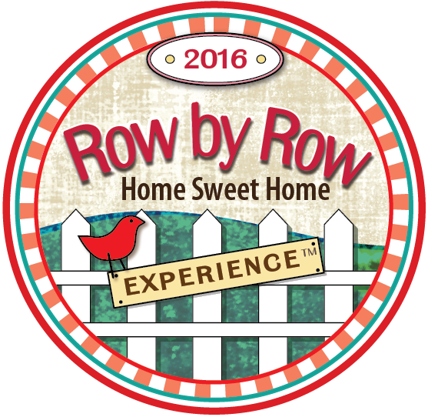

Row By Row June 21 through September 5
Take a vacation and visit local quilts shops all over the USA, Canada and Europe! There are over 3,600 shops participating this year. The theme is ON THE GO and we are busy creating our unique row for your quilt. Our row will be easy to make and definitely will feel like Long Island. We will also have new license plates and the uses for these are just endless. We like the eyeglass case but I’ve seen some pretty unique and creative stuff. Collect them.

Pieceful Quilting Long Arm Quilting Service
Prices are for allover free motion quilting. We do not do custom work. 50% deposit due upon drop –off.
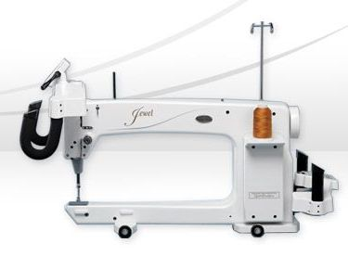
- Pricing includes Signature solid colored thread.
- Specialty thread such as variegated or poly blend can be purchased and used for your quilt.
- We do free motion quilting in a free form pattern of loops, leaves, stars, flowers or hearts
- We recommend Quilters Dream Select batting. We do not accept Mountain Mist batting.
Quilting is estimated at 3 cents per square inch. Multiply width times length and rounded up the nearest dollar. There is a minimum charge of $70.
Services provided for an additional charge
- Prep fee: Ironing, squaring piecing the back or extending the back. $40 per hour.
- Binding Fee: 30 cents per linear inch.
- Rush fee: 25% of the total cost of the quilting service.

Join us for FREE Sit and Sew
Every Friday from 11am to 4pm
Bring your latest project, sewing machine and whatever else you may need to sew the day away among others who love to do what YOU love to do.

PRIVATE LESSONS
We are happy to organize customized private lessons in our classroom for individuals or small groups. Call 631 670-6254 for details.



