Seams Sew Easy
January Newsletter
2326 Mack Rd. Fairfield OH
(513)860-1373

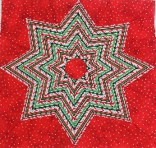
Munch Bunch
Join the Munch Bunch in 2017 as they learn how to make ten different star blocks using the "squedge" ruler. The first class will be January 4th when you'll see the ten-different star blocks you can make with this ruler and Carol will help you decide how to choose your fabric. Cost: Jan $5 then each additional class $15 Plus Supplies (includes pattern). The 1st Wed of every month 5:30 pm to 8:30 pm.

Sashiko Club - Sashiko as you Go
Come explore your Sashiko machine as you create a stunning showcase of over one dozen different traditional Sashiko designs. In this project, you will be working with smaller sections that are easy to manipulate as you quilt the Sashiko design. Cost $25 includes stencil. Sat Jan 7 at 10:30 am to 1:30 pm

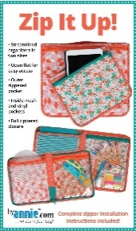
It's My Bag - Zip It Up!
These zippered organizers feature an outer quilted pocket plus inner pockets made from mesh and vinyl for easy visibility of contents. Each pocket has a zipper closure and there's a zippered closure around the entire outside of the organizer. The large size holds an iPad Pro and the smaller case holds an iPad mini. Cost $30 Wed Jan 11 & Jan 25 5:30 to 8:30.

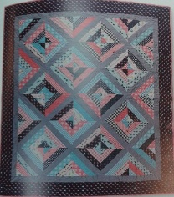
Jenny Doan - Paper Stories
Fast and easy quilt using a Jelly roll. Cost $30. Thu Jan 12th 10:30 to 1:30. And Thu Jan 19th 10:30 am to 2:30 pm.

Strip Club – UFO

UFO Night come join the fun and finish your projects from previous months. Cost: $20. Friday Jan 13th 5-10 p.m.

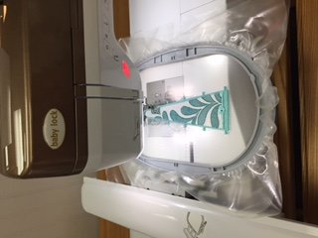
Embroidery Club - Back to the Basics
A monthly club to explore the wonders of machine embroidery. We will learn a technique and then put it to use with samples or a project. The club is the perfect place to experiment and learn something new to enhance your machine embroidery experience. Cost: $20. Club fee + Kit fee. EC1: Sat Jan 14, 10 to 1 p.m. EC2: Sat Feb 11, 10 to 1 p.m. EC3: Sat Mar 11, 10 to 1 p.m.

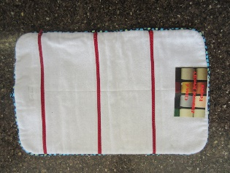
Serging with Mark - Zippered Jewelry Keeper
Never lose your jewelry again while traveling! Create a pocketed & zippered roll up travel case for your jewelry. Great gift idea for the frequent flyer. Learn how to sew in zippers on your serger, it's easier than you realize! Cost: $30. Mon Jan 16, 5:30 to 8 p.m.

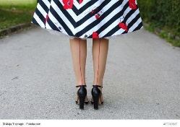
Fashion Club Join us to work on that garment you have been wanting to make but may not have been sure where to start or bring a project you started and never finished. Receive guidance on how to modify the pattern to obtain that perfect fit as well as assistance with all the steps to completion of your garments. Cost: $25, Sat Jan 21, Feb 18, and Mar 18 from 10 to 3 pm.

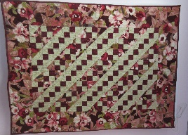
Introduction to Quilt Making
If you have ever wanted to learn how to make a quilt, this is the class for you. This class begins with a discussion of the different brands of rotary cutting equipment and how to use them correctly and efficiently Cost $90. Tue Jan 17, Jan 24, Jan 31, Feb 7, Feb 14, Feb 21 5:30 pm to 8:30 pm.

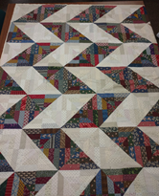
Slanted Diamonds
Come explore the wonders of antique reproduction fabrics and scrap quilts as you assemble a very versatile block that can be arranged to make many different designs. No need to worry about color or color placement -- anything works. Everything is just a matter of value - light and medium/dark. Cost $35 includes instructions. Thu Jan 19 & Jan 26 at 5:30 pm to 8:30 pm.

Lone Star Learn how to create the lone star block using only four colors to create dramatic stars that will be the focus of any quilt. You will learn the simple steps on how to get all your points to match and how to set in the background triangles and squares. We will work on this block during 4 classes. Fridays Jan 27, Feb 10 and 24, Mar 10 from 10 to 1 p.m.

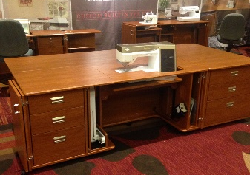
Sewing Studio We are opening the classroom one Friday evening each month for anyone who wants some help with a project or just wants a group to sew with. There will be an instructor available. Cost: $15 refunded in purchase of regular priced merchandise. Friday Jan 27 and March 24 from 5 to 10 pm and Feb 24 from 10:30 to 2:30 pm.

Weekender Tote This may be the most useful bag you will ever create! Multiple pockets and a double zip opening make it perfect for a weekend getaway. Cost: $45 on Feb 17 from 10 to 2 pm and Feb 25 from 10 to 3 pm.

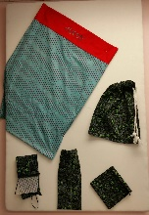
Learning to Sew

This four-week class will cover all the basic skills needed to start on your way to sewing success! Or, if you haven't sewed in a while and need a refresher, this is the class for you. Cost $125 includes supplies. Thur Jan 5th, 12th, 19th and 26th from 5:30 to 8 pm.

Sit and Sew Fridays

On the first Friday of each month bring a UFO or other quilting project to work on. It's always fun to sew with other people, maybe learn a new technique. Let's get out of the house, meet new people, and get some projects finished. Each person will have their own 6' table. There will be 4 ironing stations and 2 cutting tables. Pack a lunch - there is as refrigerator, microwave, and coffee. Be sure to be on time so you don't miss the demo on a new product or technique. Cost $5. Friday Jan 6th, Feb 3rd and March 3rd from 11 to 3 pm. In June and December, we will have a show and tell with a pot-luck lunch.

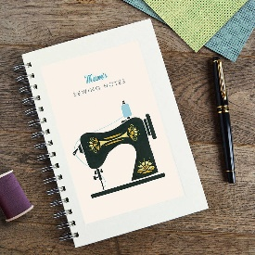
Sewing techniques Notebook

Join Betty as she covers multiple techniques with multiple applications- Bags, totes, pillows, garments and home décor. you will leave class with a notebook of samples and directions. Cost: $35 includes directions and kit. Friday Jan 20th from 10 to 3 pm.

Edge to Edge Embroidery

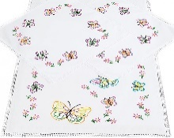
Learn the easy connect edge to edge quilting technique on an embroidery machine. You can use 5 x 9 in - 6 x 11 in - or 7 x 13 in. $15 plus book and supplies. Wed Feb 8th from 1 to 4 pm.

Stop in and see us on Local Quilt Shop Day

