Welcome to our 2017 Education and Event Calendar, itemizing classes scheduled in January 2017 through April 2017.
Class Pass
(146055)

Purchase a SWI Class Pass for $59.95 and attend as many eligible classes as your schedule permits – all for just $10 a session!

Here’s how it works:

- Purchase the SWI 2017 Season Class Pass for $59.95.
- Pay just $10 per eligible class session, regardless of retail price!

Classes eligible for the class pass are designated with a CP in the class title. Classes excluded from the class pass include (but are not limited to) longarm certification courses, Mastery courses and special event classes.

Class Pass classes are non-refundable once you have registered! Please check your schedule carefully before registering!

Take advantage of this great opportunity to learn a few new skills and interact with like-minded sewists!

We’ve scheduled classes and events to challenge your skills, enrich your sewing and embroidery experience, and provide you with opportunities to interact with like-minded sewers. We have a wide range of sewing, fabric art, quilting, home dec, and embroidery classes available. Our goal is to make SWI your favorite sewing/embroidery/quilting shop. We strive to bring you state-of-the-art tools and techniques, stimulate your creativity, and to simplify sewing and embroidery so that you may enjoy your craft. We hope you find our 2017 calendar of classes and events inspiring!

The classes and events we have scheduled (so far!) are included in this brochure. As additional classes are developed, we will add them to our web site, so check www.seworthit.com, often!

Every attempt will be made to hold these classes as scheduled. Please note however, that a minimum of four participants may be required to conduct the class. In the event a class must be rescheduled, we will let you know ASAP, and reschedule or refund the class fee, if necessary. It is important that we have your current phone and email information so that we are able to contact you with any scheduling changes and/or updates.

As a refresher, our cancellation policy is as follows:

Event fees are payable upon registration. Should you need to cancel for any reason, please refer to the registration receipt for the cancellation policy.

Class fees are payable upon registration. Class fees are refundable in the form of a store credit towards another class or a gift certificate (if applicable) if you cancel prior to 7 days before the scheduled class. If you need to cancel within 7 days, the class registration fee is not refundable. Please note: If you are using a SWI Class Pass, Class Pass classes are non-refundable once you have registered! Please check your schedule carefully before registering!

Each and every class offered has a store sample available for you to see in person. (Samples available approximately 45 days before the class.) Pictures simply do not do the sample justice. Come in to the store and SEE what you can make!

As always, thank you for your business. We look forward to our 2017 journey together.

Mastery Courses
Mastery courses are offered EXCLUSIVELY to SWI machine customers. When you buy a sewing or embroidery machine from SWI, these courses are FREE to you for as long as you own your machine. Take them once, twice, or whenever you feel you need a refresher! These courses, referred to as “Mastery Courses,” were developed to help you get the very most from your machine purchase. Babylock’s innovative line of sewing and embroidery machines are technologically advanced and extremely feature rich. Mastering your machine will help you truly enjoy your purchase!

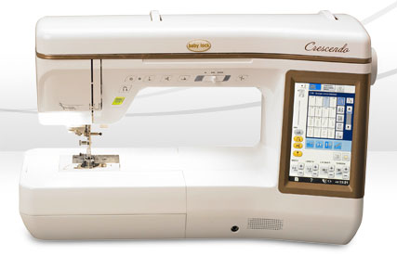
BabyLock Mastery Course Series
Exclusive to SWI BabyLock machine customers! Explore the incredible power of your BabyLock as we delve into 9 specific topics. Check our website for more details about each class!

Please note: You may sign up for only one mastery session at a time.

BabyLock Mastery Course Series

Topic | Date(s) | Time | Class ID
Machine Basics (B1) | Tuesday, January 10  Tuesday, April 11 | 10:00 AM – 12:00 PM | 146098  146429 | Lecture Demo
Sewing Basics (B2) | Tuesday, January 17  Tuesday, April 25 | 10:00 AM – 12:00 PM | 146099  146430 | Hands On
Embroidery 101 (B3) | Tuesday, January 24  Tuesday, May 9 | 10:00 AM – 12:00 PM | 146100  146431 | Hands On
Troubleshooting (B4) | Tuesday, January 31  Tuesday, May 23 | 10:00 AM – 12:00 PM | 146101  146432 | Lecture Demo
Embroidery Lettering (B5) | Tuesday, February 7  Tuesday, June 6 | 10:00 AM – 12:00 PM | 146102  146433 | Hands On
Quilting Basics (B6) | Tuesday, February 21  Saturday, February 11  Tuesday, June 20 | 10:00 AM – 12:00 PM | 146104  146103  146434 | Hands On
Decorative Stitches (B7) | Tuesday, February 28  Tuesday, July 5 | 10:00 AM – 12:00 PM | 146105  146435 | Hands On
Using the Laser  (Sewing and Quilting)  (B8) | Tuesday, March 21  Tuesday, July 18 | 10:00 AM – 12:00 PM | 146106  146436 | Hands On
Special Features (Couching)  (B9) | Tuesday March 28  Tuesday, August 15 | 10:00 AM – 12:00 PM | 146107  146437 | Hands On

Destiny VIP Mastery Courses - 12 classes and two projects!
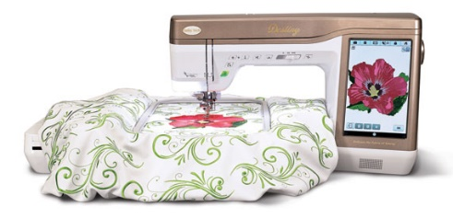
Exclusive to SWI Destiny VIP customers! Explore the incredible power of your Destiny as we delve into 12 specific topics. Our Mastery Classes are designed to help you understand, and master, the power of this incredible machine! As a VIP customer, you may take these classes as many times as your schedule permits – free for as long as you own your machine!

This year, we’ve also scheduled two DESTINY SPECIFIC projects – each one designed to help you understand and master specific features of your Destiny.

You may register for only ONE Mastery class at time. Please note that a minimum of four participants is required to conduct the class. In the event a class must be rescheduled, we will let you know ASAP. Please make sure we have your current contact information.

One of the benefits of purchasing a Destiny from SWI is the ability to reserve one of SWI’s classroom Destiny’s for your SWI classes. This makes it even more convenient for you, and is provided to you, our Destiny VIP customers, on a first come, first serve basis. Reserving a Destiny is your responsibility – SWI staff will not automatically reserve a Destiny for you, so please make sure you request a Destiny when you register for a class.

Here are a few other important points to note:

- Classroom machines only include the machine, power cord, foot pedal, and embroidery arm. You must provide all other machine parts needed for your class (e.g. – shank, thread stand, embroidery foot, walking foot, etc.). If you forget a machine part or accessory and wish to rent one from SWI, the rental fee is $10. Please be diligent as you pack for class!
- Bring in all items listed for supplies for each class on website
- You must call at least 24 hours prior to the class to cancel – if you no show, there may be a charge for the next class
- Be sure to bring a sewing machine needle to put in the machine
- Bind your Destiny Manuals – Office Max approximately $8 for the Manual and Quick Reference Guide

SWI has six classroom Destiny’s, so reserve your spot by calling or stopping by the store. If the classroom machines are already reserved, you are welcome to bring your own Destiny to class, or simply listen and learn!

Class dates and topics are shown on the following page.

DESTINY VIP MASTERY CLASSES

Topic | Date(s) | Time | Class ID
Machine Basics (B1) | Tuesday, January 10 | 10:00 AM – 12:00 PM | 146098 | Lecture Demo
Sewing Basics (B2) | Tuesday, January 17 | 10:00 AM – 12:00 PM | 146099 | Hands On
Embroidery Basics (B3) | Tuesday, January 24 | 10:00 AM – 12:00 PM | 146100 | Hands On
Troubleshooting (B4) | Tuesday, January 31 | 10:00 PM – 12:00 PM | 146101 | Lecture Demo
Embroidery Lettering (B5) | Tuesday, February 7 | 10:00 AM – 12:00 PM | 146102 | Hands On
IQ Applique Basics (DM1) | Tuesday, February 14  Saturday, January 21 | 10:00 AM – 12:00 PM  10:00 AM – 12:00 PM | 146109  146108 | Hands On
Quilting Basics (B6) | Tuesday, February 21  Saturday, February 11 | 10:00 AM – 12:00 PM  10:00 AM – 12:00 PM | 146104  146103 | Hands On
Decorative Stitches (B7) | Tuesday, February 28 | 10:00 AM – 12:00 PM | 146105 | Hands On
IQ Embroidery Basics  (DM2) | Tuesday, March 7  Saturday, March 11 | 10:00 AM – 12:00 PM  10:00 AM – 12:00 PM | 146110  146111 | Hands On
Embroidery Placement (Laser/Camera)  (DM3) | Tuesday, March 14 | 10:00 AM – 12:00 PM | 146112 | Hands On
Using the Laser  (Sewing and Quilting)  (B8) | Tuesday, March 21 | 10:00 AM – 12:00 PM | 146106 | Hands On
Special Features (Couching)  (B9) | Tuesday, March 28 | 10:00 AM – 12:00 PM | 146107 | Hands On

Destiny VIP Exclusive Classes – Projects!

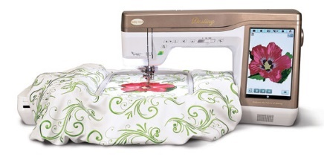
NEW! How about a little “practical practice” with your Destiny? We’ve developed two class “projects” each focused on helping you master a specific feature of your machine! Even better, as you learn, you’ll complete the project!
Destiny Upgrade Project – Mia Wall Hanging

Select one of the following class dates:

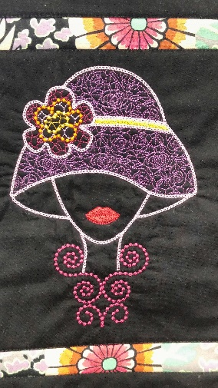
January 11, Wednesday, 10:00 AM – 1:00 PM (146114)

February 8, Wednesday, 10:00 AM – 1:00 PM (146115)

March 8, Wednesday, 10:00 AM – 1:00 PM (146116)

If you purchased the Destiny Upgrade Kit from SWI, you are eligible to take this FREE mastery course to help you learn how to get the very most from your Destiny Upgrade. We'll be making the MIA wall hanging using the new IQ Embroidery features -- sew fun....and the optimal way to learn!
We have three sessions scheduled, each session identical, so select the date that best fits your schedule.

Class Fee: Free for SWI Destiny Upgrade Customers only
Educator – SWI Staff
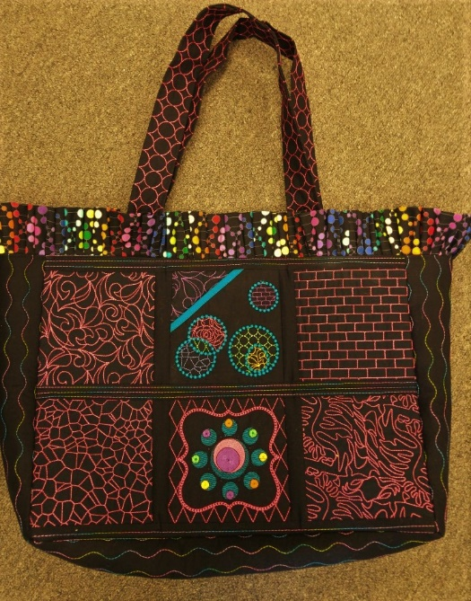
CP - Destiny VIP Project – Quilted Tote

What better way to learn how to use your Destiny than with a “real” project! You’ll make a stunning tote that will be the envy of all your girlfriends! First, you’ll use IQ Embroidery to make your blocks (Session One). You’ll then quilt your tote with your Dual Feed Foot (Session Two), and finally you’ll construct your bag with a variety of sewing techniques (Session Three). You’ll be amazed at what you’ll learn – and even better – you’ll have a gorgeous tote!

February Series (3 Sessions)

February 1, Wednesday, 10:00 AM – 1:00 PM (146117)

February 15, Wednesday, 10:00 AM – 1:00 PM (146118)

February 22, Wednesday, 10:00 AM – 1:00 PM (146119)

March Series (3 Sessions)

March 1, Wednesday, 10:00 AM – 1:00 PM (146120)

March 15, Wednesday, 10:00 AM – 1:00 PM (146121)

March 22, Wednesday, 10:00 AM – 1:00 PM (146122)

Class Fee: $10 per class, $30 total plus supplies, Educator – SWI Staff

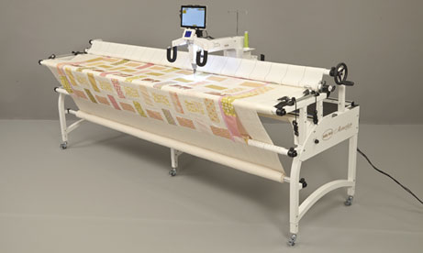
Longarm Mastery Classes

For SWI longarm machine customers only! Now that you own your longarm machine, let SWI experts help you master your skills! In each if these mastery courses, we will focus on one specific topic. If you are a new SWI longarm customer, these courses are invaluable as you begin to explore the power of your new longarm quilting machine. If you’ve taken these courses before, consider attending again to brush up on your skills or ask the expert now that you have some “home hand on” experience.
As a SWI machine customer, you may take as many Mastery courses as you like – they are free and offered only to you --- our SWI machine customer!

Mastery Class Topics and Dates:

January 20, Friday, 1:30 PM – 3:30 PM (146123)
Basics – Quilt Prep and Loading and Tension
- In this class, we will cover everything you need to know about putting your quilt on the frame, including using zipper leaders, centering, full or partial floating and basting. We’ll also cover the basics of setting and adjusting tension. The skills reviewed in this class are critical to getting started with your longarm quilting.

February 23, Thursday, 1:30 PM – 3:30 PM (146124)
Block to Block
- Block work is a critical skill for creating one-of-a-kind custom quilts. Learn how to create custom blocks in this not to be missed session.

March 16, Thursday, 1:30 PM – 3:30 PM (146125)
Pro-Stitcher - Edge to Edge
- Edge to Edge designs work exactly the way the name describes - from one edge of the quilt to the other. This easy to accomplish quilting method will have you quilting those unfinished objects in record time! Learn how to define your quilt design for optimal performance.

April 20, Thursday, 1:30 PM – 3:30 PM (146126)
Corners and Borders
- Learn how to quilt corners and borders. This is a “Don’t miss” class for creating customized quilts.

.

Longarm Certification
January 12, Thursday, 10:00 AM – 4:00 PM (146127)
February 10, Friday, 10:00 AM – 4:00 PM (146128)
March 9, Thursday, 10:00 AM – 4:00 PM (146129)
April 6, Thursday, 10:00 AM – 4:00 PM (146130)

Ready to take your quilting skills to the next level? This hands-on class will teach you how to use a longarm machine. Once certified, you will be able to rent a SWI longarm to quilt your quilts! What fun!
Rent a Longarm

Complete your quilts faster than ever by renting SWI’s longarm machines! You will be amazed at how easy it is to finish your own quilts on these industry leading machines.

In order to rent a SWI longarm, you must first be certified.
During the class, you’ll receive a Longarm Certification Handbook (to take notes and to take home) and a SWI Certification Card for identification. This card is for your use only and is needed to make a reservation to rent the machine. You will also receive your own very own set of zippers for the longarm leaders.
Class fee is non-refundable, non-cancellable, and non-transferable. To provide hands on training, there will be only four students in each class. Supplies needed for class - absolutely nothing! SWI WILL PROVIDE EVERYTHING YOU NEED!

Class Fee: $175
Instructor: SWI Staff

Serger Mastery Classes

For SWI serger machine customers only! NEW this season, join us once a month for mastery courses designed specifically for the amazing BabyLock sergers!

Serged stitches add stretch and strength to seams, simplify edge-finishes, and are often used to embellish a project. With so many stitch options to choose from, it's hard to know which stitch to use on which fabrics and how to effectively set up your serger for the best result! Let us help! In this four class series, we’ll cover a variety of stitches and finishes to help you master your Babylock serger. These classes are available to SWI serger machine customers only – and are FREE for as long as you own your machine!

Mastery Class Topics and Dates:

January 30, Monday, 10:00 AM – 12:00 PM (146243)
Three and Four Thread Overlock
- In this class, we will focus on a serger basic – the overlock stitch! We’ll teach you how to navigate both inside and outside corners, and teach you how to use the overlock stitch for zippers and more!

February 27, Monday, 10:00 AM – 12:00 PM (146244)
The Rolled Edge and the WAVE Edge
- This class is all about finishing! We’ll cover the rolled edge – which is a perfect finish for fast dinner napkins, as well as the Wave Stitch which is the perfect finish for garments, as well as home dec projects – including placemats, table runners and quilts!

March 27, Monday, 10:00 AM – 12:00 PM (146245)
The Cover Stitch
- One of our favorite stitches is the cover stitch! The cover stitch makes garment construction sew fast and sew easy! You’ll want to make T shirts in all your favorite colors! But don’t under estimate this stitch – it’s perfect for dust ruffles, aprons, tablecloths and sew much more!

April 24, Monday, 10:00 Am – 12:00 PM (146246)
The Chain Stitch
- The chain stitch is a great stitch for embellishing and finishing. Use the chain stitch instead of topstitching for a beautiful result! If you want to learn how to use this stitch – don’t miss this class!

.

Technique Classes:
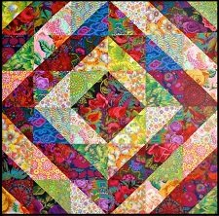
CP - Beginning Quilting (146056)

Class Session Dates: (4 sessions)

January 19, Thursday, 10:00 AM – 1:00 PM

February 2, Thursday, 10:00 AM – 1:00 PM

February 9, Thursday, 10:00 AM – 1:00 PM

February 16, Thursday, 10:00 AM – 1:00 PM

If you’ve always wanted to quilt but didn’t know where to start, this class is for you! This four class series will have you quilting in no time! In the very first session, our award-winning quilter will help you select your fabrics and take you through which tools are “must haves” for quilting, and which are optional. For the second through the fourth sessions, bring your sewing machine! We’ll start with fabric preparation and rotary cutting, and then proceed to piecing where we’ll share the secrets to perfectly straight seams and blocks that fit! We’ll be with you every step of the way as you discover the joy of designing and creating your very own quilt! Welcome -- new quilter!

Skill Level: Beginner
Class Fee: $25 per session, $100 total ($40 total if you purchased the SWI Class Pass)
Instructor: Pam

CP - Quilting with your Walking Foot

February 10, Friday, 10:00 AM – 3:00 PM (146057)

March 10, Friday, 10:00 AM – 3:00 PM (146160)
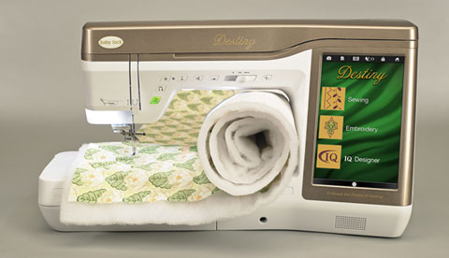

Join us and learn straight line quilting, organic quilting, echo quilting and more – all while using your Walking Foot! In this hands on class, you will practice a variety of techniques – after which you will be quilting like a pro! All sewing machine brands welcome!

Skill Level: Confident Beginner and Beyond
Class Fee: $25
Instructor: Lisa

CP – Introduction to Free Motion Quilting

February 8, Wednesday, 1:00 PM – 4:00 PM (146058)

March 8, Wednesday, 1:00 PM – 4:00 PM (146060)
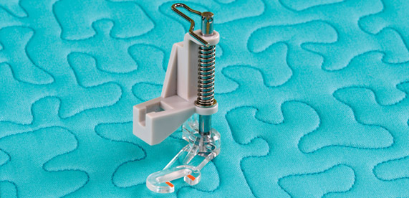
Bring your own machine, and learn the art of free motion quilting in a relaxed and fun environment. We’ll practice a variety of techniques, both on paper, and on your quilt sandwich. Each of the class will focus on different free motion filler and quilting designs, so consider signing up for both. After all -- practice makes perfect!

Skill Level: Confident Beginner and Beyond
Class Fee: $25/each
Instructor: Lisa
CP - Quilting in the Hoop

February 20, Monday, 10:00 AM – 2:00 PM (146059)

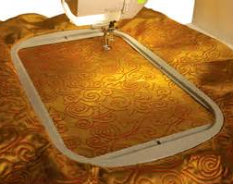
Yes you can quilt in the hoop! Let SWI’s expert teach you the basics of quilting in the hoop – from simple designs for placemats to background quilting for larger projects. We’ll be showcasing the 10 minute table runner quilted in the hoop, but you may select any placemat or runner for your “practical practice” project. You’ll add a new skill to your repertoire and be sew glad you did!

P.S. – Destiny Owners – Quilting in the hoop is amazing with the new IQ Region/Fill stitches included in the Destiny Upgrade!

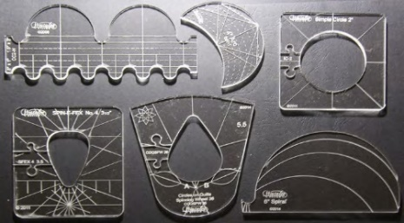
Skill Level: Confident Beginner and Beyond
Class Fee: $25
Instructor: Kim
Ruler Work for Domestic Machines

January 13, Friday, 1:00 PM – 4:00 PM (146061)

February 6, Monday, 1:00 PM – 4:00 PM (146062)

March 7, Tuesday, 1:00 PM – 4:00 PM (146063)

Introducing ruler work for domestic machines! Beautiful blocks and borders are within your reach with these innovative tools! Free motion quilters rejoice!
If you purchased your ruler foot and template set from SWI, select one of the scheduled classes and enroll for FREE! In each session we will cover the basics of ruler work, followed by "practical" practice with each ruler. If you’ve already taken one free classes, you may attend additional sessions for just $10.00!
Skill Level – Beginner and beyond
Fee: $25, $10 with your SWI Class Pass
Instructor: Lisa
CP – Applique University – Learn multiple ways to applique!

Four class sessions: Attend one or all four!

January 18, Wednesday, 1:00 PM – 4:00 PM (146064)

February 1, Wednesday, 1:00 PM – 4:00 PM (146065)

February 15, Wednesday, 1:00 PM – 4:00 PM (146066)

March 1, Wednesday, 1:00 PM – 4:00 PM (146067)

In this four class series, you will learn a wide variety of applique techniques, including hand-turn, back basting and (of course!) machine applique. As you learn, you’ll create three different blocks – perfect for a small wall hanging or tablerunner! Our instructor is award-winning – but better yet, she’s patient, encouraging and fun! Take this course series to learn from the best and find your own applique style! Sign up for one class, or all four, and become an expert.

Class 1 - Machine applique
Class 2 - Hand applique using freezer paper templates
Class 3 - Needleturn and back basting
Class 4 - Circles, stems and reverse applique

Skill Level: Beginner
Class Fee: $25 each -- $10 each with your Class Pass
Instructor: Pam

CP - EmbroideryWorks (146068)

March 7, Tuesday, 10:00 AM – 1:00 PM

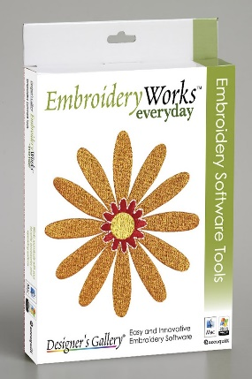
EmbroideryWorks provides embroiderers with a toolbox filled with all the essential design editing functions needed to create beautiful embroidery. Like any software, however, it takes time to learn and master. If you purchased the software, but haven’t really used it as much as you’d like, this is the class for you! From beginner to more advanced embroiders, our instructor will help you get the most from your software purchase.

Skill Level – Beginner and beyond
Fee: $25
Instructor: Kim

CP – Introduction to Studio III Embroidery Software

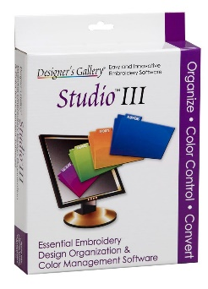
February 28, Tuesday, 10:00 AM – 1:00 PM (146069)

If you own (or are thinking about purchasing) Studio III, this is the class for you! Spend more time embroidering and less time searching. Studio III remembers where you save your designs even when you don't. We’ll teach you how to make your embroidery selection process a snap! We’ll even teach you about color sorting options for perfect embroidery every time! Let us help you shorten the learning curve for this wonderful software!

Skill Level: Confident Beginner and Beyond
Class Fee: $25
Instructor: Kim
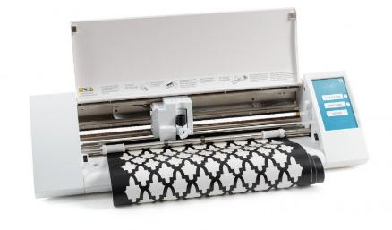
CP - Silhouette Basics

January 16, Monday, 10:00 AM – 1:00 PM (146070)
If you love applique, you either own – or are thinking about owning -- the Silhouette Cameo. It makes cutting applique shapes fast and easy! As with any software, there’s a learning curve. This class is all about getting you comfortable with your Silhouette. We’ll teach you the basics – scanning in your designs, cleaning up the scans, duplicating and mirroring, and navigating the menus. You’ll be amazed at how easy it is to use this awesome tool! If a Silhouette Cameo is on your “wish list”, consider attending this class to get an idea of what you could accomplish with this applique tool time-saver.

Skill Level – Beginner and beyond
Fee: $25
Instructor: Kim

CP – Intro to Paper Piecing

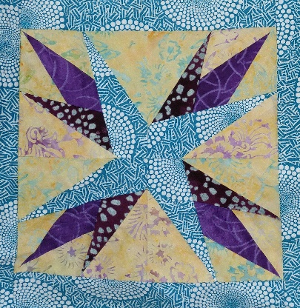
January 31, Tuesday, 10:00 AM – 2:00 PM (146071)

Interested in giving paper piecing a try? Our Introduction to Paper Piecing class is perfect for quilters that want to learn this relaxing and fun technique! With the guidance of our award-winning quilter, you will construct a paper pieced block, which you can then turn into a fun tote! What a great way to learn!

Skill Level – Beginner and beyond
Class Fee: $25
Educator: Pam

CP – Leaf Wallhanging

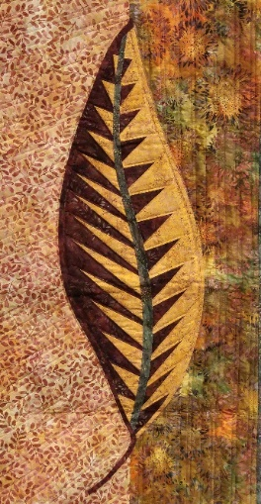
Two class sessions:

February 3, Friday, Friday, 10:00 AM – 2:00 PM (146072)

February 24, Friday, Friday, 10:00 AM – 4:00 PM (146073)

Ready for a more challenging paper piecing project? If you’ve long admired Judy Niemeyer’s gorgeous and intricately designed patterns, you’ll want to take this class. The One Leaf Wall hanging is the perfect project -- challenging, but doable – especially with our paper piecing expert guiding you along the way!

Skill Level – Beginner and beyond
Class Fee: $25/each session
Educator: Pam

CP – Flourish Runner (146074)

April 12, Wednesday, 10:00 AM – 2:00 PM
Add a bit of sophistication to your dining room with this stunning tablerunner that features QUILT AS YOU GO and STITCH AND FLIP techniques, followed by simple applique! If you’re new to quilting, quilt as you go refers to a process where you piece and quilt in one step, which means that when you’re done piecing (and quilting), you’re done! To make this class even better, we’ll cut out the flower appliques using the Silhouette, which makes this tablerunner a breeze to complete! We love this technique – and you will too!

Skill Level – Beginner and beyond
Class Fee: $25
Educator: Pam

CP – T Shirt Quilt

Two class sessions:

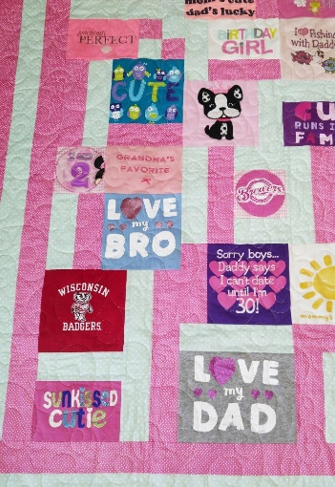
February 4, Saturday,10:00 AM – 2:00 PM (146075)

February 23, Thursday, 10:00 AM – 2:00 PM (146076)

If you quilt, chances are a family member or a friend has asked you to make a T shirt quilt for them. T shirt quilts are fun and rewarding to make, and incredibly satisfying to give. We’ll share our favorite techniques for t shirt stabilization, and review options for designs. You’ll be amazed at how easy a T Shirt Quilt is to make! Don’t miss this unique class!

Skill Level – Beginner and beyond
Class Fee: $25 per session; $50 total ($20 total if you purchased the SWI Class Pass.)
Educator: Pam

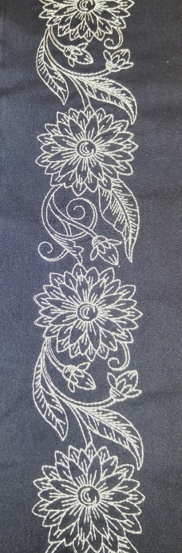
CP – Continuous Hoop Embroidery

January 23, Monday -10:00 AM – 2:00 PM (146077)

Create beautiful borders for garments and home decorator projects by learning how to use the continuous hoop embroidery function of your embroidery machine. Create a beautiful border on a pillowcase as you learn!

Skill Level – Beginner and beyond
Class Fee: $25
Educator: Kim

CP – Flower Power Quilt

Two class sessions:

March 16, Thursday, 10:00 – 2:00 PM (146078)

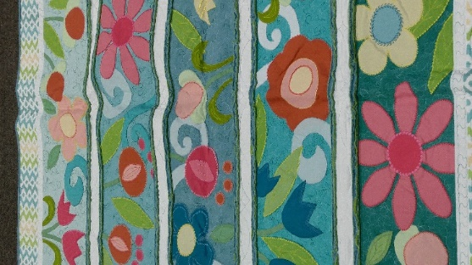
March 30, Thursday, 10:00 AM – 2:00 PM (146079)

Take appliqué to a new level with Flower Power! This exuberant design features oversized blooms – making it perfect for showcasing the specialty stitches on today’s sewing machines. We’ve also added a fun chenille border – the perfect addition to make the rows pop! Pick fat quarters for your appliqués, plus a graduated background fabric and create your own modern masterpiece!!

Skill Level: Intermediate
Class Fee: $25 per session; $50 total ($20 total if you purchased the SWI Class Pass.)
Educator: Pat

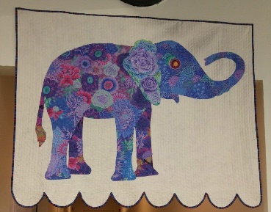
CP – Collage Art Quilt Wall Hanging

February 7, Tuesday, 10:00 AM – 3:00 PM (146080)

February 13, Monday, 10:00 AM – 3:00 PM (146267)
Want to learn the basics of collage quilts? Select one of five patterns and attend this introductory class to get you started on your very own masterpiece. It's easier -- and more fun -- than you think! Begin your artistic journey in a class room setting where different ideas and techniques are used by each of the attendees!

Skill Level: Beginner and Beyond
Class Fee: $25
Instructor: Kim

CP – Spring in Prague – Join SWI’s BLOCK of the Season Progam!

Five class sessions:

January 19, Thursday, 10:00 – 2:00 PM (146081) – Applique Prep - Silhouette

February 2, Thursday, 10:00 – 2:00 PM (146131) – Bird Blocks

February 9, Thursday, 10:00 AM – 2:00 PM (146132) – Vertical Blocks

March 2, Thursday, 10:00 – 2:00 PM (146133) – Square Blocks

March 9, Thursday, 10:00 – 2:00 PM (146134) – Word Blocks
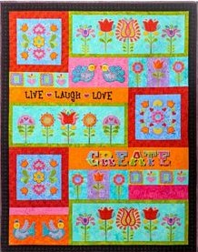
This whimsical applique embroidered quilt is based on antique lace designs from the Czech Republic and Romania. The quilt is bright and beautiful, and better yet, we’ll help you make in a series of five sessions! If you’ve always wanted to do a Block of the Month” quilt – this series of for you! We’ll help you complete your quilt before the “Sarasota Season” ends!

Skill Level: Intermediate
Class Fee: $25 per session; $125 total ($50 total if you purchased the SWI Class Pass.)
Instructor: Pat

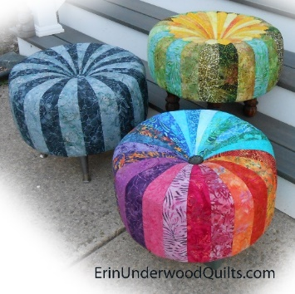
CP – Tuffet (146082)

March 6, Monday, 10:00 AM – 3:00 PM

Are you ready to make something new?? How about this adorable tuffet? Perfect as an accent for your living room, and a pretty place to rest your weary feet! Even better – this tuffet is fun to make! Quick and cute!

Skill Level – Beginner and beyond
Class Fee: $25
Instructor: Kim

CP – Project Bag

January 17, Tuesday, 1:00 PM – 4:00 PM (146083)
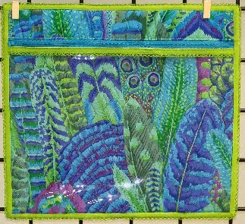
Start the year with our Project Bag class where you’ll make your very own “designer” project bag -- great for organizing everything you need for each of your projects. A zipper keeps everything safe and a see-through vinyl window, trimmed in crochet-edged bais tape, allows you to see at a glance what is in each bag.

Skill Level: Beginner and Beyond
Class Fee: $25
Instructor: Lisa

CP – Minky for Me

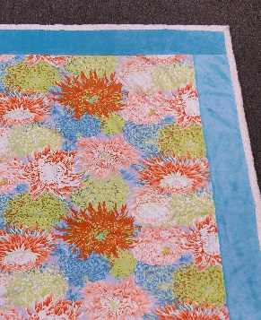
February 21, Tuesday, 1:00 PM – 4:00 PM (146084)

If you’ve made a children’s quilt (or two!) with Minky, you know how luxurious, soft and comforting cuddle fabric can be. Why not make a grownup cuddle quilt? You’ll learn how to work with Minky, as well as learn some great “stitch and flip” techniques. Make a Minky…for you!

Skill Level: Beginner and Beyond
Class Fee: $25
Instructor: Lisa

CP – Color Explosion – Weekend Quilt Project (146085)

Friday, March 24 and Saturday, March 25, 10:00 AM – 5:00 PM
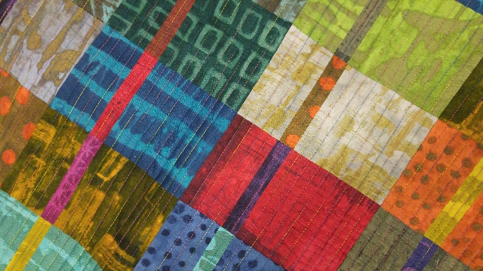
New this season! Spend a weekend with us and create a quilt! On Friday morning, we’ll select and cut our fat quarters. After lunch, we’ll piece the afternoon away, while creating our quilt blocks. Saturday, we’ll put our quilt together, and begin to quilt. You’ll be amazed at how quickly you can create this stunning quilt!

Skill Level: Beginner and Beyond
Class Fee: $50 ($20 with your SWI Class Pass)
Instructor: Lisa

CP – Faith, Hope, Love Wallhanging (146086)

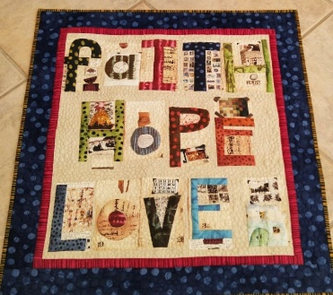
April 5, Wednesday, 10:00 AM – 3:00 PM

Using the stunning “Studio Alphabet” panel as a starting point, make a quilt or wallhanging with your own customized message. We love “Faith, Hope and Love" but quilters choice! We’ll show you how to customize your wall hanging or quilt – perhaps with your daughter’s name, or family motto. You’ll learn how to create improv quilt blocks and borders – a great new skill to add to your repertoire. This is sure to be a high-energy class with lots of great tips and techniques for personalization. Don’t miss it!

Skill Level: Beginner and Beyond
Class Fee: $25
Instructor: Lisa

CP – Sassy Stash Scrap Quilt, Tablerunner or Placemats

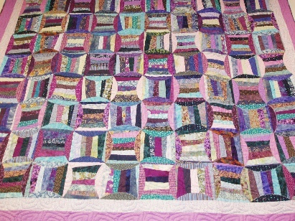
January 20, Friday, 10:00 AM – 2:00 PM (146135)

January 30, Monday, 10:00 AM – 2:00 PM (146136)

Raid your scrap basket for this fun -- and budget friendly -- quilt! If you're not up for a quilt -- you can make a tablerunner, bed runner, or a placemat! Either way, let us show you a great new way to use your scraps to create something gorgeous!
In the first session, we'll focus on block construction and scrap selection. In the second session, we will begin quilt construction and review quilting options! Enroll in one session -- or opt for both! Either way -- have fun while cleaning out your scrap basket!

Skill Level: Beginner and Beyond
Class Fee: $25
Instructor: Will

CP – Serge Simple

January 16, Monday, 1:00 PM – 4:00 PM (146087)

February 13, Monday, 1:00 PM – 4:00 PM (146088)

March 13, Monday, 1:00 PM – 4:00 PM (146089)
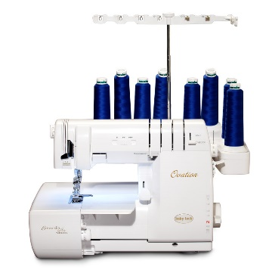
Calling all serger owners! Attend our “Serge Simple” project classes and fall in love with your serger once again! Each month, we’ll feature one serger based project to encourage you to use and appreciate your serger. Fun, practical, and simple projects for your home and for you!

Here’s what we’ll make by month:

- Janaury – Sew Pretty Apron. This ENCORE class from the SWI 2016 Retreat will have you using the 4 thread overlock, as well as the WAVE stitch. If you loved the retreat project, here’s your chance to make another apron while exploring the vast capabilities of your serger!
- February – Pillowcases (with or without ruffles). You’ll learn - 4 thread overlock, ruffling on the serger foot, 3 thread rolled hem and three thread overlock.
- March – Napkins. You’ll learn - 3 thread overlock, 3 thread rolled hem and how to turn corners while serging.

Skill Level: Beginner and Beyond
Class Fee: $25
Instructor: Lisa

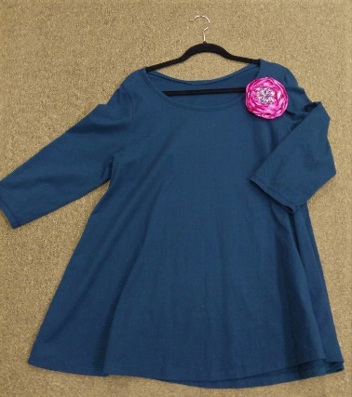
CP – Swing T Shirt

March 3, Friday, 10:00 AM – 4:00 PM (146263)

Skill Level: Beginner and Beyond
Class Fee: $25
Instructor: Lisa

CP - Sit and Sew - Weekly

Join us twice a month for a FREE sit and sew session. SWI staff members will be available to help you with your current project – plus you get to catch up with your friends in a fun, friendly environment. Finish your projects, get help from the SWI team, and be social! The sessions are free, but registration is required.

Class Fee: Absolutely None – It’s Free!

January 9, Monday, 1:00 PM – 4:00 PM – 146090

January 23, Monday, 1:00 PM – 4:00 PM – 146091

February 6, Monday – 1:00 PM – 4:00 PM – 146092

February 20, Monday – 1:00 PM – 4:00 PM – 146093

March 6, Monday – 1:00 PM – 4:00 PM – 146094

March 20, Monday – 1:00 PM – 4:00 PM – 146095

April 3, Monday – 1:00 PM – 4:00 PM – 146096

April 17, Monday – 1:00 PM – 4:00 PM – 146097

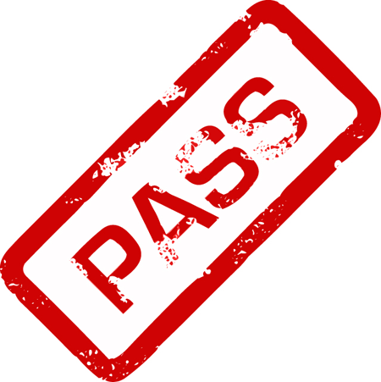
SWI Class Pass
Valid January 1, 2017 – April 30, 2017
(146055)

Purchase a SWI Class Pass for $59.95 and attend as many eligible classes as your schedule permits – all for just $10 a session!

Here’s how it works:

- Purchase the SWI 2017 Class Pass for $59.95.
- Decide which eligible classes you would like to attend.
- Pay just $10 per eligible class session, regardless of retail price!

Classes eligible for the class pass are designated with a CP in the class title. Classes excluded from the class pass include (but are not limited to) the longarm certification courses, Mastery courses and other classes not specified as “CP”.

Once you have registered for the Class Pass, and paid your $59.95 registration fee, the rest is easy! Decide which class sessions you would like to attend and ask a SWI team member to help you enroll. Each class session is just $10!

Each class has a maximum number of participants, and registration is on a first come, first serve basis. With the incredible value of our SWI Class Pass, we expect many of these classes will fill up quickly, so register early!

Considerable time and energy has been invested in designing the class and preparing the class samples. Therefore, it’s important that you note the following cancellation requirements:

- There are NO REFUNDS for class pass classes. Please check your schedule carefully before you register for a class.
- If you no show more than two times, your SWI Class Pass may be suspended.
- Please utilize SWI fabric and supplies for your class pass projects. We appreciate your support!

Serger Sensation Workshop (146158)

  - FEBRUARY 17 – 18, 2017
Friday and Saturday
  - 9:30 AM – 5:00 PM

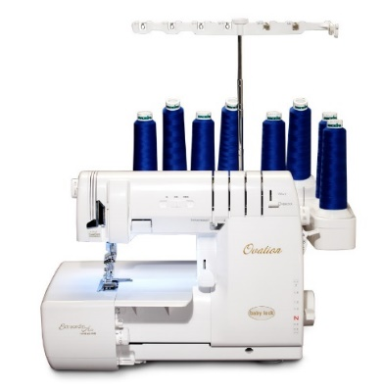
If you own, or are thinking about purchasing a serger, this event is for you!

Learn how to do more than overcasting --
did you know that sergers can be used for:

- Quick zipper installations?
- Inserting piping fast than you ever thought possible?
- Crocheting edges of blankets and bibs?
- Binding a quilt with the wave stitch?
- Cover hems for shirts and skirts?
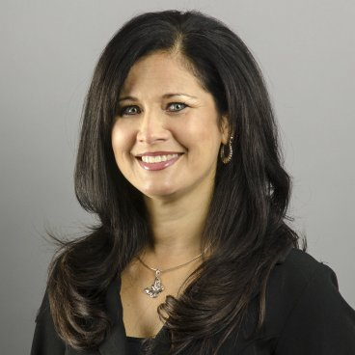
Join Lori Hernandez, Babylock National Education Expert, for 2 fun filled days of learning about the fabulous Baby Lock serger. Move beyond overcasting seams to sew much more! Try decorative edges, zippers, piping, belt loops, pintucks, crochet lace, and more. The first day is all about learning new techniques. On the second day, you’ll create a project with your newly acquired serger skills! A great way to learn while making something fabulous!

- Bring your own Baby Lock serger or we will provide one for you*!
- Lunch & snacks provided daily!
- From beginner to advanced, all are welcomed!
- Registration fee: $179.
* Optional – Don’t own a Babylock Serger? For $25 (for both days!), you may rent one of SWI’s sergers!

Secrets to Successful Embroidery
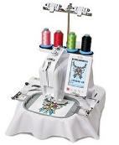
If you’ve never embroidered….
If you’re a novice and you “hope for the best” when you embroider….
If you’ve been embroidering for years……
YOU’LL WANT TO COME TO THIS EVENT!
Secrets to Successful Embroidery
January 26 – January 28, 2017 (146154)
Thursday - Saturday
10:00 AM – 4:00 PM

You’ll learn:
- Practical advice on how to select the right stabilizer – and how to maximize your stabilizer to minimize waste.
- Why you don’t need to hoop (WHAT!) – One of our favorite secrets to success!
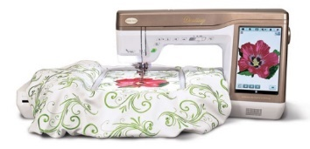
- What to embroider. Caps, lace, towels and more!
- How to select the right design – hooping, density and design options.
- The secrets to great monogramming! Go Monogram Crazy!
- How to solve your embroidery problems!

This all-inclusive, 3 day event is $149*! SWI provides the embroidery machines and supplies. To ensure all attendees get hands on experience -- space is limited! Register today!
*Event Cancellation Fee: $25 (Prior to 1/13/17). After 1/13/17, no cancellations.

