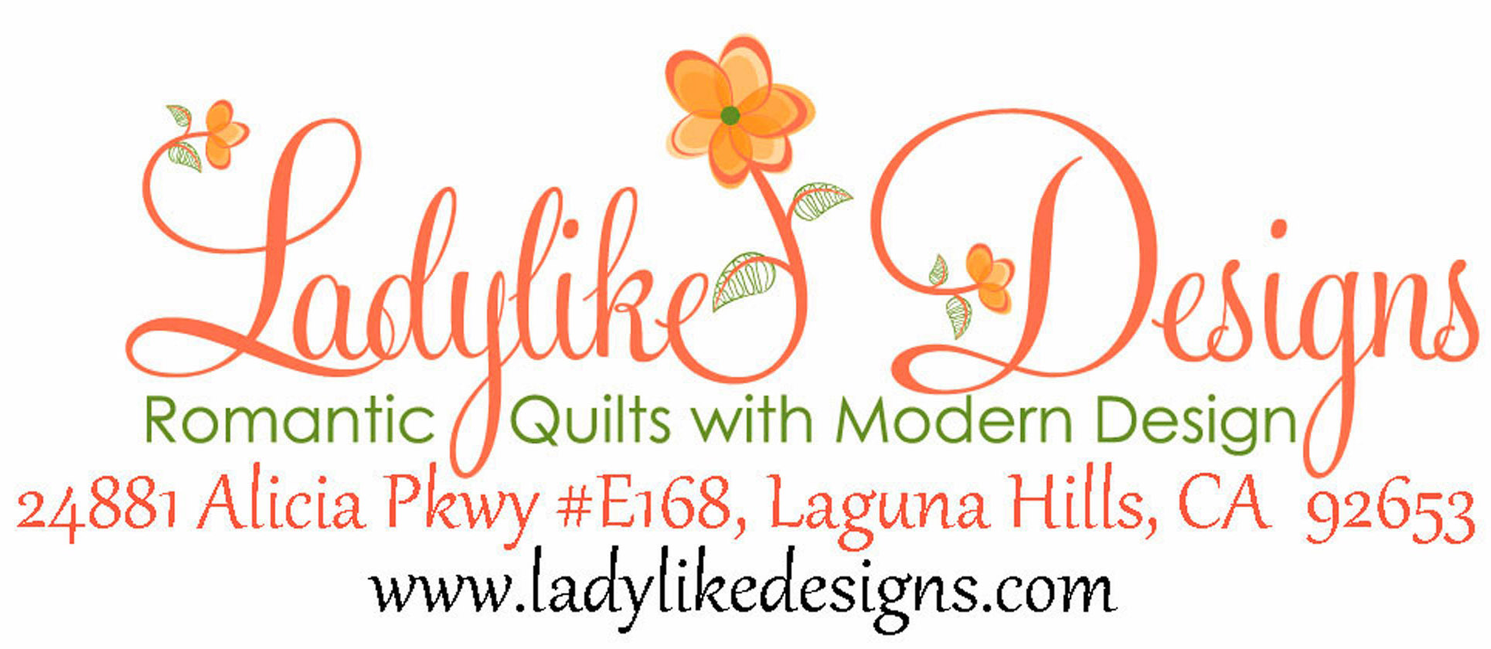

Bev Remillard

Let me introduce myself…
Loving romance and all that it encompasses naturally leads me toward pretty, tasteful and romantic fabrics, which inspires me to design patterns and quilts with the same charm and grace. I love colors of all hues and florals are my favorite and every once in a while I brake out of my box and play with brights, batiks and geometrics.

Making quilts and designing patterns is such a passion I turned it into my business. Over the past 15 years I have been able to produce quilts of varying ability and challenges, which have been a joy to make. I’m usually working on about 5 projects at a time, you know one leads to the next...

Teaching is also an important part of my life – I truly enjoy watching other quilters explore color, pattern and design and consider myself blessed to see their finished beauty.

I look forward to speaking and teaching with your guild.
Thank you for the consideration, Bev Remillard
Speaking
Simple Lady™ Designs
Many years ago I was teaching a quilt class expecting the normal quilter to walk in and was surprised to find the Project quilter. She was not interested in the history and beauty of quilting and fabric, she just wanted to get it done! This lecture is made for today's woman, who is just too busy and time is a special commodity. I've created a new series of designs to make it possible for anyone to break away from the busyness or the dullness in life and just have fun.... quilting! . I explore the challenges with the right fabrics, colors and patterns for any project and the simplicity of an each design, no matter what phase of life. Simple Lady designs focuses on quilts, toppers, runners, gifts, etc that can be done in no time! In my lecture I show the importance of creating and the benefits for all. My workshops for these classes have kits for purchase. I also bring merchandise to sell that coincides with the SimpleLady™ theme as well as other patterns and kits. The fee for this lecture is $350.00.

Romancing the color
This lecture focuses on the challenges of choosing the best fabrics and particularly the best color values to express a pattern in the best way possible. Like an artist, I've been blessed with an eye for color and design which leads me to make many different quilts as an expression of my craft. Though the years I've discovered a sense of style that guides my quilts in a colorful, pretty and romantic way. I like to take chances with the combinations of colors/fabrics as a prepare a pattern and the praise and encouragement I receive has encouraged me to share my process with others. This lecture is part information and part fun – I try to include the guild group in the discussion.
The fee for this lecture is $350.00

I try to keep both my lectures light hearted with plenty of free discussion. I enjoy interacting with the group and love the feed back they often share. I am able to pull the group together as needed to ensure the discussion does not get off track or out of control.

Speaking and Workshop – Bev Remillard 2016
Workshops
I love to teach workshops with guild friends, they are so interesting and fun to spend the day with!! My workshops are all day classes – generally 6-8 hours. I prefer a minimum of 10 participants and can max at 20. If necessary to go higher than 20, there will be an additional fee of $10 per person. Please ask for a volunteer to be an administrator and helper.
These quilts are so much fun and so easy, group should go home with the top finished.
Workshop Fee: $350.00 6 Hours (Includes a lunch break)

Please choose from the following workshops
1. One day workshop – related to SimpleLady™ Lecture
The following projects work best with 2 or more choices being taught at the same time. The group likes having a choice and also they like being able to see other options. This workshop is helpful in emphasizing a creative nature and quilting for fun. Most of these quilts, toppers, etc. use precuts, which is a big time saver. Sewing machine and rotary cutting knowledge a must!

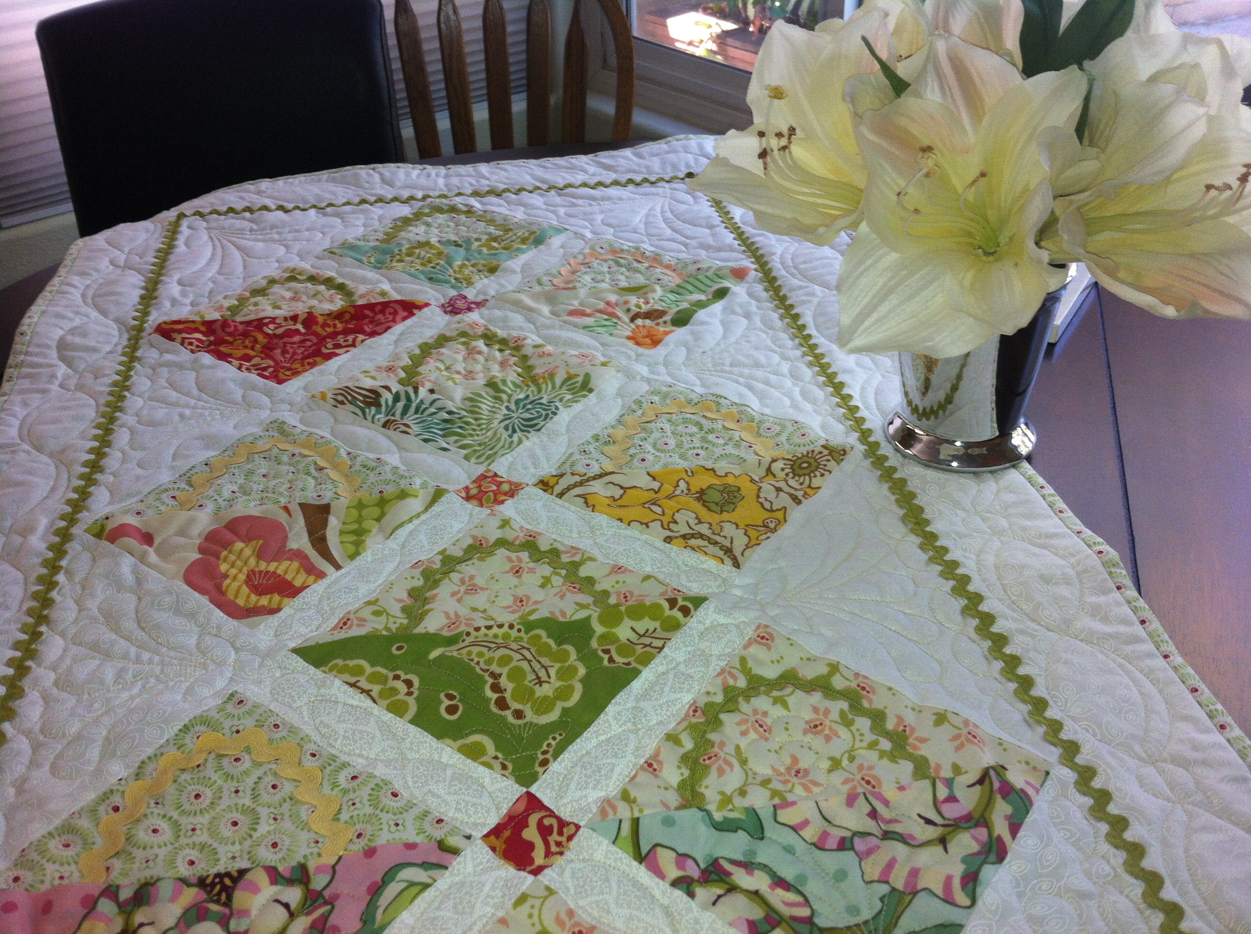
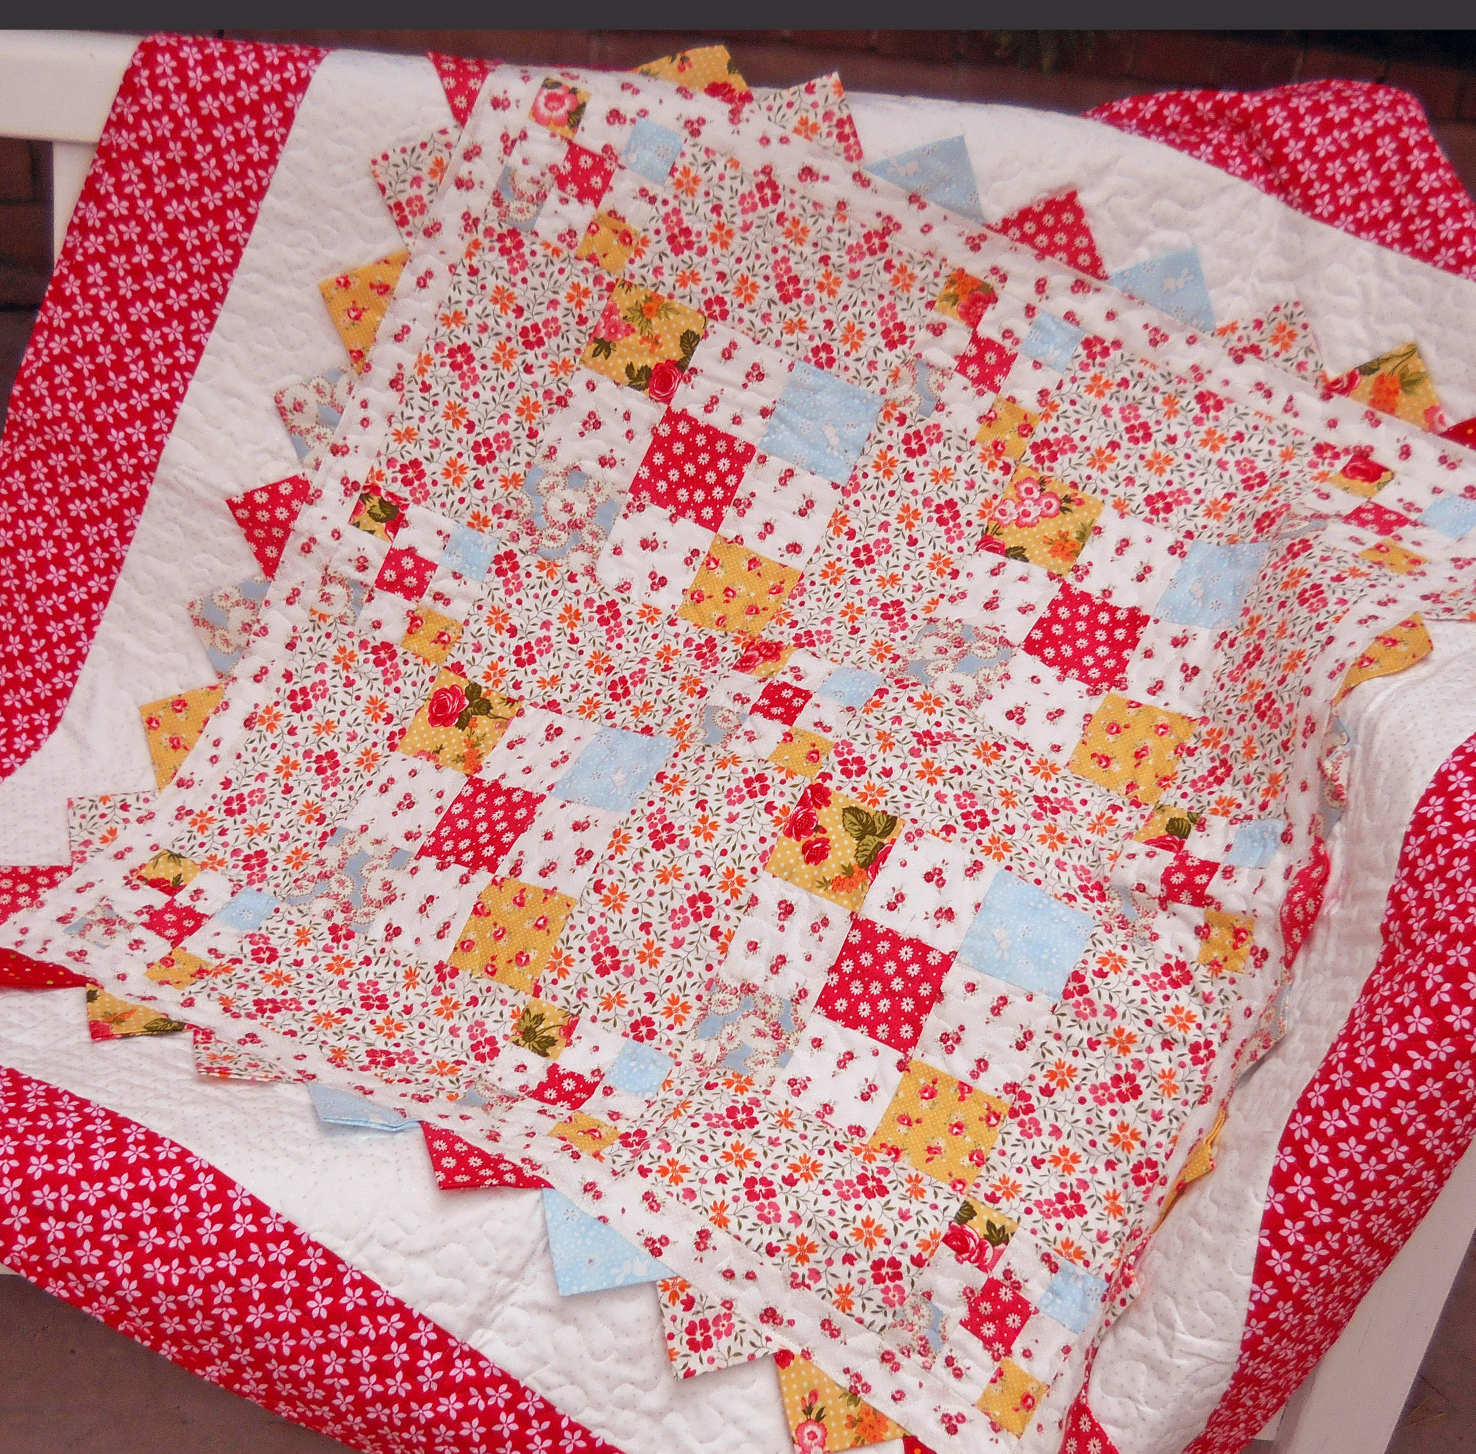
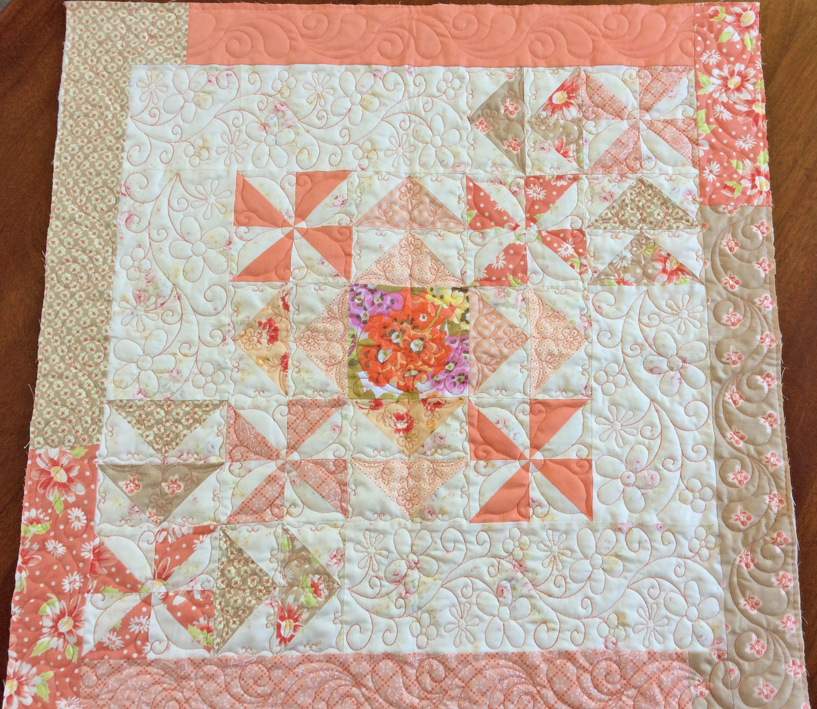
Katie Rose Basket Beauties Runner Cosmo Charms
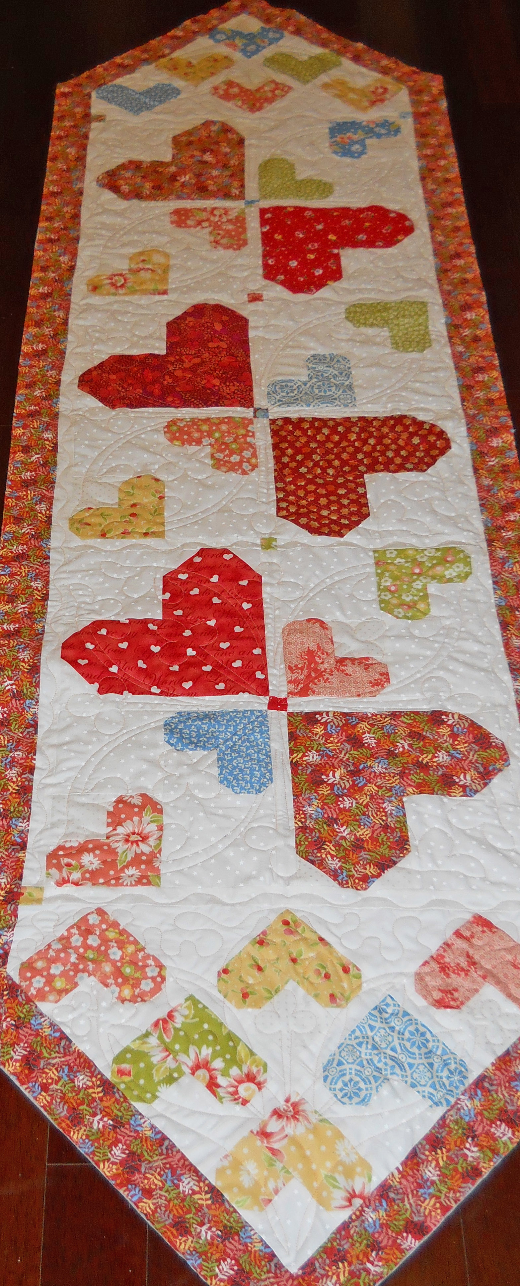
Mini Four Square Dresden Pillow/Mat Random Runner
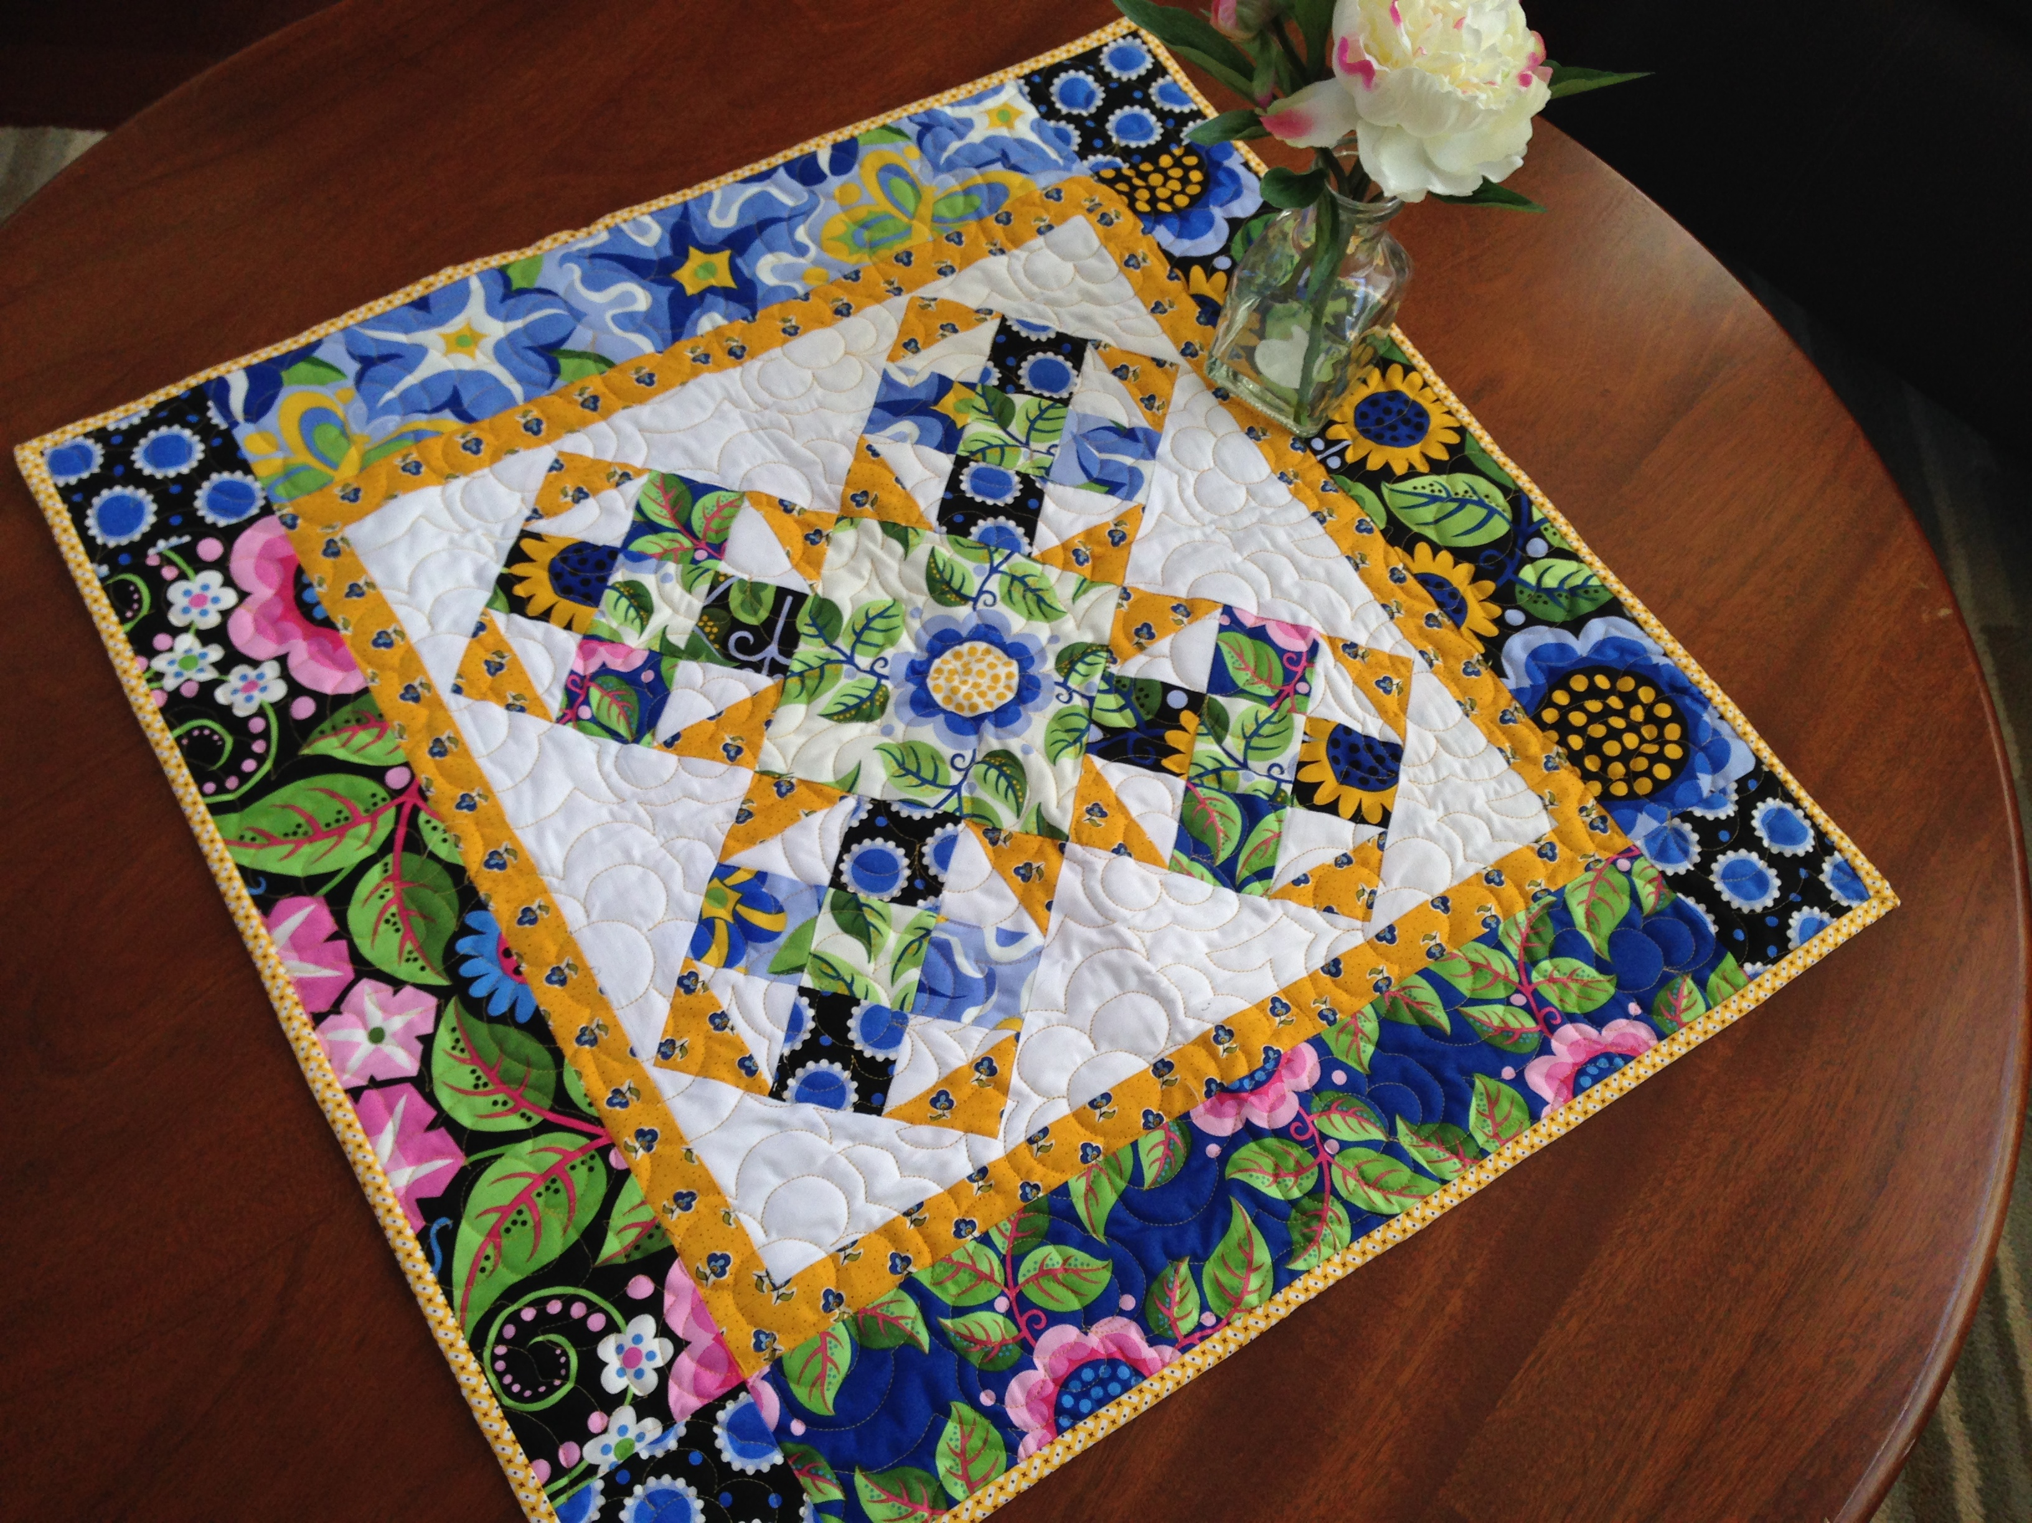
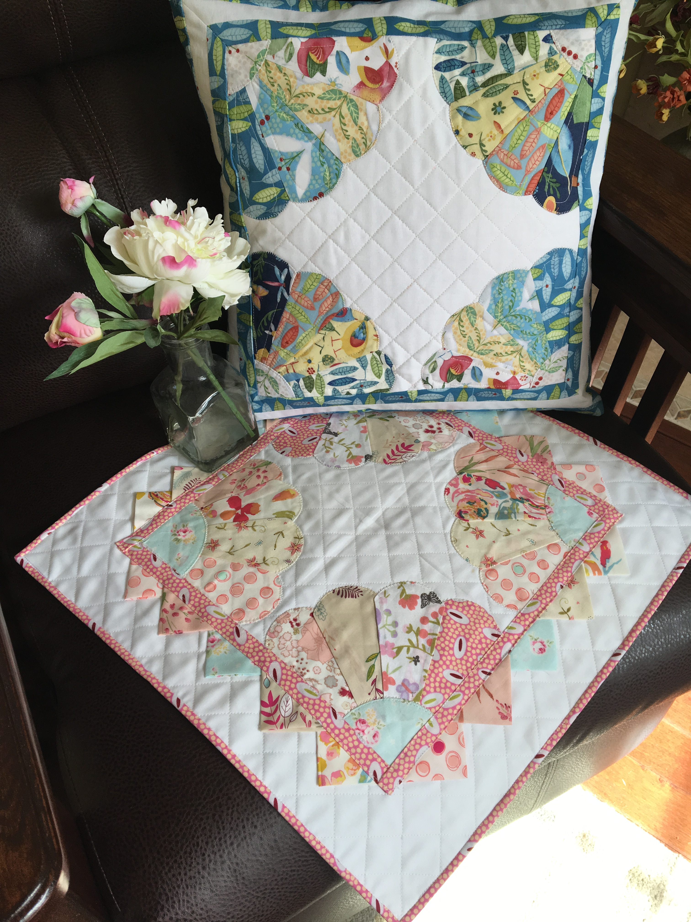

Visit my website page for Simplelady™ to see all my designs.
Speaking and Workshop – Bev Remillard 2016
www.ladylikedesigns.com
2. One day workshop – related to Color/Design Confidence lecture
From the following designs, please choose one for the group. In these workshops, I relate color values beyond the light, medium and dark and truly show how to use patterns and precuts in the quilt that they might never have thought of before. These projects are for intermediate quilter.
Workshop Fee: $400.00 8 Hours (Includes a lunch break)

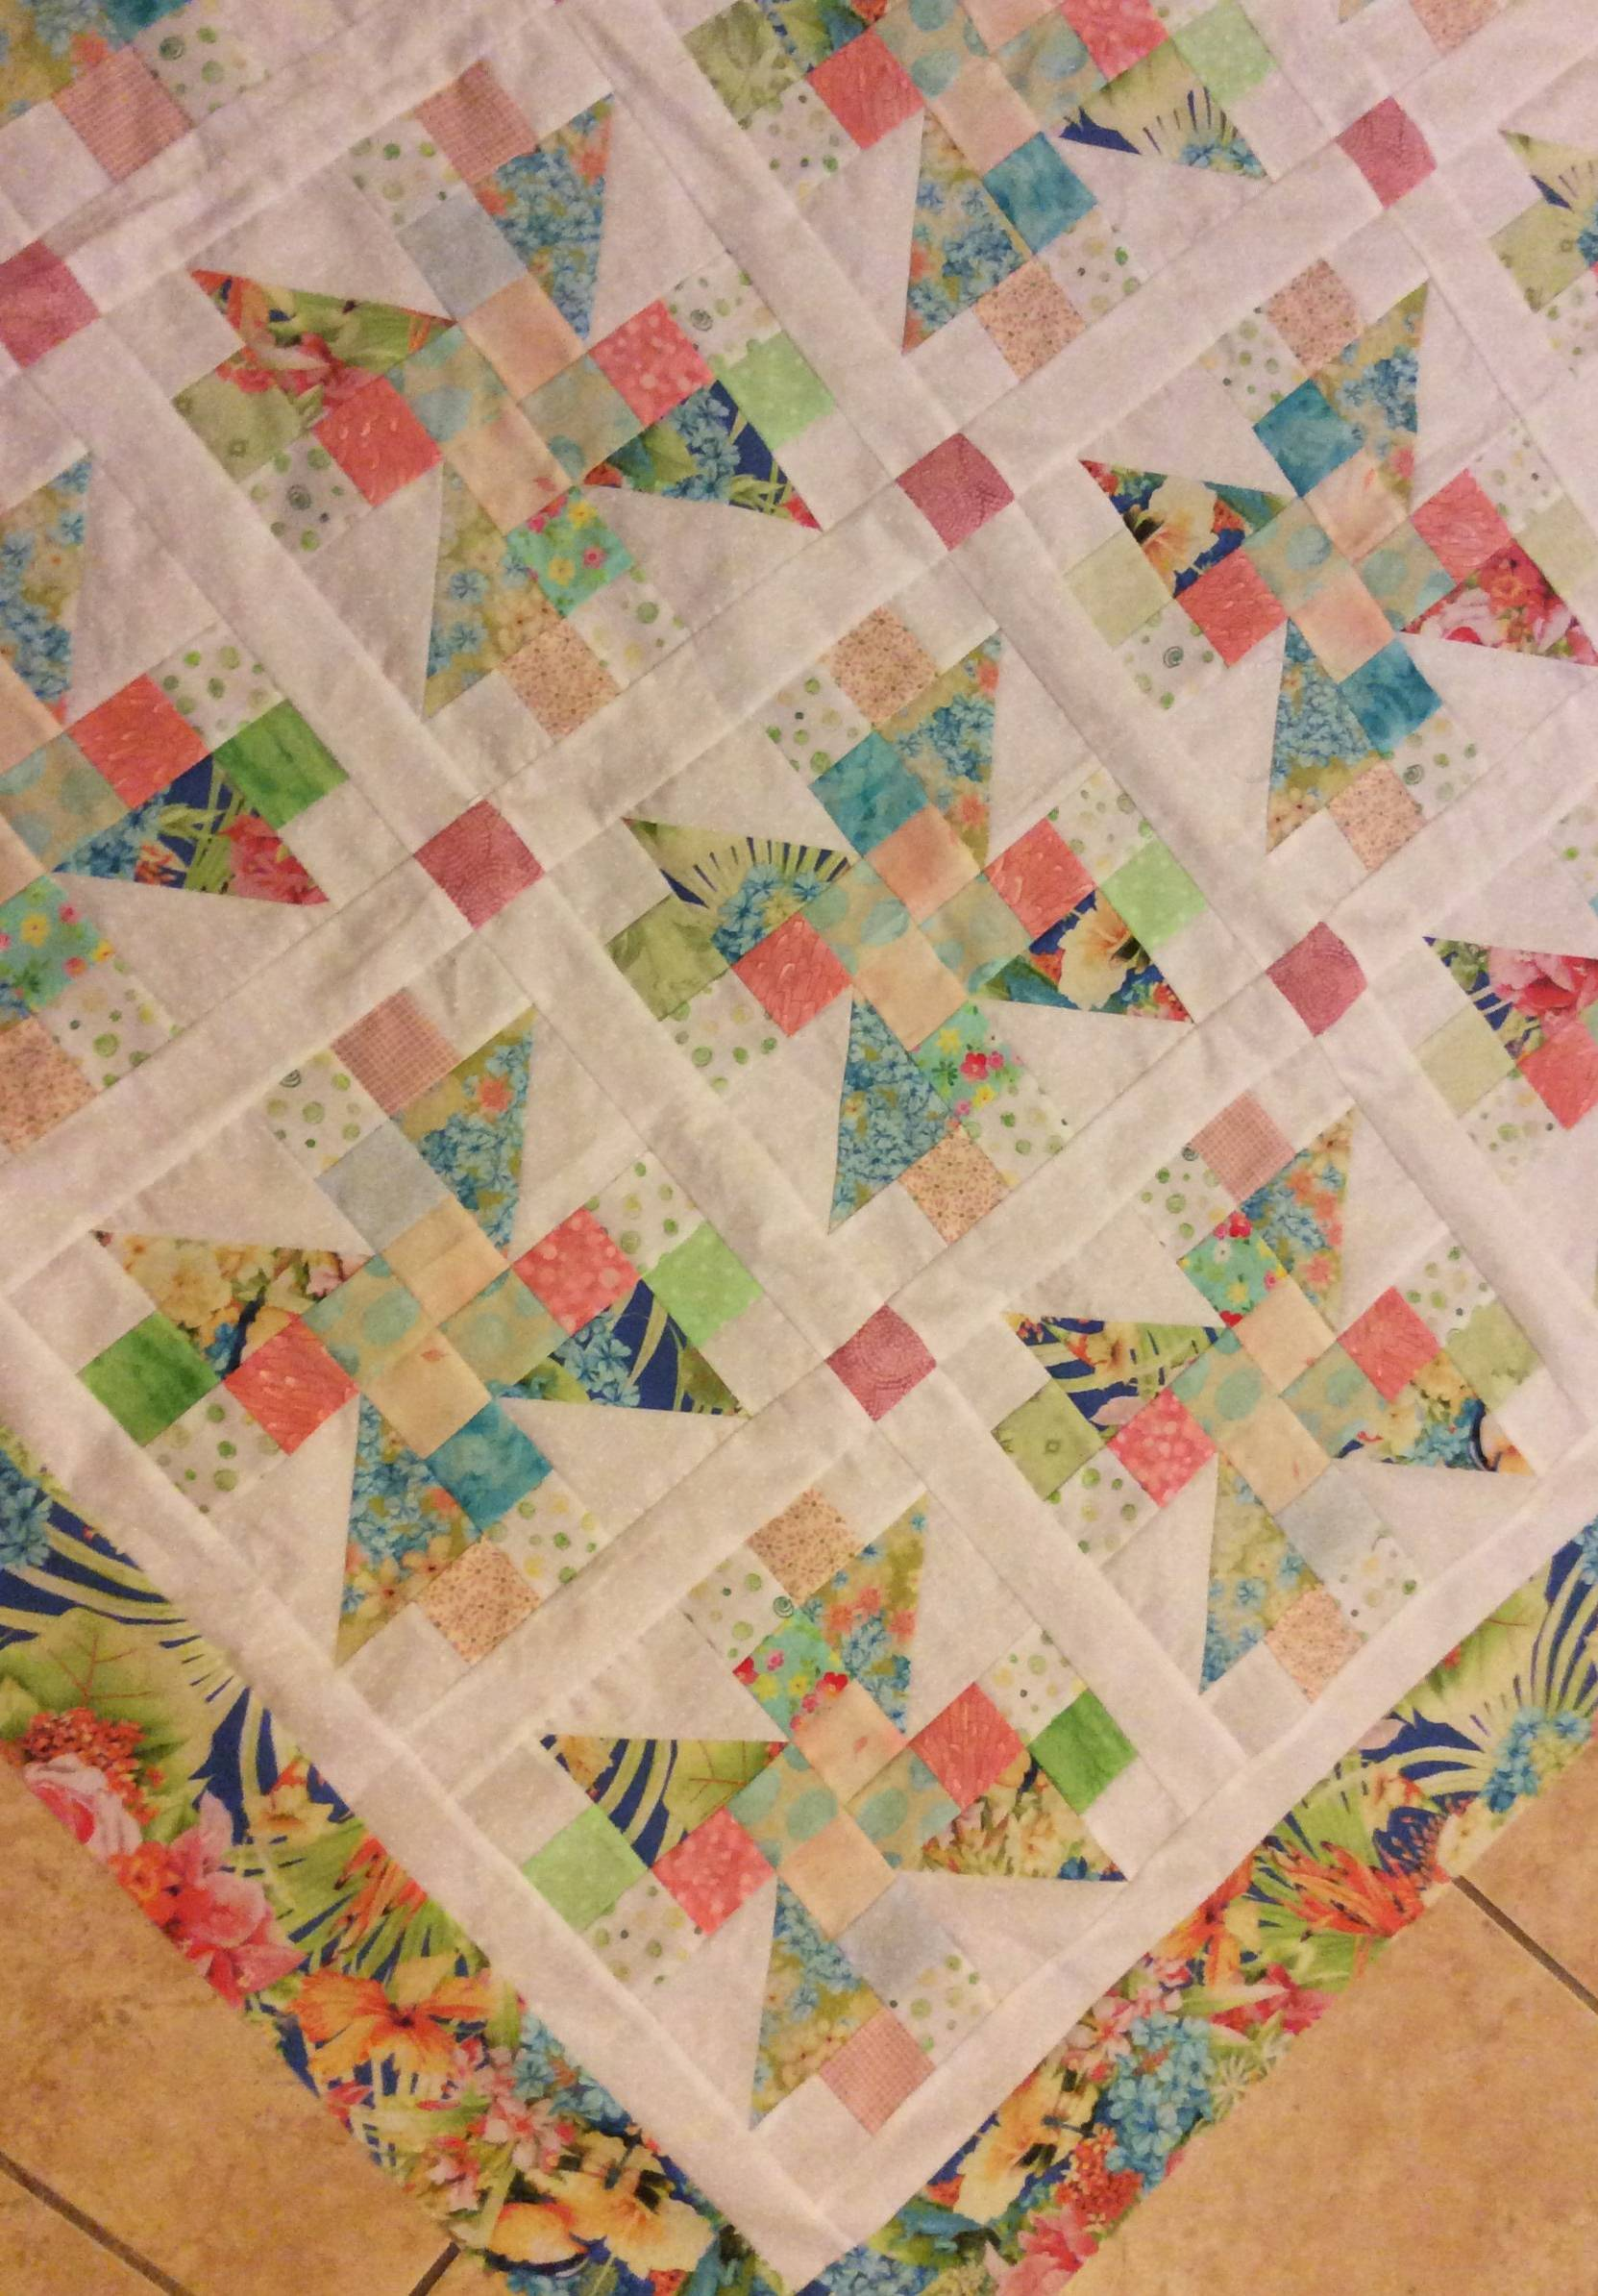
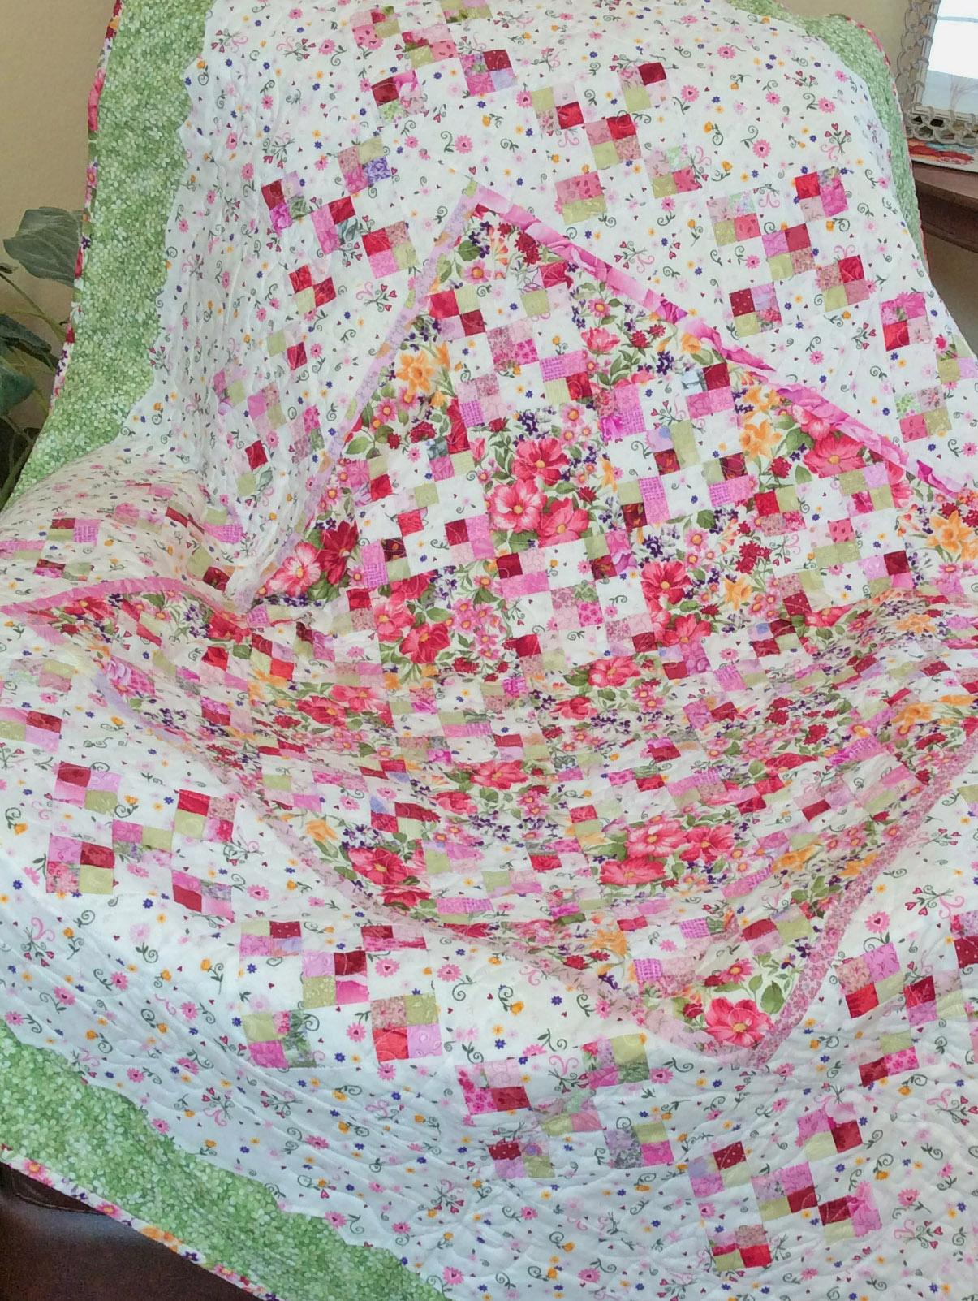

Cherry Delight French Swirl
Modern Candy Christmas Cake
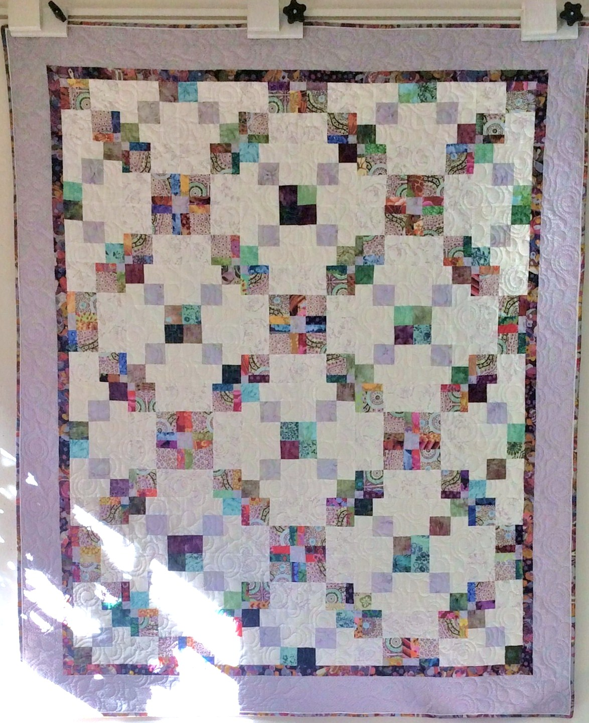
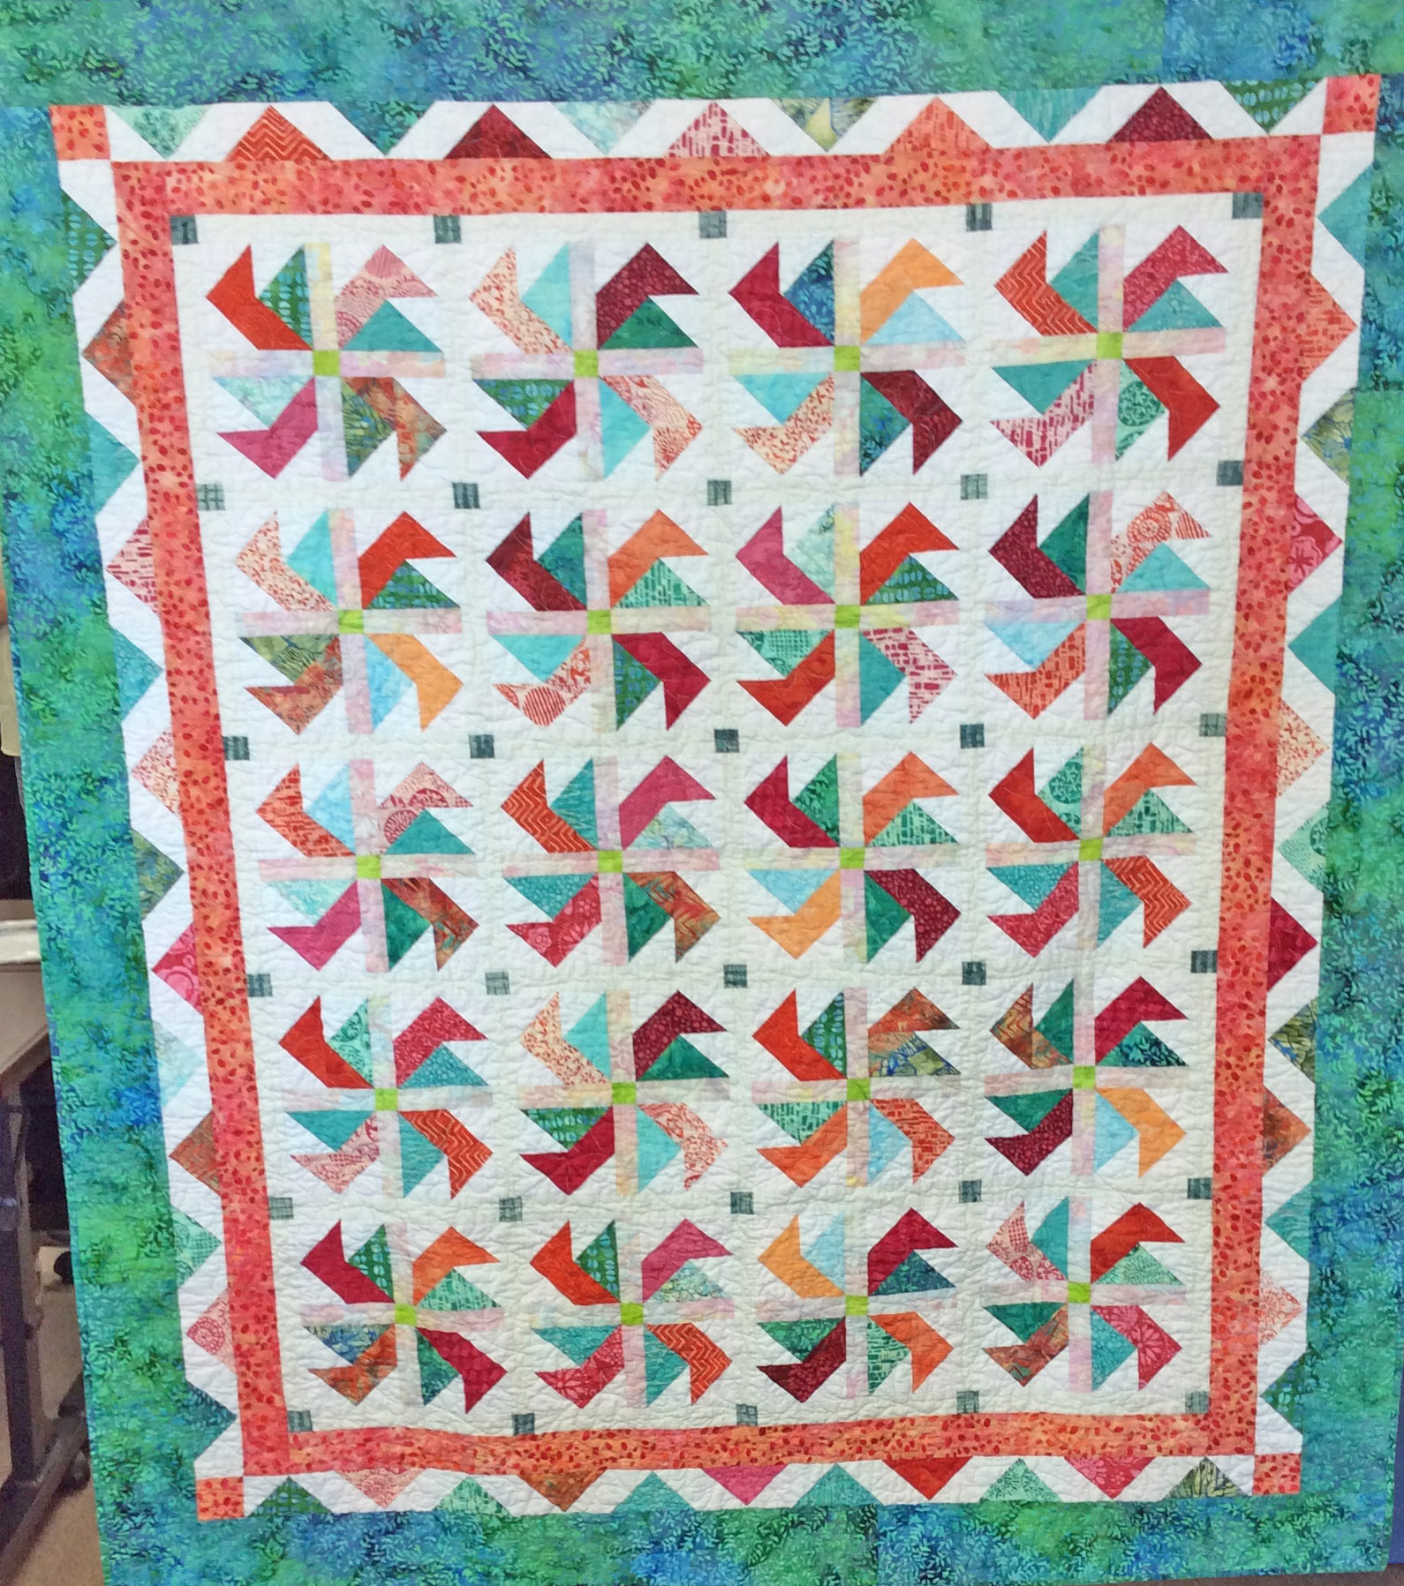

I look forward to coming to your guild meeting - Thank you,
Bev Remillard
bevquiltlady@aol.com
www.ladylikedesigns.com
Speaking and Workshop – Bev Remillard 2016

