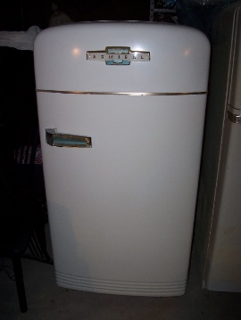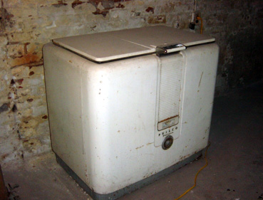
Refrigerator Recycling Program
This program is geared toward decreasing residential refrigeration loads through the removal and recycling of inefficient models. The Recycling Program is being offered for existing residential customers who are served by Brigham City Public Power. This plan will include landlords who own appliances in rental properties as well. The Refrigerator Recycling Program will be offered to qualifying citizens of Brigham City until funding for the program is exhausted.
Customers will receive a $20.00 incentive check to discontinue use of their working second refrigerators and/or freezers or to replace their working primary refrigerator and freezer with new, more energy efficient models. To qualify for the Refrigerator Recycling Program customers must allow the removal of their existing appliances for recycling. All appliances must be plugged in and working. Size of the appliance is a minimum of 10 cubic feet (utilizing inside measurements).
To ensure that appliances are not resold on the secondary market, any citizen requesting to participate in the Refrigerator Recycling Program will have to agree to collection and removal by Bell X101. This incentive will be available on a maximum of two appliances per qualifying household. All checks will be mailed within 30 days of the appliance collection date.

