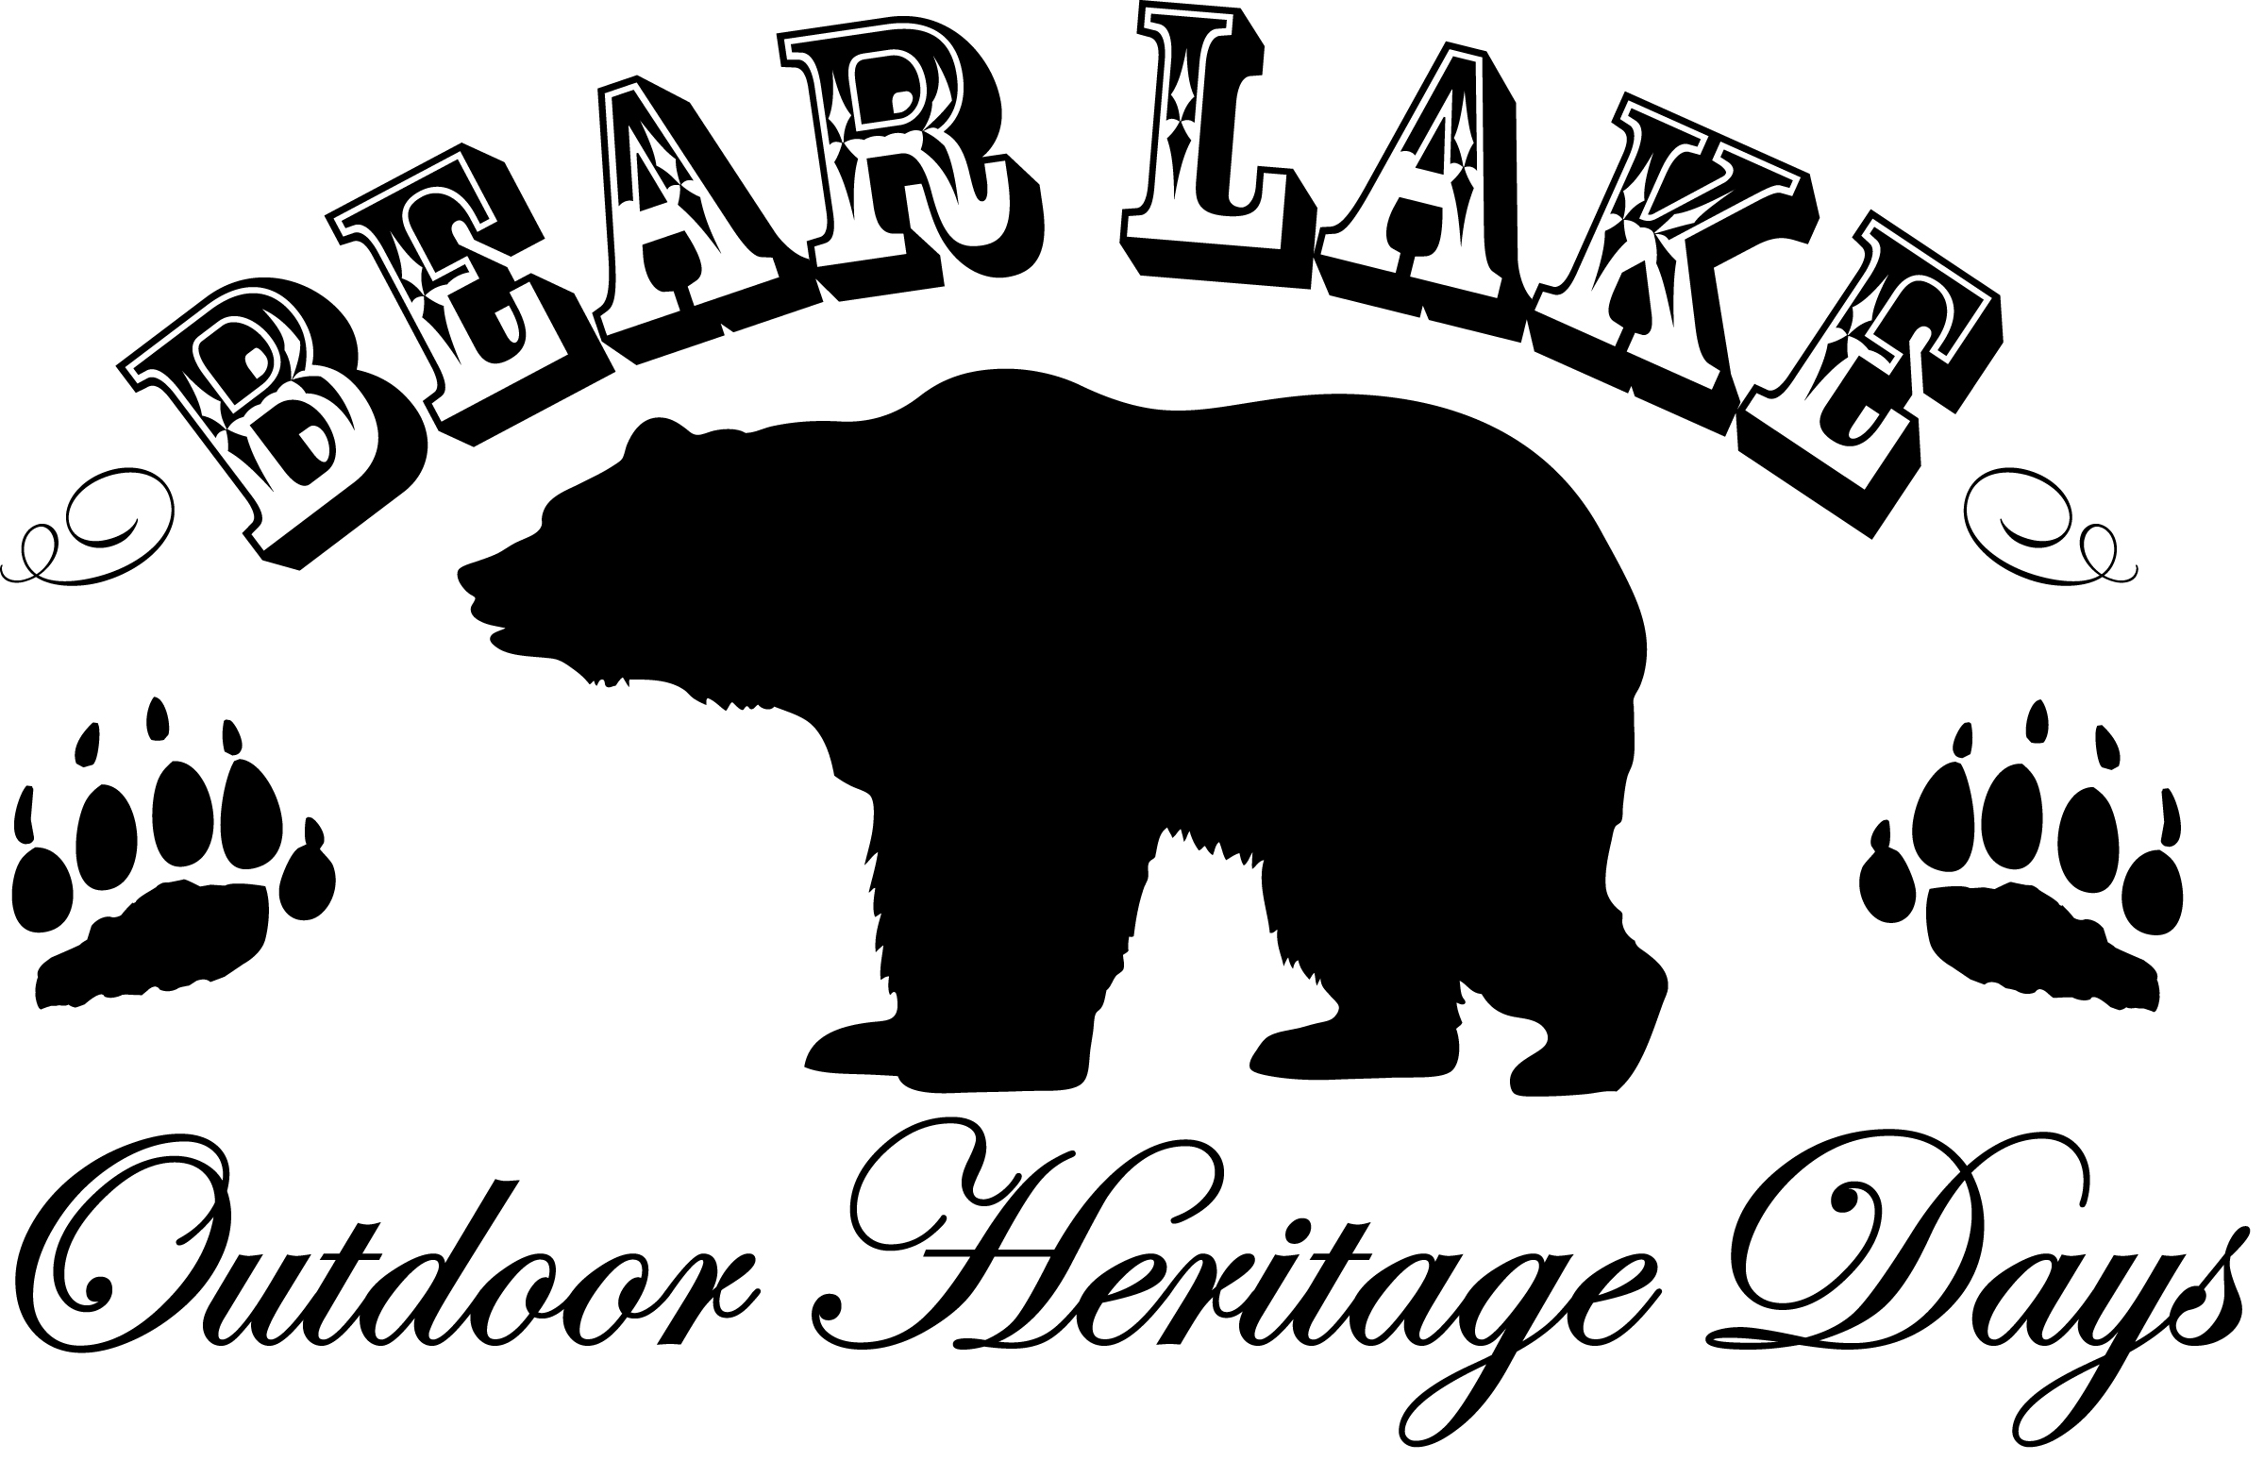
September 8, 2012 Garden City Office Complex
10AM: Candy Cannon
All Day Activities!
Old Time Photos
Gun Display
Poaching Trailer
Live & Silent Auctions
Prize Giveaways
Kettle Corn, Cotton Candy
Root beer, Lemonade

10AM – 5:30PM: Fishing Derby Catch a tagged fish in the Garden community pond and win a prize!
10am – 1pm: Petting Zoo
10:30AM – 12pm: Kids Games Stick horse Race, 3 Legged Race, Gunny Sack Race!
11am: Fly Fish Cast
11am: Pie Eating Contest
12pm: Fish Catch Lady’s jump first, kids go next. Fry the fish you catch for lunch!
3pm: Team Flapjack Flip Grab a partner and practice flipping!
3:30pm: Chicken Splat! Tickets will be sold until event begins. Try and guess where the chicken will SPLAT!
3:30pm: Set-up for Dutch Oven Dessert Cook Off
4pm – 5PM: Tight Rope Walk Held at the Garden City fish pond. Can you make it across the pond??
5pm: Dutch Oven Dinner and Dutch Oven Dessert Live Auction during dinner!
6pm: Gun Raffle! Tickets available at local merchants now thru event day! Do not need to be present to win!

