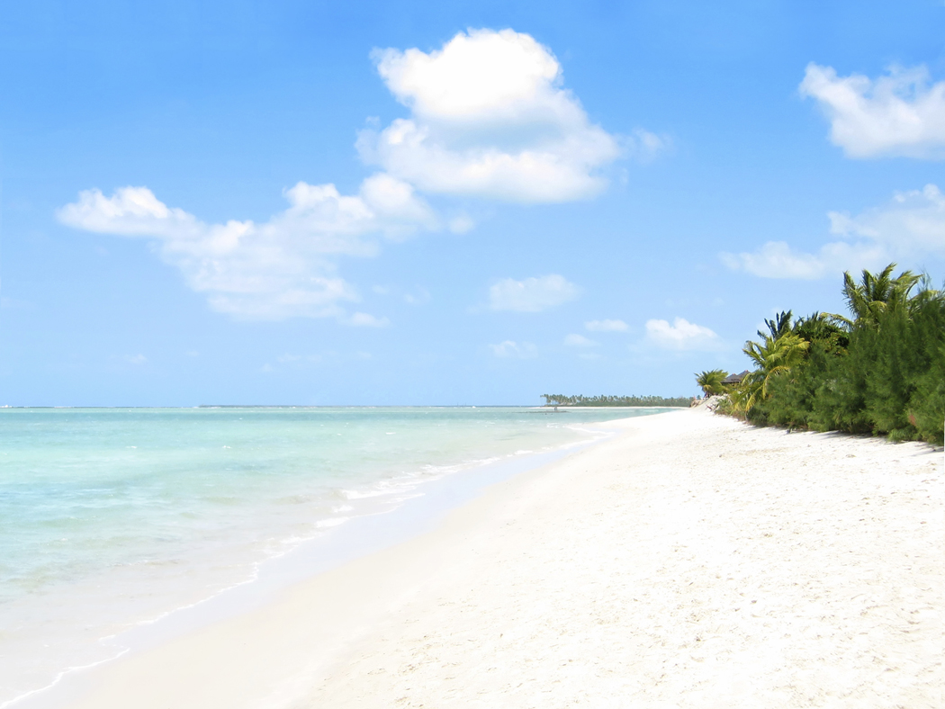
QUILTING ON THE BEACH® 2015 - RETREAT IN KONA, HAWAII!
Saturday, February 7, through Saturday, February 14, 2015
Our 6th annual winter quilt retreat will be held at the King Kamehameha Kona Beach Hotel (Courtyard by Marriott) – by the pier in Kailua-Kona and includes six days of special classes and lectures offered by national quilting instructors including Rob Appell, Pam Bocko, Barbara Bieraugel and other great instructors. Two bus trips are also available: (1) Big Island Tour on Saturday, February 7, with stops at the Cherry Blossom Festival in Waimea, visits to a Kona Coffee Plantation and a Macadamia nut farm, and a special luncheon. (2) Quilt Shop Hop Tour on Saturday, February 14 taking you all around the Big Island and stopping at all of our local Quilt Shops.
Come for the day or spend the week! Sew, learn, and meet quilters from around the world. Save the dates for what will be a quilter’s week to remember!
Organized and Hosted by: Quilt Passions Quilt & Needlework Store in Kailua-Kona, Hawaii.
Brochure available August 2014. Details also available at quiltpassions.net
Email: retreat@quiltpassions.net or call Quilt Passions at: (808) 329-7475
***7TH Annual Big Island Quilt Shop Hop – February 2015***
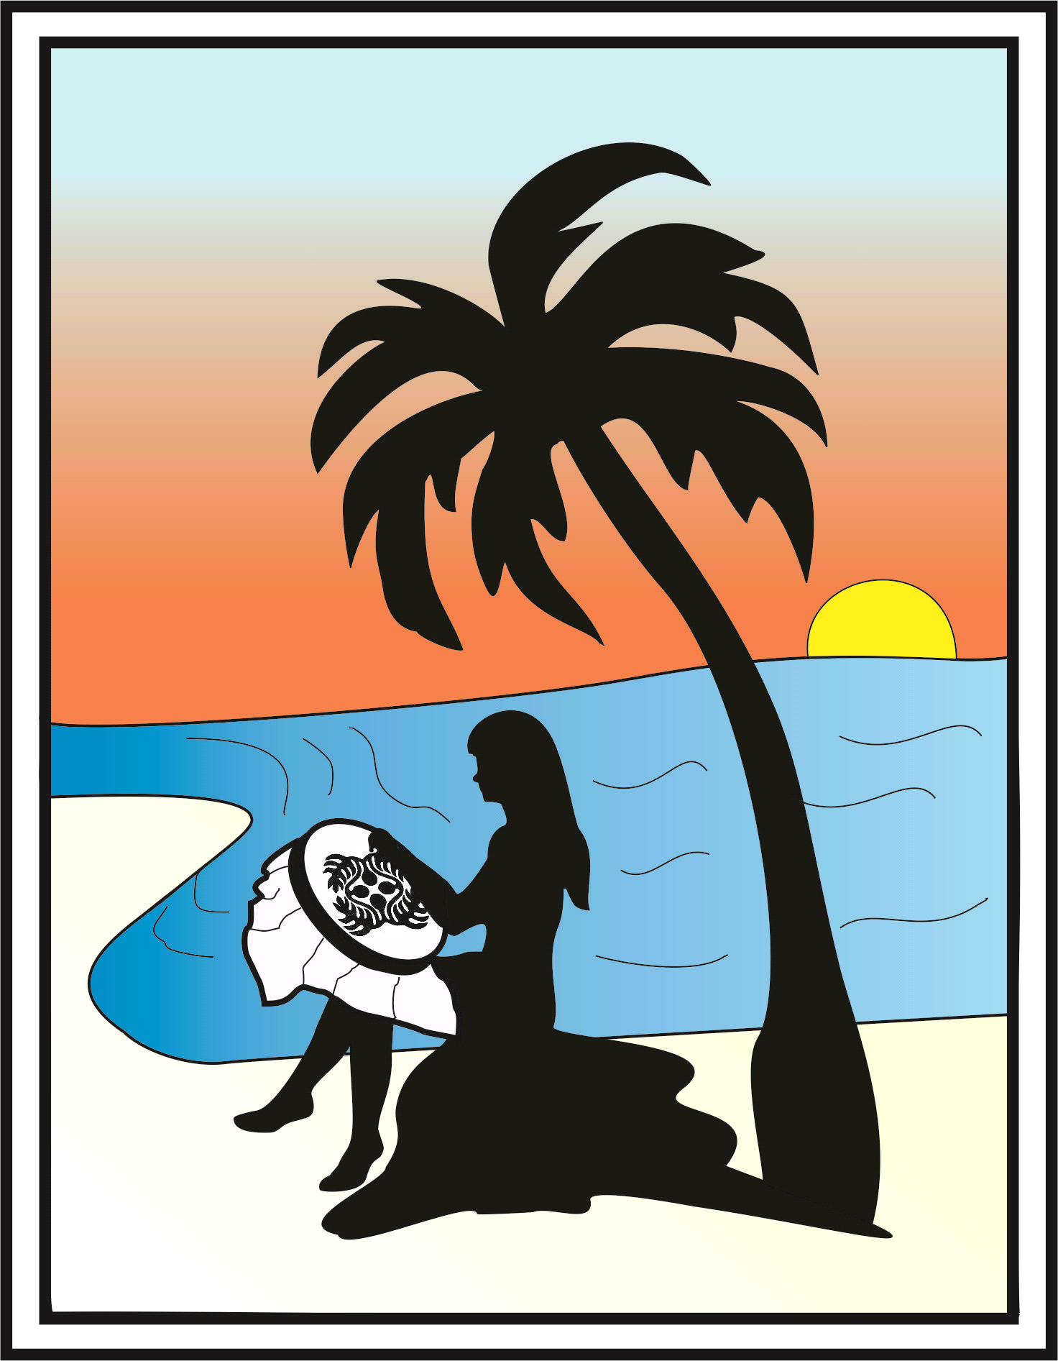
QUILTING ON THE BEACH® 2015 - RETREAT IN KONA, HAWAII!
Saturday, February 7, through Saturday, February 14, 2015
Our 6th annual winter quilt retreat will be held at the King Kamehameha Kona Beach Hotel (Courtyard by Marriott) – by the pier in Kailua-Kona and includes six days of special classes and lectures offered by national quilting instructors including Rob Appell, Pam Bocko, Barbara Bieraugel and other great instructors. Two bus trips are also available: (1) Big Island Tour on Saturday, February 7, with stops at the Cherry Blossom Festival in Waimea, visits to a Kona Coffee Plantation and a Macadamia nut farm, and a special luncheon. (2) Quilt Shop Hop Tour on Saturday, February 14 taking you all around the Big Island and stopping at all of our local Quilt Shops.
Come for the day or spend the week! Sew, learn, and meet quilters from around the world. Save the dates for what will be a quilter’s week to remember!
Organized and Hosted by: Quilt Passions Quilt & Needlework Store in Kailua-Kona, Hawaii.
Brochure available August 2014. Details also available at quiltpassions.net
Email: retreat@quiltpassions.net or call Quilt Passions at: (808) 329-7475
***7TH Annual Big Island Quilt Shop Hop – February 2015***

