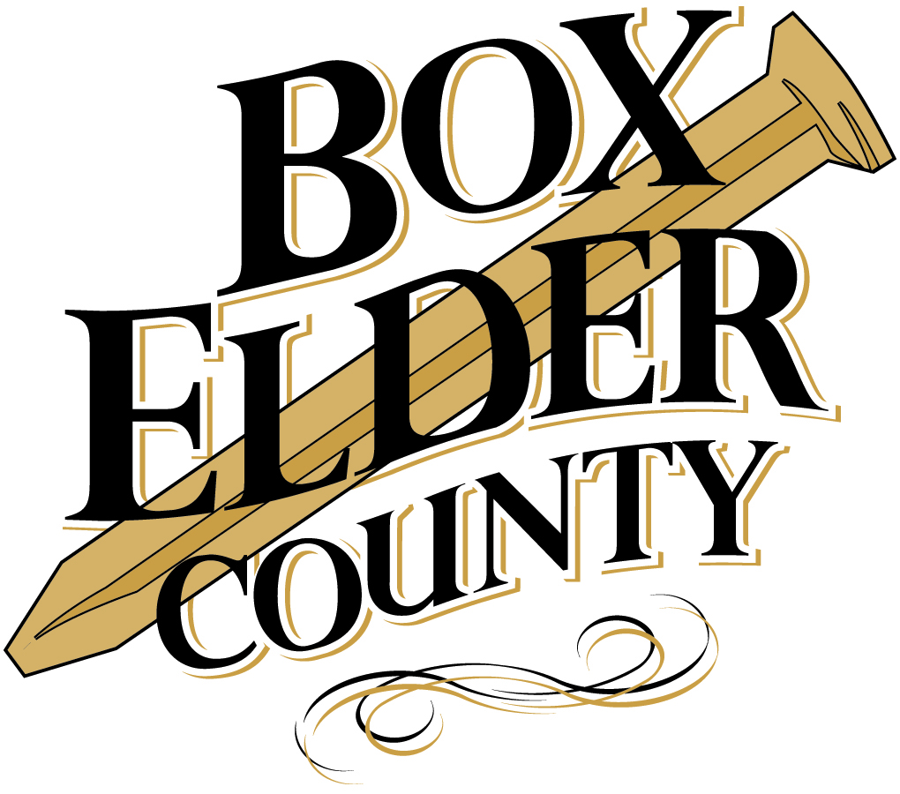

Box Elder County
Tourism Tax Advisory Board
2016 Grant Packet
***Grants are due February 29, 2016, 5:00 pm***

Packet Includes:

- Tourism Development Fund Policy
- Tourism Tax Advisory Board Mission Statement, Goals and Objectives
- State of Utah TRCC Tax Code
- Grant Application

Grant Checklist:

- Please submit applications electronically to: tourism@boxelder.org
- Applications may instead be submitted in person. Please include one copy of the completed grant application in the following manner:
  - Paper clipped, not stapled.
  - No binders, folders, notebooks required.
  - If submitting pictures, please scan them to 8.5 X 11 paper
  - If submitting odd sized information, such as blueprints, drawings, etc., please scan them to 8.5 X 11paper
- Please submit to:

Box Elder County Tourism Office
01 South Main
Brigham City Utah 84302
435-734-3315
tourism@boxelder.org

Box Elder County Tourism Tax Advisory Board

Tourism Development Fund Policy
Mission. The mission of the Box Elder County Tourism Tax Advisory Board (TTAB) is to encourage tourism promotion to advance sustainable economic development. The Board will work with other tourism-related entities on projects to improve existing tourism products or initiate new ones. The projects should follow the Mission and Goals of the Advisory Board. The Mission and Goals are found in the grant packet.

The TTAB Tourism Development Fund is available to assist tourism projects, to include: events, activities, festivals, conference, or programs, as well as aid in infrastructure projects that directly benefit tourism. This fund is not guaranteed year-to-year. The applicants are encouraged to work toward becoming self-sustaining.

Purpose. The Box Elder County Tourism Tax Advisory Board shall, at its annual budget meeting, allocate a set amount of its budget as a “Tourism Development Fund” for tourism development by organizations developing projects in the Box Elder County area. The Tourism Development fund has the following purpose:
- To increase tourism in Box Elder County
- To assist new tourism projects
- To help organizations develop new tourism projects
- To increase the advertising exposure of Box Elder County outside of the County
- To involve more people and organizations in tourism promotion

Eligibility. Tourism Development Funds are available organizations that promote tourism-related attractions, events, festivals, or programs. These events should encourage overnight stays in Box Elder County with immediate impact on the tourism economy.

Tourism Development Funds are derived from restaurant and hotel taxes and may only be used for the purpose of promoting recreation and tourism.

Application Policy. Please read this section BEFORE submitting your application. Requests for funds will be approved under the following conditions:
- The proposed attraction, event, activity, festival or program must relate directly to the priorities of the TTAB mission statement and goals.
- The funds may not be used for salary or wages.
- The funds may be used for direct mail only if it can be documented and is going to be sent outside Box Elder County.
- It is encouraged that promotional funds be spent outside Box Elder County. Promotional activities are expected to encourage tourists to spend the night in Box Elder County.
- Any printed material must be included with the application and reviewed by the Advisory Board prior to printing. If the Advisory Board does not review printed material, funding will not be granted. Printed materials must include the Box Elder County Tax Advisory Board logo and the words: “Funded by the Box Elder County Tax Advisory Board.
- A follow up report must be submitted within sixty (60) days following the completion of the project.

Application Procedure
- Fill out the attached application, complete with an attached detailed description of the project, its purpose, strategies, and actions, and how this project ties into the TTAB mission and goals. Include any pictures you feel will be helpful.
- Make sure the application is signed and dated by a representative of the organization. Applications will be stamped with the date they are received at the TTAB office
- Application deadline: February 29, 2016, 5:00 pm. The application must be received at the TTAB office no later than February 29, 2016. A postmark of February 29, 2016 will not be accepted. Applications may be hand-delivered to the TTAB office at 01 South Main, Brigham City, UT 84302, Rooms 20 or 24.
- Applications will be screened by the Box Elder County Tourism Tax Advisory Board and recommendations made to the Box Elder County Commission.
- Successful applicants will be notified in April, 2016.

Primary consideration will be given to those who strive for the following criteria:
- Does the project meet the intent and requirements of the State statute? (mandatory requirement)
- Does it benefit tourism in the area, especially overnight visitors and what is the immediate impact?
- What is the likelihood of successful completion and what is the experience of the project manager?
- What is the availability of other sources of funding and/or the ability to leverage grant funds?
- What is the potential for the project to generate more dollars for the fund in the future?

Payment of Tourism Development Fund. Once funding has been approved, the applicant must follow the proper steps in order to be considered for future grants. If these steps are not followed, funding will not be granted in the future.
- Payment will be made based on agreement specified in grant award.
- A follow up report must be completed within sixty (60) days after project completion. The report must contain the following:
  - Appropriate documentation of completed work and execution of final payments to include copies of invoices or checks for service rendered. All documents must be received sixty (60) days after completion of project. All matching funds must be accounted for as well
  - A written evaluation report documenting the event and success of project. Please include who the audience was, number of attendees, etc.
For questions, please call the office at 435-734-3315.
Tourism Tax Advisory Board Mission Statement

The mission of the Box Elder County Tourism Tax Advisory Board is to develop criteria and an application process that will assist the fair evaluation of all requests for tourism enhancement. Such enhancement is that which best reflects and affects the recreation, heritage, cultural and scenic wonders of the whole county. The process is to encourage coordination of all tourism promotion and strategies commensurate with tax revenue to advance sustainable economic development. The Board will then make recommendations to the Box Elder County Commission for allocation of funds. This constitutes all taxes enacted by the Utah State Legislature and Box Elder County relating to tourism.

The criteria & application process must be in compliance with the purpose of the Tourism, Recreation, Cultural, and Convention (TRCC) Tax in Utah Code Annotated Title 59, chapter 12, section 601.

Goals and Objectives

1. Increase visitor numbers, trip duration and visitor sales by promoting Box Elder County as an all-season tourism destination.

2. To create awareness of Box Elder County as a refuge or oasis for peace, tranquility, and serenity that will leave visitors feeling refreshed, rejuvenated and inspired.

3. Be an advocate of the tourism industry and represent the best interests of Box Elder County on issues of public interest and policy.

4. Build the credibility of the tourism industry as an important force in the region’s economy and vitality of life by educating the government, business, labor and professional communities.

5. Pursue relationships with organizations and tourism providers that foster mutual goals, provide cooperative marketing and funding mechanisms, and offer partnership opportunities to increase tourism to Box Elder County.

6. Provide quality, timely, up-to-date information to those seeking tourism information on Box Elder County by telephone, internet, mail or in person. Collect tourism data to assist with market analysis and research.

7. Encourage and assist new and appropriate tourism developments or events to Box Elder County. Help existing community events expand their market outside Box Elder County.

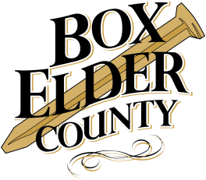

Box Elder County Tourism Tax Advisory Board

2016 Tourism Development Application

Contact Information
Organization Name
Name of Applicant
Address
City ST ZIP Code
Phone
Cell Phone
E-Mail Address

Project Narrative
Project Title
Describe your project, event, activity, or attraction:

How will your project, event, activity, or attraction increase tourism to Box Elder County:

Project Starting Date
Project Ending Date

Demographics
Identify your target market(s):
Age(s): 1-18 19-30 31-50 50-65 65 or older
Gender(s) Male Female
Where from: Box Elder County In-State_________ Out of State _________
Expected attendance: _________

Promotion
How do you plan to advertise and promote your project, event, activity, or attraction? How many brochures, posters, etc. will be printed and how will you distribute them? Will your ad run in the newspaper or on radio or television? How often?
Is this project a: One-time event? Annual event?

Budget
Please attach a budget for your project or fill in the information below. Please note documentation of expenditures will be required at the end of the project. The more specific you can be the better. Include copies of estimates, letters of support for in-kind work to be done, etc. The TTAB Board likes detail!

Project Expenditures (please list)

____________________________________ $_________________
____________________________________ $_________________
____________________________________ $_________________
____________________________________ $_________________
____________________________________ $_________________
Total Project Cost $_________________

Project revenue to apply to project (please list all including in-kind amounts, other grants, cash, etc.)

____________________________________ $_________________
____________________________________ $_________________
____________________________________ $_________________
____________________________________ $_________________
____________________________________ $_________________
Total Box Elder County Tourism Tax Advisory Funds Requested $_________________
Total Revenue for Project $_________________

Evaluation
How will you measure the success of your project, event, activity or attraction?

What is the expected economic impact of your project, event, activity, or attraction?
Number of participants spending the night in Box Elder County: _______________________
Number of nights they will be staying in Box Elder County: ______________________
Number of motel/hotel rooms booked in Box Elder County: ______________________

Previous Grant Awards
Have you received TTAB grants in the past? If so, was project completed successfully? Was a follow-up evaluation submitted to Box Elder County? Do you have any outstanding grant projects? What is the expected completion date?

