Figure Flattering Quiltwear
Two Methods for making a custom fit “Not Quite a Sweatshirt Jacket”.

Method I:
Fall Coat was made using method I

Supplies:
2 sweatshirts (pre-washed) with set in sleeves (not raglan sleeves)
Simple 3 piece shawl collar jacket pattern that fits you.
(We used the Figure Flattering Quiltwear
Wild & Scrappy Shawl collared jacket pattern)

Buy sweatshirt to fit your largest body part. On first sweatshirt remove all bindings. Remove sleeves and cut across shoulders. Cut straight up center front. See figure A. For this method I like Gildan sweatshirts, they run larger, longer and wider in the hip. For a heavier shirt get the 100% cotton, for a lighter weight buy the 50-50 blend.

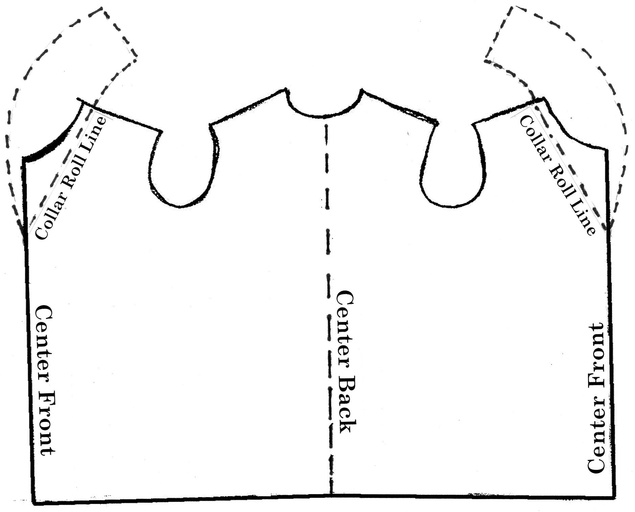
Figure A

- Pattern: Pin jacket pattern front to jacket pattern back at the side seams, pin at underarm seam and at side hem, on seam line. Add tissue to bottom of pattern to add length to jacket as desired.
- Add to length of sweatshirt body. Cut second sweatshirt straight across beneath armholes. Also cut up center front line. Matching center fronts, but horizontal edge together with the first sweatshirt hem and zig-zag edge. This will add length to your coat.
- Shawl Collar: using remaining scraps from second sweatshirt, add onto first sweatshirt base to accommodate shawl collar pattern.
- Fold Sweatshirt base along center back.

- Place pattern center back seam line on sweatshirt fold, aligning armholes. Rough cut with extra ½” all the way around pattern. (Center front should be parallel with straight of grain.)
Note: If armholes do not line up, then place pattern onto sweatshirt aligning armholes. Cut up center back including a seam allowance.
- Trim seam allowance off center back seam, but edges together and zig-zag. If your pattern has a curved center back seam, straighten it out before cutting. Finished piece should look like Figure A above.
- Rough cut sleeves per your jacket pattern.
- Apply fabrics to the base sweatshirt and sleeves, be sure to apply fabrics to both sides of shawl collar going at least 2” past the roll line on shawl collar. Quilt as desired.
- Lay pattern onto quilted pieces and cut out, this is the final cut.
- Sew Shoulder seams and sew in sleeves, using ½” seam allowance.
- Adjust length as needed and bind all raw edges as you would for a quilt.

Method II:

Supplies:
2 yards medium weight fleece or sweatshirt yardage.
Simple 3 piece shawl collar jacket pattern that fits you.
(We used the Wild & Scrappy Shawl collared jacket pattern for this coat)

- Pattern: Pin pattern front to pattern back at the side seams, pin at underarm seam and at side hem, on seam line. Add tissue to bottom of pattern to add length to jacket as desired.
See Figure A above.
- Lay jacket pattern out on fleece and trace around pattern pieces both body and two sleeves. Note: Remember to flip the body right to left as if you were placing the center back seam line on a fold. See Figure A.
- Apply fabrics to the base sweatshirt and sleeves, be sure to apply fabrics to both sides of shawl collar going at least 2” past the roll line on shawl collar. Quilt as desired.
(You may machine quilt or long-arm here)
- Lay pattern pieces back onto fleece, trace and cut out.
- Assemble jacket.
Note: remember seam allowances? Sometimes I cut off seam allowances for side and center back seams. I then but the edges together and zig-zag or flatlock serge the edges together. This helps to cut down on the bulk. However I ALWAYS sew armhole seams with a normal seam allowance. You may then zig-zag or serge the edge of the armhole seam. This adds to the tailored shape of the set in sleeve.

You will look great in a garment made with either method. The idea is to get a good fit on the shoulders and across the bust line. No football player shoulders here.

Happy Quilting!

