

Lone Star Quiltworks 8th Anniversary
Can you believe it? We have made it 8 years! Come and help us celebrate with week long deals including select $8.00 per yard fabric!

Visit us each day, Tuesday, May 21st through Saturday, May 25th and receive a free star pattern for a 12" block. Put all five stars together and you will have a small wall hanging or table runner. Take a look at our sample using of course, maroon and white!
We would like to thank you for helping us grow our business over the last eight years. You are not only our customers but our friends as well !

  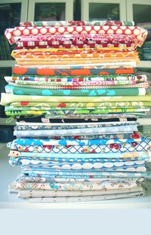
  Join our celebration with select fabrics priced at $8.00 per yard with a one yard minimum cut.
  Pass the word, tell all your friends and come join the fun!
  Need your sewing machine cleaned? Armando, the Machine Whisperer, will be helping us celebrate our anniversary by visiting on May 21st. Please call the shop for info regarding dropping off your machine.
  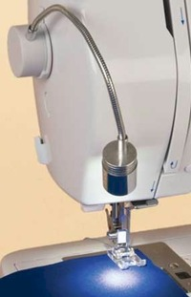
  Our absolute best selling notion the Bendable Bright Light will be on sale at 8% off with a preorder. Can't see your sewing at the machine? Illuminate your world with this wonderful notion.
  Terry A. Skrabanek
  Lone Star Quiltworks
  4301A S Texas Ave
  Bryan, TX 77802
  979 595 1072
  www.lonestarquiltworks.com
  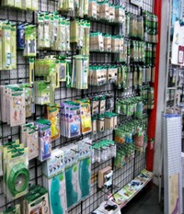
  Stop by each day during the week for 8% off of one notion per day! Limit 5 per customer per week.
  Facebook
  Like us on our Facebook page to receive the latest shop info!

