Worldwide Quilting Day at Lone Star Quiltworks

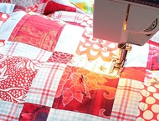
Come join us as we celebrate Worldwide Quilting Day! We will be having an Open Sew on Saturday, March 16th from 10A-2P Cookies and lemonade will be provided. Bring your favorite project to work on. Please RSVP to the number listed below.

  Save the date #1
  
  Connie Watkins will be starting a six part needle turn applique class on Tuesdays from 10A-Noon. Dates will be 4/9, 4/30, 5/7, 5/14,6/4, and 6/18.
  Yum Yum!
  
  Terry will bake some yummy, yummy cookies and have fresh lemonade for Worldwide Quilting Day. Come and join us for some demo fun!
  Save the date #2
  
  Rose Ann Cook will be visiting Friday, April 19th and 20th for a book signing and trunk show. Details for a wine and cheese party to follow!

  Baby Lock Ellisimo!
  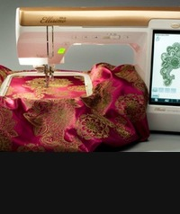
  Come see what this top of the line sewing/embroidery/quilting machine for Baby Lock can do. We will have this amazing machine set up for Worldwide Quilting Day.
  Clover Desk Needle Threader!
  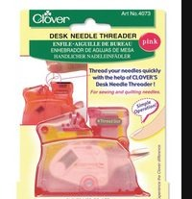
  Having trouble threading that needle are you? Watch us demo the Clover Desk Jet Needle Threader. You will be AMAZED at how your life will be improved. 15% off during the month of March :)
  Baby Lock Evolution!
  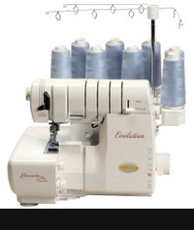
  Baby Lock's absolute best eight thread serger will be showing off her attributes this Saturday. Wondering what a serger can do? Stop by and take a look.

Terry A. Skrabanek
Lone Star Quiltworks
4301A S Texas Ave
Bryan, TX 77802
979 595 1072
www.lonestarquiltworks.com

Facebook
Please help us grow our Facebook page by "liking" us at
http://www.facebook.com/pages/Lone-Star-Quiltworks/188471957876182

