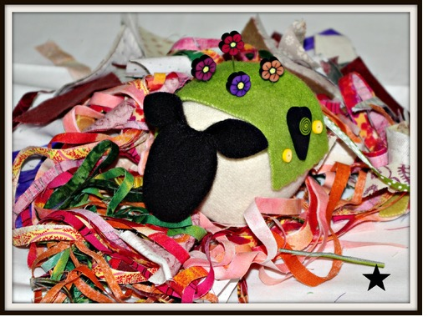

Introducing Tallulah the sheep !! A new LSQW Breakfast Club Block of the Month !!

First meeting date will be Wednesday, March 20th at 9AM

Can't you see this cute little wool sheep pincushion sitting at your sewing table? Are you thinking of a name for your sheep already?
You will start out by receiving the pattern, wool, feet, walnut shells, roving, and five starter fimo clay pins for your very own sheep. Each month you will receive a new outfit for your sheep, and five new fimo clay pins. The outfits and pins will be "holiday" coordinated when possible.
Our meeting day will be the third Wednesday of each month at 9AM. We will take turns bringing a breakfast goodie to include the recipe. LSQW will provide the coffee, juice, and paper products. We will compile all of the recipes for you to receive at the end of the program, just like a mini cookbook.
So here is the BEST part! We want you to take your sheep with you on your travels. Send us some pictures so that we can place them on our website and Facebook page. Can't you see it now? Tallulah at the beach, Tallulah does Dallas, Tallulah at the drag races. (Guess where that is coming from Mr. John!)

  We would love to have you participate with us. This new Breakfast Club cost will require a start up fee of $29.99 and eleven months at $19.99 per month. We will require a credit card to be on file at the shop for monthly billing.
  Can't make it to the shop? We will be happy to ship your sheep. (Say that one 3 times fast !)
  Interested in this fabulous club? Call Lone Star Quiltworks at the number listed below. Spaces will be filling fast.
  Terry A. Skrabanek
  Lone Star Quiltworks
  4301A S Texas Ave
  Bryan, TX 77802
  979 595 1072
  www.lonestarquiltworks.com
  Come and join the flock at LSQW. Can't you just see a group of these pincushion sheep in a fabric rounding pen? What about a mini house for them? Okay, I am out of control with this concept, but they are soooo cute and the possibilities are limitless. Start thinking "sheep decorating" now !
  Facebook
  Please help us grow our Facebook page by "liking" us at
  http://www.facebook.com/pages/Lone-Star-Quiltworks/188471957876182

