

Lone Star Quiltworks
Here is a link to our May thru August Class Schedule. Lots of great new classes including a paper pieced Feathered Star, Kidz Kamp, and a Bargello class. Signup sheets are ready and waiting.
http://www.lonestarquiltworks.com/classes.htm

  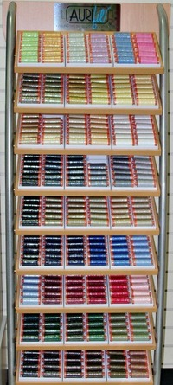
  New to the shop! A full size Aurifil thread display. This thread is super fine, wonderfully strong, and sheds absolutely no lint. Loved by Edyta Sitar, Marti Michell, Pat Sloan, and many more renowned quilters.
  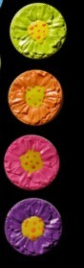
  New daisy ClingOn Design, the great magnetic pin holder!
  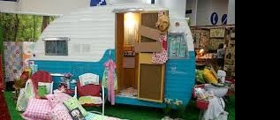
  Get your Glamping on! Super new line from Moda fabrics. Camping with glamour. Superb for quilts, clothes, bags, and just fun, fun, fun. Here is a link to the page showing the individual fabrics.
  Don't forget to follow us on Facebook for more frequent store "happenings".
  AND
  if you enjoy text marketing we send one weekly special to your phone via text. To sign up text the word Quilt to 37332 and follow the confirmation prompts.
  Terry A. Skrabanek
  Lone Star Quiltworks
  4301A S Texas Ave
  Bryan, TX 77802
  979 595 1072
  www.lonestarquiltworks.com

