Twisted Table Runner
28" x 10 1/5" (approx)

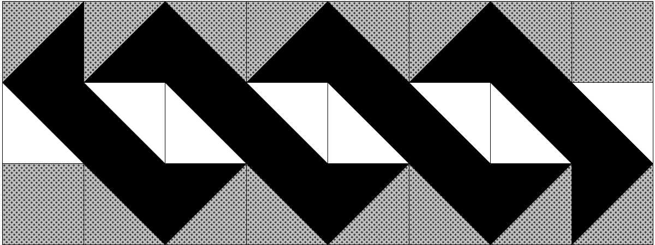

Choose 3 different fabrics
C
BB
A
From Fabric A, cut:
- Six strips, 4" x 10 1/2"

From Fabric B, cut:
- Four strips, 4" x 10 1/2"
- Two, 4" squares

From Fabric C, cut:
- Two strips, 4" 10 1/2"

Using 3 1/1" Finished Thangles you will be making 22 HSTs in two different fabric combinations
The 3 1/2" finished Thangle strip will yield 4 HSTs. You will need the following:
- Eight HSTs using Fabric A & C (2 Thangle strips)
- Fourteen HSTs using Fabric A & B (4 Thangle strips )
You can easily change the dimension of the twist by using different sized Thangles. Just remember you will cut your strips 1/2" wider than the finished HST. For example if you are using 2 1/2" Finished Thangles you will cut your strip 3" x 10 1/2". You can also add additional HSTs to make a longer runner.
Courtesy of - www.washtubquilts.com

