Welcome to our 2016 Education and Event Calendar, itemizing classes scheduled in January 2016 through April 2016.
Class Pass
(144166)

New this season – Purchase a SWI Class Pass for $59.95 and attend as many eligible classes as your schedule permits – all for just $10 a session!

Here’s how it works:

- Purchase the SWI 2016 Class Pass for $59.95.
- Pay just $10 per eligible class session, regardless of retail price!

Classes eligible for the class pass are designated with a CP in the class title. Classes excluded from the class pass include (but are not limited to) the Sew Modern Club, longarm certification courses, Mastery courses and the Creative Serger Event.

Class Pass classes are non refundable once you have registered! Please check your schedule carefully before registering!

Please see the last page of this brochure for additional details on registering and using the class pass.

Take advantage of this great opportunity, learn a few new skills and interact with like-minded sewists!

We’ve scheduled classes and events to challenge your skills, enrich your sewing and embroidery experience, and provide you with opportunities to interact with like-minded sewers. We have a wide range of sewing, fabric art, quilting, home dec, and embroidery classes available. Our goal is to make SWI your favorite sewing/embroidery/quilting shop. We strive to bring you state-of-the-art tools and techniques, stimulate your creativity, and to simplify sewing and embroidery so that you may enjoy your craft. We hope you find our 2016 calendar of classes and events inspiring!

The classes and events we have scheduled (so far!) are included in this brochure. As additional classes are developed, we will add them to our web site, so check www.seworthit.com, often!

Every attempt will be made to hold these classes as scheduled. Please note however, that a minimum of four participants may be required to conduct the class. In the event a class must be rescheduled, we will let you know ASAP, and reschedule or refund the class fee, if necessary. It is important that we have your current phone and email information so that we are able to contact you with any scheduling changes and/or updates.

As a refresher, our cancellation policy is as follows:

Event fees are payable upon registration. Should you need to cancel for any reason, please refer to the registration receipt for the cancellation policy.

Class fees are payable upon registration. Class fees are refundable in the form of a store credit towards another class or a gift certificate (if applicable) if you cancel prior to 7 days before the scheduled class. If you need to cancel within 7 days, the class registration fee is not refundable. Please note: If you are using a SWI Class Pass, Class Pass classes are non-refundable once you have registered! Please check your schedule carefully before registering!

Each and every class offered has a store sample available for you to see in person. (Samples available approximately 45 days before the class.) Pictures simply do not do the sample justice. Come in to the store and SEE what you can make!

As always, thank you for your business. We look forward to our 2016 journey together.

Mastery Courses
Mastery courses are offered EXCLUSIVELY to SWI machine customers. When you buy a sewing or embroidery machine from SWI, these course are FREE to you for as long as you own your machine. Take them once, twice, or whenever you feel you need a refresher! These courses, referred to as “Mastery Courses,” were developed to help you get the very most from your machine purchase. Babylock and BERNINA’s innovative line of sewing and embroidery machines are technologically advanced and extremely feature rich. Mastering your machine will help you truly enjoy your purchase!

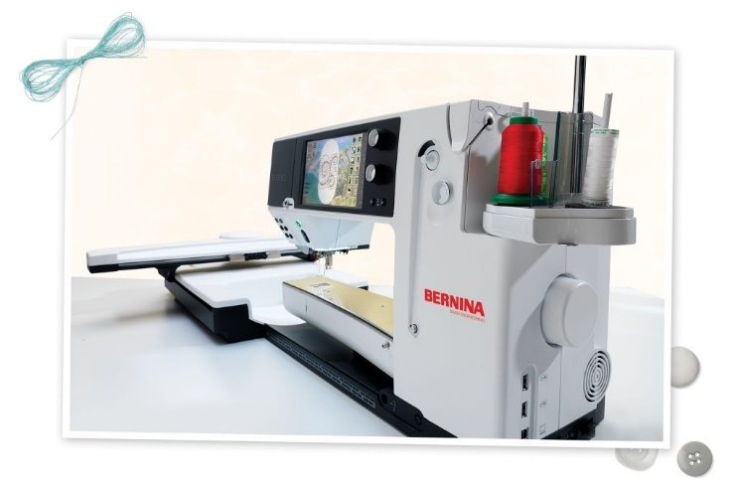
NEW – BERNINA Mastery Course Series
Exclusive to SWI BERNINA customers! Explore the incredible power of your BERNINA as we delve into 4 specific topics. Our Mastery Classes are designed to help you understand, and master, the power of your BERNINA machine! As a SWI machine customer, you may take these classes as many time as your schedule permits – free for as long as you own your machine!
Please note: You may sign up for only one mastery session at a time.

Bernina Mastery Course Series

Topic | Date(s) | Time | Class ID
Basics (B1) | Tuesday, February 16 | 10:00 AM – 12:00 PM | 144493 | Hands On
Sewing (B2) | Tuesday, March 1 | 10:00 AM – 12:00 PM | 144494 | Hands On
Embroidery Basics (SWI 1) | Tuesday, March 15 | 10:00 AM – 12:00 PM | 144495 | Hands On
Quilting (B4) | Tuesday, March 29 | 10:00 AM – 12:00 PM | 144496 | Hands On

NEW – BERNINA Specialty Feet
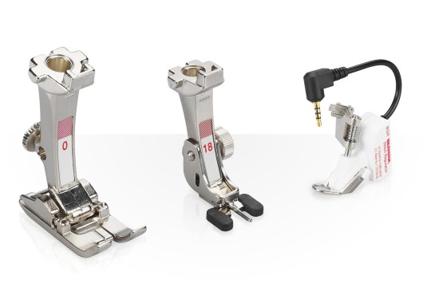
BERNINA's specialty feet can make your sewing and embroidery efforts even easier and more enjoyable. Whether it's making piping, working with heavy fabrics, or inserting zippers, BERNINA has the appropriate presser foot and/or accessory for every project! With so many options to choose from, you may have wondered which foot does what. Wonder no more! It’s time to get a little “faster on your feet” with our NEW BERNINA Specialty Feet Mastery classes! We’ve scheduled two sessions, each focused on helping you understand how to utilize BERNINA's specialty feet.
The sessions are lecture demo – no need to bring anything!

Class Dates:
February 29, Monday - 10:00 AM - 11:00 AM (144497)
March 22, Tuesday - 10:00 AM - 11:00 AM (144498)

NEW - Explore BabyLock’s Specialty Feet

Whether you own the “BabyLock Foot” package or have you thought about purchasing the foot package, chances are you’ve wondered what all those feet can do! Wonder no more! It’s time to get a little “faster on your feet” with our NEW BabyLock Specialty Feet Mastery classes! We’ve scheduled two sessions per month, each focused on helping you understand how to utilize BabyLock’s specialty feet. The sessions are lecture demo – no need to bring anything! – attend each one, or just a few. Each session focuses on specific feet so check our website for details!

Class Dates:

January 11, Monday, 1:00 PM – 3:00 PM (144116)

Topic: All about feet for Quilting

January 26, Tuesday, 10:00 – 12:00 PM (144117)

Topic: All about feet for Specialty Sewing

February 12, Friday, 10:00 AM – 12:00 PM (144118)

Topic: All about feet for Finishing Edges (Binding, Gathering, Ruffling)

February 25, Thursday, 10:00 AM – 12:00 PM (144119)

Topic: All about feet for General Sewing

March 5, Saturday, 10:00 AM – 12:00 PM (144120)

Topic: All about feet for Cording and Piping

March 16, Wednesday, 10:00 AM – 12:00 PM (144121)

Topic: All about feet for inserting zippers and attaching buttons

NEW – Explore BabyLock’s “For the Love of Sewing”

BabyLock (and SWI!) want you to get the most out of your Baby Lock products. That’s why BabyLock offers instant access to helpful video tutorials through two programs. The Love of Knowledge Center gives Destiny owners four years of unlimited access to hundreds of video tutorials - 24 hours a day, seven days a week. In addition, all BabyLock patrons have access to the Sew at Home OnDemand library.

To help you get more familiar with these two great resources, SWI has scheduled a monthly lecture demo focused on the “Love of Sewing” website. These classes are FREE! And are a great way to get more comfortable with online learning.

Dates:

Select one of the following class dates:

January 22, Friday, 10:00 AM – 12:00 PM (144122)

February 19, Friday, 10:00 AM – 12:00 PM (144123)

March 9, Wednesday, 1:00 PM – 3:00 PM (144124)

Longarm Classes:
Longarm Certification 101

January 14, Thursday, 10:00 AM – 4:00 PM (144195)
Rent a Longarm

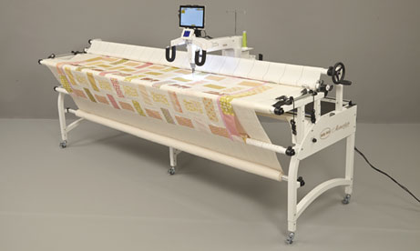

Complete your quilts faster than ever by renting SWI’s longarm machines! You will be amazed at how easy it is to finish your own quilts on these industry leading machines.

In order to rent a SWI longarm, you must first be certified.

February 19, Friday, 10:00 AM – 2:00 PM (144210)
Ready to take your quilting skills to the next level? This hands-on class will teach you how to use a longarm machine. Once certified, you will be able to rent a SWI longarm to quilt your quilts! What fun!
During the class, you’ll receive a Longarm Certification Handbook (to take notes and to take home) and a SWI Certification Card for identification. This card is for your use only and is needed to make a reservation to rent the machine. You will also receive your own very own set of zippers for the longarm leaders.
Class fee is non-refundable, non-cancellable, and non-transferable. To provide hands on training, there will be only four students in each class. Supplies needed for class - absolutely nothing! SWI WILL PROVIDE EVERYTHING YOU NEED!

Class Fee: $175
Instructor: SWI Staff
Longarm Mastery Classes

For SWI machine customers only! Now that you own your longarm machine, let SWI experts help you master your skills! In each if these Mastery courses, we will focus on one specific topic. If you are a new SWI longarm customer, these courses are invaluable as you begin to explore the power of your new longarm quilting machine. If you’ve taken these course before, consider attending again to brush up on your skills or ask the expert now that you have some “home hand on” experience.
As a SWI machine customer, you may take as many Mastery courses as you like – they are free and offered only to you --- our SWI machine customer!

Mastery Class Topics and Dates:

January 15, Friday, 1:30 PM – 3:30 PM (144395)
Basics – Quilt Prep and Loading and Tension
- In this class, we will cover everything you need to know about putting your quilt on the frame, including using zipper leaders, centering, full or partial floating and basting. We’ll also cover the basics of setting and adjusting tension. The skills reviewed in this class are critical to getting started with your longarm quilting.

February 9, Tuesday, 1:30 PM – 3:30 PM (144396)
Corners, Borders and Cropping – Oh my!
- Learn how to crop out shapes, corners and borders. This is a “Don’t miss” class for creating customized quilts!

March 15, Tuesday, 1:30 PM – 3:30 PM (144397)
Pro-Stitcher - Edge to Edge
- Edge to Edge designs work exactly the way the name describes - from one edge of the quilt to the other. This easy to accomplish quilting method will have you quilting those unfinished objects in record time! Learn how to define your quilt design for optimal performance.

April 22, 1:30 PM, Friday, 1:30 PM – 3:30 PM (144398)
Block to Block
- Block work is another critical skill for creating one-of-a-kind custom quilts. Learn how to create custom blocks in this not to be missed session.

Destiny VIP Mastery Courses – New and Expanded!
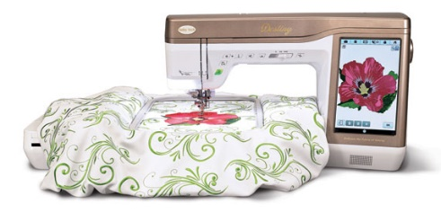
Exclusive to SWI Destiny VIP customers! Explore the incredible power of your Destiny as we delve into 12 specific topics. Our Mastery Classes are designed to help you understand, and master, the power of this incredible machine! As a VIP customer, you may take these classes as many time as your schedule permits – free for as long as you own your machine!

You may register for only ONE Mastery class at time, except for those Destiny Mastery courses listed below that are scheduled on the same day. New this year, we have scheduled two mastery courses – one in the morning and one in the afternoon on select dates! You can now spend an entire day exploring your Destiny! We’ve also included Thursday evening and Saturday classes. Please note however, that a minimum of four participants is required to conduct the class. In the event a class must be rescheduled, we will let you know ASAP. Please make sure we have your current contact information.

One of the benefits of purchasing a Destiny from SWI is the ability to reserve one of SWI’s classroom Destiny’s for your SWI classes. This makes it even more convenient for you, and is provided to you, our Destiny VIP customers, on a first come, first serve basis. Reserving a Destiny is your responsibility – SWI staff will not automatically reserve a Destiny for you, so please make sure you request a Destiny when you register for a class.
Here are a few other important points to note:

- Classroom machines only include the machine, power cord, foot pedal, and embroidery arm – You must provide all other machine parts needed for your class (e.g. – shank, thread stand, embroidery foot, walking foot, etc.)
- Bring in all items listed for supplies for each class on website
- You must call at least 24 hours prior to the class to cancel – if you no show, there may be a charge for the next class
- Be sure to bring a sewing machine needle to put in the machine
- Bind your Destiny Manuals – Office Max approximately $8 for the Manual and Quick Reference Guide

SWI has six classroom Destiny’s, so reserve your spot by calling or stopping by the store. If the classroom machines are already reserved, you are welcome to bring your own Destiny to class, or simply listen and learn!

Class dates (including Thursday evenings and Saturdays!) and topics are shown on the following page.

DESTINY VIP MASTERY CLASSES

Topic | Date(s) | Time | Class ID
Basics (DM1) | Wednesday, January 13  Saturday, January 23 | 10:00 AM – 12:00 PM  10:00 AM – 12:00 PM | 144081  144082 | Lecture Demo
Sewing Basics (DM2) | Wednesday, January 13  Thursday, January 28 | 1:00 PM – 3:00 PM  5:30 PM – 7:30 PM | 144083  144084 | Hands On
Embroidery Basics (DM3) | Wednesday, January 20  Thursday, January 14 | 10:00 AM – 12:00 PM  5:30 PM – 7:30 PM | 144085  144087 | Hands On
Troubleshooting (DM4) | Wednesday, January 20  Thursday, February 11 | 1:00 PM – 3:00 PM  5:30 PM – 7:30 PM | 144089  144090 | Lecture Demo
Embroidery Lettering (DM5) | Wednesday, January 27  Saturday, February 20 | 10:00 AM – 12:00 PM  10:00 AM – 12:00 PM | 144091  144092 | Hands On
IQ Applique Basics (DM6) | Wednesday, February 10  Saturday, March 19 | 10:00 AM – 12:00 PM  10:00 AM – 12:00 PM | 144093  144094 | Hands On
Quilting Basics (DM7) | Wednesday, February 10  Thursday, March 10 | 1:00 PM – 3:00 PM  5:30 PM – 7:30 PM | 144095  144096 | Hands On
Decorative Stitches (DM8) | Wednesday, February 17  Saturday, March 12 | 10:00 AM – 12:00 PM  10:00 AM – 12:00 PM | 144097  144098 | Hands On
IQ Embroidery Basics  (DM9) | Wednesday, February 17  Thursday, March 17 | 1:00 PM – 3:00 PM  5:30 PM – 7:30 PM | 144099  144100 | Hands On
Embroidery Placement (Laser/Camera)  NEW (DM10) | Wednesday, February 24  Saturday, February 6 | 10:00 AM – 12:00 PM  10:00 AM – 12:00 PM | 144101  144103 | Hands On
Using the Laser  (Sewing and Quilting)  NEW (DM11) | Wednesday, March 2  Saturday, April 9 | 1:00 PM – 3:00 PM  1:00 PM – 3:00 PM | 144102  144104 | Hands On
Special Features (Couching and Bobbin Work)  (DM12) | Wednesday, March 16  Thursday, February 25 | 1:00 PM – 3:00 PM  5:30 PM – 7:30 PM | 144105  144106 | Hands On

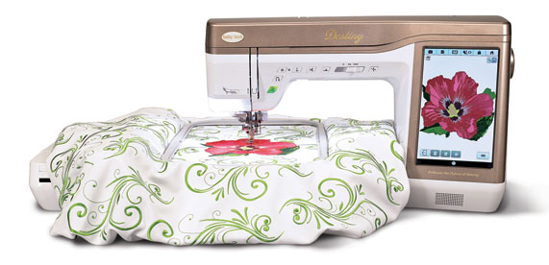
Destiny VIP Exclusive Classes – Projects!

NEW! How about a little “practical practice” with your Destiny? We’ve developed three classes, offered once per month, each focused on helping you master a specific feature of your machine! Even better, as you learn, you’ll complete the project!

IQ Embroidery Project – Tea Towel

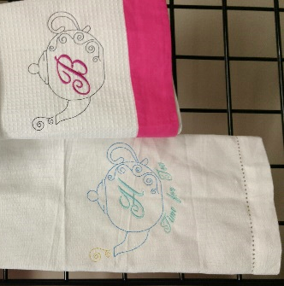
Select one of the following class dates:

January 27, Wednesday, 1:00 PM – 4:00 PM (144107)

February 13, Saturday, 10:00 AM – 1:00 PM (144108)

March 10, Thursday, 10:00 AM – 1:00 PM (144109)

Make a cute tea towel as you learn how to use the IQ Embroidery feature of your Destiny. You’ll cut and paste, manipulate and layer designs, all using the IQ feature of your Destiny. You’ll also gain experience with lettering, as you’ll customize your tea towel with your favorite kitchen saying, or your last name. Finally, you’ll stitch out your towel and admire your completed project!

Class Fee: $10 plus supplies
Educator – SWI Staff
IQ Applique Project – Your choice of SWI Applique Pattern

Select one of the following class dates:

January 18, Monday, 10:00 AM – 1:00 PM (144113)

February 27, Saturday, 10:00 AM – 1:00 PM (144114)

March 9, Wednesday, 10:00 AM – 1:00 PM (144115)

What better way to learn IQ Applique than with a “real” pattern! First, you will select one of SWI’s applique patterns. In class, we will teach you how to use IQ create your very own “in the hoop” applique. You’ll get great practical practice on a “real life” pattern that you want to do! Fun!

Class Fee: $10 plus supplies
Educator – SWI Staff

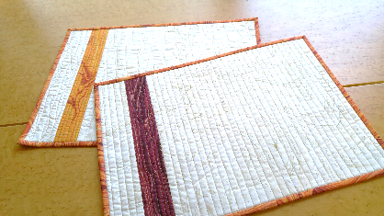
Quilting with the Dual Feed Foot

Select one of the following class dates:

January 22, Friday, 1:00 PM – 4:00 PM (144110)

February 24, Wednesday, 1:00 PM – 4:00 PM (144111)

March 17, Thursday, 1:00 PM – 4:00 PM (144112)

Let’s quilt! In this class, you’ll learn how to quilt with your Dual Feed Foot. We often refer to the Dual Feed Foot as the “walking foot on steroids”, so get ready for a super charged class! You’ll be making placemats, each with a different quilting motif. In class, we’ll piece and quilt at least two placemats!

Class Fee: $10 plus supplies
Educator – Lisa

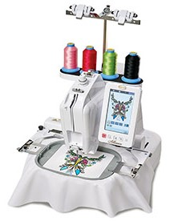
Alliance Mastery Classes

For SWI machine customers only! Now that you own an Alliance, let SWI experts help you master your skills! As a SWI machine customer, you may take as many Mastery courses as you like – they are free and offered only to you --- our SWI machine customer!

Alliance Mastery Class Topics and Dates:

February 26, Friday, 10:00 AM – 12:00 PM (144469)
Basics
- Even if you’ve own and used your Alliance for a few months, this is a great course to attend! We’ll cover the basics, including hooping, threading and toubleshooting! Our SWI expert has tips and tricks to help you get the very most from your purchase! Don't miss this exclusive class for SWI Alliance machine owners!

March 18, Friday, 1:00 PM – 3:00 PM (144490)
Advanced Features
- In this informative session, we'll "go beyond" the basics and start reviewing a variety of more complicated embroidery scenarios. Your Alliance is perfect for those "hard to embroider" items! Now that you've used your Alliance for a few a projects, it's time to delve a bit deeper into it's capabilities! Don't miss this exclusive class for SWI Alliance machine owners!

Sew Modern at Sew Worth It!

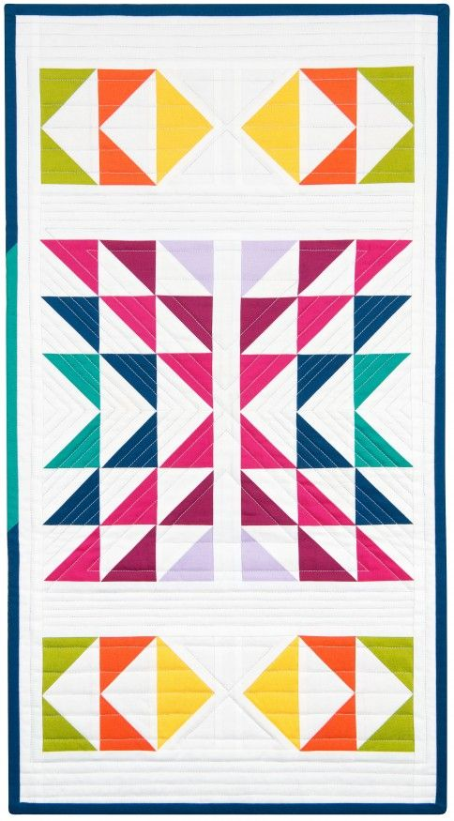
Last year, we started a new Sew Modern Club at SWI --- a monthly session focused on modern quilting techniques, patterns, and fabrics! Each month, one fat quarter bundle of 10 fabrics is highlighted along with the "modern movement" inspired projects that you can create with them. At some of the meetings, patterns (free and purchased) are featured, and at other meetings, discussions are focused on modern quilting techniques with the featured fabric bundles. The class is a lecture/demo format so no need to bring your machine - just come and learn what the modern quilting is all about!

Saturday’s – 10:00 AM – 11:30 PM

Club Meeting Dates:

January 9, 2016 (142777)

February 13, 2016 (142778)

March 12, 2016 (142780)

April 9, 2016 (142781)

Pricing:

- Monthly Club Meeting and Fat Quarter Bundle: $25/month
- Monthly Club Meeting and Half Yard Bundle: $40/month

What a great way to embrace the Modern Quilt Movement and build your stash! Join the Club!

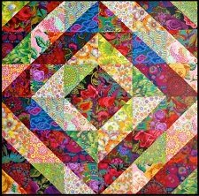
Technique Classes:
CP - Beginning Quilting (144194)

Class Session Dates: (4 sessions)

January 13, Wednesday, 10:00 AM – 1:00 PM

January 20, Wednesday, 10:00 AM – 1:00 PM

January 27, Wednesday, 10:00 AM – 1:00 PM

February 10, Wednesday, 10:00 AM – 1:00 PM

If you’ve always wanted to quilt but didn’t know where to start, this class is for you! This four class series will have you quilting in no time! In the very first session, our award-winning quilter will help you select your fabrics and take you through which tools are “must haves” for quilting, and which are optional. For the second through the fourth sessions, bring your sewing machine! We’ll start with fabric preparation and rotary cutting, and then proceed to piecing where we’ll share the secrets to perfectly straight seams and blocks that fit! We’ll be with you every step of the way as you discover the joy of designing and creating your very own quilt! Welcome -- new quilter!

Skill Level: Beginner
Class Fee: $25 per session, $100 total ($40 total if you purchased the SWI Class Pass)
Instructor: Pam

CP - Quilting with your Walking Foot

February 22, Monday, 10:00 AM – 3:00 PM (144199)
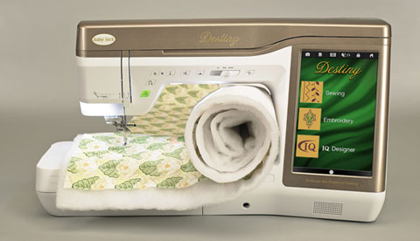

Join us and learn straight line quilting, organic quilting, echo quilting and more – all while using your Walking Foot! In this hands on class, you will practice a variety of techniques – after which you will be quilting like a pro! All sewing machine brands welcome!

Skill Level: Confident Beginner and Beyond
Class Fee: $35
Instructor: Lisa

CP - Perfecting your Quilt

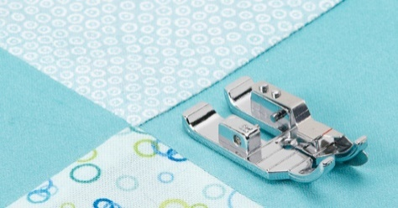
February 2, Tuesday, 10:00 AM – 2:00 PM (144176)

February 16, Tuesday, 10:00 AM – 2:00 PM (144192)

March 1, Tuesday, 10:00 AM – 2:00 PM (144193)

Even the most experienced quilter will benefit from this class series! These three classes will address a variety of best practices from accurate cutting and piecing to how to correctly press your blocks to avoid distortion. Why not let our SWI quilting expert lead you through a series of quilting best practices to help you achieve more accurate results? Quilts that lay flat, and completed blocks that fit together perfectly – Sign me up! You may register for one – or all three of these awesome classes.
Session topics are listed below:

Session 1 – February 2
Basic principles of quilting; Different ways of piecing standard components of blocks and templates; Quilting tools and how to use them; Color Selection -- how to choose fabrics using your knowledge of scale and color schemes
Session 2 – February 16
Piecing half square triangles, quarter square triangles, flying geese, pinwheels; straight set quilts vs. diagonal settings; putting borders on your quilt and the way if affects the outcome
Session 3 – March 1
Discussion of battings, how to sandwich your quilt, quilting your quilt, how to do bindings, hanging sleeve and steps to enter a quilt show and what judges expect to see

Skill Level: Confident Beginner and beyond
Class Fee: $25/each
Instructor: Pam

CP - Free Motion Quilting

January 16, Saturday, 10:00 AM – 1:00 PM (144196) – All Over Free Motion Designs

February 6, Saturday, 10:00 AM – 1:00 PM (144197) – Free Motion Shapes

March 5, Saturday, 10:00 AM – 1:00 PM (144198) – Border and Filler Designs
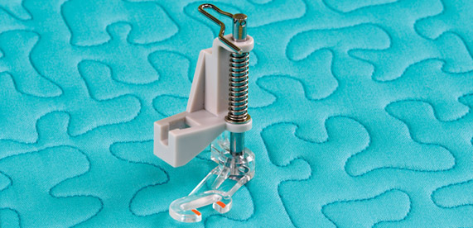
Bring your own machine, and learn the art of free motion quilting in a relaxed and fun environment. We’ll practice a variety of techniques, both on paper, and on your quilt sandwich. Each of the three monthly classes will focus on different free motion filler and quilting designs, so consider signing up for all thee. After all -- practice makes perfect!

Skill Level: Confident Beginner and Beyond
Class Fee: $25/each
Instructor: Lisa
CP - Quilting in the Hoop

January 25, Monday, 10:00 AM – 2:00 PM (144174)

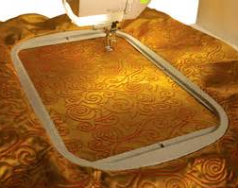
Yes you can quilt in the hoop! Let SWI’s expert teach you the basics of quilting in the hoop – from simple designs for placemats to background quilting for larger applique projects. You’ll add a new skill to your repertoire and be sew glad you did!

Skill Level: Confident Beginner and Beyond
Class Fee: $25
Instructor: Kim

CP - Computer Basics – Know your PC!

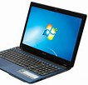
January 15, Friday, 10:00 AM – 2:00 PM (144175)

Another must for productive sewing and embroidery is effectively utilizing your PC. Instead of calling your son or daughter – or heavens forbid your spouse! – take this class! You’ll need to bring your PC – sorry no Mac’s – and your notebook to jot down the valuable tips you’ll receive.

Skill Level: Beginner
Class Fee: $25
Instructor: Kim

CP - Organizing your Embroidery Designs

February 9, Tuesday, 10:00 AM – 2:00 PM (144177)

Where did I put that design? One of the many challenges of building a robust embroidery design library is how to effectively organize it. Should your Christmas Cat design be included under “animals” or Christmas? There’s nothing more frustrating than being unable to find your designs when you want them! Attend this class and learn how to organize your designs for improved results. With an organized system, you can easily find the designs you need instead of hunting through folder after folder, or scanning through a long list of designs.

Skill Level: Confident Beginner and Beyond
Class Fee: $25
Instructor: Kim

CP – Introduction to Studio III Embroidery Software

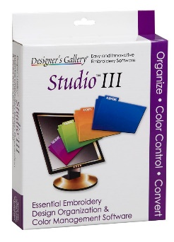
March 11, Friday, 10:00 AM – 2:00 PM (144178)

If you own (or are thinking about purchasing) Studio III, this is the class for you! Spend more time embroidering and less time searching. Studio III remembers where you save your designs even when you don't. We’ll teach you how to make your embroidery selection process a snap! We’ll even teach you about color sorting options for perfect embroidery every time! Let us help you shorten the learning curve for this wonderful software!

Skill Level: Confident Beginner and Beyond
Class Fee: $25
Instructor: Kim

CP - Better Binding

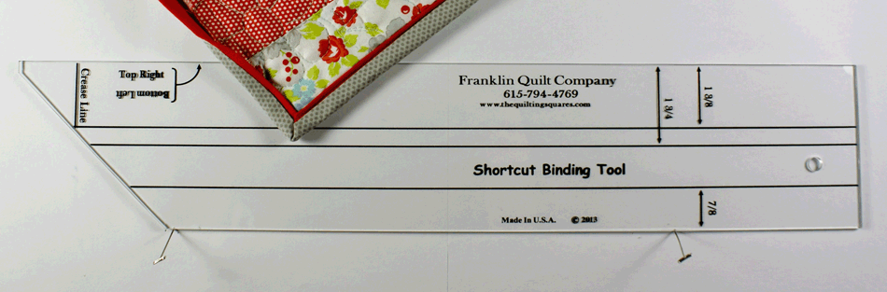
March 2, Wednesday, 10:00 AM – 2:00 PM (144179)
Binding is often a quilter’s least favorite task. It doesn’t have to be! There are techniques, tools and tricks to better, faster, easier binding. Attend this class and learn how to make your least favorite quilting task one of your favorites! We’ll even show you how to attach quilt binding by machine! Cool!

Skill Level: Confident Beginner and Beyond
Class Fee: $25
Instructor: Kim

CP - Accuquilt Go! – Back to Basics

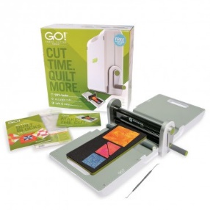
March 15, Tuesday, 1:00 PM – 4:00 PM (144180)

Dust off your Accuquilt Go! and bring it to class for a great refresher as to all of the wonderful things you can do with your Accuquilt Go! Cutter! We’ll cover how to use your Accuquilt cutter for optimal results, as well as how to keep it clean and in top working order! Make the most of the tools you own by attending this class.

Skill Level – Beginner and beyond
Fee: $25
Instructor: Lisa

CP - Silhouette Basics

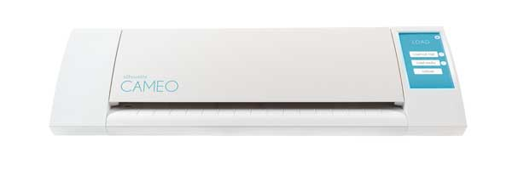
January 19, Tuesday, 10:00 AM – 2:00 PM (144181)
If you love applique, you either own – or are thinking about owning -- the Silhouette Cameo. It makes cutting applique shapes fast and easy! As with any software, there’s a learning curve. This class is all about getting you comfortable with your Silhouette. We’ll teach you the basics – scanning in your designs, cleaning up the scans, duplicating and mirroring, and navigating the menus. You’ll be amazed at how easy it is to use this awesome tool! If a Silhouette Cameo is on your “wish list”, consider attending this class to get an idea of what you could accomplish with this applique tool time-saver.

Skill Level – Beginner and beyond
Fee: $25
Instructor: Kim

CP - Silhouette – Workshop (144211)

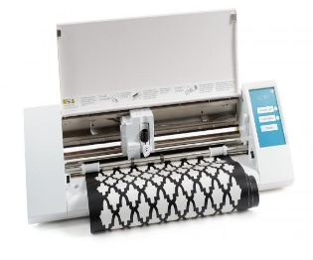
February 23, Tuesday, 10:00 AM – 2:00 PM
If you’ve already taken our Silhouette basics course, then it’s time for our workshop! In class you will work on two different “real life” applique scenarios. You’ll start the day with a simple applique shape, and learn how to manipulate, copy and re-size your scanned design. We’ll then move on to a more complex applique, one that requires you to scan in an image in portions. You don’t want to miss this opportunity to learn while doing!

Skill Level – Beginner and beyond
Fee: $25
Instructor: Kim/Lisa

CP - Cuddle Class

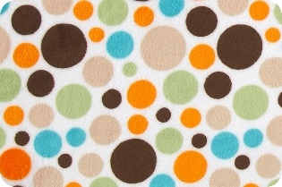
March 18, Friday, 10:00 AM – 2:00 PM (144182)
If you’re like most quilters, you’ve made your share of baby quilts. Babies -- and children of all ages -- love quilts, especially quilts made with cuddle or minky fabric. Learn how to work with cuddle fabric for the loved ones in your life. We’ll review cutting, sewing, applique and binding techniques, as well as which tools and techniques work well with cuddle. Don’t miss this opportunity to learn how to work with this luxurious fabric!

Skill Level – Beginner and beyond
Fee: $25
Instructor: Pam

CP – Introduction to Paper Piecing

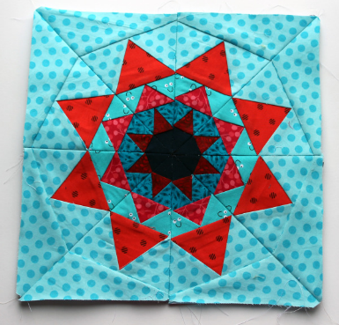
February 25, Thursday, 10:00 AM – 2:00 PM (144172)

Interested in giving paper piecing a try? Our Introduction to Paper Piecing class is perfect for those quilters that have been wanting to learn this relaxing and fun technique! With the guidance of our award winning quilter, you will construct a series of paper pieced blocks, after which you will combine them to make a beautiful compass block wall hanging or pillow. What a great way to learn!

Skill Level – Beginner and beyond
Fee: $25
Instructor: Pam

CP – Introduction to Curved Piecing

March 14, Tuesday, 10:00 AM – 2:00 PM (144173)
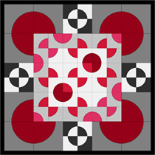

Are you intimidated by curved blocks? Have you wanted to piece a Drunkard’s Path quilt but been afraid to try? If so, this is the class for you! Sewing curves is easier than you think – especially when you’re assisted by our award winning quilter! We will teach you how to get perfect results while sewing curves, as well as share best practices to avoid “wonky” seams. With over 80 documented variations of the Drunkard’s Path block layout, why not master one of the versatile – and loved -- quilt blocks on the planet?

Skill Level – Intermediate
Fee: $25
Instructor: Pam

Ruler Work for Domestic Machines

March 8, Tuesday, 1:00 PM – 4:00 PM (144478)
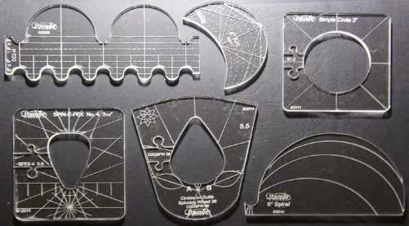
Introducing ruler work for domestic machines! Beautiful blocks and borders are within your reach with these innovative tools! Free motion quilters rejoice!
If you purchased your ruler foot and template set from SWI, select one of the scheduled classes and enroll for FREE! In each session we will cover the basics of ruler work, followed by "practical" practice with each ruler.

CP – Domestic Ruler Free Motion - Practical Practice Projects!

February 12, Friday, 1:00 PM – 4:00 PM (144183)

February 26, Friday, 1:00 PM – 4:00 PM (144184)

March 11, Friday, 1:00 PM – 4:00 PM (144185)
If you purchased the domestic machine free motion ruler set, then chances are you’re anxiously waiting for the right project to quilt with your new rulers! Wait no more! We have designed three projects – perfect for practical practice with your rulers! You may sign up for one, or all three, each one is different, and each one uses different rulers from the starter set! The three projects are as follows:
Project One:  Easy HST Placemats | Project Two:  Retro Circle Quilt | Project Three:  Tilt-A-Whirl Wall Hanging
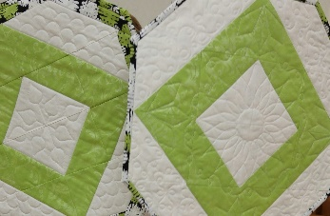 | 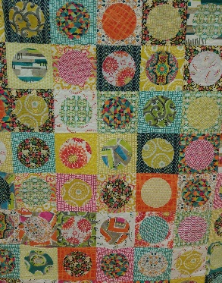 | 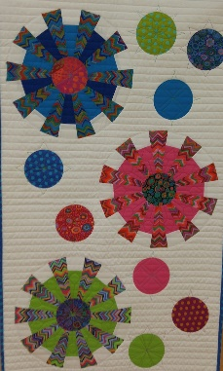
Skill Level – Beginner and Beyond
Class Fee: $25
Instructor: Lisa

CP – Easiest Ever Bargello Tablerunner

February 3, Wednesday, 1:00 PM – 5:00 PM (144186)

This has to be the easiest bargello pattern ever! Purchase our kit which includes just one yard of Hoffman’s innovative pre-printed fabric, and we’ll show you how to make this stunning tablerunner in a just a few hours! If you’d prefer a Bedrunner – that would work too! Talk about a quick gift!

Skill Level – Beginner and beyond
Class Fee: $25
Educator: Lisa

CP – Delhi Tablerunner

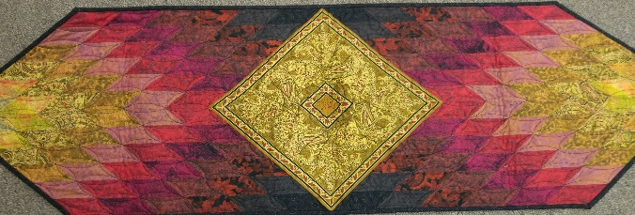
April 7, Thursday, 10:00 AM – 2:00 PM (144201)

This stunning, Jinny Beyer designed tablerunner evokes thoughts of rich warmth and deep conversations! Available in multiple colorways, select a kit and get quilting! We’ll show you how!

Skill Level – Beginner and beyond
Class Fee: $25
Educator: Pat
CP – Chenille Pillow

January 26, Tuesday, 10:00 AM – 2:00 PM (144187)
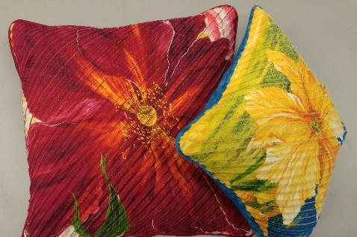
These pillows will definitely make you smile! Take two flower panels, add a few layers of solid fabric, and create your very own simply stunning pillows! We’ll teach you how to create chenille fabric – so even if pillows aren’t your thing, you’ll still benefit from this “how-to” class! These pillows are so easy to make, you’ll want to make more than one!

Skill Level – Beginner and beyond
Class Fee: $25
Educator: Lisa

CP – Ruffled Serger Pillow

March 17, Thursday, 10:00 AM – 2:00 PM (144188)

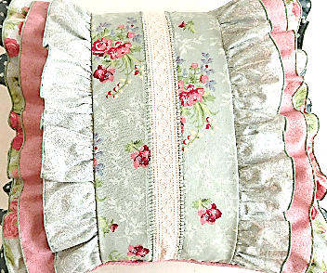
When was the last time you used your serger? Why not enroll in this class and refresh your serger skills while creating a gorgeous new pillow? This pillow features rolled edges, ruffles, and a decorative flatlock stitch. When you complete this project, you’ll have a pretty patchwork pillow. You’ll also have rejuvenated serger skills.

Skill Level – Beginner and beyond
Class Fee: $25
Educator: Pat

CP – Serger Necklace

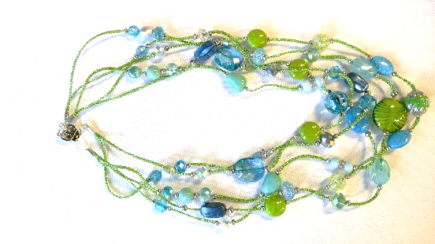
March 3 – Thursday -10:00 AM – 2:00 PM (144189)

Sergers aren’t just for hems and seams! You can use your serger to create beautiful jewelry! Let us show you how!

Skill Level – Beginner and beyond
Class Fee: $25
Educator: Pat

CP – Daisy Basket Mini Tote

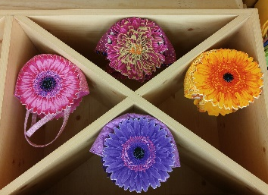
March 3 – Thursday -10:00 AM – 2:00 PM (144190)

Pretty as a picture – and just in time for Easter gift-giving! Grandmothers take note – Your granddaughters will delight in these flower purses! Select one of our many gorgeous Kaffe Fassett prints, or decide to create your own flower fabric with polka dots and fussy cutting -- either way, this easy to make tote is sure to please!

Skill Level – Beginner and beyond
Class Fee: $25
Educator: Pam

CP – Potpourri Quilt (144191)

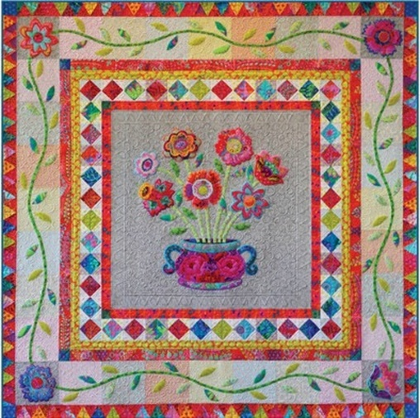
Two class sessions:

January 29, Friday, 10:00 – 2:00 PM

February 5, Friday, 10:00 AM – 2:00 PM

This whimsical quilt is absolutely stunning! Why not create your own masterpiece while learning new skills?? We will take you through a variety of applique methods, as well as share how to utilize decorative stitches to enhance your quilt top. This is a two session class series, so get ready to learn a lot! Come see this stunning quilt in person. It’s gorgeous!

Skill Level: Intermediate
Class Fee: $25 per session; $50 total ($20 total if you purchased the SWI Class Pass.)
Instructor: Pat

CP – Going in Circles Placemats
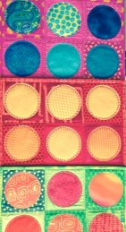

February 15, Monday, 10:00 AM – 2:00 PM (144256)

April 4, Monday, 10:00 AM – 2:00 PM (144257)

Break out your charm packs and create a fun set of placemats for your patio or kitchen! These placemats are quick to stich and fun to make. We’ll also show you how to use the circle attachment to add decorative stitching to these beauties! Guaranteed to please, especially with a few decorative stitches thrown in

Skill Level: Beginner and Beyond
Class Fee: $25/ each class; $50 total, or $20 with your 2016 SWI Class Pass!
Instructor: Will

CP – Love Squared Quilt

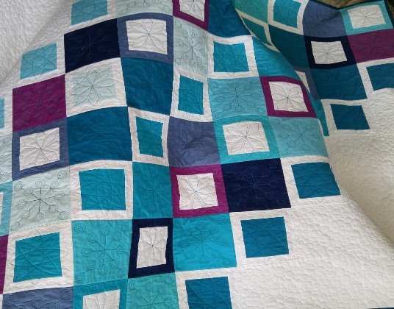
March 1, Tuesday, 1:00 PM – 5:00 PM (144451)

March 21, Monday, 1:00 PM – 5:00 PM (144452)

This quick to piece quilt is the perfect choice for a little “practical practice”. In the first class, we’ll show you how to “speed piece” this simple, but stunning quilt. In the second session, we’ll assist you as you quilt this beauty. You may choose to quilt your version of Love Squared with your domestic rulers (as we did), or you may opt to quilt with your walking foot. Either way, our instructor to help you get this quilt finished in record time!

Skill Level: Beginner and Beyond
Class Fee: $25/ each class; $50 total, or $20 with your 2016 SWI Class Pass!
Instructor: Lisa

CP - Sit and Sew - Weekly

Join us twice a month for a FREE sit and sew session. SWI staff members will be available to help you with your current project – plus you get to catch up with your friends in a fun, friendly environment. Finish your projects, get help from the SWI team, and be social! The sessions are free, but registration is required.

Class Fee: Absolutely None – It’s Free!

January 12 – 1:00 PM – 4:00 PM – 144387

January 29 – 1:00 PM – 4:00 PM – 144388

February 8 – 1:00 PM – 4:00 PM – 144389

February 29 – 1:00 PM – 4:00 PM – 144390

March 7 – 1:00 PM – 4:00 PM – 144391

March 21 – 1:00 PM – 4:00 PM – 144392

April 11– 1:00 PM – 4:00 PM – 144393

April 25 – 1:00 PM – 4:00 PM – 144394

Creative Serger Series
With Serger Artist – Deb Canham
Create your own designer tote while exploring the power and flexibility of your Babylock Serger in this four class series!

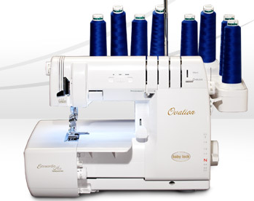
Thursday’s, 10:00 AM – 4:00 PM
January 28, February 4, February 11, February 18

Join us for four full days of exploring your BabyLock Serger! You’ll have ample opportunity to explore your creative side while learning a variety of functional stitches and techniques. You’ll also have the opportunity to utilize a variety of specialty feet. You will receive fully illustrated and written instructions – perfect for when you’re ready to make your next Designer Tote!

Event Fee (includes all four sessions): $175 (144125)
Optional Prep Session: $25* (144200)
- Our optional prep session is Thursday, January 21, from 10:00 AM – 3:00 PM. The Creative Serger Supply List (available online at www.sewworthit.com), includes detailed pre-class prep work that must be completed before our first session. If you would like assistance, consider attending the prep session!

Special Longarm Classes:
Art and Stitch Class Series

This three class series will have you creating customized quilts quickly and expertly! If you own the Art and Stitch program, don’t miss this opportunity to get the very most from your software purchase by investing in three full days of training from a certified instructor.

Class dates and topics are as follows:

Class One: Personalized Meanders: an Introduction to Art and Stitch (144399)
January 23, Saturday, 10:00 AM – 4:00 PM

Class Two: Using Art and Stitch to Applique and to Create Filled Shapes and Blocks (144400)
February 5, Friday, 10:00 AM – 4:00 PM

Class Three: Using Art and Stitch to Create Modern Quilt Elements (144401)
February 27, Saturday, 10:00 AM – 4:00 PM

Class Eligibility: Must own the Art and Stich Software. Anyone may attend these classes, regardless of where you purchased your longarm.

Class Fee: $50 per class or $125 for the three class series.

Please note: Art and Stitch class fees are non-refundable one you have enrolled.

For more details, see each class description on our website.

SWI Class Pass
Valid January 1, 2016 – April 15, 2016
(144166)

New this season – Purchase a SWI Class Pass for $59.95 and attend as many eligible classes as your schedule permits – all for just $10 a session!

Here’s how it works:

- Purchase the SWI 2016 Class Pass for $59.95.
- Decide which eligible classes you would like to attend.
- Pay just $10 per eligible class session, regardless of retail price!

Classes eligible for the class pass are designated with a CP in the class title. Classes excluded from the class pass include (but are not limited to) the Sew Modern Club, longarm certification courses, Mastery courses and the Creative Serger Event.

Once you have registered for the Class Pass, and paid your $59.95 registration fee, the rest is easy! Decide which class sessions you would like to attend and ask a SWI team member to help enroll. Each class session is just $10!

Each class has a maximum number of participants, and registration is on a first come, first serve basis. With the incredible value of our new SWI Class Pass, we expect many of these classes will these class to fill up quickly, so register early!

As with all of the classes at SWI, considerable time and energy has been invested in designing the class and preparing the class samples. Therefore, it’s important that you note the following cancellation requirements:

- There are NO REFUNDS for class pass classes. Please check your schedule carefully before you register for a class.
- If you no show more than two times, your SWI Class Pass may be suspended.

We look forward to learning with you in 2016!

