
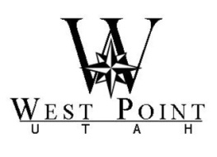
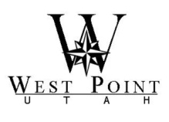 Mayor Erik Craythorne
Council
Gary Petersen, Mayor Pro Tem
Jerry Chatterton
Andy Dawson
R. Kent Henderson
Roger Woodward
West Point City Council Agenda City Manager
West Point City Municipal Center – 3200 West 300 North Gary Hill
February 7, 2012
_______________________________________________________________________________

The February 7, 2012 West Point City Administrative Session and City Council Meeting have been canceled.

Posted and dated this February 2, 2012

__________________________________
MISTY ROGERS
City Recorder
If you plan to attend this meeting and, due to disability, will need assistance in understanding or participating therein, please notify the City at least eight hours prior to the meeting and we will seek to provide assistance.

