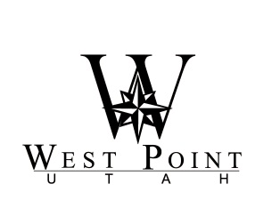
Mayor
Erik Craythorne
Council
Gary Petersen, Mayor Pro Tem
Jerry Chatterton
Andy Dawson
R. Kent Henderson
Roger Woodward
West Point City Council Agenda City Manager
West Point City Municipal Center – 3200 West 300 North Gary Hill
Friday, January 6, 2012
_______________________________________________________________________________

City Council Retreat
8:30 am Continental Breakfast

9:00 am Welcome and Call to Order – Mayor Craythorne

9:05 am Review of Policy Priorities & Quarterly Update – Mr. Gary Hill
10:00 am SR 193 Update and Residential Impact Discussion – Mr. Randy Jeffries, UDOT
11:15 am Break
11:30 am Council Business – Mayor Craythorne
      - Liaison appointments and city representation discussion
12:00 noon Lunch (provided)
1:00 pm Future Needs Discussion – Mr. Gary Hill

2:30 pm Break
2:45 pm Recreation Center Update – Mr. Boyd Davis
3:00 pm City Finance Update and Budget Preview – Mr. Kyle Laws
3:30 pm General Recycling Program – Mr. Kyle Laws
4:30 pm Adjourn

After the meeting the City Council and members of staff will meet socially for dinner.

6:30 pm Dinner at Roosters - 748 Heritage Park Blvd, Layton

Posted and dated this January 3, 2012

__________________________________
MISTY ROGERS
City Recorder
If you plan to attend this meeting and, due to disability, will need assistance in understanding or participating therein, please notify the City at least eight hours prior to the meeting and we will seek to provide assistance.

