The Sewing & Stitchery Expo brings the best of the best for your learning pleasure! In their own words, they share a little something of themselves!
A - F | G - M | N - Z

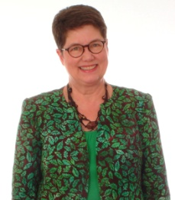
Marta Alto
Portland, OR
Palmer/Pletsch
Brenda Asmus
Michell Marketing Inc.

Donna Babylon
More Splash Than Cash
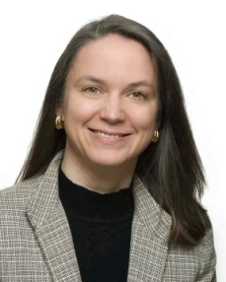  Marci Baker  Alicia's Attic teaching for The Pine Needle | Recognized internationally for her expertise in quilting, Marci enjoys sharing ideas that simplify the process of sewing and quilting. Her Qtools™ and Know Before You Sew™ products provide easy-to-follow solutions for common sewing and quilting problems. All types of projects are successfully completed with the wealth of information she offers. Enthusiasm and inspiration can be seen throughout her lectures, workshops and books. She has been featured in HGTV’s Simply Quilts; NBC’s The Jane Pauley Show; Redbook; and has published in numerous quilting magazines. Marci, her husband, their sons, Kevin, Marcus, and their pet snake, Scooby, live in Fort Collins, Colorado, where they enjoy the beautiful Rocky Mountains.
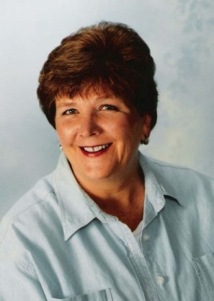  Cheryl Barnes  West Chicago, IL  Golden Threads | Cheryl’s loves auditioning and selecting just the right quilting designs that will enhance any quilt top. She is the founder/owner of Golden Threads, which publishes quilting designs in many formats. Her personal goal is to empower and educate quilters to become confident and excited about quilting their tops. Cheryl has authored several books, magazine articles, filmed training DVD’s for frame quilters and has appeared numerous times on quilting shows filmed for TV and the Internet.
Sandra Betzina
San Francisco, CA
Power Sewing
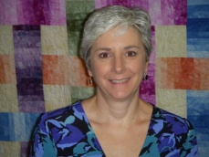  Carol Bledsoe  Gardenville, NV  Alto's/Sew EZ Quilting | Carol Bledsoe began sewing at an early age. She made mostly clothing and home dec items until she started quilting in 1992. She started taking quilting classes in 1995. From that point on she was hooked. Her mentor is her mom who is an avid quilter. She taught Carol that it’s OK to think outside the box.  Carol is the Alto’s QuiltCut2 Distributor and Teacher/Rep for the Western United States. She does shows, works with shops and quilt guilds in Washington, Oregon, California, Arizona, Nevada, Utah and Colorado. Whenever possible she teaches classes. Her most popular class is the QuiltCut Owner and Prospective Buyer Class which is a hands-on class that she has developed to teach people how to use the QuiltCut2 Fabric Cutting System to its full potential.
Ryliss Bod
Tacoma, WA
Bates Technical College
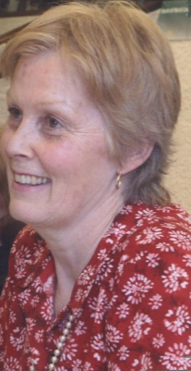
Jan Bones
Winnipeg, Manitoba
Lingerie Secrets Patterns
Lorene Bonewitz  Hurst, TX  Sew It Up.com | Lorene Bonewitz is the owner and founder of The Grapevine Collection of Fine Fashion Fabrics which had its start in 1998 in Colleyville. Texas. This shop is a culmination of her passion for sewing and embroidery. Her career path previously, however, was in the fields of education, as a college and high school language teacher and, in real estate, as a broker of homes and commercial developments in Houston. In 1986, she and her husband moved to the Dallas/Ft Worth area and were blessed with two wonderful children. She stayed home raising them for 10 years, all the while honing her skills in sewing and embroidery. Lorene actually began sewing at the age of 9 designing new garments for her Barbie. With the help of her mother and both grandmothers, who all sewed and embroidered, Lorene was exposed to many forms of fiber art. Since opening the shop, she has travelled and studied with many of her mentors: Margaret Islander, Sandra Betzina, Judy Barlup, Judith Baker Montano, Diana Vandervoot, Susan O'Connor, Martha Pullen, Beverly Sheldrick and Lynn Weeks to mention just a few.  In order to reach customers worldwide, Lorene opened up SewItUp.com, which is her website,a natural extension of The Grapevine Collection. Making sample garments and accessories to inspire her customers who, in turn, wanted to copy them, gave Lorene the idea of kitting up her designs. These kits are the core of the web store. The quality of the fabric selection found at the shop, along with the quantity of specialty trims and buttons, make SewItUp.com's kits stand out. Her trims have been featured in Sew News several times, her fabrics in the May 2007 issue of Southern Living as well as the most recent January 2009 issue. This issue heralded her newest endeavor, Sewing in Sothern Comfort. She is leading four retreats scheduled for 2009 which are three day sewing escapes. Also, her kits were in the summer 2008 issue of Butterick and McCall's Sewing Today and the incredible six page feature article in the August 2008 issue of Sew Beautiful. Lorene has two new apron kits which will appear in the upcoming March issue of Quick Quilts and then an article regarding the quality of her kits in the May issue of Sew News.  Lorene's initial dream in opening up a shop was to share with others her knowledge and passion for the needle arts in an environment where women feel at home in to learn and grow. Most of her customers would agree that she has accomplished that goal. You may visit the shop on any Wednesday or Thursday from 10am - 5pm, or any Friday or Saturday from 10am - 4pm. It is located at 700 West Harwood, Ste B in Hurst, Texas. The phone number is 817-514-6061. Please visit her website at www.sewitup.com
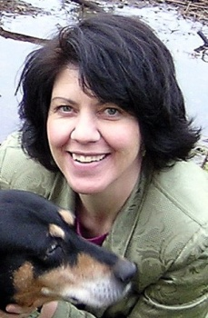
Dana Bontrager
Kamiah, ID
Dana Marie Design Co.
Ann Bourgeois
Ontario, Canada
Philosophers Wool
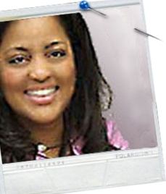  Tammie Bowser  South Pasadena, CA  Mosaic Quilt Studio | She is a contemporary artist with an ability to paint with fabric. She excels at teaching this art to others. Her art reflects passionate energy with the use of only fabric and thread. The images have an element of magic that is surprising and award winning.  In her previous career, she was a fashion designer and she has been expressing herself in fabric since four years of age. She has demonstrated her ideas on “Simply Quilts”, “Sewing with Nancy” and The Smithsonian Craft Show. Winner of the Japan award at Quilt National ’07.  In the current economic climate Tammie has learn how to use Social Media to keep her business alive and thriving…and growing! She can teach you why reputation and trust are important in web 2.0 world and knowing what technologies to use and how to make more money for your craft business!
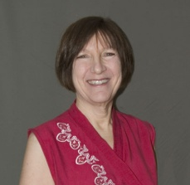 | Bobbi Bullard  Bullard Designs  Award winning Bobbi Bullard has been a leader in the embellishment and machine embroidery world since 1996. Focusing on beautiful clothing that is flattering to the wearer, she teaches a variety of processes including new ways of combining machine embroidery, dyes, and rubber stamps. Bobbi’s work has been seen in Threads, Belle Armoire, Creative Machine Embroidery, Quiltmaker, Embroidery Journal and Designs in Machine Embroidery.
Eleanor Burns
Quilt In A Day
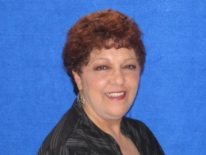  Maddie Bushman  Janome America | Maddie Bushman is our bi-lingual international educator for Janome America. She teaches embroidery for the beginner/intermediate, Digitizing, Customizing, garment construction, pattern fitting, Quilting, home decor and crafts. She is considered one of our Serger experts and has been instrumental in introducing our new models. Several of her projects are featured on Sew News Magazine, the Janome website and in the Janome Digest as well as. She has also been a television guest several times on the Kaye Wood Show (Kaye’s Quilting Friends) and Quilt Central TV. She has traveled throughout the United States, Central America, Belgium, Holland, Spain, Costa Rica and The Dominican Republic teaching and promoting the benefits of owning Janome Sewing/Embroidery machines and sergers.
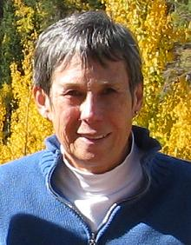  Karen Campbell  Wild Ginger Software | Karen Campbell learned to hand sew when she was 5 and started making her own clothes at age 12. Commercial patterns were just a starting place for creating her own designs. While living in Japan she studied flat pattern design and tailoring.  She has taught sewing and flat pattern design to children and adults and written articles on design and construction techniques. She has also done Costume Design. Many of her designs & flat pattern techniques are featured in "The Costume Book" by Mary Burke Morris.  She currently lives in Colorado Springs, CO with her husband Jim and four black cats.
Teri Chandler
Sew Wonderful Dreams
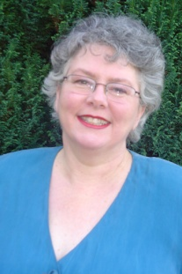  Kathleen Cheetham  Petite Plus Patterns | Kathleen Cheetham is an author, designer and pattern maker who believes that every woman can look great if she sews. Kathleen produces Petite Plus Patterns®, operates a custom-sewing and pattern making shop and teaches classes on fitting, design and technique. She is the author of Perfect Plus, Sew a Mix & Match Wardrobe for Plus & Petite Plus and a contributing author to Threads and Sew News magazines.
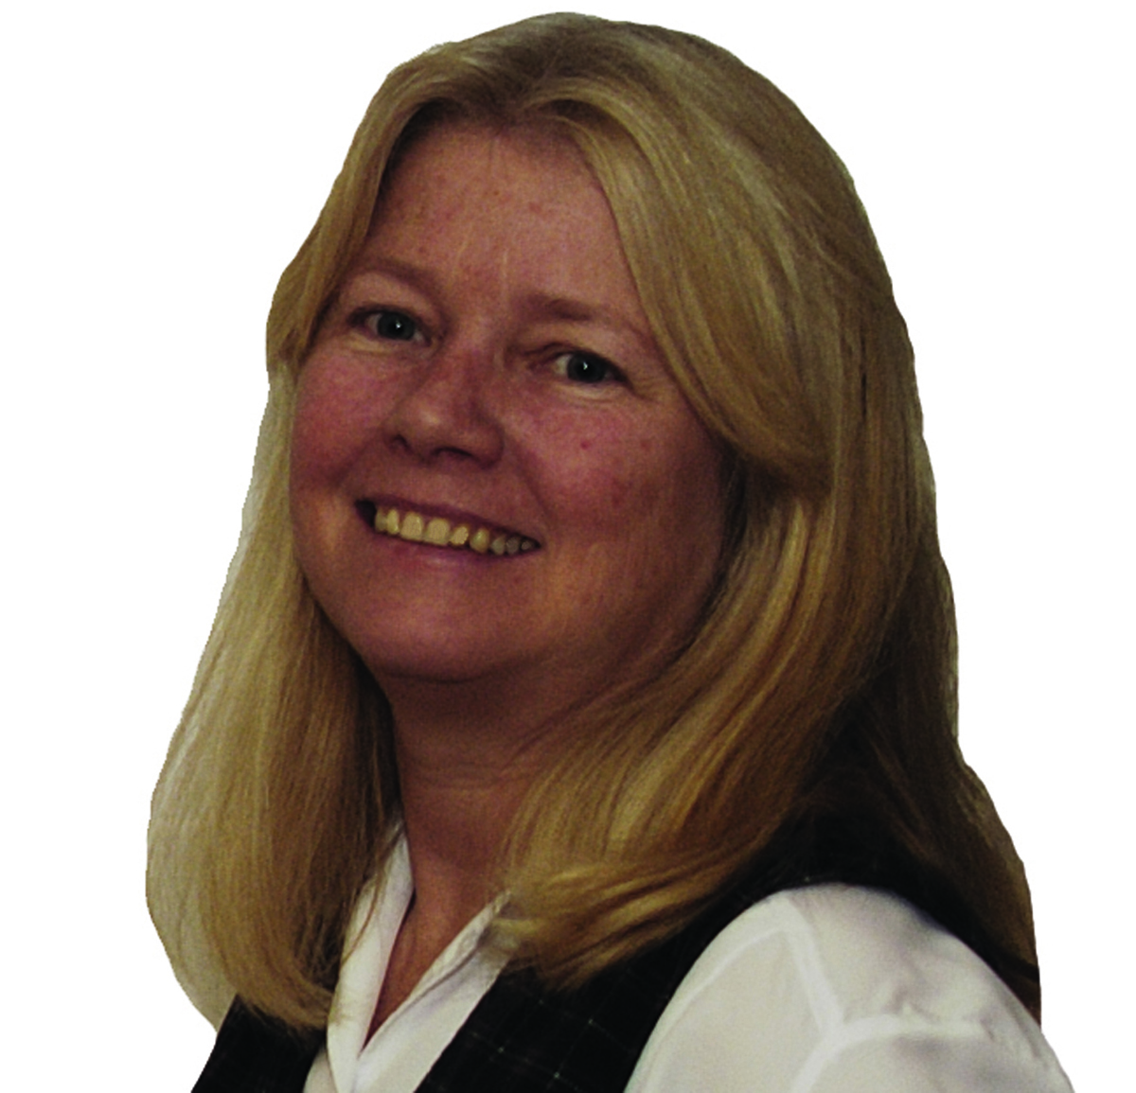  Kandi L. Christian  Sew Timeless | Kandi L. Christian, MBA is a well-known instructor of classes both in the US and England. She is a author of six books on sewing and the business of sewing and teaching. She frequently writes articles for major sewing and embroidery magazines. She had been a featured speaker and many sewing events throughout the US. Her “Turning Your Passion to Profit” business lectures are always sell out She was also tapped by the BBC to be their expert seamstress for their TV show “While You Were Out.” In addition to owning Sew Timeless, she is a licensed Martha Pullen instructor,
Pam Clarke  Design With Lines/Log Cabin Dry Good | Pam Clarke has been quilting since the late 1960's and sewing for 46 years. She lives in Spokane, WA and grew up in Sacramento, CA. Pam has been machine quilting and teaching machine quilting, piecing and applique classes since 1988. She is the owner of Homes Stitches, a professional machine quilting business tht was started in 1099 and Log Cabin Quilt Shop which offers longarm machine rental, classes and quality fabric. Her work can be seen in several published magazines and books. She quilted for Debbie Mumm, K-P Kids, Fiber Mosaics, Mary Lou and Company, Fabric Sales, Kaufman, Bernatix, Retta Weirheim and Martingale. To date, she has quilted over 7000 quilts and has made several hundred. Pam has appeared on Quilt Central and with Linda Taylor for PBS.
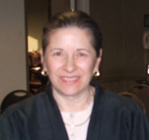  June Colburn  June Colburn Designs II Inc | Designer June Colburn is best known for her clothing and quilt designs featuring Asian styles and fabrics, available in her June Colburn Designs II line of patterns. Several of her ethnic and fashion patterns have also been featured in Simplicity Pattern catalogs for several years. A three-time Bernina Fashion show participant and guest on Simply Quilts, June teaches and lectures on Asian design, color, many sewing, quilting and embellishment techniques, including dyeing, discharging and silk screening. Contact her at: june@junecolburn.com, and visit her website: www.junecolburn.com.
Ron Collins
Power Sewing
Barbara Crawford
Crawford Designs
Connie Crawford
Fashion Patterns by Coni
Glorianne Cubbage
Bernina NW
Louise Cutting
Cutting Corners Inc
Pam Damour
The Decorating Diva
Glennis Dolce
Shibori Girls Studio teach for Things Japanese
Karen Erickson
Home Fashions U
Alba Fekete
Janome America
Nancy Fiedler
Janome America
Lee Fletcher
Sulky of America
Jane Garrison
YLI Corporation
Helen Gibb
Helen Gibb Ribbonwork
Geri Grasvik
The Pink Needle
Janeal Grosinger
Jaicee Designs Inc
Judy Hahner
Bernina of America
Simon Haskins
Jenny Haskins Products/RNK Distributing
Maggie Hayes
The Pine Needle
Lorraine Henry
LH Enterprises/Two Easy Tape Co.
Joan Hinds
Fancywork & Fashion
Mary Jo Hiney
Mary Jo Hiney Designs
Nannette Holmberg
Faux Chenille
Laura Jones
Beach Garden Quilts
Sharlene Jorgenson
Quilting From The Heartland
Debra Justice
Labours of Love
Stephanie Kelinman
Fabric Studio
Deborah Kreiling
Simplicity Pattern Co. Inc
Linda Lee
The Sewing Workshop
Cindy Losekamp
Sew Artfully Yours
Roberta Lowes
Fibers Etc.
Linda MacPhee
MacPhee Workshop
Marsha McClintock
SAF-T-POCKETS Patterns
Linda McGehee
Ghee's
Carol McKinney
Janome America
Lyla Messinger
LJ Designs
Megan Miles
Pacific Fabrics & Crafts
Sandy Miller
Cutting Corner
Kathy Monoghan
Pendelton Woolen Mill Store
Mary Mulari
Mary's Productions
Mary Libby Neiman
On The Surface
Luveta Nickels
The Junk Jeans People
Tammy O'Connell
Peacock Patterns
Pattie Otto
Great Copy Patterns
Pati Palmer
Palmer/Pletsch
Carla Peery
Carla Peery Designs teaching for Things Japanese
Malah Peterson
Sulky of America
Vaune Pierce
Vaunce
Cecelia Podolak
Material Things
Dodi Lee Poulsen
Pacific Fabrics & Crafts
Bob Purcell
Superior Threads
Heather Purcell
Superior Threads
Sue Purdy
Sue's Solar: Printing & Silk Screens
Mary Lou Rankin
Park Bench Pattern Co.
Mattie Rhoades
Quiltsmart teaching for Of My Hands
Londa Rohlfing
Londa's Creative Threads
Kathy Ruddy
Live Guides Inc
Peggy Sagers
Silhouette Patterns
Becky Scellato
Shibori Dragon
Lisa Shaw
Buzz Tools Inc
Linda Simmons
Sulky of America
Robyn Spady
Spady Studios teaching for Ah! Kimono
Connie Spurlock
Sew Wonderful Dreams
Kathy Stachowicz
Baby Lock
Janice Stewart
Janice Stewart Designs
Gita Sturm
Gita Maria Inc
Katherine Tilton
Marcy Tilton
Marcy Tilton
Marcy Tilton
Katrina Walker
Katrina Walker teaching for Things Japanese & Quality Sewing & Vacuum
Mech Watne
PerfectBorders.com
Cheryl Weiderspahn
Homestead Specialities Pattern
Linda Wenturine
Bernina of America
Morgaine Wilder
Carolien Homespun
Kaye Wood
Kaye Wood Inc
Dini Yan
Momo-Dini Embroidery Art
Nancy Zieman
Nancy Zieman Productions

