TOWN OF GRAND LAKE
ORDINANCE NO. 8-2011

AN ORDINANCE REPEALING AND REPLACING THE TOWN OF GRAND LAKE Municipal CODE CHAPTER 11 MUNICIPAL PROPERTY REGULATIONS

WHEREAS, pursuant to Colorado Revised Statutes, The Town of Grand Lake Board of Trustees has the authority to adopt and amend the Town of Grand Lake Municipal Code; and,

WHERAS, the Town of Grand Lake Planning Commission held a public hearing on this matter on March 16, 2011, and, after discussing the matter, provided a favorable recommendation to the Board of Trustees to adopt the proposed Ordinance 8-2011; and,

WHEREAS, the Town of Grand Lake Board of Trustees held a public hearing on this matter on May 9, 2011; and,

WHEREAS, The Town of Grand Lake Board of Trustees has determined that it is in the best interest to have all municipal property regulations in one Chapter of the Grand Lake Municipal Code,

NOW THEREFORE BE IT ORDAINED BY THE BOARD OF TRUSTEES OF THE TOWN OF GRAND LAKE, COLORADO, THAT:

Part 1: Chapter 11 of the Code of the Town of Grand Lake, Colorado, is hereby repealed and replaced to read as follows;
Chapter 11
Municipal Property Regulations

Chapter 11-1: Purpose and Scope
- Standards and Regulations for Improvements within Right-of-Ways
  - General Standards and Regulations
    - Street, Sidewalk and Boardwalk Plan: The arrangements, classification, extent, width, grade and location of all streets, sidewalks and boardwalks shall conform to the street, sidewalk and boardwalk plans and Municipal Code of the Town and shall be designed in relation to existing and planned streets, sidewalks and boardwalks, topographical conditions, public convenience and safety, and the proposed uses of the land to be served by such streets, sidewalks and boardwalks.

Chapter 11-2: Street Development Policies, Standards and Specifications

- PURPOSE AND SCOPE
  - PURPOSE - The purpose of this document is to specify established standard principles and practices to be used in the design and construction of streets in order to provide for uniformity of streets within the Town of Grand Lake and to ensure the safety of the general public. Designs of streets for construction within the Town of Grand Lake limits shall be approved by the Town prior to such construction. The design factors, formulas, and tables are intended to serve as guidelines for street design. Ultimate responsibility for actual design, however, remains with the design engineer. Sound engineering judgment must always be applied.
    - The purposed of this Section Ordinance is to define policies and procedures, as well as to establish standards relating to the development of new streets and the improvement of existing streets in the Town of Grand Lake. The Section Ordinance is not intended to be used as a substitute for knowledge, experience, or judgment, but as a guide to aid in deciding those factors needed to intelligently plan, design, construct, and upgrade Town streets.
    - Simply meeting the minimum requirements contained herein is discouraged. For example, higher standards should be used in those situations where they could be applied at little or not extra cost. On the other hand, If in a particular circumstance it can be clearly demonstrated that a certain requirement is unduly restrictive, a variance will be considered.
    - The requirements contained herein shall apply to all new construction or other work done one, over, or under any town street, Town street right-of-way, or other streets within the jurisdiction of the Town of Grand Lake that are planned for, subject to, or may become subject to public use.
- GENERAL PROVISIONS
  - SHORT TITLE - These regulations, together with all future amendments, shall be know as the Town of Grand Lake Street Development Policies Standards and Specifications Manual (hereinafter referred as Street Standards). The original Street Standards were adopted by the Board of Trustees on July 9, 1973, and are hereby repealed and replaced with these Street Standards.
  - JURISDICTION - These Street Standards shall apply to all land within the Town of Grand Lake except where superseded by State of Colorado Department of Transportation jurisdiction.
  - TRAFFIC IMPACT STUDY
    - A traffic impact study, prepared by a Licensed Colorado Registered Professional Engineer, is required for street classification or developments forseeably expected to cause a 20% increase in traffic to adjacent roadways, or as required by Planning Commission or Town Staff. A traffic impact study shall conform to the State of Colorado Access Code (Section 2.3 Part 5c). The traffic impact study shall reference the Institute of Transportation Engineers Trip Generation Manual to determine traffic volumes for each land use. In general, existing and proposed infrastructure improvements shall be determined by information provided by the owner/applicant in the Traffic Impact Study and by comments generated during Town of Grand Lake review and acceptance of that study.
    - Design elements such as asphalt paving, curb and gutter, and sidewalks, may be required by the Planning Commission, Town Staff, Public Works Director or results from the Traffic Impact Study.
  - PURPOSE - The purpose of this document is to specify established standard principles and practices to be used in the design and construction of streets in order to provide for uniformity of streets within the Town of Grand Lake and to ensure the safety of the general public. Designs of streets for construction within the Town of Grand Lake limits shall be approved by the Town prior to such construction. The design factors, formulas, and tables are intended to serve as guidelines for street design. Ultimate responsibility for actual design, however, remains with the design engineer. Sound engineering judgment must always be applied.
  - REVIEW AND APPROVAL - The Town Staff (or hired Engineer) will review all submittals for general compliance with the specific Street Standards. An approval by the Town does not relieve the owner, engineer, or designer from responsibility of ensuring that the calculations, plans, specifications, construction and record drawings are in compliance with the Street Standards. PERMIT AND REGULATIONS
    - Any person, business, corporation, governmental agency or any other entity wishing to perform construction and/or excavation work in the Town right-of-way shall obtain a Right of Way Permit from the Town.
    - A Right of Way Permit shall be required for each excavation site in the Town right-of-way.
    - The permit shall be issued only to the person, business, corporation, governmental agency or other entity who shall be doing the actual excavation work and who shall be responsible for compliance with rules, standards and specifications imposed by this Chapter.
    - The cost for the issuance of each Right of Way Permit shall be Twenty ($20.00) Dollars set by Resolution, as adopted by the Town Board of Trustees.
    - Right of Way Permits shall be obtained seven (7) days prior to the beginning of excavation.
      - Unless a bona fide emergency exists constituting an immediate danger to life, health, or property, failure to obtain a Right of Way Permit at least seven days in advance of the beginning of excavation shall be cause to assess a penalty of 100% of the amount of the fee of the permit.
    - At the time of application, the applicant shall submit construction plans, specifications, and written work schedule covering the general sequence of work to be performed.
      - A sketch will suffice for minor installations.
      - Permits for major installations shall be signed by the Town.
      - Failure to submit these items shall be sufficient reason to deny the application for the permit.
      - Neither the submitted specifications nor the work schedule may be modified after the Right of Way Permit has been issued without the written consent of Town Staff.
      - Unless otherwise specified on the permit, Right of Way Permits shall be valid for the period of four (4) weeks from the date of issuance.
      - The schedule and the plans shall not be changed after the License is approved without the consent of the Town.
    - The Town may regulate and require such safety and warning equipment, safety practices, hours of work, or any other aspect of the proposed work it deems necessary to protect the public health, safety and welfare.
    - Unless by emergency, no work will be permitted to start on a Friday, nor continue through the weekend.
    - Applications must be submitted, and approved by Town Staff. No permits shall be issued without permission of the Town.
      - Generally, applications should not be submitted between October 8th and April 25th and all construction should be completed by October 15th.
      - Permits may be issued, pending weather, on a case-by-case basis, between October 15th and May 1st.
    - Permits must be available at the work site on demand to Town personnel at all times.
  - BONDING AND INSURANCE
    - Bonding
      - No such permit shall be issued unless and until the applicant has filed with the Town a bond conditioned to indemnify the Town (and its officers and employees), or evidence of insurance for any liability (including defense costs) of Town (and its officers and employees), for any loss, liability or damage that may result or accrue from or because of the making, existence or manner of guarding or constructing any such excavation.
        - The term “Bond” shall be any uncancellable surety secured unto the Town and acceptable to the Town Attorney. Bonds shall be in the amount of 115% the estimated construction cost as approved by the Town Staff. A Warranty Performance Guarantee shall be equal to fifteen percent (15%) of the total estimated cost of the improvements. The Warranty Guarantee shall provide security for the costs which may be incurred in repairing and/or replacing improvements during a warranty period of two years following Initial Acceptance by the Town.
          - If the applicant anticipates the need for more than one (1) Right of Way Permit in the following twelve calendar months acceptable collateral in the amount of Ten Thousand ($10,000) Dollars shall be required for the twelve month period.
      - Bonds shall be forfeited if local public pressures warrant Town participation in completing the work, or if in the opinion of the Town, the work is not progressing in a satisfactory manner. As logical units of work are completed and approved by the Town Staff, application may be made for a partial release of bond.
    - Insurance
      - Such bond or insurance shall be in an amount of no less than $600,000.00, the rate of governmental immunity, and shall be issued by a business licensed to do business in the State of Colorado as a surety or insurer. Insurance shall be required in accordance with the municipal insurance requirements, as adopted by Resolution by the Town Board of Trustees.
    - The cost for the issuance of each Right of Way Permit shall be Twenty ($20.00) Dollars and shall be accompanied by cash, performance bond or other collateral acceptable to the Town in accordance with the schedule below:
      - If the applicant anticipates the need for one (1) Right of Way Permit in the following twelve calendar months and the length of the encroachment is:
        - less than 50 feet $1,000 collateral
        - more than 50 feet and less than 100 feet $2,000 collateral
        - more than 100 feet $25/linear foot of excavation collateral
      - If the applicant anticipates the need for more than one (1) Right of Way Permit in the following twelve calendar months acceptable collateral in the amount of Ten Thousand ($10,000) Dollars shall be required for the twelve month period.
  - REVIEW AND APPROVAL - The Town Staff (or hired Engineer) will review all submittals for general compliance with the specific Street Standards. An approval by the Town does not relieve the owner, engineer, or designer from responsibility of ensuring that the calculations, plans, specifications, construction and record drawings are in compliance with the Street Standards.
    - Approval of a development of land Land Use Development under these Regulations shall not constitute acceptance by the Town of the roads, streets, or other public lands as indicated for dedication on the Plat or Plan. The dedication of any of these lands for Town use of any nature within the Town shall be accepted by the Town only by specific action of the Town Board of Trustees.
  - INDEMNIFICATION - The holder of any right-of-way permit shall have no recourse whatsoever against the town or its officials, boards, commissions, agents, or employees for any loss, costs, expenses, or damages arising out of any provision or requirement of the permit or Road Standards, or because of the Town’s enforcement activities. Granting of a franchise or permit shall not imply or be construed to mean the Town shall be responsible for the design, construction, or operation of the facility or for public safety during the facility’s installation, operation, or maintenance.
  - Safety and Public Convenience
    - The Contractor shall at all times so conduct his work as to assure the least possible obstruction to public traffic. The safety and convenience of the general public and the residents along the road and the protection of persons and property shall be provided for at all times.
    - Flag men shall be required for one lane or otherwise unsafe operations.
    - Adequate warning signs, barricades, lighting, flags and other devices as may be required by the Public Works Director shall be provided and paid for by the Applicant.
    - Excavation operations are to conform to the requirements established by the Industrial Commission of Colorado.
  - Road Closures
    - When road closures are permitted, the Applicant must:
      - Submit a written notice to the Town one week in advance of the closing of the road.
      - Notify one week in advance the Grand Lake Fire Protection District and Grand County Sheriff’s Office of the exact location, date, and time traffic will be impeded.
      - Erect and maintain, at his own expense, necessary barricades, flashers, construction signs, flagmen and take all necessary precautions for public safety and convenience.
      - Road closures will be permitted only between the hours of 8:30 a.m. and 3:30 p.m., if an approved, adequately signed detour is provided and the closure was explicitly provided for in the permit.
    - No road closures are permitted for the weekends.
  - RELATIONSHIP TO OTHER STANDARDS - Since the Town is the approval authority for land use changes, these Street Standards, which stipulate certain minimum conditions for land use changes shall apply. If state government, federal government or special districts impose more stringent standards, this difference is not considered a conflict. The more stringent standard shall apply.
  - TOWN COMPREHENSIVE PLAN - The Board of Trustees has adopted Comprehensive Plans showing all streets, trails/walkways, and paving improvements for future planning in the Town of Grand Lake. Referencing these Comprehensive Plans to aid in design is recommended.
  - AMENDMENT AND REVISIONS - These policies and criteria may be amended as new technology is developed and/or experience gained in the use of these Street Standards which indicates a need for revision. The Board of Trustees, following the recommendations of the Town Staff and the Planning Commission, may consider amendments to these Standards.
  - REGULATORY COMPLIANCE - All work shall comply with all applicable federal, state, county, and local regulations.
  - PENALTIES/ENFORCEMENT
    - GENERAL - In addition to all other enforcement actions authorized under the code, the Town may withhold or withdraw plan or development permit approval, revoke approval, forfeit the submitted financial guarantee, and/or refuse to accept work performed, if a permittee fails to comply with any requirement set forth in this chapter or the Road Standards. Further, the Town may bring civil suit to enforce any requirement, enjoin violation or seek any other remedy available at law or equity.
    - ROAD APPROACHES - Failure to Construct Properly. In addition to all other enforcement actions authorized under the code, any person, firm, partnership, association, joint venture, corporation or other legal entity who fails to construct an approach properly will be required to compensate the Town for the improvement or removal of the approach. Compensation shall include administration time as well as equipment and materials to remove or improve the approach. Reimbursement shall be made to the Town of Grand Lake Public Works Department.
    - FAILURE TO NOTIFY - In addition to all other enforcement actions authorized under the code, if a permittee fails to notify the Town, as required by the Road Standards, then the Town may require sampling and/or testing post-construction, either by the Project Engineer or the Town. Costs for such testing and/or sampling shall be borne by the permittee. When such testing and/or sampling is required, the Town may prohibit or limit further work until all such tests and/or sampling have been completed and corrections made to the satisfaction of the Town. In addition to this provision, the Town reserves its right to bring any or all other enforcement action for the failure to notify.
    - INDEMNIFICATION - The holder of any right-of-way permit shall have no recourse whatsoever against the town or its officials, boards, commissions, agents, or employees for any loss, costs, expenses, or damages arising out of any provision or requirement of the permit or Road Standards, or because of the Town’s enforcement activities. Granting of a franchise or permit shall not imply or be construed to mean the Town shall be responsible for the design, construction, or operation of the facility or for public safety during the facility’s installation, operation, or maintenance.
  - SEVERABILITY - If any provision of this ordinance, or its application to any person, entity or circumstance is for any reason held invalid, the remainder of the Ordinance, or the application of the provision to other persons, entities or circumstances are not affected.
- ROADWAY DESIGN AND TECHNICAL CRITERIA
  - GENERAL
    - Streets shall be designed to bear a logical relationship to the topography and shall be paved with asphalt or concrete.
    - All streets (does not include driveways) shall be designed by a Licensed Colorado Registered Professional Engineer.
    - Unless modified herein, all designs shall comply with the CDOT (Colorado Department of Transportation) Design Guide, latest edition. Other manuals recommended for reference include A Policy on Geometric Design of Highways and Streets and Guidelines for Geometric Design of Very Low-Volume Local Roads (ADT<400) both published by the American Association of State Highway and Transportation Officials (AASHTO). Deviation from the requirements of these criteria must be approved by Town Staff.
  - STREET CLASSIFICATION
    - Streets in the Town of Grand Lake are classified according to the average daily traffic (ADT) associated with a particular road. For design purposes, street classifications will be determined by the Town, or a traffic study, prepared by a Licensed Colorado Registered Professional Engineer, will be required. The following street classifications (determined by the ADT) shall be utilized in determining the criteria under which a street is to be designed.
      - Major Collector Streets (ADT > 2000) – Designed for the movement of heavy local traffic. Major collectors generally connect minor collectors and some local streets to arterials and highways. Parking is discouraged on major collectors. (example - West Portal Road)
      - Minor Collector Streets (ADT 500 - 2000) – Designed for the movement of principle generators within a community, such as neighborhood shopping centers, schools and recreation areas. Minor Collectors carry traffic from local streets to Major Collectors. (example - Center Drive)
      - Local Streets (ADT < 500) – Provide primary access to abutting properties.
        - Commercial (example - Grand Avenue)
        - Residential (example - Mountain Avenue)
  - INSPECTION AND TESTING
    - Adequate inspections assure compliance to Town standards and are the basis for the Town Staff recommendation to the Board of Trustees for maintenance acceptance and for release of bond.
    - All soils and material testing shall be done by a soil/material-testing firm under the supervision of a Colorado Registered Professional Engineer.
    - Improvements made within Town ROW, soil testing and identification of the existing conditions shall be submitted to the Town with recommendations for structural section. Structural sections shall be designed in accordance to 2.14 Pavement Design.
    - Improvements within Town ROW shall be supervised by a soil/material-testing firm. The testing firm will be required to provide subgrade and road base for compaction test, materials testing of asphalt, road base, and concrete, and density tests of asphalt. All tests shall meet CDOT requirements. Reports shall be provided to the Town.
    - If unsuitable soils are encountered, a modified design shall be submitted by the soils-testing firm to the Town for approval.
    - The Town may not accept projects or may require a longer warranty period if there are test failures or testing has not been completed according to the requirements of this section or recommendations by the soils-testing firm.
  - TOWN MAINTENANCE - Acceptance of town roads does not constitute acceptance for town maintenance or access by emergency vehicles.
  - BONDING AND INSURANCE
    - The term “Bond” shall be any uncancellable surety secured unto the Town and acceptable to the Town Attorney. Bonds shall be in the amount of 115% the estimated construction cost as approved by the Town Staff. A Warranty Performance Guarantee shall be equal to fifteen percent (15%) of the total estimated cost of the improvements. The Warranty Guarantee shall provide security for the costs which may be incurred in repairing and/or replacing improvements during a warranty period of two years following Initial Acceptance by the Town.
    - Bonds shall be forfeited if local public pressures warrant Town participation in completing the work, or if in the opinion of the Town, the work is not progressing in a satisfactory manner. As logical units of work are completed and approved by the Town Staff, application may be made for a partial release of bond.
  - DESIGN DRAWING REQUIREMENTS
    - All construction plans, pertaining to this Street Design Criteria, designed for construction in the Town of Grand Lake must meet the following criteria:
      - 24 inch by 36 inch blueline or blackline prints.
      - 1 inch = 50 feet horizontal and 1 foot = 5 feet vertical or 1 inch = 20 feet horizontal and 1 inch = 2 feet vertical. (Larger scales will be considered.)
      - The plan must include a statement, signed and stamped by the Registered Licensed Professional Engineer who prepared or directed preparation of the construction plans, on the cover sheet:
        - “These construction plans for (name, subdivision, development, or project) were prepared by me (or under my direct supervision) in accordance with the requirements of the Town of Grand Lake.”
        - Name of Engineer
        - Name of Firm
    - Any construction plans, pertaining to this Street Design Criteria, designed for construction in the Town of Grand Lake shall contain the following information:
      - Scale.
      - North arrow.
      - Plan view of all streets, including neighboring streets.
      - Grades.
      - Profiles or existing ground and proposed street at centerline (existing ground dashed).
      - Length of vertical curves, BVC’s, EVC’s and PVI’s.
      - Culverts including locations, size and slope, and minimum cover.
      - Cross pans including location, size and slope.
      - All other structures.
      - Existing and proposed utility locations and elevations.
      - Existing and proposed signage.
      - Bench Mark, located within 1,000 feet of the street, tied to U.S.G.S. datum, and referenced to the Town of Grand Lake datum.
      - Horizontal curve data including radii, delta angles, bearing, distances, centerline stations at 100 foot intervals, and BC and EC stationing.
      - Right-of-way widths.
      - Street cross sections for all typical sections.
      - Street Names, including all intersecting streets.
      - Flow arrows showing direction of drainage.
      - Existing and finished grade contours, 2’ spacing (1’ spacing may be requested for more detail in flat areas).
      - Complete design drawings for all structures, such as bridges and box culverts.
      - Stamp and signature of the Licensed Colorado Registered Professional Engineer under whose direction the plans were prepared.
      - Snow Storage Area
      - Soils report (where required).
  - AS-BUILT DRAWING REQUIREMENTS - Upon completion of all improvements, the design engineer, soils engineer, and construction engineer shall provide a letter to the Town that all improvements have been constructed per the approved road design and construction plans. A set of as built drawings shall be provided prior to the final inspection of the improvements and any release of any remaining financial guarantees. The Warranty Guarantee becomes effective at time of final inspection approval.
  - TRAFFIC IMPACT STUDY
    - A traffic impact study, prepared by a Colorado Registered Professional Engineer, is required for street classification or developments forseeably expected to cause a 20% increase in traffic to adjacent roadways, or as required by Planning Commission or Town Staff. A traffic impact study shall conform to the State of Colorado Access Code (Section 2.3 Part 5c). The traffic impact study shall reference the Institute of Transportation Engineers Trip Generation Manual to determine traffic volumes for each land use. In general, existing and proposed infrastructure improvements shall be determined by information provided by the owner/applicant in the Traffic Impact Study and by comments generated during Town of Grand Lake review and acceptance of that study.
    - Design elements such as asphalt paving, curb and gutter, and sidewalks, may be required by the Planning Commission, Town Staff, Public Works Director or results from the Traffic Impact Study.
  - PARTIALLY DEVELOPED RIGHT-OF-WAY
    - Half streets are prohibited.
    - When a proposed half street in one subdivision is adjacent to another property, the approval of the adjacent owner shall be obtained and the entire right-of-way shall be platted and dedicated by the owners. The responsibility for acquiring the additional right-of-way shall be with the sub divider.
  - STREET NAMES AND NEW STREETS
    - New streets are added to the Town Street System by Resolution passed by the Board of Trustees.
    - Sources of new streets are: Additions, realignments, Relinquished State Highways, Subdivisions and other developments.
    - Before a new street becomes a part of the Town Street System, the owner/applicant must follow the procedures for acceptance outlined by the Town of Grand Lake.
    - Names of new streets shall not duplicate names of existing streets. New streets which are extensions of or which are in alignment with existing streets shall bear the names of the existing streets.
    - The Town of Grand Lake reserves the right to review/approve any street names.
  - SNOW STORAGE AREA
    - Dedicated snow storage areas shall be shown on the construction plans. The required snow storage to provide is calculated at 33% of the total parking, pathways, and driving areas (including shoulders).
      - The Condominium/Townhome/HOA Declarations shall provide for the removal of snow by the owner’s association when storage areas are at capacity upon notice by the Town.
  - SIGNAGE AND STRIPING PLAN - All signs and street markings shall be designed, constructed, and placed in accordance with the Manual of Uniform Traffic Control Devices, latest edition, unless otherwise approved by the Town.
  - TEMPORARY UNPAVED STREET
    - Under certain circumstances, the Town Staff may allow either a delay of final paving of a new street, or a delay in the final lift, until the following construction season to allow sufficient time for roadway stabilization or until a certain percentage of build out occurs.
      - In those cases, all street construction up to and including base work shall be completed.
      - While unpaved, the Town of Grand Lake shall require maintenance such as, but not limited to dust control and continuous grading.
      - Unpaved streets shall be graded to a three percent crown and then re-graded and compacted as required by these standards prior to paving.
      - Unpaved streets may not be accepted by the Town for maintenance purposes.
- ROADWAY SPECIFICATIONS
  - Roadways shall be designed using the standards in the CDOT Design Guide unless otherwise modified herein. Items not covered in either source shall use A Policy on Geometric Design of Highways and Streets. Table 4 summarizes the minimum roadway construction requirements.
  - Additional Guidelines for Private Streets
    - Development Abutting Major Rights-of-Way - Where a development abuts or contains an existing or proposed primary street or highway, the Planning Commission may require service streets, reverse frontage lots with screen planting in a reservation strip along the rear property line, deep lots with rear service alleys abutting the primary street or highway, or such other treatment as may be necessary for adequate protection of residential properties and for separation of through and local traffic.
    - Development Containing Major Right-of-Ways - Where a development borders on or contains highway right-of-way, the Planning Commission may require a street approximately parallel to and on each side of such right-of-way, at a distance suitable for the appropriate use of the intervening land. Such land would be appropriately used for park purposes in residential districts, or for commercial or industrial purposes in non-residential districts. Such distances shall be determined with due regard for the requirements of approach grades and future grade separations.
    - All private streets shall be conveyed to a private home or property owners association. If the private association or person(s) owning the private streets in the Development should in the future request that any private streets be changed to public streets, the private association or owner(s) will bear the full costs of reconstruction or any other action necessary to make the streets conform to the applicable standards for public streets. The private association or owner(s) shall also agree that these streets shall be made to conform and be dedicated to public use without compensation to the private association or owner(s).
    - Private streets shall afford abutting properties reasonably adequate access for entry by private and emergency vehicles and should be designed to standards at least equal to public streets.
  - INGRESS AND EGRESS
    - Subdivision road system shall be designed with two or more dedicated access roads for separate, multiple ingress and egress, where practical.
    - Restriction of access shall be required when a development or portion thereof adjoins an arterial highway. Marginal access streets, reverse frontage with screen planting contained in a non-access reservation, deep lots or similar treatment shall be required to reduce the impact of traffic on residential properties and to avoid interference with the movement of the traffic on arterial highways.
  - SIDEWALKS AND PATHWAYS
    - Sidewalks, pedestrian, and bicycle paths shall be constructed in accordance with the roadway templates and/or the Town’s master trail concepts. See Table 4 and Figure 4.
    - Streets with on street parking require sidewalks or boardwalks.
    - Handicap ramps shall be shown at all curb returns and must be shown (located) at all "T" intersections. Whenever designing a handicap ramp, reference the Town of Grand Lake Standard Detail to be used to construct that ramp. See Figure 5.
  - CUL-DE-SAC TERMINUS CRITERIA
    - Dead end streets, with the exception of those indicated in this Section, shall be prohibited.
    - Cul-De-Sac Criteria
      - See Figure 6 for cul-de-sac configuration.
      - If topography dictates the use of a longer cul-de-sac, the approval of the Town Staff shall be obtained.
      - Drainage should be toward the intersecting street or a drainage easement shall be required between the cul-de-sac and the rear lot line of the lowest lot.
    - A T-shaped and Y-shaped terminus may be provided in mountainside developments as an alternative to the circular turnaround. Where provided, the “wings” of the T or Y shall be at least twenty feet (20’) deep, measured from the street boundary, and at least sixteen feet (16’) wide exclusive of parking space. Curbs at the intersection of the street and the “wings” of the T or Y shall be rounded with a minimum radius of twenty feet (20’).
  - HORIZONTAL ALIGNMENT - See Table 1 below.
    - Table 1: HORIZONTAL CURVES

Design Speed (mph) | Minimum Curve Radius* (Ft.)
20 | 110
25 | 200
30 | 330
35 | 510
40 | 760
* AASHTO “Green Book”

    - Standard for Curvature – Table 1 gives minimum centerline radii for curves. The table is based on design speed only. Increased radii may be required if minimum sight distances are not satisfied.
    - Super elevation – Refer to the AASHTO, latest edition. For low speed Local Streets super elevation is generally not used. Consult with the Town if super elevation is used.
    - Small Deflection Angles – For small deflection angles, curves should be of sufficient length to avoid the appearance of an angle in the road.
    - Reversing Curves – True reversing curves shall not be used in the Town of Grand Lake except as noted herein. In cases where curves in opposite directions must be used, a tangent between shall be used. A minimum 50-foot tangent shall be used if at all possible between reverse curves to facilitate steering and control. Lesser tangent lengths may be considered with deflection angle curves less than 10 degrees.
    - Broken Back Curves - Broken back curves consisting of two curves in the same direction joined by a tangent less than 50 feet shall not be used in the Town of Grand Lake, except on local streets with prior approval from the Town Staff.
    - Coordination with Vertical Alignment – To avoid the possibility of introducing serious traffic hazards, coordination is required between horizontal and vertical alignment. Particular care must be exercised to maintain proper sight distances at all times.
    - Pavement Transition – A pavement transition is the area of variable pavement width encountered when changing from one roadway width, or section, to another. All pavement transitions shall be based on the following formula:
      - L = WS² /60
        - Where: L = length of transition or taper (in feet)
        - S = posted speed limit (in mph)
        - W = offset in feet
  - VERTICAL ALIGNMENT - Design controls for vertical alignment are shown on Table 2 below.
    - Table 2: VERTICAL ALIGNMENT CONTROLS (From AASHTO “Green Book”)

Description | Design Speed | Min. K Value Crest | Min. K Value Sag
Local | 20 | 7 | 17
Local | 25 | 12 | 26
Local | 30 | 19 | 37
Collectors | 35 | 29 | 49
Collectors | 40 | 44 | 64
Collectors | 45 | 61 | 79

    - Grade Line – The grade line is a reference line by which the elevation of the pavement and other features of the roadway are established. The grade line shall coincide with the street centerline for all streets.
    - Grade – The minimum and maximum grades as measured at centerline shall be 1.0% and 8.0%, respectively. Grades in excess of 8.0% will require a variance request. The maximum permissible grade at intersections is shown in Section 2.7, Part 4.
    - Excessive changes in grade, which create a roller coaster effect, shall not be permitted. Connections with existing streets shall be smooth transitions and existing grades shall be shown in the design for at least 150 feet on all sides of a connection.
    - Vertical Curves – Properly designed vertical curves should provide adequate sight distance, safety, comfortable driving, good drainage, and pleasing appearance. Vertical curves in the Town of Grand Lake shall be parabolic curves. The use of grade breaks in lieu of vertical curves is discouraged. However, if a grade break is necessary, the algebraic difference shall not exceed 0.80% (.008 ft/ft).
  - STOPPING SIGHT DISTANCE
    - A primary consideration in the design of a street is to provide adequate sight distance for safe and efficient operation. AASHTO standards shall be met for these types of sight distance.
    - Table 3: STOPPING SIGHT DISTANCE (From AASHTO "Green Book”)

Design Speed (mph) | Stopping Sight Distance
15 | 100
20 | 125
25 | 150
30 | 200
35 | 250
40 | 275
45 | 325

  - INTERSECTION ALIGNMENTS
    - Intersections of local streets with major streets shall be kept to a minimum. Whenever intersections do not align, offsets should be designed according to the roadway classification and follow Figure 7.
    - Minimum angle of Intersection – Intersections shall approximate right angles as closely as possible. The minimum angle allowed for any type of intersection shall be 70 degrees.
    - Radius – All intersections shall have a paved radius on all four corners with minimum radius as shown in Figure 7. Design radii should accommodate the largest vehicle expected to commonly use the intersection.
      - For Fire Lane Configuration see Figure 8.
    - Cross Street Standard – All local streets intersecting Major Collector Streets shall be constructed to Minor Collector Street standards for a distance of 200 linear feet as measured from the edge of the Major Collector Street right-of-way. This shall include street width (asphalt and base) and right-of-way width.
    - Grades – Grades at intersections are based upon street classification.
      - Table 4: GRADES

Collector | Local
100’ @ 3% max. | 100’ @ 3% max.
100’ @ 3% max. | 50’ @ 4% max.

    - Maximum grades may be increased in extreme terrain when approved by the Town. Access to cross streets should be designed to the section of lesser grade whenever possible, although flattening the through street at the intersection is recommended.
    - Separation – Intersections shall not occur at less than 300 linear foot separation wherever possible. In no case shall two intersections be within 200 linear feet (edge to edge of ROW) of each other. Opposing intersections (4 way) are required when intersecting with a major road and certain intersections of two collector streets. T-type intersections have shown to be far safer than cross-type and shall be considered in the design of residential subdivisions. See Figure 7.
    - Intersection at a Curve – Intersections should not be placed on a curve unless all applicable sight and stopping distances are complied with.
    - Intersection Sight Distance – Intersection sight distance is defined by AASHTO as adequate when a driver has an unobstructed view of the entire intersection and sufficient lengths of the intersecting road to avoid collisions. AASHTO standards shall be met for the sight triangle. Obstructions of any type installed by private property owners are prohibited within Town ROW.
  - CONTINUATION OF ROADWAYS AND TRAILS
    - Streets, bike pathways, walkways, and easements shall be aligned to join with the planned or existing public ways adjacent to the subdivision. The Planning and Zoning Commission may require public ways to provide direct, continuous routes to all adjacent lands, whether such adjacent lands have been subdivided or not. The location of public ways providing access to adjacent lands shall be selected by the subdivision planner provided such location shall be reasonably calculated to provide usable access to the adjacent lands. The cost of such public ways leading to and within a subdivision shall be borne by the sub divider.
    - Streets shall be extended to boundaries of the property, where practical, except where such extension is prevented by topography or other physical conditions, or where the connection of streets with existing or probable future streets is deemed unnecessary for the advantageous development of adjacent properties.
    - Where future extension of a street is anticipated, a temporary turn-around meeting Town Cul-de-sac standards, may be required.
  - SHOULDER STANDARDS
    - Width – The width of improved shoulder will vary with use and location. The improved shoulder shall consist of 6 inches of compacted road base at grade with the improved roadway surface. The decision to allow or not allow parking shall be made by the Town. See Figures 1-3.
    - Side Ditches – Side ditches shall be used in all cut sections. All roadside swales shall be sized to handle the historical 100-year storm flows tributary to the street, unless alternate routes for the major runoff are provided. Culvert sizes shall be designed to carry the 100-year historical flows. The slope from the edge of the shoulder to the bottom of the side ditch shall not exceed 3:1. In cases where adequate erosion control measures are designed, a steeper grade may be utilized, not exceeding 2:1.
    - Side Slopes – Side slopes shall not exceed 3:1, unless otherwise approved by the Town Staff or based upon a slope stability analysis provided by a Colorado Certified Geotechnical Engineer. Where slopes equal to or greater than 3:1 are used, special provisions for erosion control and re-vegetation shall be made. Any proposal to deviate from a maximum 3:1 slope shall be accompanied by a soils study that addresses the slope protection being proposed.
    - Clear Zones- Clear zones are unobstructed, relatively flat area provided next to the traveled roadway for the recovery of errant vehicles. The design of clear zones should be designed according to AASHTO Roadside Design Guide. See Figures 1-3.
  - CULVERTS
    - Size – All culverts installed shall be sized to handle the 100-year (historical) storm flows using the Grand County Drainage Standards. Prior to installation, all culverts must be approved by Town Staff. All culverts shall be installed with flared end sections.
    - Cover – Minimum cover over all culverts shall be 12 inches from top of pipe to finish road grade, unless otherwise approved by the Town Staff. Additional cover may be required for larger culverts in accordance with the manufacturer’s recommendations.
    - Type – Corrugated steel pipe, reinforced concrete pipe, reinforced concrete boxes, or high density polyethylene (HDPE) shall be used.
  - RETAINING WALLS
    - Where necessary to meet required side slope grades, walls may be utilized.
    - Height – Retaining walls may not exceed 6 feet in height and require a 4’ shelf between walls. Any walls exceeding 6’ will require a variance.
    - Location – Retaining walls may not be located closer than 10 feet from the traveled lanes (maximum separation is desired).
    - Design – Retaining walls over 4’ must be designed by a Colorado Professional Engineer. Retaining walls should include façade design, which is subject to approval by the Town and county building department.
  - CONCRETE
    - Concrete Class and Additives - Concrete used for concrete drainage and sidewalks shall meet the following minimum requirements:
      - Mix Design – A mix design shall be submitted to the Town for all concrete to be used within Town ROW.
      - Strength – Minimum 4000 psi
      - Fibers – “FiberMesh” fibers or approved substitute shall be added to the concrete, for strength, at a rate of 1.5 pounds of fiber per cubic yard of concrete.
  - GUARDRAIL - Guardrail requirements shall be as specified in the CDOT M & S Standards and AASHTO Roadside Design Guide, latest edition. Corten steel shall be used for all guardrail installations unless otherwise approved by the Town Staff.
  - PAVEMENT DESIGN - Pavement design is required for all construction. The following pavement design shall be adhered to for all new roads and all existing roads impacted during construction.
    - Thickness Design – Thickness design shall be in accordance with the procedures as outlined in the CDOT Design Manual-Pavement Design, latest edition. All new streets constructed in the Town of Grand Lake must be designed per these methods or other methods acceptable to the Town Staff.
    - Minimum Base and Asphalt Thickness - The pavement design shall be used unless the designed thickness is less than the minimum allowable according to the street classification found in Table 4.
    - Plant Mix Pavement and Base Course
      - Plant Mix pavement shall be State Highway Grading C.
      - Final top lift shall be CX.
      - Base shall be State Highway Class 6.
      - Sub-base shall be State Highway Class 5.
    - Portland Cement Concrete Pavement
      - Concrete shall conform to State Highway requirements for Class “P”.
      - “FiberMesh” fibers or approved substitute shall be added to the concrete, for strength, at the rate of 1.5 pounds of fiber per cubic yard of concrete.
  - CONSTRUCTION TRAFFIC CONTROL - Construction work zone traffic shall be controlled by signs, barricades, detours, etc. which are designed and installed in accordance with the Manual on Uniform Traffic Control Devices, most recent edition, and applicable Town of Grand Lake standards. A traffic control plan shall be submitted and approved by the Town of Grand Lake prior to the start of any construction.
  - CONSTRUCTION SPECIFICATION - Construction shall conform to the latest edition of the Colorado Department of Transportation Standard Specifications for Road and Bridge Construction.
  - Table 5

 | Local |  | Minor Collector |  | Major Collector
 | Parking | Without Parking | Parking | Without Parking | Parking | Without Parking
ADT Limit | < 500 |  | 500 - 2000 |  | >2000
Design Speed | 20 – 35 |  | 30 - 45 |  | 30 - 45
Driving Lanes | 2
Parking Width | 10 | N/A | 10 | N/A | 10 | N/A
Clear Zone | N/A | N/A | 10 |  | N/A | 10
Median Width (If Necessary) | 16
Minimum Right-Of-Way | 60 |  | 80 |  | 100
Roadbed Width | 42 | 30 | 44 | 32 | 60 | 52
Pavement Width* | Not Required |  | 44* | 24* | 56*` | 40*
Curb Type | N/A | Type 1 | TBD** | Type 1 | TBD** | TBD**
Sidewalk Width | 8
Curb Radius  Intersection w/ major collector  Intersection w/ minor collector  Intersection w/ local | 30  25  25
Minimum Horizontal Centerline Radius | 200 – 510 |  | 330 – 760 |  | 330 - 760
Minimum Tangent Between Reverse Curves | 50
Minimum Grade | 1.0%
Maximum Grade | 8.0%
Pavement Section  Asphalt  Base/Sub-Base | 4” Minimum  Geotechnical Design Required
Table 5: ROADWAY CLASSIFICATIONS

* Pavement Width should reflect driving lanes, parking and median, if required.
** As directed by Town staff, “To Be Determined” on a case-by-case basis

ALL VALUES SHOWN ARE DESIGN MINIMUMS AND SHOULD BE USED AS A GUIDE.
IT IS RECOMMENDED TO EXCEED ALL DESIGN MINIMUMS WHENEVER POSSIBLE

- EROSION CONTROL AND DRAINAGE
  - EROSION CONTROL
    - Care shall be taken in designing streets to minimize the total area disturbed, as well as to have all disturbed areas revegetated per Town Street Design Criteria to prevent future erosion.
    - An acceptable erosion control plan must be approved by the Town Staff and utilized by the Contractor to prevent excessive erosion during and after construction.
    - If, in the opinion of the Town Staff, adequate measures to control erosion are not being taken, the Contractor may be ordered to stop all work within until satisfactory arrangements for control are made.
  - SOIL STABILIZATION
    - Exposed soil shall be stabilized and protected from erosive forces within 14 days of achieving final grade.
    - Appropriate stabilization methods include: rolled erosion control products (RECP’s), turf reinforcement mats (TRM), proprietary geosynthetics or bonded fiber matrix (BFM’s).
    - The Town is opposed to mulching and will not permit erosion control practices that include hay, or other seed-bearing materials.
  - RESEEDING
    - All areas disturbed within Town right-of-way during street construction shall be covered with 4 inches of topsoil and reseeded with a native seed mixture which is certified free of noxious weeds and approved by the Town within 14 days of achieving final grade.
    - The mix shall be applied to a prepared smooth base area free from foreign matter and excessive amount of rock (three inch diameter or larger).
    - The mix shall be applied at a rate and in a manner as recommended by the Natural Resources Conservation Service (N.R.C.S, Kremmling Office).
    - Final vegetation will be achieved when 70% of the existing vegetation surrounding the disturbance is met.
    - The Town, at its discretion, may require further re-vegetation efforts (i.e. soil netting) to ensure proper growth.
  - STEEP SURFACE SLOPES
    - On all areas of land proposed for development whereon the general configuration of the undisturbed surface slopes fifteen percent (15%) or more in any direction, a grading plan showing revised contours for street construction shall be submitted.
      - Such plan shall show the extent and percent slope of cut and fill areas created by street construction.
    - Any proposed retaining structures shall be designed in detail.
    - The Planning Commission may require wider roadbed widths for snow storage and guard rails where it feels these measures are appropriate.
    - All cut and fill slopes and retaining structures shown as a result of street construction shall be located within the dedicated right-of-way proposed.
    - No back slope shall exceed a ratio of one and one-half foot (1-1/2’) vertical to one foot (1’) horizontal.
    - A revegetation plan shall be submitted for all cut and fill slopes in excess of one foot (1’) vertical to three feet (3’) horizontal.
      - Such plan shall use native or similar plants and include a cost estimate.
      - The revegetation plan shall be implemented concurrently with street construction.
    - Steep Slopes
      - Any slopes 3:1 or greater shall receive, in addition to all requirements listed above, proper slope protection, approved by the Town Staff.
      - Slopes greater than 3:1 require specific engineering design and are subject to approval by the Town.
  - DRAINAGE
    - All drainage appurtenances shall be designed and constructed in compliance with the CDOT M & S Standards and CDOT Standard Specifications for Road and Bridge Construction.
    - All earth drainage ways shall have a minimum flowline grade of 1.0%, 2.0% should be utilized whenever possible. This does not apply to designed sedimentation basins.
  - Drainage ways including roadside ditches with sides slopes exceeding 4:1 shall be treated with an approved rolled erosion control product and/or slope protection.
- PRIVATE DRIVEWAY AND EMERGENCY ACCESS REQUIREMENTS AND CRITERIA
  - CRITERIA FOR ACCESS ONTO TOWN OF GRAND LAKE ROADWAYS
    - GENERAL
      - The term driveway or access are interchangeable terms and refer to the specific locations granted to properties adjacent to Town ROW for the purpose of accessing the property.
      - Accesses for all purposes shall conform to the requirements in this section.
      - A driveway is defined as serving no more than 1 single-family residence or 1 multi-family unit (not to exceed a 4-plex).
        - Shared driveways are encouraged for no greater than two (2) single-family residences, upon permission by the Planning Commission.
      - For a commercial access, the Town of Grand Lake Roadway Design Standards must be used.
    - STATE HIGHWAYS Access to state highways are governed by CDOT through the State Highway Access Code.
    - TOWN ROADWAYS
      - Private driveway access to Town roads shall be in accordance with Figures 1-4.
      - Access to adjacent lots shall not be limited by prior development.
      - The Town may request driveway stakes prior to approval.
  - BASIC PRINCIPLES FOR DRIVEWAYS
    - SIGHT DISTANCE
      - To the greatest extent possible, all openings for driveways shall be located at the point of optimum sight distance along the street.
      - For openings and driveways, there shall be sufficient space reasonably cleared of obstructions such that drivers entering the property will have sufficient sight distance to enable them to make proper and safe movements.
      - The profile of a driveway approach and the grading of the adjacent area shall be such that, when a vehicle is located on the driveway outside the traveled portion of street, the driver can see a sufficient distance in both directions to enable the vehicle to enter the street without creating a hazardous traffic situation.
    - UTILITY REPLACEMENT
      - Adjustments, which must be made to utility poles, street light standards, fire hydrants, catch basins or intakes, traffic signs and signals, or other public improvements, or installations, which are necessary as the result of the driveway location, shall be accomplished without any cost to the Town of Grand Lake.
    - ABANDONED DRIVEWAYS - The property owner shall restore any driveway, which has been abandoned.
    - DRIVEWAYS APPROACHES
      - Curb cuts in mandatory boardwalk areas, or where a boardwalk or sidewalks exist, are prohibited.
        - Where alley access may not be feasible in mandatory boardwalk areas, side street access is encouraged.
        - Alley access shall be required for all Commercial and Commercial Transitional Zoned parcels where practical and feasible.
          - Where not practical or feasible, accesses shall be designed to minimize conflicts between pedestrians and motor vehicles.
        - Alley access shall be encouraged for all Residential Zoned, or residentially developed parcels.
      - Driveway approaches, where the driveway is to serve as an entrance only or as an exit only, shall be appropriately signed and maintained by and at the expense of the property owner
        - The property owner shall be required to provide some means of ensuring that the motorists will use the driveway
      - Driveway approaches to underground facilities may be acceptable.
        - These approaches shall be designed to minimize conflicts between pedestrians and motor vehicles.
    - SNOW STORAGE
      - Storage of snow from the driveways will not be allowed on public right-of-way.
      - Storage area(s) shall be provided on private property and should be calculated to accommodate 33% of the total driveway area.
    - ACCESS TO MAJOR COLLECTOR STREETS
      - No driveway will be allowed to access onto a major collector street unless no other access exists.
      - No new subdivisions will be approved in which driveways must exit onto major or minor collector streets, unless approved by the Town.
    - EROSION CONTROL - See Chapter 4 of the Street Standards.
    - GATED ACCESS
      - Driveway gates are prohibited on Town right-of-way.
      - The Town and the fire department shall approve all gates prior to construction.
    - EXEMPTION AND CONFORMITY
      - Existing paved driveways may be repaved to the existing width.
      - Existing gravel driveways being relocated or paved shall follow these standards.
  - MINIMUM DESIGN STANDARDS
    - RESIDENTIAL DRIVEWAYS
      - The width of all driveways shall be 14’ min. and 16’ max.
      - The use of wide driveways is discouraged.
      - Driveways must use a minimum of 4” of road base and 8” of pit run, but a pavement design may be required.
      - Culvert size must be a minimum of 18” and have a minimum cover of 12”.
        - Additional cover may be required according to the pipe specifications.
      - Access radii shall be 10’ or 15’ for driveways designed for emergency access (See Figures 2 and 3).
      - An access shall not exceed a 4.0% grade for the first 25’, measured from the edge of the nearest drive lane. (See Figure 9)
    - ACCESS POINT LOCATION
      - Driveways may be placed in any side setback.
      - The edge of the driveway shall not be less than five feet (5 ft.) from the property line.
      - Driveways must maintain a minimum of 25’ separation (measured from the closest edge) unless existing driveways or lot conditions do not make this possible.
      - The driveway setback is increased to 10’ from the property line when located next to a vacant lot. This is required in order to not restrict the adjacent property with the 25’ driveway separation.
      - In general, property shall be limited to one access point.
        - Corner lots will be required to access the street with the lowest classification.
        - Variances may be granted for access onto the higher-classified street and looped driveways located mid block when a minimum 100’ of separation exists between the edges of each drive and 50’ from the adjoining property lines.
    - ACCESS ROADWAYS FOR FIRE APPARATUS
      - All driveways that are further than 150’ from a road in the public right-of-way will be required to meet the design standards depicted in Figure 3 and are required to install a fire department turn around. (See Grand County Road and Bridge Standards Figure 1.)
- ROAD CUT STANDARDS AND REGULATIONS
  - The purpose of this section is to prescribe the standards and procedures to be followed by the contractor and/or his representative in making proper excavations and backfilling of installations within the Town road Rights-of-Way (R.O.W.), and to define the position of the Town in administering this regulation.
  - PERMIT AND REGULATIONS
    - Any person, business, corporation, governmental agency or any other entity wishing to perform construction and/or excavation work in the Town right-of-way shall obtain a Right of Way Permit from the Town.
    - A Right of Way Permit shall be required for each excavation site in the Town right-of-way.
    - The permit shall be issued only to the person, business, corporation, governmental agency or other entity who shall be doing the actual excavation work and who shall be responsible for compliance with rules, standards and specifications imposed by this Chapter.
    - Right of Way Permits shall be obtained seven (7) days prior to the beginning of excavation.
      - Unless a bona fide emergency exists constituting an immediate danger to life, health, or property, failure to obtain a Right of Way Permit at least seven days in advance of the beginning of excavation shall be cause to assess a penalty of 100% of the amount of the fee of the permit.
    - At the time of application, the applicant shall submit construction plans, specifications, and written work schedule covering the general sequence of work to be performed.
      - A sketch will suffice for minor installations.
      - Permits for major installations shall be signed by the Town.
      - Failure to submit these items shall be sufficient reason to deny the application for the permit.
      - Neither the submitted specifications nor the work schedule may be modified after the Right of Way Permit has been issued without the written consent of Town Staff.
      - Unless otherwise specified on the permit, Right of Way Permits shall be valid for the period of four (4) weeks from the date of issuance.
      - The schedule and the plans shall not be changed after the License is approved without the consent of the Town.
    - The Town may regulate and require such safety and warning equipment, safety practices, hours of work, or any other aspect of the proposed work it deems necessary to protect the public health, safety and welfare.
    - Unless by emergency, no work will be permitted to start on a Friday, nor continue through the weekend.
    - Applications must be submitted, and approved by Town Staff. No permits shall be issued without permission of the Town.
      - Generally, applications should not be submitted between October 8th and April 25th and all construction should be completed by October 15th.
      - Permits may be issued, pending weather, on a case-by-case basis, between October 15th and May 1st.
    - Permits must be available at the work site on demand to Town personnel at all times.
  - BONDING AND INSURANCE
    - Bonding
      - No such permit shall be issued unless and until the applicant has filed with the Town a bond conditioned to indemnify the Town (and its officers and employees), or evidence of insurance for any liability (including defense costs) of Town (and its officers and employees), for any loss, liability or damage that may result or accrue from or because of the making, existence or manner of guarding or constructing any such excavation.
        - The term “Bond” shall be any uncancellable surety secured unto the Town and acceptable to the Town Attorney. Bonds shall be in the amount of 115% the estimated construction cost as approved by the Town Staff. A Warranty Performance Guarantee shall be equal to fifteen percent (15%) of the total estimated cost of the improvements. The Warranty Guarantee shall provide security for the costs which may be incurred in repairing and/or replacing improvements during a warranty period of two years following Initial Acceptance by the Town.
          - If the applicant anticipates the need for more than one (1) Right of Way Permit in the following twelve calendar months acceptable collateral in the amount of Ten Thousand ($10,000) Dollars shall be required for the twelve month period.
      - Bonds shall be forfeited if local public pressures warrant Town participation in completing the work, or if in the opinion of the Town, the work is not progressing in a satisfactory manner. As logical units of work are completed and approved by the Town Staff, application may be made for a partial release of bond.
    - Insurance
      - Such bond or insurance shall be in an amount of no less than $600,000.00, the rate of governmental immunity, and shall be issued by a business licensed to do business in the State of Colorado as a surety or insurer.

    - The cost for the issuance of each Right of Way Permit shall be Twenty ($20.00) Dollars set by Resolution, as adopted by the Town Board of Trustees.and shall be accompanied by cash, performance bond or other collateral acceptable to the Town in accordance with the schedule below:
      - If the applicant anticipates the need for one (1) Right of Way Permit in the following twelve calendar months and the length of the encroachment is:
        - less than 50 feet $1,000 collateral
        - more than 50 feet and less than 100 feet $2,000 collateral
        - more than 100 feet $25/linear foot of excavation collateral
      - If the applicant anticipates the need for more than one (1) Right of Way Permit in the following twelve calendar months acceptable collateral in the amount of Ten Thousand ($10,000) Dollars shall be required for the twelve month period.

  - REVIEW AND APPROVAL - The Town Staff (or hired Engineer) will review all submittals for general compliance with the specific Street Standards. An approval by the Town does not relieve the owner, engineer, or designer from responsibility of ensuring that the calculations, plans, specifications, construction and record drawings are in compliance with the Street Standards.
    - Approval of a development of land Land Use Development under these Regulations shall not constitute acceptance by the Town of the roads, streets, or other public lands as indicated for dedication on the Plat or Plan. The dedication of any of these lands for Town use of any nature within the Town shall be accepted by the Town only by specific action of the Town Board of Trustees.
  - INDEMNIFICATION - The holder of any right-of-way permit shall have no recourse whatsoever against the town or its officials, boards, commissions, agents, or employees for any loss, costs, expenses, or damages arising out of any provision or requirement of the permit or Road Standards, or because of the Town’s enforcement activities. Granting of a franchise or permit shall not imply or be construed to mean the Town shall be responsible for the design, construction, or operation of the facility or for public safety during the facility’s installation, operation, or maintenance.
  - BORING/JACKING/HORIZONTAL DIRECTIONAL DRILLING
    - Where the installation crosses an asphalt surfaced roadway 5 years old or newer, the installation shall be made by boring or jacking boring, jacking or horizontal directional drilling beneath the roadway surface.
      - However, open cutting shall be allowed to the edge of the shoulder portion of the road.
    - No water shall be used in boring and no tunneling shall be permitted.
    - Any variance to this will require Town approval.
  - CUTS
    - ASPHALT CUTS
      - Pavement cuts are permitted only when unsuccessful attempt(s) have been made to bore or jack the installation or site constraints exists. (i.e. attachment to manholes).
      - Suitable material excavated from the trench may be used for backfill.
        - At no time will wet, soggy, frozen or other unsuitable material be allowed as backfill.
        - If proper backfill material is not at the excavation site, suitable material must be brought in and unsuitable material removed from the site.
        - Backfill shall extend to the subgrade of the road.
        - Backfill shall consist of previous material free of three inch (3”) or larger rock and shall be placed in maximum eighteen inch (18”) lifts.
        - Each lift is to be compacted to ninety-five percent (95%) before the next lift is installed.
      - All road cut backfill should use flowable fill material during construction.
        - Any road cuts within paved Right-of-ways older than five years shall require proof of density test meeting the requirements of CDOT’s Materials Test Procedure Module by compaction or flowable fill.
      - All cuts made in asphalt, concrete, or chip seal surfacing shall be made by mechanically cutting to a true horizontal and vertical line, and shall be cut one foot wider than the top of the trench excavation.
        - The final pavement cut shall not be made until immediately prior to patching.
        - All excavations that are made in paved streets must be completely restored within 48 hours after acceptance of the backfill by the Town.
      - In hot mix asphaltic concrete, temporary repairs shall be made by tamping and rolling into place a cold mix asphaltic concrete.
        - Such cold mix patches shall be removed and replaced by a permanent hot mix asphaltic concrete as soon as weather and availability of materials permit.
        - Permanent hot mix asphaltic concrete patches shall be one and a half times the depth of the existing asphalt, but no less than 2", and shall be installed in accordance with good construction practice.
      - Damaged pavement shall be repaired by appropriate methods as approved by the Town.
        - In general, cracks are to be filled with the proper asphaltum product and the surface properly seal coated.
        - An asphalt concrete overlay 1 1/4" thick for the full width of the paved surface shall be required in those instances which in the opinion of the Town, the riding quality, or the appearance of the finished roadbed has been impaired.
        - Subgrade failures caused by the Applicant’s operation of heavy equipment shall be rectified by reconstructing the subgrade layers and replacing the subbase, base and asphalt pavement.
      - In the event that asphaltic concrete base, soil cement or other base course materials are encountered during excavation, restoration shall be made in kind or as otherwise specified by the Town.
      - Roads completed over excavated and backfilled trenches or cuts that show signs of depressions or evidence of failure which have not been repaired by the Applicant after reasonable notice may be repaired by the Town at the Applicant’s expense.
    - GRAVEL CUTS
      - The repair of disturbed gravel surfaces shall be completed in accordance with these Standards.
        - Placement of the gravel shall be done to ensure a smooth surface is developed and proper compaction is achieved.
        - Gravel roads shall consist of a compacted subbase to 50% of the design thickness and the remainder compacted base course.
        - Where the original surface was crushed rock or gravel for the wearing surface and foundation material, Class 6 aggregate base course shall be used as replacement material.
        - The gravel shall be screened if necessary to meet this requirement of to eliminate excess filler.
        - It shall be placed to a compacted thickness minimum of 8 inches or the thickness of the removed material plus 2 inches, whichever is greater.
        - The material will be compacted to 95% of Standard Proctor Density at least 95% of the maximum dry density.
      - An appropriate dust abatement material must be applied to gravel roads to better manage dust control.
      - Roads completed over excavated and backfilled trenches or cuts that show signs of depressions or evidence of failure which have not been repaired by the Applicant after reasonable notice may be repaired by the Town at the Applicant’s expense.
  - Quality of Material and Testing
    - Any work in which untested and unaccepted materials are used without written approval by the Town shall be performed at the Applicant’s own risk.
      - If such unauthorized materials are used in the work and found unacceptable, they shall be ordered removed and replaced at the Applicant’s expense.
    - Tests ordered by the Town to ascertain compliance with specifications shall be the most recent standard methods of AASHO and ASTM and shall be made by an independent testing firm at the expense of the Applicant. Copies of test data are to be furnished to the Town.
      - All soils and material testing shall be done by a soil/material-testing firm under the supervision of a Licensed Colorado Registered Professional Engineer.
        - The testing firm will be required to provide subgrade and road base for compaction test, materials testing of asphalt, road base, and concrete, and density tests of asphalt. All tests shall meet CDOT requirements. Reports shall be provided to the Town.
        - If unsuitable soils are encountered, a modified design shall be submitted by the soils-testing firm to the Town for approval.
        - The Town may not accept projects or may require a longer warranty period if there are test failures or testing has not been completed according to the requirements of this section or recommendations by the soils-testing firm.
    - The contractor shall be fully responsible for the maintenance and correction of any faulty construction, including unsuitable road cuts and chuckholes developed during the construction period.
  - Inspections
    - Progress Inspections
      - Adequate inspections assure compliance to Town requirements standards and are the basis for release of maintenance responsibility and/or for release of bond.
      - It is the responsibility of the contractor to contact the Town no less than one day in advance of required inspections. In-progress inspections of all elements of work will eliminate the need for extensive post-testing.
      - Any work or material which does not conform to Town standards will be brought to the attention of the contractor and if immediate corrections are not made, the construction will be stopped.
    - Final Roadway Inspection
      - Upon completion of all improvements, the design engineer, soils engineer, and construction engineer shall provide a letter to the Town that all improvements have been constructed per the approved road design and construction plans. A set of as built drawings shall be provided prior to the final inspection of the improvements and any release of any remaining financial guarantees. The Warranty Guarantee becomes effective at time of final inspection approval.
        - All roads wherein encroachment work has been performed, shall be thoroughly cleared of all debris and extraneous material.
        - All disturbed portions of right-of-way and roadway shall be restored to a condition at least as good as the original condition.
        - Items looked for are: cleanup of pavement and all roadway appurtenances; pavement failures, broken concrete, damaged signs and fencing, etc. All deficiencies must be resolved to the satisfaction of the Town.
  - Maintenance and Repair Responsibility
    - Maintenance and repair responsibility shall be the owner’s for a period of one year after completion of encroachment Right of Way work.
    - No such permit shall be issued unless and until the applicant has filed with the Town a bond conditioned to indemnify the Town (and its officers and employees), or evidence of insurance for any liability (including defense costs) of Town (and its officers and employees), for any loss, liability or damage that may result or accrue from or because of the making, existence or manner of guarding or constructing any such excavation.
      - Such bond or insurance shall be in an amount of no less than $600,000.00, the rate of governmental immunity, and shall be issued by a business licensed to do business in the State of Colorado as a surety or insurer.
  - Safety and Public Convenience
    - The Contractor shall at all times so conduct his work as to assure the least possible obstruction to public traffic. The safety and convenience of the general public and the residents along the road and the protection of persons and property shall be provided for at all times.
    - Flag men shall be required for one lane or otherwise unsafe operations.
    - Adequate warning signs, barricades, lighting, flags and other devices as may be required by the Public Works Director shall be provided and paid for by the Applicant.
    - Excavation operations are to conform to the requirements established by the Industrial Commission of Colorado.
  - Road Closures
    - When road closures are permitted, the Applicant must:
      - Submit a written notice to the Town one week in advance of the closing of the road.
      - Notify one week in advance the Grand Lake Fire Protection District and Grand County Sheriff’s Office of the exact location, date, and time traffic will be impeded.
      - Erect and maintain, at his own expense, necessary barricades, flashers, construction signs, flagmen and take all necessary precautions for public safety and convenience.
      - Road closures will be permitted only between the hours of 8:30 a.m. and 3:30 p.m., if an approved, adequately signed detour is provided and the closure was explicitly provided for in the permit.
      - No road closures are permitted for the weekends.
- UTILITIES
  - All utility installation within the Town right of way shall require a Right of Way Permit prior to any installation activity.
  - All utility lines shall be designed according to the applicable utility company or district standards; utility companies and/or districts must be contacted prior to plan submittal.
    - All utilities must be clearly labeled on the plans and include the type, size, height, etc.
  - The Town shall not maintain any utilities within the Town Right-of-Way, this includes but not limited to snow removal to gain access.
  - UNDERGROUND UTILITIES
    - All road level accesses (manholes, valves, vaults, etc.) to utilities, where permitted, shall meet AASHTO H-20 Standards and be of heavy-duty construction, capable of safely supporting anticipated maintenance equipment and vehicular traffic.
      - Installed road rated vaults must be flush.
    - Manholes and water valve boxes shall be located 6" below surface on a gravel road and 3/4" below surface on a paved road.
    - Service from public utilities and sanitary sewers shall be stubbed out for each lot in such a manner that it will not be necessary to disturb the street pavement, curb, gutter, roadside ditch, sidewalk, and/or right-of-way when connections are made.
    - When the possibility exists of lowering the surrounding water table and thereby adversely affecting wells in the area, suitable seep plugs shall be installed in the trench at minimum five hundred foot (500’) intervals.
    - INSTALLATION
      - All utilities installed within the Town Right-of-Way shall be installed in conduit beneath the road (min. 30” past flowline – lowest continuous elevation). This includes existing, proposed or platted roads or driveways.
      - Table 6: REQUIRED RIGHT OF WAY MINIMUM DEPTHS

UTILITY | MINIMUM DEPTH | CONDUIT REQUIRED
WATER | Based on district standards | No
SANITARY SEWER | Based on district standards | No
ELECTRICAL* | 4’ | Yes
FIBER OPTICS | 3’ | Yes
GAS* | 3’ | No
PHONE | 3’ | Yes
T.V. CABLE | 3’ | Yes
* minimum depth is reduced to 3’ at service crossings

      - Utility placement by plowing shall be allowed only after the approval of the Town.
    - BRIDGE / CULVERT CROSSING
      - In general, utilities are not permitted to be attached to bridges but must be placed at least 3' below the ditch or creek flowing as close to the right-of-way line as conditions permit.
      - The utility must be continued 3' below the flowline elevation for a minimum distance of at least 10' on either side of the ditch bank or 20' beyond the Historic High Water Line as determined by the Town. This would generally permit future bridge and channel improvements without the necessity of relocating utilities.
      - Where utilities are permitted to be attached to bridges due to overriding conditions encountered in the field, as judged by the Town, then such utilities shall be placed so as not to obstruct the waterway of the bridge.
  - ABOVE GROUND UTILITIES
    - All aboveground utilities shall be located and installed so as not to cause unnecessary obstruction to pedestrian and vehicular traffic or damage to the utility itself that could be harmful to the general public.
      - No pole or structure aboveground shall be set to be in conflict with a pedestrian walkway or be set less than 3' from the shoulder of any Town road.
        - However, a lesser distance will be considered if insufficient cleared right-of-way does not permit this minimum distance and safety concerns are addressed.
        - In no case will a pole be permitted within the clear zone unless proper safety measures are in place (i.e. guardrail, breakaway posts, etc.).
      - All above ground utilities located within the Town R.O.W. (i.e. vaults, pedestals, etc.) shall be visible or flagged (a rigid material with contrasting color) a minimum of 8’ above the surrounding ground elevation. The flagging should be a rigid material with a contrasting color and shall placed on/next to the object nearest to the road.
    - OVERHEAD LINES
      - The minimum vertical clearance of overhead utility lines and equipment above a road in the Town shall be at a height in which not to restrict vehicles complying with C.R.S. 42-4-504(1): “No vehicle unladen or with load shall exceed a height of 13’; except that vehicles with a height of 14’6” shall be operated only on highways designated by the State Department of Transportation”
      - This clearance shall apply to conductors at maximum final sag conditions with ½” of ice at 32ºF (no wind displacement), at 120ºF (no wind displacement), or maximum conductor temperature for which the line was designed to operate, whichever produces the largest final sag.
      - This clearance shall consider possible snow accumulation and/or future road grades/surfacing changes on the roadway up to 1’.
    - FIRE HYDRANTS
      - Fire Hydrants, installed at the developer’s expense, shall be placed a minimum of 10’ away from the shoulder but not more than 15’.
      - All fire hydrants shall be flagged according to the district standard or a minimum of 4’ above the outlet.
    - STREET LIGHTING
      - Street lighting may be required (i.e. intersections).
      - All street lighting requirements will be down cast, reviewed on a case-by-case basis, and will be installed at the developer’s expense.
      - In no case shall the Town be responsible for maintenance of any street lighting.

- ACCEPTANCE PROCEDURES AND REQUIREMENTS
  - This section sets forth the procedures related to acceptance of road improvements in the Town of Grand Lake. It is intended to maintain a uniform road development policy throughout the Town and to provide a clear statement of procedures for road acceptance.
  - GENERAL POLICIES
    - Where road improvements are required for a subdivision or development, the initial capital cost will be paid by the developer. After acceptance of the roads for maintenance, the Town will then provide a normal level or maintenance as available funds, manpower and equipment permit. A normal level or maintenance means street snowplowing and repair and cleaning of drainage structures.
    - Dedications
      - Dedication of Public and Private Rights-of-way for streets giving access to adjacent lands and adjoining dedicated streets, and drainage and utility easements, may be required.
    - The Town will maintain only those roads specifically accepted for maintenance by the Board of Trustees. Acceptance of town roads does not constitute acceptance for town maintenance or access by emergency vehicles.
    - Where a new development impacts an existing road or drainage facility by accessing onto the road or increasing storm runoff onto or along the road, the developer(s) will be responsible for upgrading the roadway to the minimum standards required by these Street Standards. The construction of new roadways for the purpose of providing access to a development is the responsibility of the developer(s).
    - The following traffic control aspects shall apply to acceptance procedures.
      - OPENING TO THE PUBLIC - Roadways shall not be opened to general public traffic until necessary traffic control devices have been installed. Before a new roadway is accepted by the Town, it shall be properly signed and striped according to the approved plans.
      - ADDITIONAL SIGNAGE - If during acceptance inspection of the new subdivision or development it becomes evident that additional signs are needed, the Town shall inform the owner/developer in writing. These additional signs shall be the responsibility of the owner/develop to install such signs.
  - Inspections
    - Progress Inspections
      - Adequate inspections assure compliance to Town requirements standards and are the basis for release of maintenance responsibility and/or for release of bond.
      - It is the responsibility of the contractor to contact the Town no less than one day in advance of required inspections. In-progress inspections of all elements of work will eliminate the need for extensive post-testing.
      - Any work or material which does not conform to Town standards will be brought to the attention of the contractor and if immediate corrections are not made, the construction will be stopped.
    - Final Roadway Inspection FOR ROAD CUTS
      - Upon completion of all improvements, the design engineer, soils engineer, and construction engineer shall provide a letter to the Town that all improvements have been constructed per the approved road design and construction plans. A set of as built drawings shall be provided prior to the final inspection of the improvements and any release of any remaining financial guarantees. The Warranty Guarantee becomes effective at time of final inspection approval.
      - All roads wherein encroachment work has been performed, shall be thoroughly cleared of all debris and extraneous material.
      - All disturbed portions of right-of-way and roadway shall be restored to a condition at least as good as the original condition.
      - Items looked for are: cleanup of pavement and all roadway appurtenances; pavement failures, broken concrete, damaged signs and fencing, etc. All deficiencies must be resolved to the satisfaction of the Town.
      - Maintenance and Repair Responsibility
        - Maintenance and repair responsibility shall be the owner’s for a period of one year after completion of encroachment Right of Way work.
        - No such permit shall be issued unless and until the applicant has filed with the Town a bond conditioned to indemnify the Town (and its officers and employees), or evidence of insurance for any liability (including defense costs) of Town (and its officers and employees), for any loss, liability or damage that may result or accrue from or because of the making, existence or manner of guarding or constructing any such excavation.
        - Such bond or insurance shall be in an amount of no less than $600,000.00, the rate of governmental immunity, and shall be issued by a business licensed to do business in the State of Colorado as a surety or insurer.
  - Probation Acceptance
    - Once public improvements (streets and/or drainage) which are covered by a valid Town permit are constructed to Town standards, the subdivider or developer may send a letter to Town Staff requesting inspection to be made of the public improvements for probationary acceptance.
      - This requirement may be waived for nine (9) months should weather conditions necessitate it. All improvement bonds, escrow funds, etc., are to be held by the Town until paving is complete. A fugitive dust control plan is to be included in the PD documents and implemented during construction
      - All streets are to be completed and paved before a certificate of occupancy (C.O.) is issued on a structure(s).
    - The letter shall fully describe the improvements for which the request is being made. It is the strict practice of the Town Board to accept all the public improvements for a subdivision at one time. If the owner/developer desires partial acceptance of public improvements, a request for such treatment should precede the acceptance request. The request should justify and define the partial acceptance schedule and explain the circumstances of the case. The letter shall designate a contact person for the owner/ developer, an address, and a telephone number. Included with the letter shall be the Record Drawings for the public improvements designed and constructed by the owner/developer.
    - ACCEPTANCE INSPECTION SCHEDULING - Within ten working days of receiving the request for acceptance, the Town shall provide written acknowledgement to the owner/developer that the probationary acceptance request was received. The acknowledgement letter shall indicate a time and date for the acceptance inspection to be performed by the Town. The owner/developer shall be responsible for assuring all the public improvements are in good repair, are clean and free from dirt and debris, and are generally in an acceptable condition for thorough visual inspection on the date indicated in the acknowledgement letter.
    - TOWN’S RESPONSE - Within ten working days following an acceptance inspection, the Town shall provide the owner/developer a written list of deficiencies for the public improvements. These deficiencies must be rectified by the owner/developer as a condition of the Town granting probationary acceptance. The owner/developer shall obtain necessary permits prior to commencing the remedial work. Such permits shall be issued on a “no fee” basis.
    - RE-INSPECTION SCHEDULING - When the owner/developer completes the repairs according to the deficiency list previously provided, a re-inspection may be scheduled by calling the Town Engineer.
    - TOWN’S RESPONSE - The Town Engineer shall grant or deny probationary acceptance based on re-inspection for compliance to the written deficiency list previously provided to the owner/developer. If new deficiencies are found, either in quality or extent of construction, the owner/developer shall be notified in writing that these new deficiencies shall be corrected as a condition of final acceptance. Probationary acceptance will not be delayed by discovery of new deficiencies. The Town shall issue written notice either granting or withholding probationary acceptance within ten (10) working days of the acceptance re-inspection. If acceptance is denied, cause(s) shall be explicitly delineated. The probationary acceptance letter shall specify the date on which the owner/developer is eligible to request Final Acceptance. The probationary acceptance period will normally be two (2) years. It may be longer under unusual circumstances.
    - PERFORMANCE GUARANTY REDUCTION - Upon receipt of the Probationary Acceptance Letter, the owner/developer is eligible to have the subdivision agreement collateral reduced to 20% of the original value. If the probationary acceptance is for only part of the public improvements, the reduction in collateral shall correspond to the value of the accepted improvements. (See Section 8-3-1 of the Town Code.)
  - FINAL ACCEPTANCE
    - Once public improvements have been totally completed and the designated warranty period as outlined in the Probationary Acceptance documents have been met, the owner/developer may request Final Acceptance. The letter requesting Final Acceptance shall identify the public improvement by name and reference shall be made to the date of Probationary Acceptance. A contact person, address and telephone number shall be listed. The letter shall request a Final Acceptance Inspection and be accompanied by As-Built drawings.
    - ACCEPTANCE INSPECTION SCHEDULING - Upon receipt of the request, the Town will issue a response within ten (10) working days which will indicate a date and time for a final field inspection. The owner/developer is responsible for having the public improvement clean and free of debris at the time of inspection. Failure to do so shall require rescheduling the inspection. Rescheduling will be treated as a new inspection, not a re-inspection.
    - PUNCH LIST - During the field inspection, a listing of items requiring remedial action (punch list) will be prepared. This list of items shall be issued to the applicant within ten (10) working days of completing the inspection. It is the responsibility of the developer to address all items on the Punch List. Initial acceptance will occur after all items on the Punch List are reviewed, and approved, by the Town. The two-year warranty period will begin on the date of initial acceptance.
    - CORRECTIVE ACTION - The owner/developer shall then obtain necessary permits to perform corrective action prior to commencing any work operations. Such permits shall be issued on a “no fee” basis. These are required so that the Town is aware of all work on this right-of-way.
    - RE-INSPECTION REQUEST - Upon completion of all corrective work, the owner/developer shall request, in writing, a re-inspection.
    - RE-INSPECTION SCHEDULING - The Town shall notify the applicant by telephone or in writing when the re-inspection will occur. The Town will endeavor to notify the applicant twenty-four (24) hours in advance.
    - FINAL ACCEPTANCE LETTER - Upon satisfactory completion of this final inspection, the Town shall issue a Final Acceptance Letter within ten (10) working days of the re-inspection.
- VACATION / VARIANCE REQUEST AND PROCEDURE
  - VACATION REQUEST AND PROCEDURE
    - On occasion, vacation of Town Streets or various easements may be warranted, due to peculiar circumstances or changes in the overall development patterns.
      - Procedure for request of vacation of a Municipal Rights of Way shall be done in accordance with CRS 43-2-303.
    - The Board of Trustees may vacate any Town street or any portion thereof after receiving a recommendation from the Planning Commission. No street or part shall be vacated that will leave a parcel of land without access to a public road. All vacation requests must comply with Colorado Revised Statue.
      - Vacations shall be reviewed by the Planning Commission at a Public Hearing and make a recommendation to the Board of Trustees, who shall make the final determination.
        - Fifteen (15) days prior to the scheduled Public Hearing date, legal notice shall be placed in the local newspaper of general circulation advertising the time, date, and location of the Public Hearing.
        - In addition, certified letters are to be mailed at least fifteen (15) days prior to the Public Hearing to all property owners within two hundred (200’) feet of any portion of the property.
      - The Board of Trustees shall grant no vacation without first conducting a Public Hearing. The Board of Trustees will hold a Public Hearing within 45 days from receiving a recommendation from the Planning Commission.
        - Fifteen (15) days prior to the scheduled date, legal notice shall be placed in the local newspaper of general circulation advertising the time, date, and location of the Public Hearing.
        - In addition, certified letters are to be mailed at least fifteen (15) days prior to the Public Hearing to all property owners within two hundred (200’) feet of any portion of the property.
    - A Land Use Application form must be filled out and accompanied with the following:
      - Appropriate Fee; and
      - 11 copies of a vacation plat; and
      - Signed Reimbursement Agreement and applicable fees and/or deposits; and
      - A letter to the Town with a thorough justification of the vacation request.
  - VARIANCE REQUEST AND PROCEDURE
    - If a developer responsible to the Town for public improvements desires to design and construct such improvements in variance to criteria in these standards, such variance(s) should be identified in the initial submittal. An application for a variance shall be filed with Town Staff no later than 14 days prior to the next regularly-scheduled Planning Commission meeting.
    - A Land Use Application form must be filled out and accompanied with the following:
      - Signed Reimbursement Agreement and appropriate Fee and/or Deposit; and
      - 11 Applicable number of copies, as requested by Town staff, of the proposed variance requests. The request shall be signed and stamped by a Colorado Licensed Professional Engineer and signed by the developer; and
      - Identification of the section to be waived or varied; and
      - Identification of the alternative design or construction criteria to be adhered to; and
      - A thorough justification of the variance request including which of the ‘Considerable Hardships’ the variance would apply to (See Section #9.3: Hardships for Consideration); and
    - Variances from the Street Standards shall be reviewed by the Planning Commission at a Public Hearing and make a recommendation to the Board of Trustees, who shall make the final determination.
      - Fifteen (15) days prior to the scheduled Public Hearing date, legal notice shall be placed in the local newspaper of general circulation advertising the time, date, and location of the Public Hearing.
      - In addition, certified letters are to be mailed at least fifteen (15) days prior to the Public Hearing to all property owners within two hundred (200’) feet of any portion of the property.
    - The Board of Trustees shall grant no variance from any provision of this regulation without first conducting a Public Hearing. The Board of Trustees will hold a Public Hearing within 45 days from receiving a recommendation from the Planning Commission.
      - Fifteen (15) days prior to the scheduled date, legal notice shall be placed in the local newspaper of general circulation advertising the time, date, and location of the Public Hearing.
      - In addition, certified letters are to be mailed at least fifteen (15) days prior to the Public Hearing to all property owners within two hundred (200’) feet of any portion of the property.
  - HARDSHIPS FOR CONSIDERATION
    - As per Section #12-3-5(b)-9(A), Variance requests will only be granted if the applicant can demonstrate one all of the following:
      - That by reason of exceptional shape, size or topography of lot, or other exceptional situation or condition of the building or land, practical difficulty or unnecessary hardship would result to the owners of said property from a strict enforcement of these Regulations;
      - That literal interpretation of the provisions of these Regulations would deprive the applicant of rights commonly enjoyed by other properties in the same district under the terms of these Regulations.
      - That the special conditions and circumstances do not result from the actions of the applicant;
      - That granting the variance request will not confer on the applicant any special privilege that is denied by this ordinance to other lands, structures, or buildings in the same district;
      - That the granting of the variance does not pose a detriment to the public good and does not substantially impair the intent and purpose of the Zone Plan and these Regulations.

Chapter 11-3: Alley Standards

- Alleys in residential developments shall be prohibited unless they are necessary to continue an existing pattern. All alleys shall be a minimum of twenty feet (20’) wide.
- Alleys shall be provided in commercial and industrial areas, except that this provision may be waived when other provisions are made and approve for service.

Chapter 11-4: Boardwalks, Sidewalks and Community Greenways

Section 11-4-1 Definitions General Guidelines

- Streets with on street parking require sidewalks or boardwalks.

- Greenway – That area of the Town Right of Way which separates the boardwalk from the traveled or parking portion of the Town Right of Way.
- Obstruction – any tree, bench, table, chair, planter boxes, sculpture, statue or any other thing, whether placed, constructed or installed on a permanently affixed or temporary basis.
- Permanently affixed obstruction – a Town approved obstruction that is placed into the Greenway which is not be moveable and will be securely fastened to the ground.
- Town – The Town of Grand Lake, Colorado.
- Temporary obstruction – a Town approved obstruction that is placed into the Greenway for a limited period of time between April 1 and Thanksgiving Day.
- Urban Forest – All vegetation growing in the Town of Grand Lake.
- Walks – any walkway primarily used by the public whether constructed of wood, concrete, or any other material. All walks existing or constructed in the public right-of-way shall comply with the terms of this Article. All walks constructed on private property for the primary use of the public shall comply with the terms of this Article.

Section 11-4-2 Duty to Keep Walks Maintained and Clean
- It shall be the duty of all property owners of every premise within the Town where walks exist or are later constructed or reconstructed to keep the walk maintained and in good repair according to the specifications contained in Section 11-1-6 of this Article.
- It shall be the duty of all property owners of every premise within the Town to keep said walks free and clear of snow, ice, mud, debris, rubbish, filth, or any object of obstruction which can impede normal pedestrian traffic flow unless said obstruction complies with this Article.

Section 11-4-3 Annual Inspections of Walks to be Performed
- At least annually, the Town Manager shall cause an inspection of all existing walks within the Town to assure that said walks are in full compliance with the provisions of this Article.
- Walks found not to be in compliance with the specifications contained in Section 11-1-6 of this Article are declared to be deficient and it shall be the duty of the property owner to repair or reconstruct the entire walk for the length of the property according to the specifications of this article Section 11-1-6 forthwith.

Section 11-4-4 Town May Contract for Walk Inspections
- The Town may enter into a contract for the annual inspection noted in Section 11-1-3 of this Article and to inspect the construction or reconstruction of walks within the Town.
- The Board of Trustees may, from time to time, establish by resolution, an inspection fee for the construction or reconstruction of walks.

Section 11-4-5 Permit for Construction or Reconstruction of Walks Required
- Prior to the construction or repair or reconstruction of any walk within the Town, the property owner shall obtain a permit from the Town.
- Insurance shall be required in accordance with the municipal insurance requirements, as adopted by Resolution by the Town Board of Trustees.
- The form and procedure for said permit shall be that used by the Town for obtaining a building permit.
- The Board of Trustees may establish by Resolution the permit fee.
- The Town of Grand Lake may act as a co-applicant on applications made for boardwalk construction or reconstruction if it is in the best interests of the Town.
- The Town of Grand Lake shall not issue this permit unless the applicant (its constituents or members) are current with the Town and all Town enterprises for all fees, assessments, charges, taxes, or amount due of any type.

Section 11-4-6 Material and Construction Specifications for Walks
- Boardwalk Material and Construction Specifications
  - Ground Preparation - Soils shall be leveled and compacted, if necessary, so as to provide a uniform bearing load for the ground joists. Ground levels shall be laid so that the boardwalk when finished shall meet the bottom sill of all entryways. In the case of highly expansive soils, or soils subject to excessive shrink/swell, the Town may permit alternate methods of securing ground joists to the ground from that specified elsewhere in the Section. The finished level of the ground shall slope from the building to the street at a grade of one inch minimum to two inches maximum for each eight feet. Surface material beneath the boardwalk will be of porous material. For construction of new boardwalks where asphalt, concrete, or other impervious surface is present, the removal of such impervious material is required prior to the construction of the boardwalk.
  - Ground Joists in contact with Soils – The ground joist shall be 6” x 6” ground contact pressured treated lumber or composite decking material (e.g. Trex) in lengths of sixteen feet, with alternating splices of eight feet. The ground joists shall be placed parallel to the building front. One row shall be offset from the building front by no greater than one inch, one row shall be offset from the street edge of the planks by no greater than one inch, and the center rows shall be equidistant from the other two rows with a maximum center of sixteen inches (16”), or to manufacturers suggested guidelines, whichever is more restrictive. Ground joists shall be anchored by half-inch rebar. Rebar shall be started one foot from the edge of each ground joist and offset toward the center thirty degrees and penetrate at least thirty inches into the ground. Ground joists within each row shall be connected by means of a flat, galvanized plate which complies with Grand Lake Building Codes.
    - Composite Decking material must be wood-like in color and appearance, consistent throughout the Town.
  - Joists Bearing on Concrete Grade Beams
    - Grade Beams - Concrete grade beams must be 8 inches thick, 8 feet long and deep enough to extend a minimum of 18 inches into the ground and to match the proposed grade line at the finish grade of the planks. A one-half inch reinforcement bar shall be placed in each corner of the grade beam with a minimum of one inch concrete cover over each bar. The grade beam shall have four ½ inch anchor bolts placed at the ends of each 2” x 4” sill plate, but provide adequate clearance of the two-inch diaphragms in the end of the joist. The grade beam shall be placed on firm soil. All topsoil, organic material and soft soil shall be removed. All over excavation shall be replaced with granular material and compacted in lifts not to exceed six inches with a “jumping jack” type compactor.
    - Sills – Sills shall be 2” x 4” above ground, pressure treated lumber or composite decking material (e.g. Trex).
    - Floor Joists – Floor Joists shall be 4” x 10” in size for a 10-foot span or less and 4” x 12” in size for spans 10-16 feet. The joists shall be pressure treated lumber or composite decking material (e.g. Trex). The joist shall be fastened to the sill in a manner which complies with Grand Lake Building Codes.
  - Planks - Planks shall be 2” x 6” above ground pressure treated lumber or composite decking material (e.g. Trex) in lengths of eight feet with a maximum 1/8 inch spacing between planks. Planks shall be secured in a manner which complies with Grand Lake Building Codes.
    - If the right-of-way is one-hundred feet (100’) wide, then the boardwalk will be eight feet (8’) in width, and the length of the planking will be eight feet (8’).
    - If the right-of-way is only eighty feet (80’) wide, then the boardwalk will be five feet (5’) in width, and the length of the planking will be five feet (5’).
    - Boardwalks shall be constructed with guidance from the Town’s Public Works Director, or designee thereof. Where identified boardwalk widths may not be possible to meet, the Town shall authorize the construction of the boardwalk as per the Public Works Director without having to receive a variance from these standards.
  - Handicapped Access Ramps and Driveways - the Board of Trustees may adopt further design standards for handicapped ramps at corner lots and for the provision of driveways by resolution presented and adopted at any regular Board meeting. These designs standards will comply with all Federal, State, and County rules and regulations which pertain to the Americans with Disabilities Act, as amended.
    - Handicap ramps shall be shown at all curb returns and must be shown (located) at all "T" intersections. Whenever designing a handicap ramp, reference the Town of Grand Lake Standard Detail to be used to construct that ramp. See Figure 5.
- Boardwalk Cover Material and Construction Specifications.
  - Should the property owner elect to construct a cover over the boardwalk, the following specifications shall be met:
    - Posts - Posts which shall meet International Building Code (IBC) specifications for bearing and spacing shall be set on concrete piers and secured by a post base connector. Concrete piers shall be eight inches in diameter and a minimum thirty inches in depth.
    - Roof Beams - Roof beams shall meet International Building Code (IBC) specifications.
    - Rafters - Rafters shall be 2” x 8” lumber, sixteen inches on center and shall have a minimum pitch of 4:12 or other appropriate pitch adequate for snow load as may be determined by the Town. Rafters, if attached to the building, shall be connected to a 2” x 8” ledger and shall be secured to the ledger by means of an angle connector. The ledger shall be connected to the building by lag bolts. If the boardwalk cover is freestanding, posts shall be placed at the building front or property line, as appropriate, and shall be constructed as per specification. Rafters shall be connected to the roof beam with a rafter connector. All connectors and construction techniques must be done in a manner which complies with Grand Lake Building Codes.
    - Roof Sheathing - Roof sheathing must comply with Grand Lake Building Codes.
    - Roof Covering - Roof covering shall be in compliance with the Design Review Standards and the Grand Lake Building Codes.
    - The street edge of the boardwalk cover shall extend one foot beyond the street edge of the boardwalk planking. The street edge of the boardwalk cover shall be 8 feet above the top of the boardwalk planking.
- Concrete Sidewalks – Stamped concrete will be the only approved type of concrete sidewalk within the Town of Grand Lake and shall only be permitted in limited circumstances such as curb cuts, driveways, ADA accesses, and locations without mandatory boardwalk requirements, etc. Concrete sidewalks shall be no less than four feet or more than eight feet in width and shall be a minimum of four inches in depth or meeting the Grand Lake Building Codes, whichever is more restrictive.
  - Ground preparation – As specified in Municipal Code 11-1-6 A(1).
  - Stamped concrete shall be used in areas of driveway accesses and should be designed simultaneously with boardwalks and greenways.
    - Stamped concrete shall have a pattern and coloring similar to the wood or composite decking material used in the boardwalk.
  - Concrete walks which meet any or all of the following conditions are declared to be deficient:
    - Slabs which are out of level with any adjoining slab in excess of one-half inch.
    - Slabs which have cracked, settled, or heaved such that one part of the slab is out of plane in excess of five per cent with another part of the same slab.
    - Slabs which have cracks in the surface in excess of a half-inch either vertically or horizontally.
    - Slabs which have holes in the surface either in excess of a diameter of three inches or one-half inch in depth.
    - Slabs which are more than one-half inch from the bottom of the door sill.

Section 11-4-7 Boardwalks to be Mandatory in Certain Parts of Town
- In order to create a uniform appearance within the Town and in order to foster rustic and Western atmosphere within the Town, boardwalks constructed of lumber or composite decking material and according to the specifications herein contained in Section 11-1-6-A shall be mandatory for the following properties:
  - Block 2, Lots 9-16, and including the west side of Lot 9.
  - Blocks 3, 4, and 5 in their entirety, excluding the alleyways, and further excluding the Hancock Street side of Block 3 and 4.
  - Block 6, Lots 9-16, including the west side of Lot 9 and the east side of Lot 16.
  - Block 9, Lots 9-16, including the west side of Lot 9 and the east side of Lot 16.
  - Block 10, in its entirety, excluding the alleyway.
  - Block 11, Lots 1-8, including the east side of Lot 1 and the west side of Lot 8.
  - Block 12, Lots 1-8, including the east side of Lot 1 and the west side of Lot 8.
  - Block 13, in its entirety, excluding the alleyway.
  - Block 18, Lots 9-16, including the west side of Lot 9 and the east side of Lot 16.
  - Block 19, Lots 1-8, including the east side of Lot 1 and the west side of Lot 8.
  - Block 20, Lots 1-8, including the east side of Lot 1 and the west side of Lot 8.
  - Block 21, Lots 9-16, including the west side of Lot 9 and the east side of Lot 16.
    - Exception: The boardwalks in the area bordered by Grand Avenue, Lake Avenue, Hancock Street, and Vine Street, inclusive of both sides of these streets, must be built using lumber, not composite decking material.
- The properties herein listed in 11-1-7A will be required to construct boardwalk when issued a building permit for:
  - erecting a building on an undeveloped lot, or otherwise developing an undeveloped lot; or,
  - new exterior construction either equaling 25% or greater of the total square footage of the predominant structure or 20% of the Grand County Assessor’s valuation; or,
  - New interior construction or major remodeling equaling 75% or greater of the total square footage.
  - For new interior construction or major remodeling equaling 50% to 75% of the total square footage, the Town Manager or his designee may enforce this requirement based on the total amount of the valuation of the project, element of connectivity to preexisting boardwalks, new ownership or management and/or the change in the type of business.

Section 11-4-8 Obstruction of Sidewalks and Boardwalks Prohibited
- Except as provided in this Article no person shall obstruct or cause to be obstructed any sidewalk or boardwalk within the Town in any manner whatsoever, but shall at all times, keep such sidewalks and boardwalks free of obstructions to the passage of foot travel.
- Nothing in this Article shall prohibit duly authorized personnel from placing items on sidewalks and boardwalks for public safety.
- For a typical one-hundred foot (100’) Right of Way, items that shall not be deemed to be obstructions so long as the continuous walking area is not reduced to less than five feet (5’), and the owner of said item has received prior written approval from the Town Manager or his designee for the placement of the item shall include:
  - Public telephones
  - Unattended drop boxes (parcel post, etc.)
  - Covered cigarette butt disposal devices
  - Posts
  - Rails
  - Decorative or flower boxes, excluding hanging flowers
  - News racks that comply with this Article.
- For a typical eighty-foot (80’) Right of Way, the post(s) for the roof covering on a covered boardwalk shall not be deemed to be obstructions so long as the continuous walking area is not reduced to less than four feet, four inches (4’-4”), and the owner of said item has received prior approval from the Town Manager or his designee for the placement of the post/roof covering.
  - The decreased continuous walking area shall not be permitted in locations where there is access into or from the structure. In these locations, a five-foot (5’) clearance must be maintained.
4. Any items that are located in entirety on the private property portion of the boardwalk or sidewalk shall not be deemed to be obstructions so long as the continuous walking area of the boardwalk or sidewalk is not reduced to less than five feet (5’).
- Display of Merchandise for Sale on Boardwalk
- Permit Required: An applicant wishing to display merchandise on the boardwalk must first obtain a permit. To obtain a permit, the applicant must submit a permit request form, a site plan which includes the location on the sidewalk or boardwalk where the wares are to be placed and the conveyance mechanism (display rack or table), and written permission from the building owner if other than the applicant. Furthermore, the applicant shall provide the Town of Grand Lake with a copy of the insurance policy and a Hold Harmless Agreement as required by this Section.
  - The boardwalk in front of a business must comply with this Article prior to a permit being issued.
  - A permit will be revoked if the boardwalk in front of that business is not maintained as required by this Article.
  - A written notice will be given to a permitee for a first violation of any provision of this Section B, and the permitee will be given one (1) hour to correct the violation.
  - A permit will be immediately revoked and a summons issued by the Town Manager or his designee upon a second or subsequent violation of any provisions of this Section B. The permitee may appeal the revocation to the Board of Trustees by submitting a written request. The Board of Trustees’ decision is final.
  - The Town of Grand Lake shall not issue this permit unless the applicant (its constituents or members) are current with the Town and all Town enterprises for all fees, assessments, charges, taxes, or amount due of any type.
- Items for sale may be displayed on the sidewalks or boardwalks and must be placed adjacent to the building wall so that the continuous walking area is not reduced to less than five feet (5’). As used in this Section, the “continuous walking area” is defined as the area remaining after measuring from the closest edge of any obstruction or other item permitted on the boardwalk to the closest edge of any other obstruction or other item permitted on the boardwalk or edge of the sidewalk or boardwalk.
- Any items placed on the sidewalk or boardwalk shall be located directly in front of the establishment displaying the goods and on the establishment’s side of the boardwalk or sidewalk. Building entrances and exits, driveways and streets shall not be obstructed by such displays.
- Any item displayed for sale on the sidewalk or boardwalk must be on a temporary display table or rack. Each display table or rack must not exceed six (6) feet in length, and the total length of all display tables and racks for a business cannot exceed ten (10) feet maximum. All display tables or racks must be removed from the boardwalk or sidewalk when the business is closed. No items may be displayed in or on cardboard boxes. No items for sale are allowed to be hung over the sidewalk or boardwalk.
- Hold harmless. Anyone placing merchandise for sale, a display rack, or table on a sidewalk or boardwalk shall indemnify, defend and hold the town, its officers and employees harmless for any loss or damage, including attorney fees, arising out of placement of said merchandise, display rack, or table.
- Insurance requirements. Anyone placing merchandise for sale, a display rack, or table on a sidewalk or boardwalk shall maintain liability insurance with a company insuring against all liability that the owner, lessor or user of the merchandise, display rack, or table may incur by virtue of the placement, care, use, and existence of the merchandise, display rack, or table. This insurance shall have a minimum limit of $600,000. The insurance shall name the Town as an additional insured and shall not be cancelable without 30 days prior written notice to the Town. Failure to comply with this provision will subject the merchandise, display rack, or table to immediate removal by the Town.
- Private Property Exemption. Nothing in this Section should be interpreted to regulate the sale or display of merchandise on private property.
- Hanging Baskets Containing Plants or Flowers
- It shall be unlawful to place or maintain a hanging plant or flower basket over the public sidewalk or boardwalk within the Town without complying with the provisions of this Subsection (C) regulating the location and liability for hanging baskets in the Town.
- Hanging baskets containing plants or flowers above sidewalks or boardwalks within the Town shall be lawful at specific locations approved by the Town Manager or his designee. The number of hanging baskets containing plants or flowers is not limited by a specific number; however, all locations must meet and be consistent with the following criteria:
  - No basket shall be hung over any area commonly used for ingress or egress, or any area that could be used for ingress or egress by a reasonable person, unless seven feet (7’) of clearance from the bottom of the basket to the walking surface of the boardwalk or sidewalk is maintained. Whenever practical, the baskets should be hung on the street facing side of posts or adjacent to the posts in order to maintain as large as possible space for ingress or egress.
  - Hold Harmless. Anyone owning, maintaining, or placing a hanging basket over a sidewalk or boardwalk shall indemnify, defend, and hold the Town, it’s officer and employees harmless for any loss or damage, including attorney fees, arising out the use, placement, removal, or maintenance of such hanging basket.
  - Insurance requirements. Anyone owning or placing a hanging basket over a sidewalk or boardwalk shall maintain liability insurance with a company insuring against all liability that the owner of the hanging basket may incur by virtue of the placement, care, use, and existence of the hanging basket. This insurance shall have a minimum limit of $600,000. The insurance shall name the Town as an additional insured and shall not be cancelable without 30 days prior written notice to the Town. Failure to comply with this provision will subject the hanging basket to immediate removal by the Town.
- Occupancy of sidewalks and boardwalks by news racks
  - Definition: As used in this Section “news racks” means and includes any self-service or coin-operated box, container, rack, structure or other dispenser used or maintained for the distributions of newspapers or news periodicals.
  - News racks regulated: It shall be unlawful to place or maintain a news rack on public sidewalks or boardwalks within the Town without complying with the provisions of this subsection (D) regulating location, maintenance, and liability for news racks in the Town.
  - News racks allowed in specified locations: News racks on sidewalks and boardwalks within the Town shall be lawful at specific locations approved by the Town Manager or his designee. The number of news rack locations in Town is not limited by any specific number; however, all locations must meet and be consistent with the following criteria:
- The continuous walking area may not be reduced to less than five feet (5’).
- News racks may not block the ingress or egress of doorway, walkway, stairway, or steps.
- The minimum distance from a fire hydrant is seven feet (7’) to the side or rear and fourteen feet (14’) to the front.
- News racks may not block or impede a fire lane.
- News racks may not block or impede a parking or loading/delivery space.
- News racks may not block access to a trash receptacle, dumpster, mailbox, manhole, water valve, or other similar area where access is necessary.
- News racks may not block or impede sweeping or snow removal.
- News racks may not block access to flower beds or other landscape areas.
  - Permit required. It is unlawful for any person to distribute or display for distribution any news rack on the sidewalk or boardwalk within the Town without first securing a permit from the Town for each separate distribution location. Such permit, which will be issued by the Town Manager or his designee, shall be pursuant to the requirements of this Section and such rules and regulations as are established by the Town Manager. There shall not be any rental charge or charges for the distribution locations.
  - News rack specifications. News racks must be no larger than sixty inches (60”) in height, twenty-four inches (24”) in width, and twenty inches (20”) in depth.
  - Maintenance. Any person using, operating, placing or maintaining a news rack on a sidewalk or boardwalk shall be responsible for the maintenance and upkeep of their racks. Such maintenance shall include, but not be limited to, painting, disposing of trash and debris in the vicinity of the news rack, working operation, and adequate anchorage. Failure to adequately maintain any news rack resulting in failure to comply with the aesthetic intentions and goals of this Section will subject the affected news rack to removal by the Town.
  - Hold harmless. Anyone owning, maintaining, placing, using or leasing a news rack on a sidewalk or boardwalk shall indemnify, defend and hold the town, its officers and employees harmless for any loss or damage, including attorney fees, arising out of use, placement, removal, maintenance or leasing of such news rack.
  - Insurance requirements. Anyone owning, placing, leasing, using or maintaining a news rack on a sidewalk or boardwalk shall maintain liability insurance with a company insuring against all liability that the owner, lessor or user of the news rack may incur by virtue of the placement, care, use, operation, removal, and existence of the news rack. This insurance shall have a minimum limit of $600,000. The insurance shall name the Town as an additional insured and shall not be cancelable without 30 days prior written notice to the Town. Failure to comply with this provision will subject the news rack to immediate removal by the Town.
  - Rights granted. The approval of any location for use as a news rack shall not be construed as granting the user any right or interest to or in the property of the Town. The rights granted by this Section are merely a license to use the property for permitted purposes, subject to the provisions of this Section.
  - Emergency removal. In the event it is determined by the Town that the location or operation of the news rack constitutes an immediate physical threat to public life, safety, or health, the news rack may be removed by the Town immediately without any prior notice or hearing. This provision shall not be enforced in any way related to the content or expression of the material distributed by the news rack. In the event of such an emergency removal, the Town shall immediately contact the news rack’s owner or user, if known, and inform the representative of the removal and the reasons therefore. If requested by the representative, the Town shall hold an immediate hearing before the Town Manager or his designee to determine whether or not the removed news rack constituted an immediate threat to the public’s life, safety, and/or health. In the event the Town Manager or his designee determines that the news rack did not constitute such an immediate threat, the Town shall immediately, at its own expense, replace the news rack to its original location. Any decision or order may be appealed to the Board of Trustees. Any appeal shall be filed in writing within 10 days after the decision of the Town Manger or his designee and shall specify the basis for the appeal. The Board of Trustees may consider the appeal based on the written submissions only, or in its discretion, may hold a hearing thereon within 30 days.
  - Any news rack on Town-owned sidewalk or boardwalk, except those that comply with the regulations of this Section, may be impounded by the Town without prior notice or hearing. The Town shall take reasonable efforts to determine the owner of the news rack and shall notify the owner of the impoundment. The owner of any impounded news rack shall be responsible for the expense of removal and storage of such news rack. If the owner fails to reclaim the impounded news rack and pay the expenses of removal and storage within 30 days after notice of impoundment, the news rack may be deemed unclaimed property and may be disposed in the same manner as other unclaimed or surplus Town property.

11-4-9 Community Greenways
- It is the intent of the Town of Grand Lake to utilize Greenways as an integral asset to the Urban Forest when placed along Town Rights of Way and to act as a buffer between vehicular and pedestrian traffic. This area, placed between the parking and traveling portion of a Town Right of Way and the boardwalk, will also aid in snow storage and drainage.
- In order to create a uniform appearance within the Town, areas that are required to have a boardwalk, as identified in this Article, are also required to have a greenway.
  - It shall be the duty of all property owners of every premise within the Town where greenways exist or are later constructed or reconstructed to keep the greenway maintained and in good appearance and repair according to the specifications outlined in this and subsequent Sections.
- Greenways shall be constructed with guidance from the Town’s Public Works Director, or designee thereof. Greenways will be between three (3) and eight (8) feet in width, dependent upon site conditions and as determined by the Town’s Public Works Director, Town Manager or their designee, and shall run the length of the property, parallel with the boardwalk.
- If the right-of-way is only eighty feet (80’) wide, then the greenway will be a maximum of three feet (3’) in width, including the stopping blocks for parking.
- Greenways shall be developed with pedestrian-scaled, Town-approved lighting consistent with existing lighting in the mandatory boardwalk areas.
- Insurance shall be required for the construction of greenways in accordance with the municipal insurance requirements, as adopted by Resolution by the Town Board of Trustees.
- Vegetation, with the exception of surface landscaping as defined in this Article, shall be in accordance with Desirable and Undesirable Plantings listed in Municipal Code Chapter 13, Urban Forestry Management.

11-4-10 Greenway Obstructions
- General:
- It shall be unlawful for any person to place any obstruction upon any Greenway, which renders the same less commodious or convenient for public use, except as outlined in this Article and authorized by the Town Manager or his designee.
- It shall be unlawful for any person to place any merchandise or advertising on the Greenways.
- It shall be unlawful for any person to conduct business in the Greenways.
- Obstructions
  - All obstructions, whether permanent or temporary, are reviewed on a case-by-case basis to determine whether or not they will be permitted. Obstructions that are in direct line of snow shed, municipal utilities, or will interfere with municipal or utility uses of the greenway must be temporary obstructions only.
  - The following items and items similar in nature may be placed in the Greenways upon receiving written approval from the Town Manager or designee. All items listed below shall be wooden, have a wood-like appearance or be painted cast iron:
    - Benches, not to exceed six feet in length.
    - Tables (four chairs maximum).
      - Shall not exceed the dimensions of nine (9) square feet.
      - Picnic tables must be painted or stained and shall not seat more than 4 people.
    - Decorative items (Wishing Wells, Wheelbarrows, Bridges, etc.)
    - Trees.
    - Permanently affixed planter boxes.
    - Permanent water features or irrigation systems.
  - The following items and items like similar nature may be placed in the Greenways upon receiving approval from the Board of Trustees:
    - Sculptures/Statues.
    - Any other item as determined by the Town Manager or designee.
- Obstruction Density
  - In order to promote the flow of pedestrian traffic with proper ingress and egress throughout the greenways, as well as to ensure the aesthetic quality of same, each business shall be limited to the number of permitted items placed in the Greenway based upon the linear frontage of said business.
    - Any business may use the space allotted to their adjoining neighbors with written permission from that neighbor.
  - For every four (4) linear feet, the business will be allotted one square foot of approved obstructions. Regardless of linear frontage, no business will be restricted to less than fifteen square feet.
    - Surface landscaping, such as grass and pavers are not considered to be obstructions and will therefore not be limited or counted in any way towards the density calculation.
      - Gravel shall not be considered an obstruction, although use of gravel as a landscape feature is discouraged. Less than 50% of surface landscaping may be gravel.
  - Less than 50% of any allotted square footage of surface landscaping may be of impervious material.
- Application Procedure
  - Any property owner or business desiring to place an obstruction in the Greenway that hasn’t previously been approved by the Town must submit a cover letter, site plan that displays the business linear frontage, the proposed surface landscaping materials, size and location of proposed and existing obstructions and a picture of the proposed obstruction.
  - The Town Manager or designee will approve or deny the application within ten (10) days of receipt of the application. Appeals to a denial made by the Town Manager will be heard by the Town Board of Trustees.
  - The Town Board of Trustees will review and approve or deny the application within 21 days of the date of the appeal by the applicant. The Board of Trustees may continue the review of the application, but said continuance shall not be for a period greater than 30 days from the original review.
- Maintenance of Allowable Obstructions – All allowable obstructions shall be maintained in a safe, presentable, and structurally sound condition at all times. This maintenance includes repair or replacement of defective or damaged parts, painting or repainting, cleaning, and any other acts required for the necessary maintenance of said obstruction.
  - The Town may choose to enter into a maintenance agreement with the applicant.
  - The Town will not be responsible for the watering or upkeep of plant materials in the Greenway unless specifically listed in a maintenance agreement.
  - The Town will not assume any liability for injuries caused by a permanently-affixed or temporary obstruction or surface landscaping element.
  - The Town will not assume any liability for any damage to an obstruction.

11-4-11 Greenways Board
- There is hereby created and established a Town Greenways Board comprised of five members, each of whom shall be a full-time Grand Lake Area resident or business owner. Greenways Board members shall be appointed by the Mayor and approved by a majority vote of the Board of Trustees. One member may be a current Town Trustee. All members shall serve without compensation; except that they may be reimbursed by the Town for actual expenses incurred in connection with their duties. The Town Manager and Public Works Director, or their designee, will serve as liaisons to the Greenways Board, but shall not serve as board members.
- The term of office shall be three years except that the term of two of the members appointed to the first board shall be for only one year and the term of two members of the first board shall be for two years. A vacancy shall exist upon the resignation or death of any member. A member may be removed by majority vote of the Board of Trustees for neglect, incompetence or malfeasance in office. A vacancy may be deemed to exist by majority vote of the Greenways Board whenever any member has missed four or more meetings in any consecutive twelve month period. In the event a vacancy shall occur during the term of any member, a successor shall be appointed by the Mayor upon approval of a majority of the Board of Trustees for the unexpired portion of the term.
- The Greenways Board shall choose its own officers, make its own rules and regulations, and keep a record of its proceedings. A majority of the members shall be a quorum for the transaction of business.
- Duties, Powers and Responsibilities
- It shall be the responsibility of the Greenways Board to study, investigate, develop, and periodically update and review the administering of the Community Forestry Plan for the care, preservation, pruning, planting, replanting, removal or disposition of trees, shrubs and other plants in parks, along streets, and in other public areas. Such plan will be presented to the Town Board of Trustees and upon their acceptance shall constitute the official community Forestry Plan for the Town.
- The Greenways Board shall also:
- Develop, maintain and publicize a list of desirable trees, shrubs, flowers and other plants for the Grand Lake area.
- Make recommendations to Town staff on appropriate plantings and forestry management practices on public property within the Town.
- Make policy and budget recommendations to the Board of Trustees to implement the official Community Forestry Plan.
- Work in cooperation with the Colorado State Forestry Service in providing technical assistance to private property owners when applicable and as determined by the Town Manager or his designee.
- Recommend planting and maintenance standards for private and public lands within the Town which shall have the force of law upon approval of a Resolution so stating adopted by majority vote of the Board of Trustees.
- Consider such other matters as may be requested by the Board of Trustees.

Section 11-4-12 Appeals
- Any person who is aggrieved by his inability to obtain a Permit for walkways or by the decision of any administrative officer or agency based upon or made in the course of administration or enforcement of this Article may appeal said decision to the Board of Trustees. The Board of Trustees shall meet within twenty-one (21) calendar days upon submittal of the written appeal by the applicant.

Section 11-4-13 Enforcement and Penalties
- Enforcement - The Town Manager or other such entity with whom the Board may contract shall be charged with the responsibility for carrying out the administration and enforcement of this Article and is hereby granted the authority to administer the provisions of this Article in accordance with the Code of Ordinances and the laws of the State of Colorado.
- Notification - Whenever the Town Manager or his designee finds a violation of any of the provisions of this Article, he shall notify the property owner responsible for the walk in writing and shall order the necessary corrective actions.
- If the property owner is in violation of Section 11-4-2 of this Article, the property owner shall have three days from the date of the notice or posting to take the necessary corrective actions.
- If the property owner is in violation of Section 11-4-3 of this Article, the property owner shall have thirty days from the date of receipt or posting of the notice to take the necessary corrective actions.
- Notice of violation of this Article may be given to a property owner by personal service, by certified mail restricted delivery, return receipt requested, to the property owner, or by posting the notice in a conspicuous place on the property.
- Penalty - Failure to comply with any of the provisions of this Article shall be punishable by a fine of not more than Three Hundred ($300.00) Dollars. Each day that such a violation continues to exist is deemed to be and shall be considered a separate offense. The Municipal Judge is hereby authorized to create and administer a penalty assessment schedule for violations found under Section 11-1-2 of this Article.
- Liability for Damages - This Article shall not be construed to hold the Town of Grand Lake, its officials, employees, or agents responsible for any damage to persons or property by reason of the inspection or reinspection or by reason of issuing a permit as herein provided.

Chapter 11-5: Bicycle and Walking Paths
  - Sidewalks, pedestrian, and bicycle paths shall be constructed in accordance with the roadway templates and/or the Town’s master trail concepts. See Table 4 and Figure 4.
  - Walking paths and/or bicycle path linkages will be required in accordance with the Master Plan pertaining to these amenities and/or in order to link up logically with established or planned ways in the Town or County in open spaces or developed areas.
    - If no such Master Plan requirements or private development plans exist, the development shall include such pathways in development plans along logical routes recommended by the Planning Commission to serve residential, non-residential and recreational facilities provided in or adjacent to the development.
    - Such pathways shall be dedicated via easements to the public or property owner’s association and may be included in any open space requirement of these or other regulations.
  - Where bicycle paths and walking paths exist side-by-side (closer than ten feet (10’)), a clear separation shall define the two either in grade (minimum of six inches (6”)) or by other means.
    - If separated by grade, the walking path shall be higher in elevation than the bicycle path.
  - Where walking and/or bicycle paths and automobile roadways exist side-by-side (closer than ten feet (10’) from the shoulder and/or pavement edge), they shall be separated by a grade elevation of seven inches (7”) minimum with the walking and/or bicycle path being higher in elevation than the automobile roadways.
  - The minimum width of all pathways is eight feet (8’).
  - Trails shall be posted with appropriate signage.

Chapter 11-6: Use of Municipal Property

Section 11-6-1: Public Property Encroachments
A. Encroachment Defined - An encroachment is any item that is placed, erected or built on the public right-of-way by a private property owner. A property owner shall seek permission from the Town to encroach onto Rights of Ways or municipal property prior to the encroachment occurring. Where an encroachment exists without Town approval, the owner shall be required to remove the encroachment at his own expense or seek permission from the Town for the encroachment to remain.

B. Types of Encroachments
1. Major Encroachments are considered encroachments that are more permanent in nature. Examples include, but are not limited to: buildings or structures, driveways, fences and retaining walls, decks and patios, some components of public utilities, as well as other immovable objects other than minor landscaping.

2. Minor Encroachments are considered encroachments that are less permanent in nature or those that are at the ground level. Examples include, but are not limited to: at-grade natural drainage and landscaping features (hedges, trees, gardens, landscaping, etc).

C. When Encroachments Will Not Be Granted - The following encroachment license or agreement requests will not be granted:
1. Additions to existing buildings or other structures that would encroach or do encroach onto municipal property or road Rights of Ways, or
2. The encroachment poses a danger to the public, or

D. When Encroachments May Not Be Granted – the following encroachment license of agreement requests may not be granted, as determined by the Town Board of Trustees:
1. The proposed encroachment is in conflict with applicable Town Departments and/or applicable utility companies, or
2. When construction has commenced prior to the issuance of a required permit from the Town.

E. Application - The application for an encroachment license or agreement must be reviewed and approved by the Town prior to the issuance of a building permit and/or prior to construction if a building permit is not required. Applications shall be submitted to Town staff and must include the following:

- A Narrative Request; and
- A Site Plan indicating exact measurements of the proposed encroachment and its position to the property boundaries; and
- Applicable Deposits and/or Fees, as set by Town of Grand Lake Board of Trustees Resolution; and
- Any other information determined by Town staff applicable to the review of the request.

Once a complete application has been received, all applicable Town Departments will be contacted for determination of staff support or concerns.

F. Review and Approval Process
1. Major Encroachments shall be reviewed by the Town Board of Trustees.

The item will be placed on the Town Board of Trustees agenda. The Board shall approve, approve with conditions, or deny the application at a public meeting. No later than 14 days prior to the meeting, Town staff shall cause certified mailings to be sent, return receipt requested, to all utility companies.

The Board may continue the application review to a later date (not to exceed 45 days) in order to obtain more information about the request or to conduct site inspections. If approved, an Encroachment License will be issued.

2. Minor Encroachments will be reviewed by Town staff. Requests for Encroachment Agreements that do not have staff support shall be directed to Town Board of Trustees and shall follow the procedures set forth for Major Encroachments. If approved by Town Staff, an Encroachment Agreement will be executed.

G. Indemnification and Insurance Requirements - The property owner is required to indemnify and save harmless The Town of Grand Lake against any and all damages which may result from the encroachment. Insurance may be required. The certificate of insurance shall be submitted to the Town prior to the execution or issuance of the Encroachment License or Agreement.

Section 11-6-2: Public Property Rental
- Short Term Rentals
    - The Town may adopt use policies for the Short Term Rental of Municipal Facilities and Structures. Such policies shall be done by Board of Trustees Resolution adoption.
    - Any group or governmental entity (User) shall be required to enter into an Application and Use Agreement with the Town of Grand Lake for the short-term use (less than 24 hours, unless otherwise noted) of any public facility and/or structure outlined herein.
- Long Term Leases
    - The Town may enter into Long Term Leases for municipal-owned property that does not have restrictions or provisions indicating otherwise
    - The Leases shall be in accordance with the Municipal Code, where applicable.
    - Entering into leases of this nature shall be done by Ordinance adoption by the Board of Trustees.

Section 11-6-3: Special Event Permitting

      - Special Event Permits
        - Special Event Permit General Information - The Special Event Permit (SEP) review process prescribed herein is intended to assure compatibility and harmony between the proposed special use with both the surrounding properties and the town at large.
          - Special Event Permit shall be utilized for the use of property in the Municipal-owned facilities, structures, on lands, Commercial, Commercial Transitional or Public Zones, or Town Rights-of-Ways by a non-profit or governmental entity sponsored group for fund-raising efforts or to hold a public event.
          - The Special Use and Special Event permit process shall not be used for the rental and subsequent use of Town facilities in accordance with Town rental policies.
          - The Town of Grand Lake shall not review requests of this nature unless the applicant (its constituents or members) are current with the Town and all Town enterprises for all fees, assessments, charges, taxes, or amount due of any type.
        - Special Event Permit Application and Required Information:
          - Applications must be submitted at least thirty (30) days prior to the date(s) of the event.
            - If the event involves a Special Events Liquor Permit, the SEP application must be made at least ninety (90) days prior to the date(s) of the event.
            - If the event is a first time event and proposed to be held for more than one (1) day, the application must be submitted at least ninety (90) days prior to the dates(s) of the event.
            - Any significant changes to the application must be made at least thirty (30) days prior to the proposed use unless caused by an emergency, as determined by Town Staff.
          - The application for this type of SEP shall contain the following information, if applicable:
            - A Town of Grand Lake Special Event Permit Application, as adopted by Resolution by the Town Board of Trustees; and
            - A damage deposit is required and is refundable after determination by Town Staff that no damage to Town Property occurred and no clean-up by Town Staff, billed at an hourly rate as determined by Resolution by the Town Board of Trustees, was necessary at a point of 24 hours after the end of the event.
                - The damage deposit shall be set by Resolution by the Board of Trustees One Hundred Dollars ($100.00).
          - The applicant shall provide the Town with an endorsed certificate of insurance, in an amount not less than one million dollars for proposed events involving alcohol, livestock, or events that could cause harm to persons or property, or items of similar nature as determined by the Town.
        - Special Event Permit Application Review and Approval
          - The Mayor, or the Mayor’s designee, may approve the SEP without referring the matter to the Board of Trustees if the SEP is either a reoccurring application or deemed to be in the best interest of the Town with the following items being taken into consideration:
            - The predominant use of the primary facility being used; and
            - The proposed event and the event hours; and,
            - Neighborhood compatibility; and,
            - Effect of the proposed event on the community; and,
            - The Town’s anticipated cost in staff time and equipment use; and,
            - Duplication of services or sales items; and,
            - Past event issues. If this is a reoccurring event with no issues in the past.
            - Permanent address of the non-profit organization or governmental entity
            - First time event
          - The Mayor, or the Mayor’s designee, will refer the matter to the Board of Trustees for approval if the event involves a Special Events Liquor Permit, the event is a first time event, or if the event has had known issues in the past. The Board of Trustees shall take the following factors into consideration:
            - The predominant use of the primary facility being used; and
            - The proposed event and the event hours; and
            - Neighborhood compatibility; and
            - Effect of the proposed event on the community; and
            - The Town’s anticipated cost in Staff time and equipment use; and
            - Duplication of services or sales items; and
            - Nature of the past event issues.
          - The Board of Trustees may permit all or only a portion of the SEP application.
          - The Board of Trustees may impose conditions on the granting of the event.

APPENDIX A
FIGURES

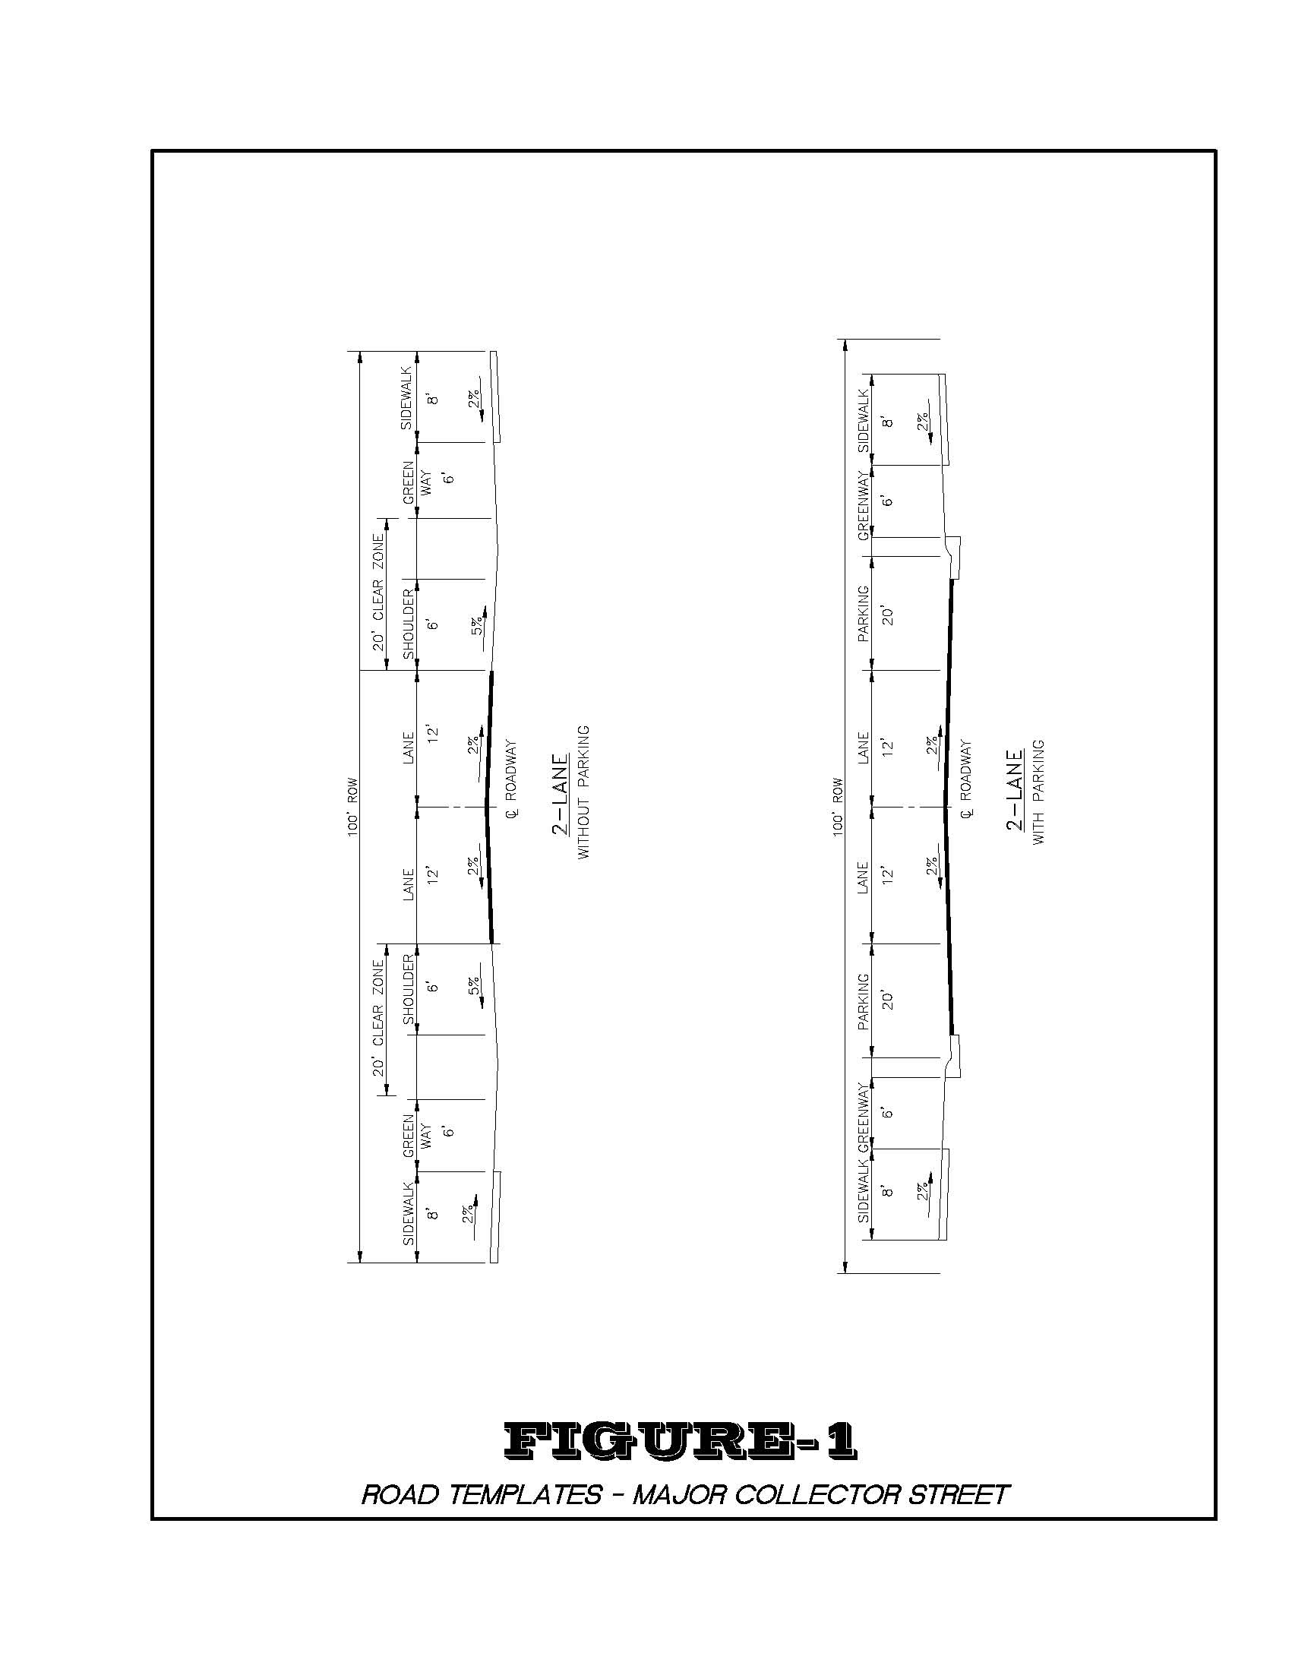

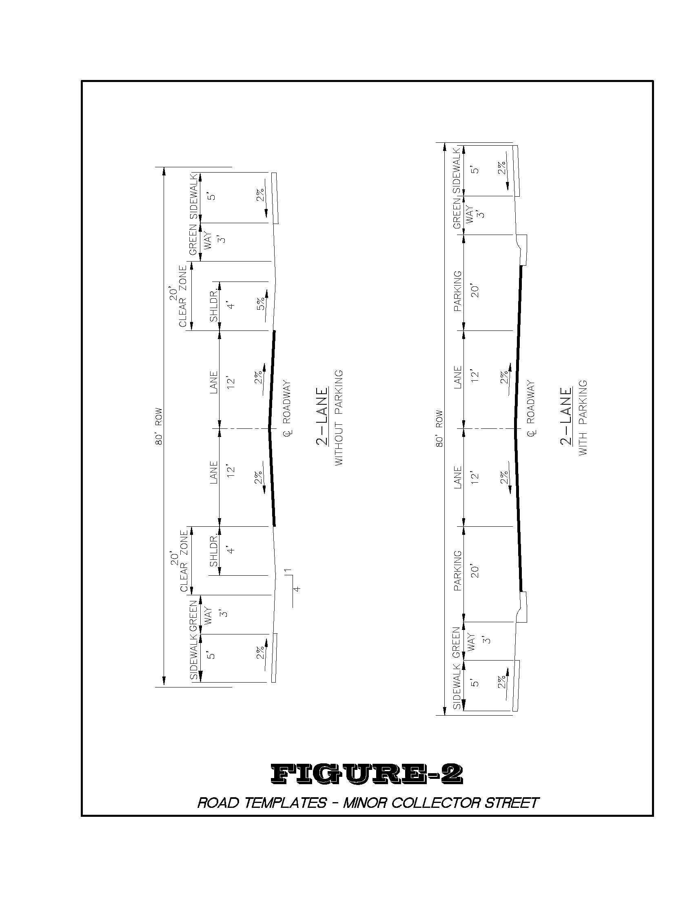

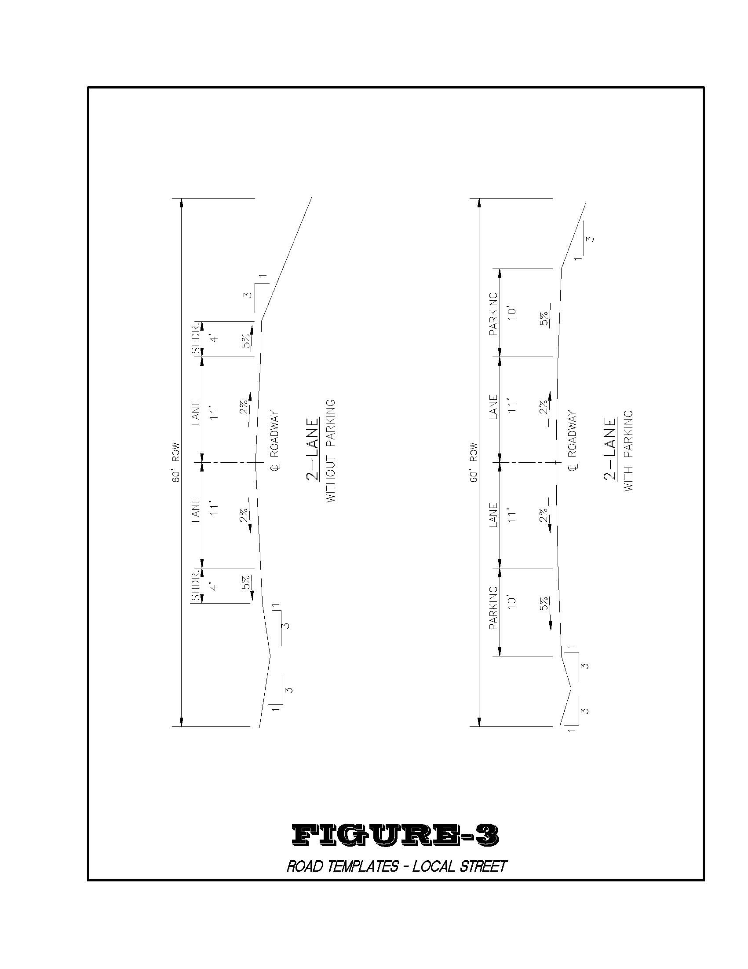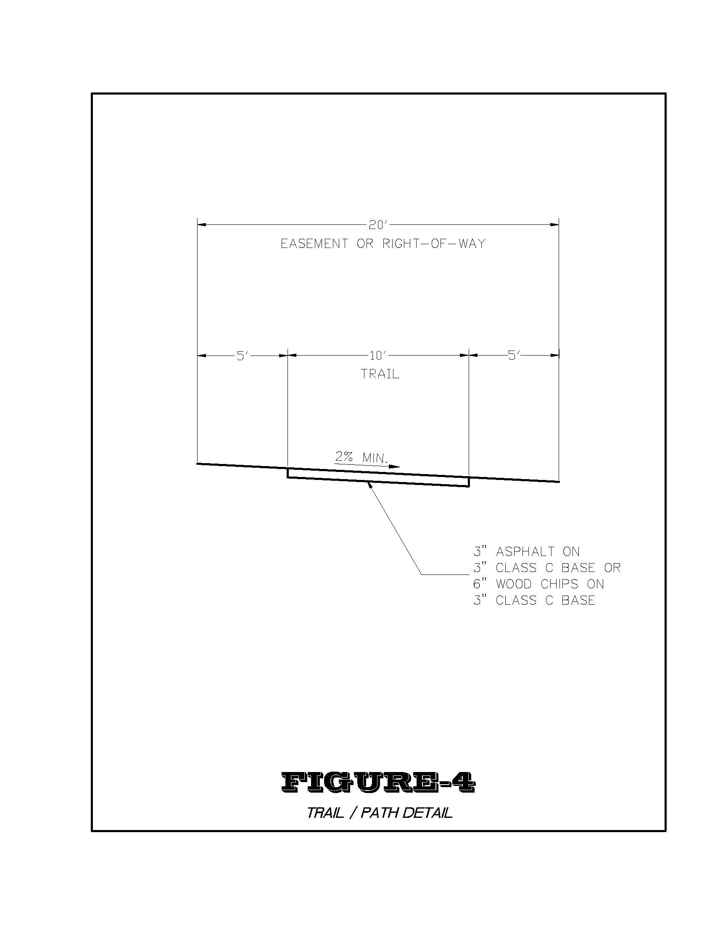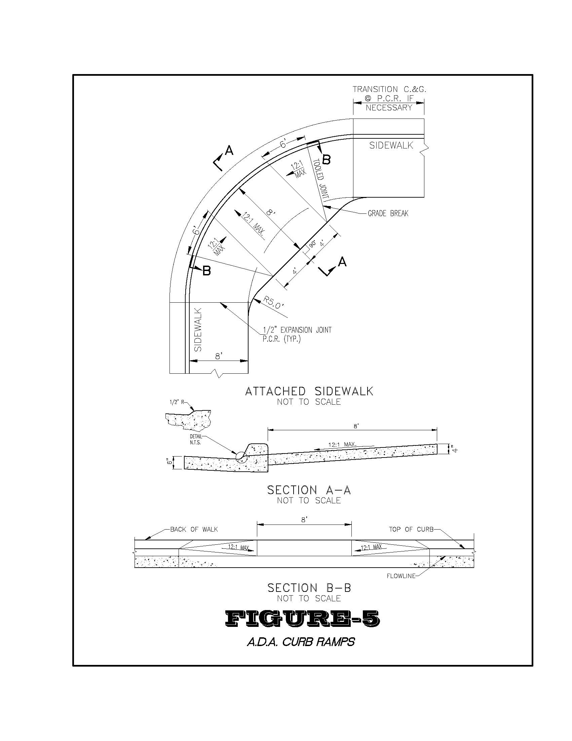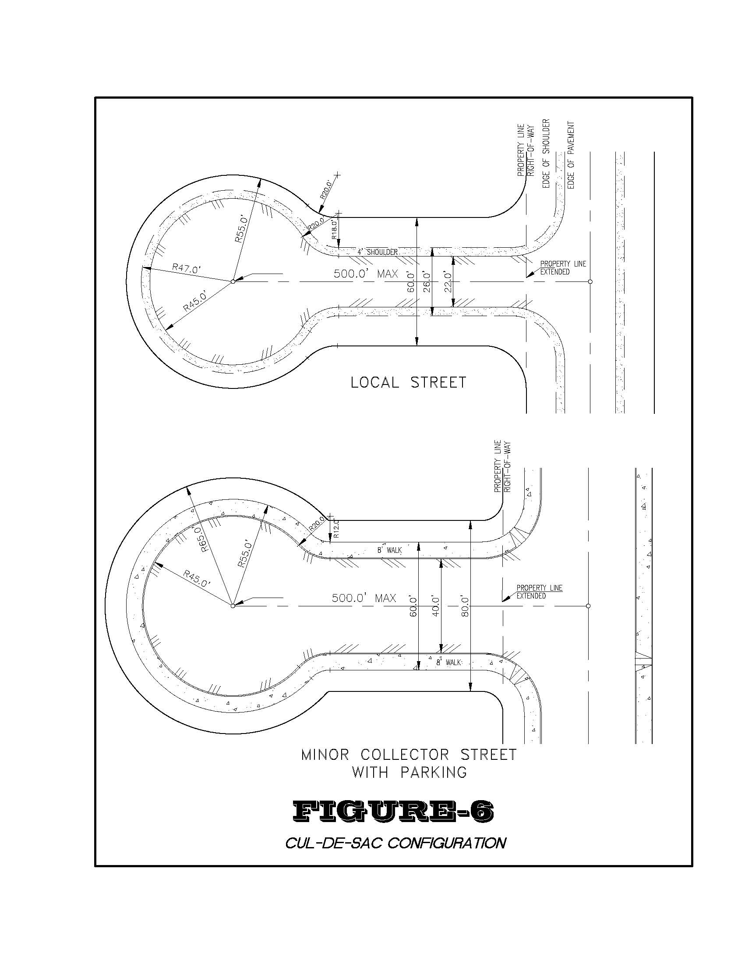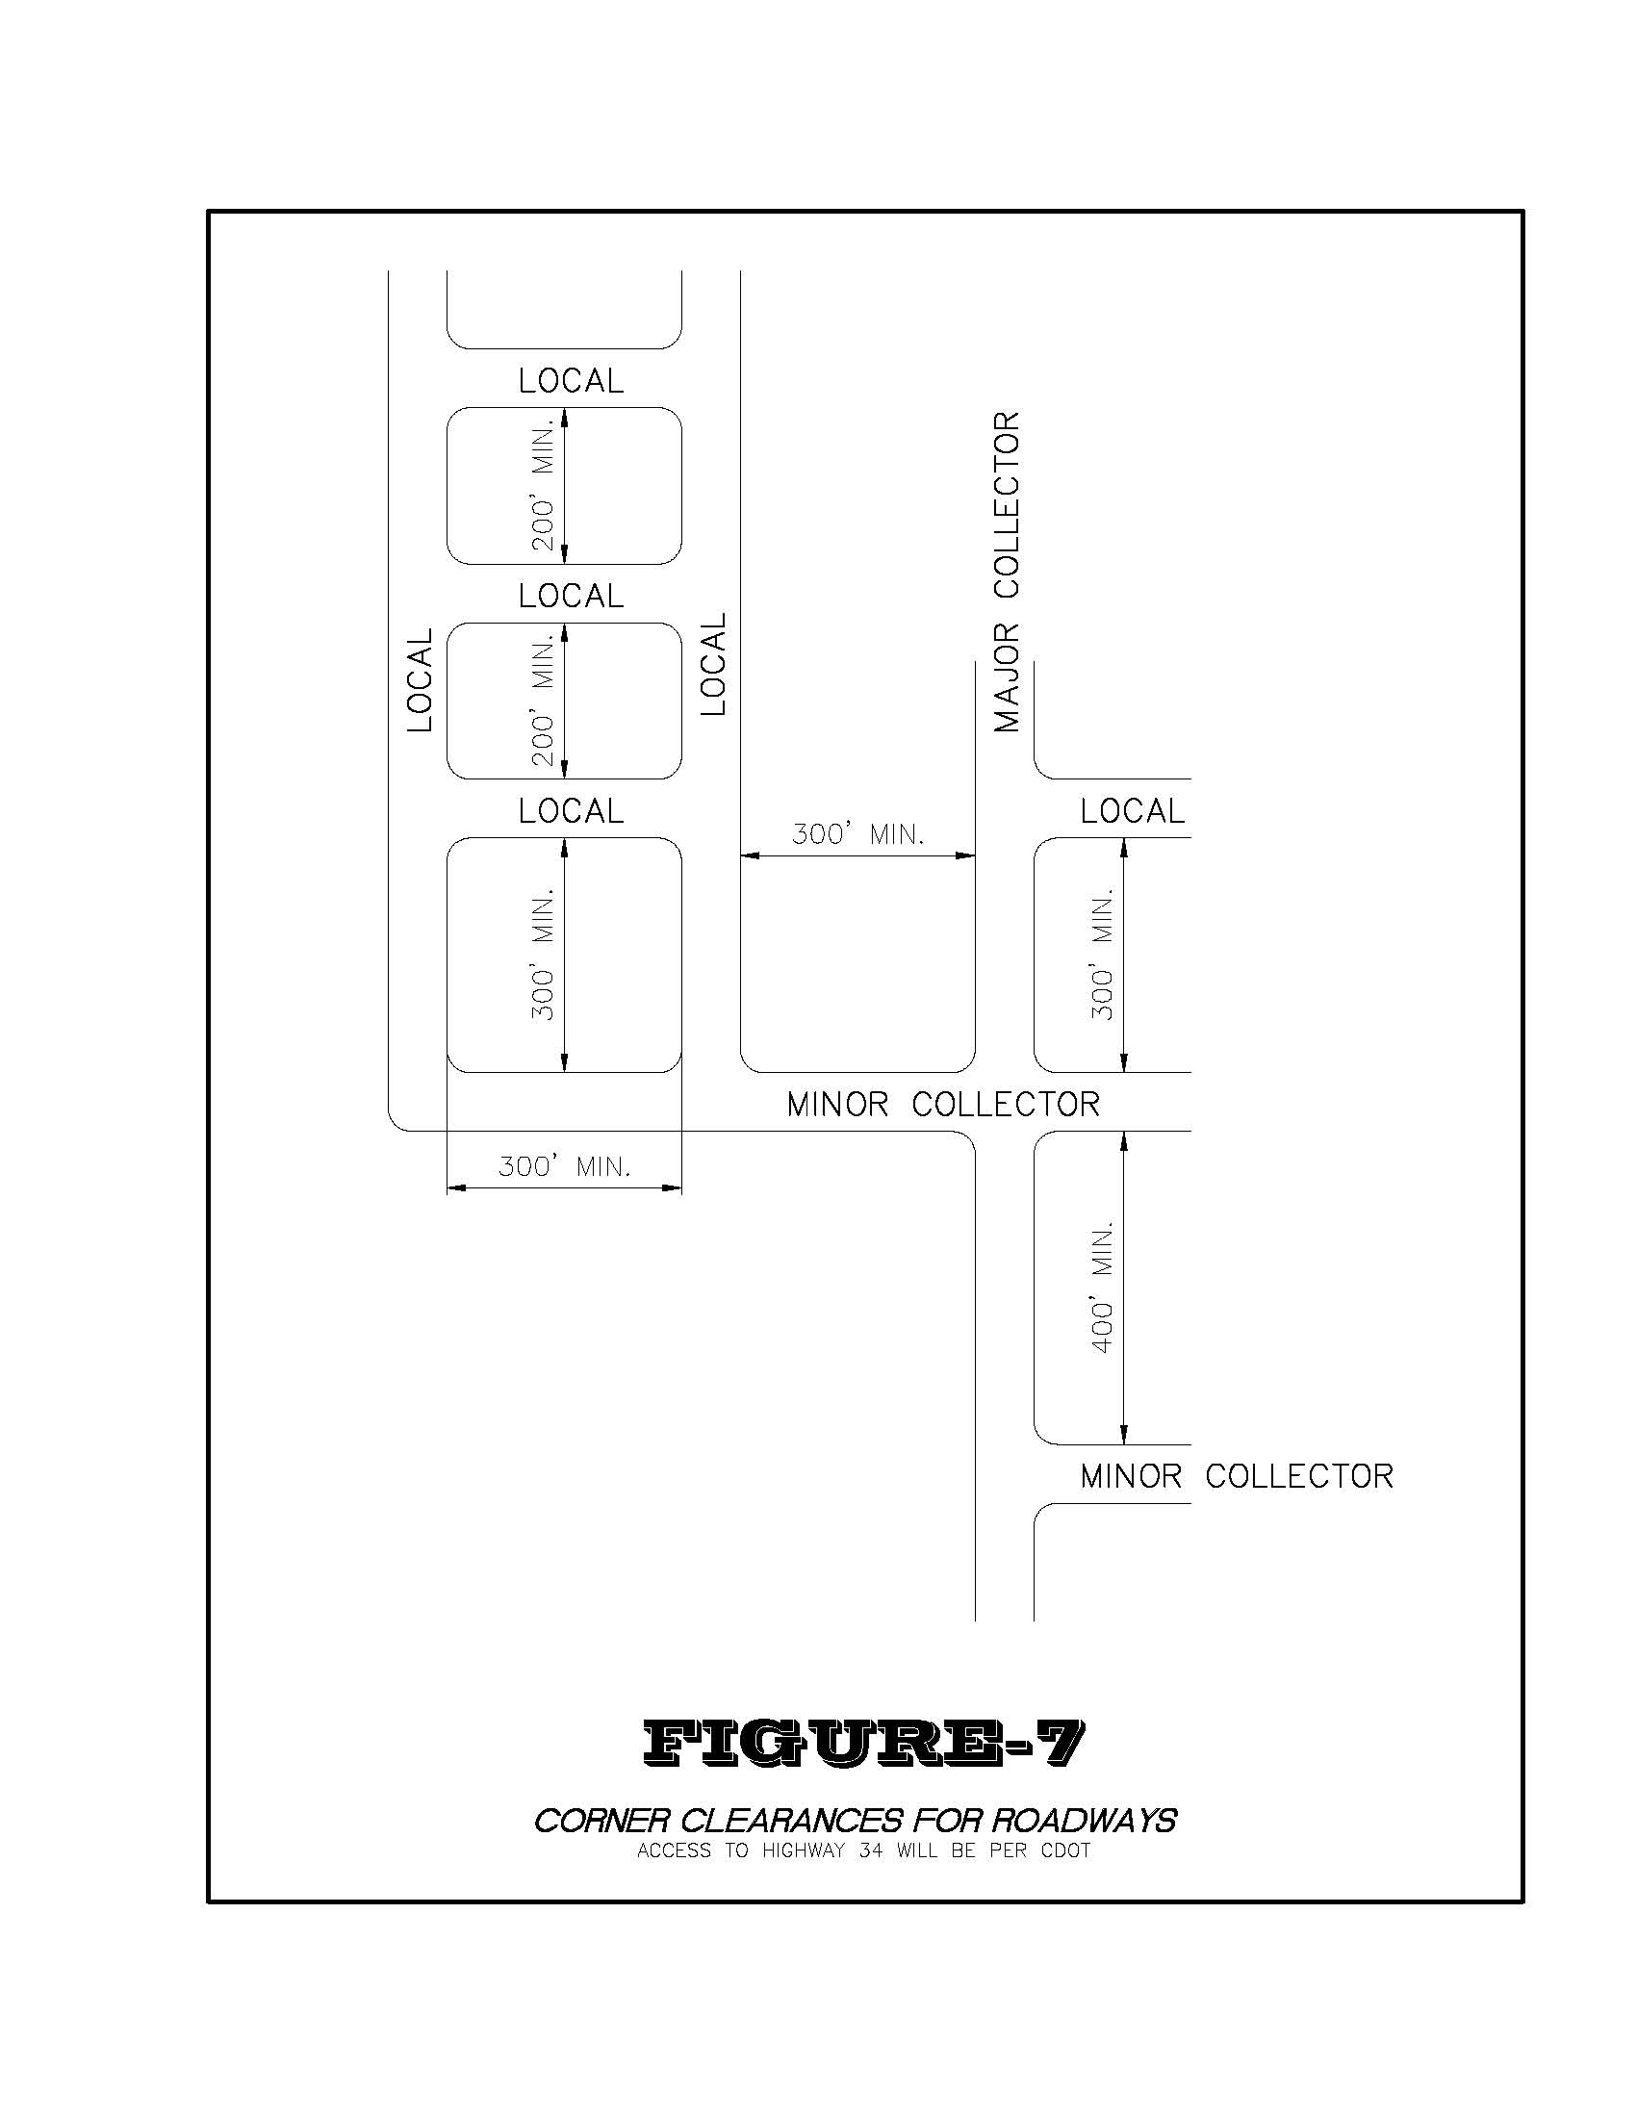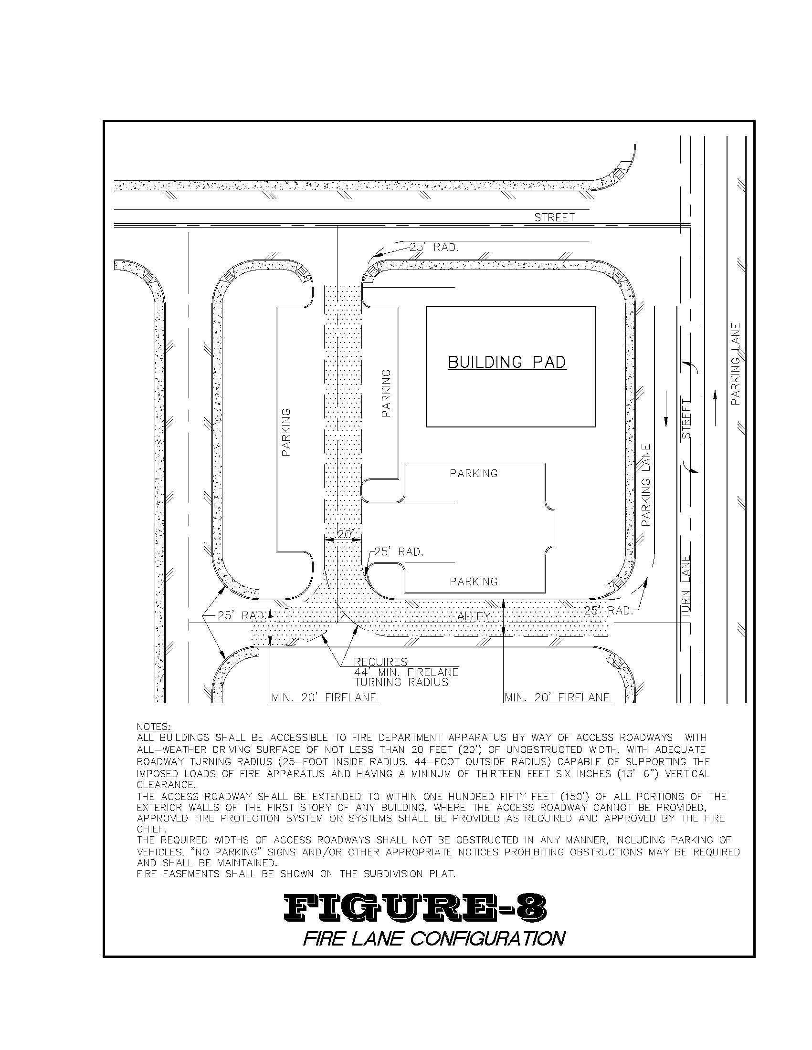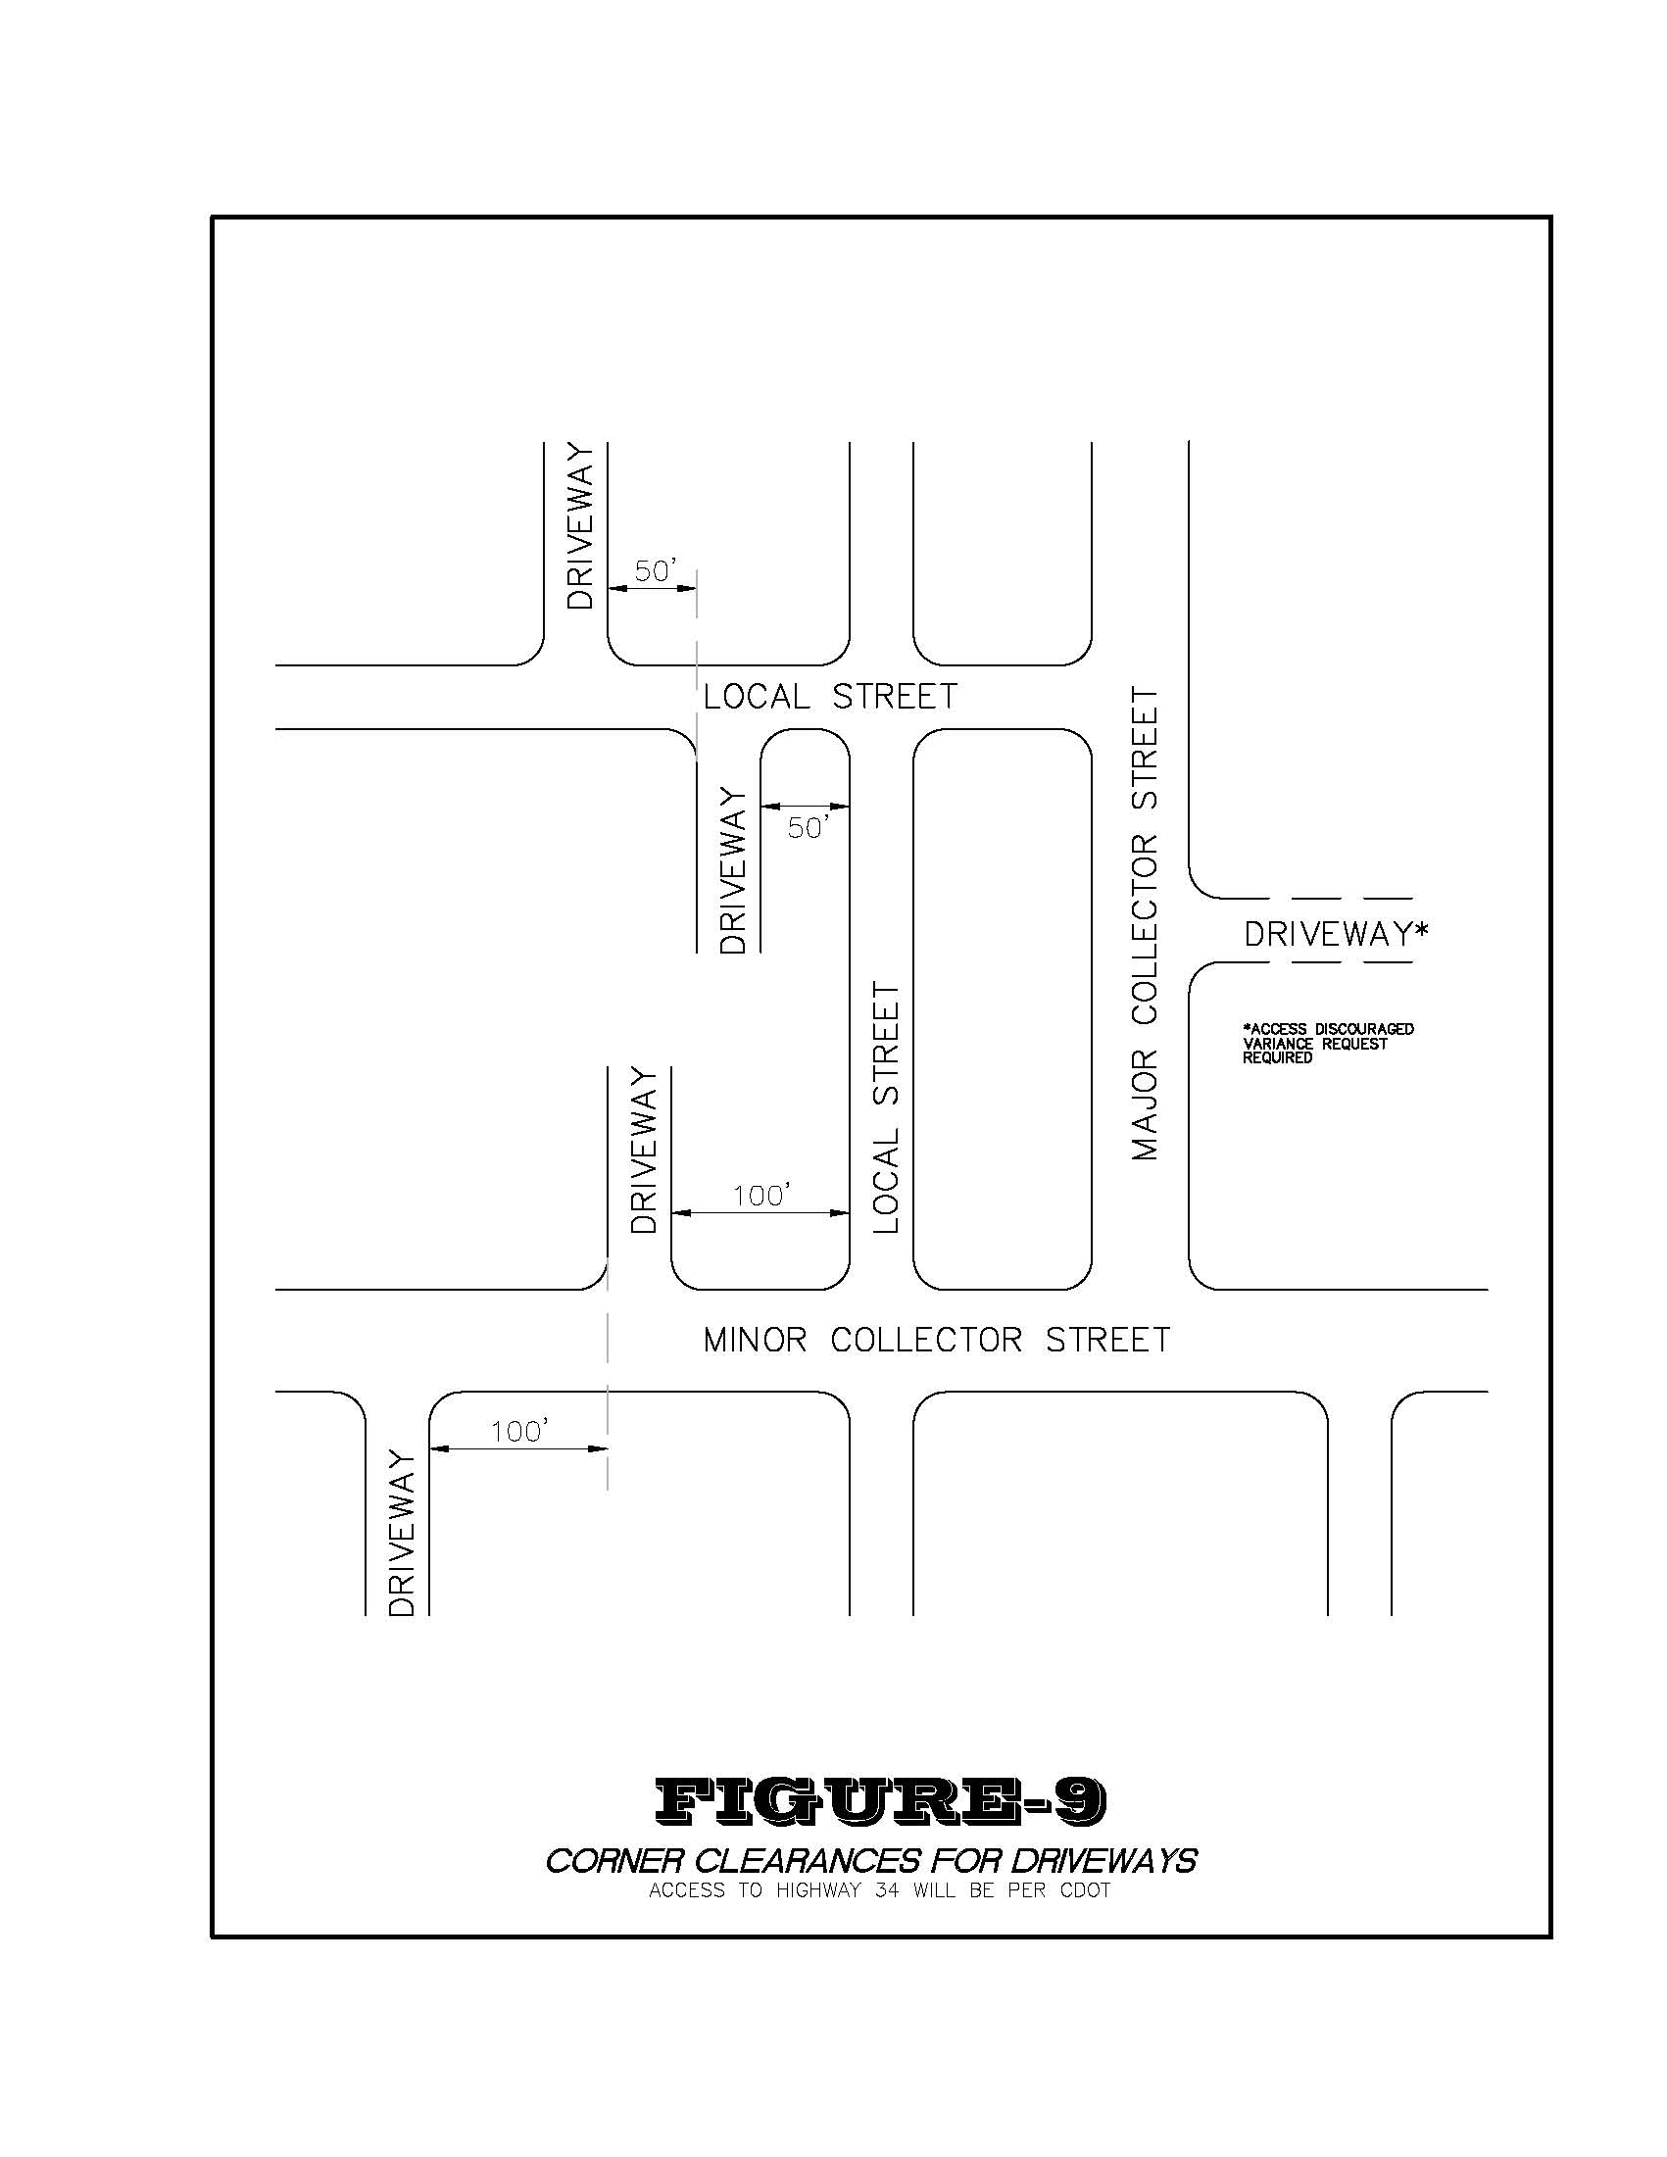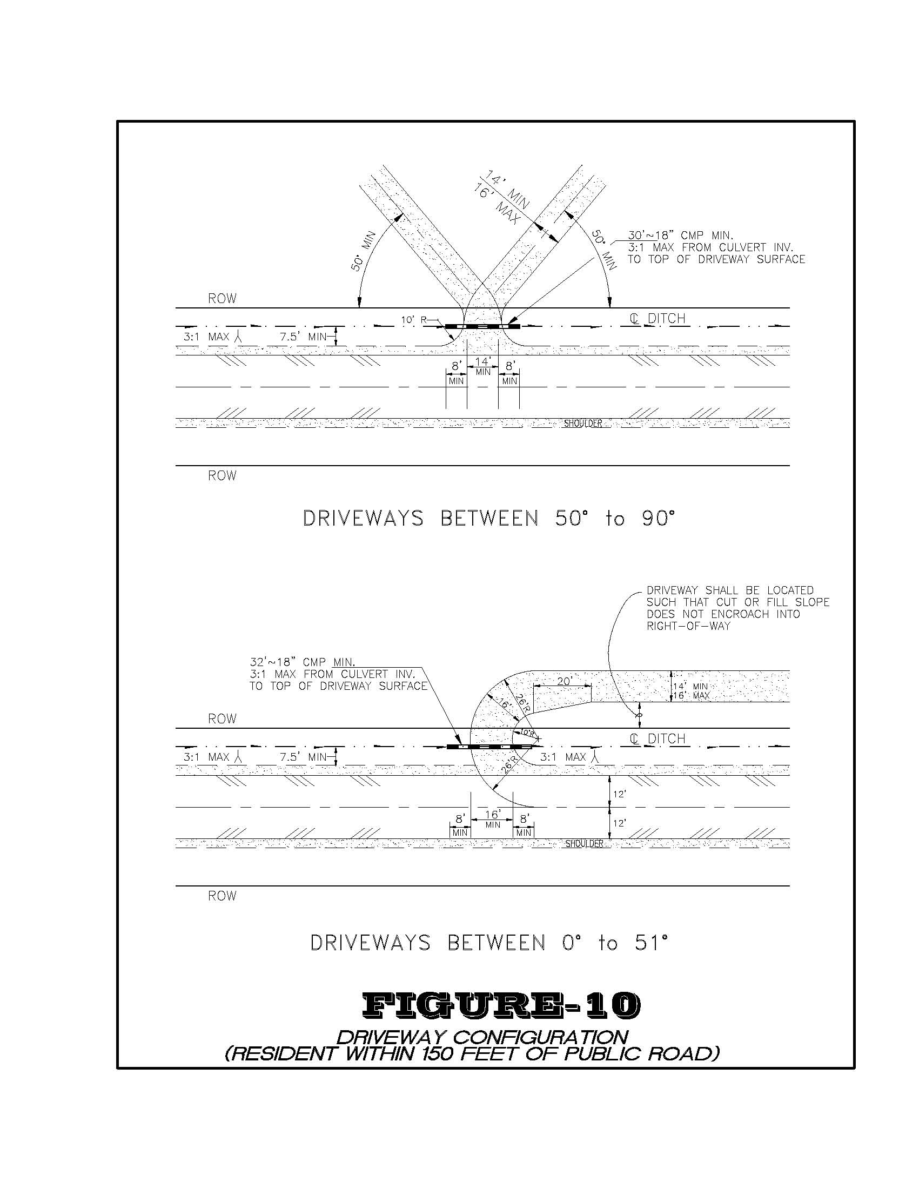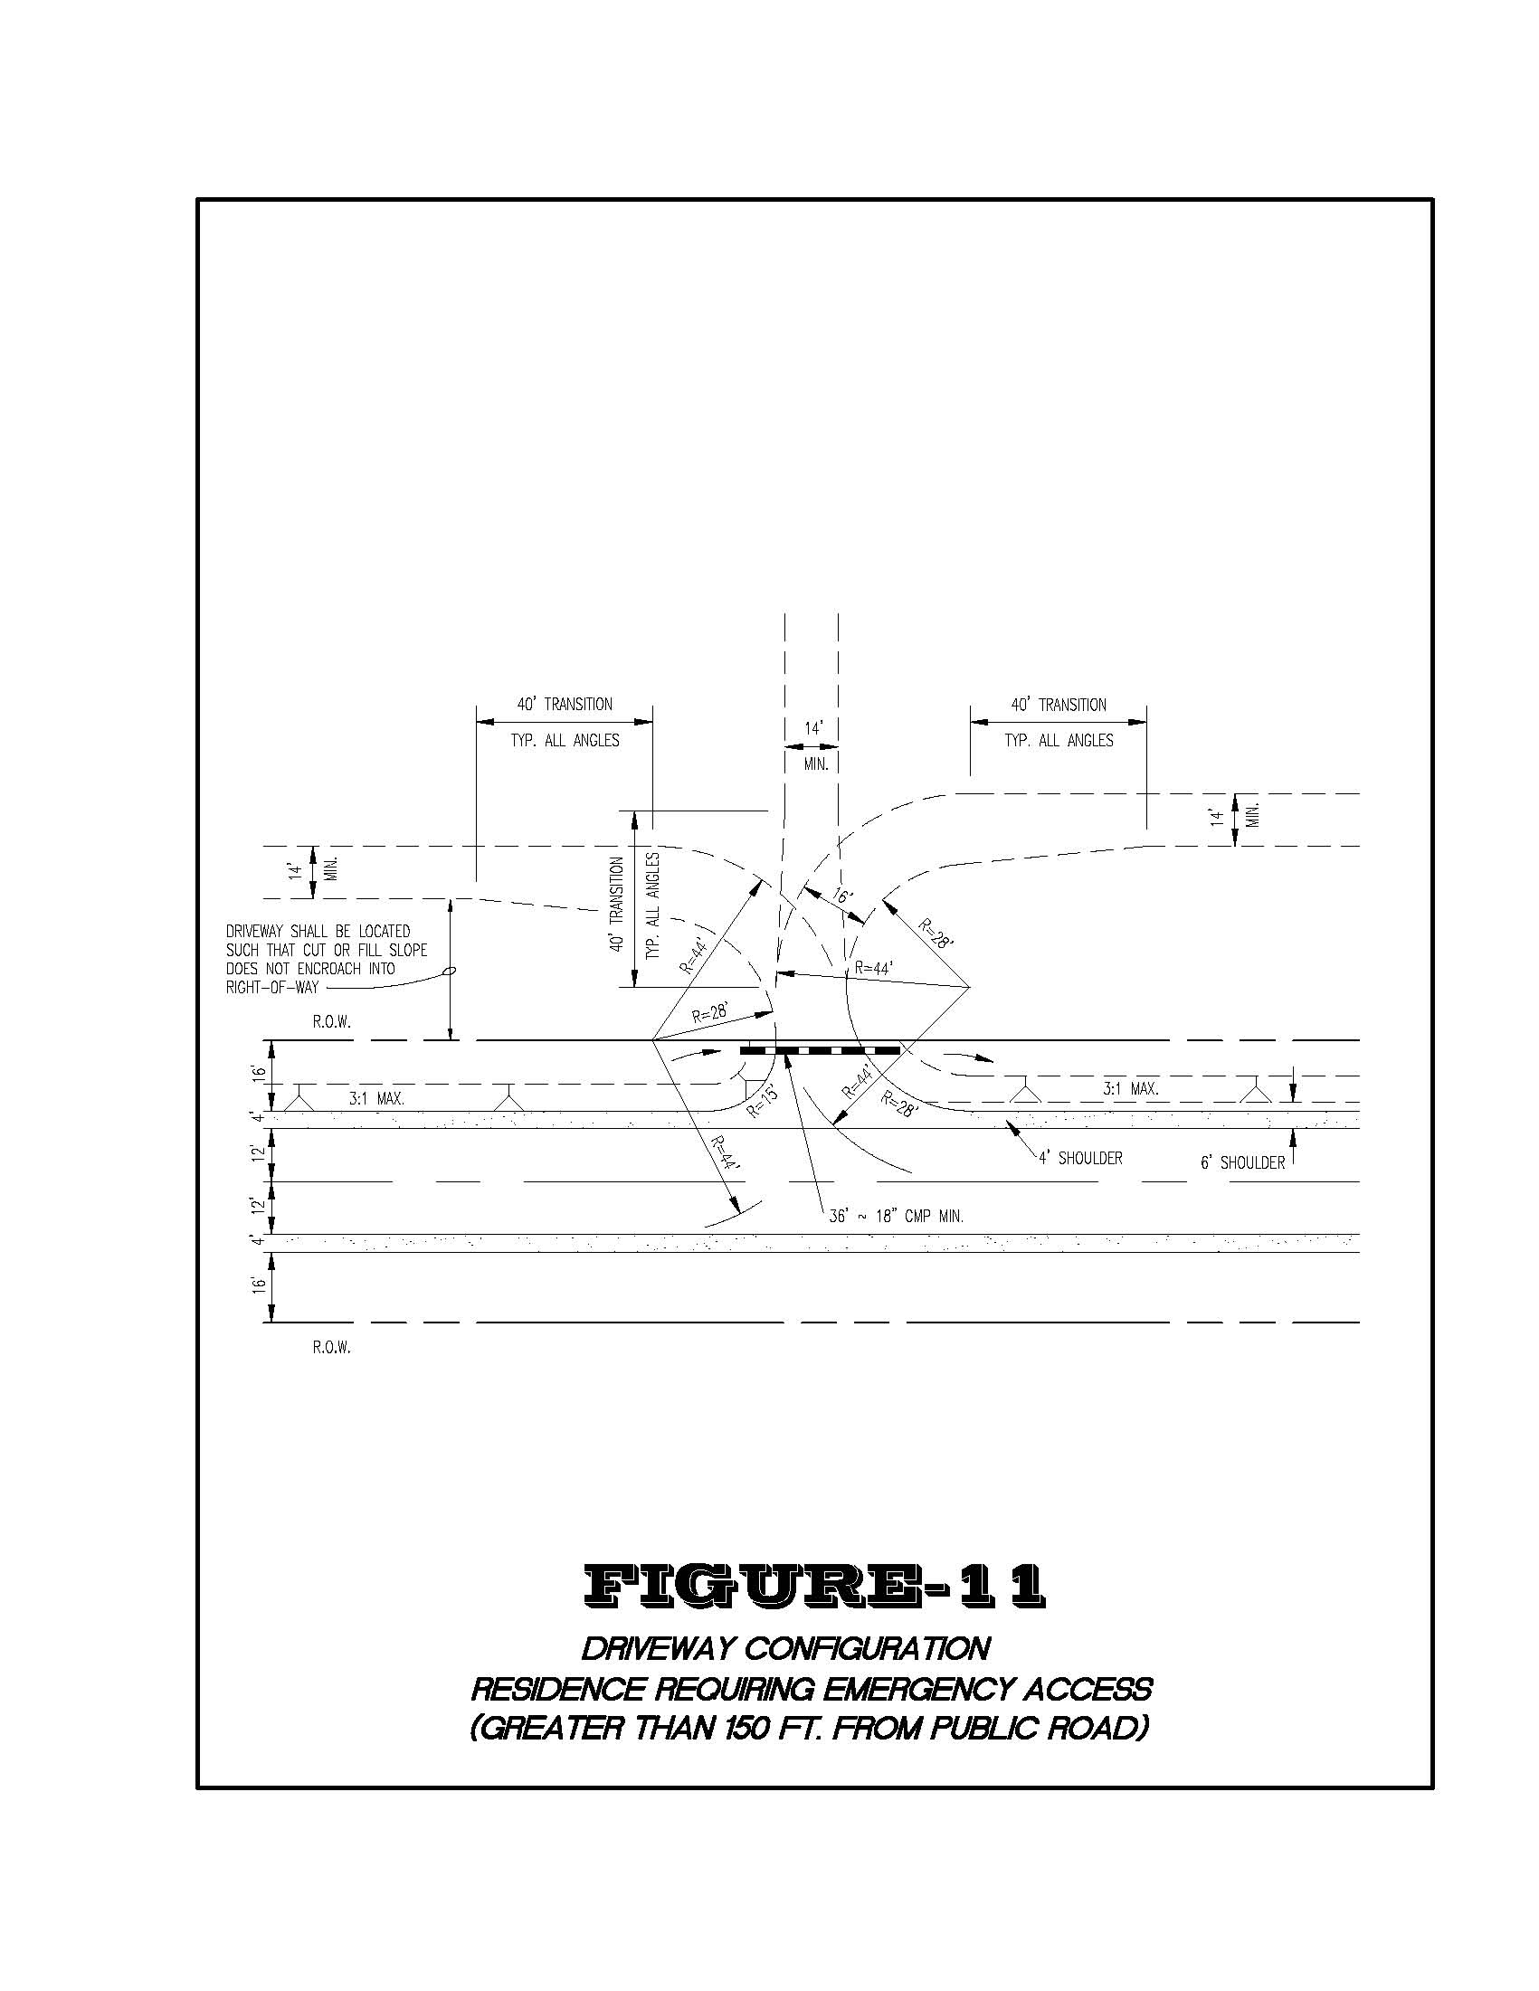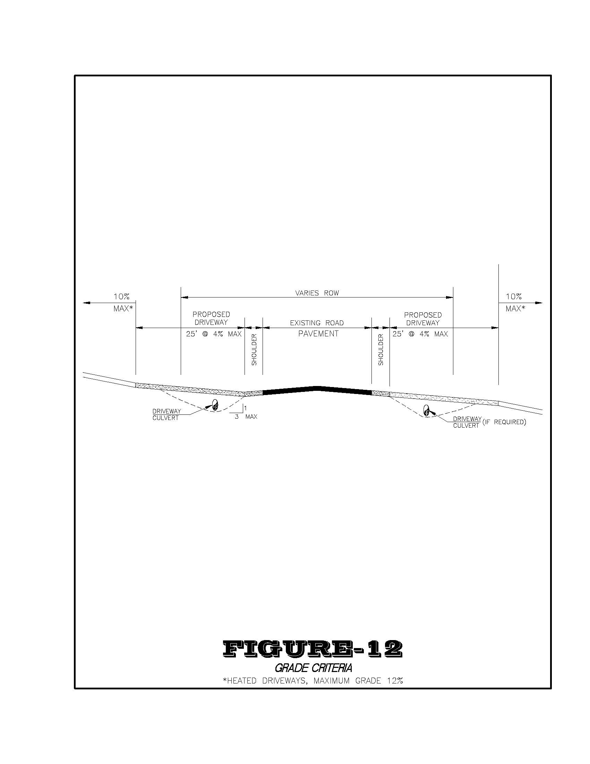
Part 2: Severability: If any Article, Section, paragraph, sentence, clause, or phrase of this Ordinance is held to be unconstitutional or invalid for any reason, such decision shall not affect the validity of the remaining portions of this Ordinance. The Board of Trustees declares that it would have passed this Ordinance and each part or parts thereof irrespective of the fact that any one part or parts be declared unconstitutional or invalid.

Part 3: Repeal: Existing Ordinances or parts of Ordinances covering the same matters as embraced in this Ordinance are hereby repealed and all Ordinances or parts of Ordinances inconsistent with the provisions of this Ordinance are hereby repealed, except that this repeal shall not affect or prevent the prosecution or punishment of any person for any act done or committed in violation of any Ordinance hereby repealed prior to the taking effect of this Ordinance.

DULY MOVED, SECONDED AND ADOPTED BY THE BOARD OF TRUSTEES OF THE TOWN OF GRAND LAKE THIS 9TH DAY OF MAY 2011.

Votes Approving: 5
(SEAL) Votes Opposing: 0
Absent: 2
Abstaining: 0

TOWN OF GRAND LAKE
ATTEST:

________________________ By: ________________________
Ronda Kolinske, CMC Judy M. Burke
Town Clerk Mayor

